**College of Alameda**

2021-22 Annual Program Update - COMM

**Program Overview**

Please provide your program’s mission statement and program’s learning outcomes

|  |
| --- |
| Program Mission Statement Communication focuses on how people use messages to generate and interpret meaning in diﬀerent contexts, cultures, channels, and media. Communication skills are among the top qualities employers look for in job candidates. The mission of College of Alameda is to serve the educational needs of its diverse community by providing comprehensive and ﬂexible programs and resources that empower students to achieve their goals. The Communication Department directly supports this mission by helping students learn why people interact the way they do while improving their own verbal, nonverbal, and written communication skills. Program Learning Outcomes Upon completion of this program a student will be able to:   * Build greater competence in interpersonal, small group, and public communication. * Express ideas and viewpoints with greater clarity. * Develop conflict management and leadership skills. |

List your program faculty and/or staff

|  |
| --- |
| Jennifer Fowler (Full Time)  Ashlie Andrew (Part Time)  Brielle Plump (Part Time)  Pati Shojaee (Part Time)  Kwesi Wilson (Part Time)  Jennifer Zenovich (Part Time) |

Describe your current utilization of facilities, including labs and other space

|  |
| --- |
| The Communication Department utilizes "smart classrooms" on campus equipped with an interactive whiteboard, digital projector, and document camera. However, our department switched to 100% online course offerings due to the COVID campus closure and shelter in place order. In Spring 2022, the department’s course offerings will include hybrid instruction as part of the return-to-campus plan. |

List your program goals from your most recent Program Review or APU. Then, provide an update on the status of the goal. Has your program achieved the goal? Have any of your goals been revised or any still in progress? Lastly, make sure to discuss which College or District goal your program goal aligns to.

If no program goals exist or if this is your first program review, work to create 2-3 goals and align them with a College or District goal.

|  |  |
| --- | --- |
| **Program Goal** | Continue SLO assessments and stay current every year. This will allow our department to meet accreditation standards. |
| Status: In-Progress or Complete? | Complete |
| Which college or district goal is aligned with your program goal? | College Goal: Data-Driven Decision Making  District Goal: Build Programs of Distinction |

|  |  |
| --- | --- |
| **Program Goal** | Increase faculty access to technology and digital teaching tools. |
| Status: In-Progress or Complete? | Complete |
| Which college or district goal is aligned with your program goal? | College: Advance CoA teaching and learning  District: Build Programs of Distinction |

|  |  |
| --- | --- |
| **Program Goal** | Expand the number of courses offered. This will allow our department to increase our reach and number of degrees awarded. |
| Status: In-Progress or Complete? | Complete |
| Which college or district goal is aligned with your program goal? | College: Advance CoA teaching and learning  District: Build Programs of Distinction |

**Program Update**

Using the dashboards, review and reflect upon the data for your program.

[**Course Completion and Retention Rates – Instructional Dashboard**](https://app.powerbi.com/view?r=eyJrIjoiNjc2MDhiNTEtNTJhZi00MDM0LTk5NDItNTRiY2EzMGI1NTZiIiwidCI6ImVlYTE2YTE2LTQ4YWYtNDc3Yi05MTEzLTA1YjFjMDExMjNmZiIsImMiOjZ9&pageName=ReportSection86d6f65e2fb41a73da4d)

[**Course Completion and Retention Rates – Student Services Dashboard**](https://app.powerbi.com/view?r=eyJrIjoiNjk3NDJjOTItNzI5MS00MDhjLWJhN2EtZjcxNzU4OTBiZDBjIiwidCI6ImVlYTE2YTE2LTQ4YWYtNDc3Yi05MTEzLTA1YjFjMDExMjNmZiIsImMiOjZ9&pageName=ReportSection86d6f65e2fb41a73da4d)

[**Enrollment Trends and Productivity Dashboard**](https://app.powerbi.com/view?r=eyJrIjoiNWJlOWZmYTEtNTY0MC00MDhkLWE5OTAtYmJjZjIxNzJiNWViIiwidCI6ImVlYTE2YTE2LTQ4YWYtNDc3Yi05MTEzLTA1YjFjMDExMjNmZiIsImMiOjZ9&pageName=ReportSection86d6f65e2fb41a73da4d)

[**Degrees and Certificates Dashboard**](https://app.powerbi.com/view?r=eyJrIjoiZjU2M2M5MzItOTcwZi00Y2U1LWJmODUtYTc0YjlhZGI2ZDhjIiwidCI6ImVlYTE2YTE2LTQ4YWYtNDc3Yi05MTEzLTA1YjFjMDExMjNmZiIsImMiOjZ9&pageName=ReportSectionde32556e136b0a8caccd)

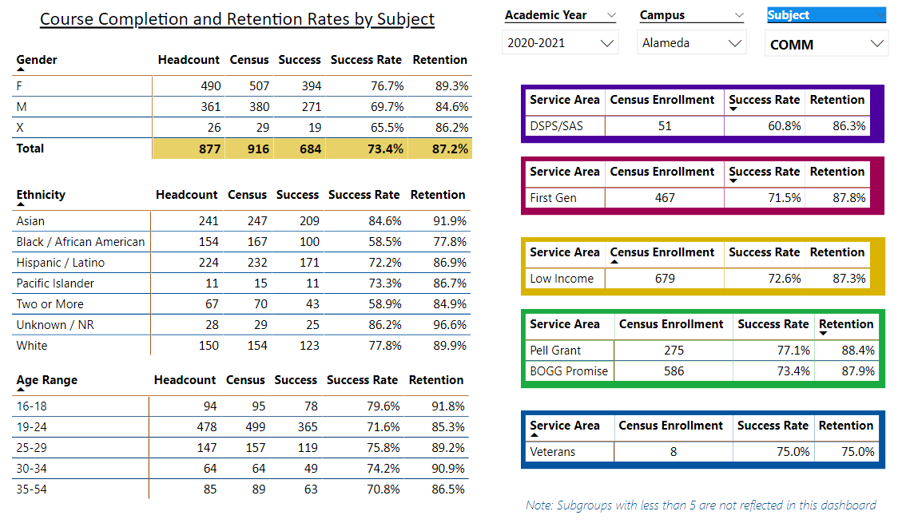

Describe any significant changes and discuss what the changes mean to your program. Consider whether performance gaps exist for disproportionality impacted students by using filters to disaggregate the data. Focus upon the most recent year and/or the years since your last comprehensive program review. Cite data points to support your reflection.

|  |
| --- |
| The Communication Department did not experience significant changes over the last year, despite the continuation of the COVID-19 pandemic. We continued all-virtual instruction and exceeded the college’s completion rate and retention rates by 2% in both areas.  An analysis of demographic completion and retention data shows a steep decrease in the number of students served in nearly every disproportionately impacted student population, matching the massive enrollment decline at California Community Colleges over the last year. Enrollment decreases were further aggravated by statewide financial aid fraud and multitudes of phantom and fake students dating back as early as Spring Intersession in 2021. However, despite a decrease in total number of students served in almost every categorical population, there were no significant differences overall in completion and retention outcomes. The most significant area of decline was SAS student completion rates, with a massive -16% decline over last academic year. The huge performance gap amongst SAS students suggests a need for better collaboration and partnership with SAS staff to figure out how faculty can close gaps. The Communication Department Chair has undergone extensive online accessibility training in the Fall 2021 semester. She plans to share universal design and accessibility training with department faculty as one way of closing the gap.  It should be noted that it is imperative for the health of the discipline—and for the health of the college generally—that departments and clusters demonstrably harmed by the fraud-caused drop in enrollment does not see reductions in their FTEF allocations or class offerings on account of security breaches outside the control of faculty or actual students. |

Describe the department's progress on Student Learning Outcomes (SLOs) and/or Service Area Outcomes (SAOs) since the last Program Review/APU.

|  |
| --- |
| All SLO data and analysis is up to date in Curricunet. The department has a streamlined method of collecting data from instructors on SLO’s from a shared Google sheet, which makes compiling and entering the data easy. Part time faculty are engaged in the process and supported by the stipends offered by the college. We strongly advocate that funding for part time faculty participation in SLO assessment continue as a way of increasing their participation and voice in this important process. |

Describe the outcomes and accomplishments from previous year’s funded resource allocation request.

|  |  |  |  |
| --- | --- | --- | --- |
| **Brief description of funded request** | **Source (any additional award outside your base allocation)** | **Total Award Amount** | **Outcome/Accomplishment** |
| N/A – we did not have any resources allocation requests last year. |  |  |  |
|  |  |  |  |
|  |  |  |  |

**Prioritized Resource Requests Summary**

In the boxes below, please add resource requests for your program. If there are no resource requested, leave the boxes blank.

|  |  |  |  |  |
| --- | --- | --- | --- | --- |
| **Resource Category** | **Description/Justification** | **Estimated Annual Salary Costs** | **Estimated Annual Benefits Costs** | **Total Estimated Cost** |
| **Personnel: Classified Staff** | N/A |  |  |  |
| **Personnel: Student Worker** | N/A |  |  |  |
| **Personnel: Part Time Faculty** | N/A |  |  |  |
| **Personnel: Full Time Faculty** | N/A |  |  |  |

|  |  |  |
| --- | --- | --- |
| **Resource Category** | **Description/Justification** | **Total Estimated Cost** |
| **Professional Development: Department wide PD needed** | Intensive training in hyflex pedagogy, including technical, performative, and DEI-related dimensions | $2500 |
| **Professional Development: Personal/Individual PD needed** | Funding for @ONE professional development courses and conference attendance. | $1000 |

**Prioritized Resource Requests Summary - Continued**

|  |  |  |
| --- | --- | --- |
| **Resource Category** | **Description/Justification** | **Total Estimated Cost** |
| **Supplies: Software** | N/A |  |
| **Supplies: Books, Magazines, and/or Periodicals** | N/A |  |
| **Supplies: Instructional Supplies** | Typical instructional supplies for online and in-person instruction. | $2000 |
| **Supplies: Non-Instructional Supplies** | Typical office supplies for department use. | $1500 |
| **Supplies: Library Collections** | N/A |  |

|  |  |  |
| --- | --- | --- |
| **Resource Category** | **Description/Justification** | **Total Estimated Cost** |
| **Technology & Equipment: New** |  |  |
| **Technology & Equipment: Replacement** |  |  |

**Prioritized Resource Requests Summary - Continued**

|  |  |  |
| --- | --- | --- |
| **Resource Category** | **Description/Justification** | **Total Estimated Cost** |
| **Facilities: Classrooms** | Technology to support hyflex instruction. I do not have an IT background but according to University of San Diego’s website, some of the technology required for hyflex instruction might include:   * 2 HD cameras with optional pan, tilt, and zoom options * 2 microphones to capture the instructor and student voice * Touch screen monitor with pen tool on the side of the monitor * Document camera (that can also be used as a camera input) * Updated podium control panel to choose camera shots | ~$6,000* per classroom  *This is my best guess at a ballpark range, but IT would be the experts in this area in making estimates. |
| **Facilities: Offices** | N/A |  |
| **Facilities: Labs** | N/A |  |
| **Facilities: Other** | N/A |  |

|  |  |  |
| --- | --- | --- |
| **Resource Category** | **Description/Justification** | **Total Estimated Cost** |
| **Library: Library materials** | N/A |  |
| **Library: Library collections** | N/A |  |

|  |  |  |
| --- | --- | --- |
| **Resource Category** | **Description/Justification** | **Total Estimated Cost** |
| **OTHER** |  |  |