**College of Alameda**

2021-22 Annual Program Update - DENTL

**Program Overview**

Please provide your program’s mission statement and program’s learning outcomes

|  |
| --- |
| To provide an educational program that promotes an atmosphere of professionalism, integrity, and educational excellence. The Dental Assisting program develops knowledge and skills that will enable the students to function as an integral part of the dental health care team. Students will have the opportunity to acquire the knowledge and proficiency to successfully assist in serving the oral health care of the community. |

List your program faculty and/or staff

|  |
| --- |
| Carla Pegues  Renee Herold  Meeying Coffer  Ledy Delfn-Icater |

Describe your current utilization of facilities, including labs and other space

|  |
| --- |
| The dental assisting department is located in the A building room A208, within our department we utilize the following rooms.  A224(lecture)  A222(lab)  A223(plaster/storage)  A205(computer lab)  A209(darkroom)  A211(radiology lab)  A206(student locker)  A204(faculty office)  A201A(office) |

List your program goals from your most recent Program Review or APU. Then, provide an update on the status of the goal. Has your program achieved the goal? Have any of your goals been revised or any still in progress? Lastly, make sure to discuss which College or District goal your program goal aligns to.

If no program goals exist or if this is your first program review, work to create 2-3 goals and align them with a College or District goal.

|  |  |
| --- | --- |
| **Program Goal** | The DA department’s goal is to always ensure the our student obtain the knowledge necessary to perform their duties in a ethical, responsible and professional manner. |
| Status: In-Progress or Complete? | In- progress |
| Which college or district goal is aligned with your program goal? | Four (4) Increase community and educational partnership. Aligns with PCCD Goal to engage and leverage partners. |

|  |  |
| --- | --- |
| **Program Goal** | To educate and train our students to master the competency of infection control to educate and protect their community and dental team. |
| Status: In-Progress or Complete? | In- progress |
| Which college or district goal is aligned with your program goal? | Six (6) Aligns to COA Goal to advance CoA teaching and learning. Aligns with PCCD Goal to build programs of distinction. |

|  |  |
| --- | --- |
| **Program Goal** | Continue to meet with industry partners in Alameda County, advisory board members, and accreditation (CODA) staff to ensure we are meeting regulated standards and to ensure the CoA’s Dental Assisting programs is meeting industry standards |
| Status: In-Progress or Complete? | In-progress |
| Which college or district goal is aligned with your program goal? | Five (5) Strengthen business and industry partnership. Aligns with PCCD Goal to engage and leverage partners and develop and manage. |

**Program Update**

Using the dashboards, review and reflect upon the data for your program.

[**Course Completion and Retention Rates – Instructional Dashboard**](https://app.powerbi.com/view?r=eyJrIjoiNjc2MDhiNTEtNTJhZi00MDM0LTk5NDItNTRiY2EzMGI1NTZiIiwidCI6ImVlYTE2YTE2LTQ4YWYtNDc3Yi05MTEzLTA1YjFjMDExMjNmZiIsImMiOjZ9&pageName=ReportSection86d6f65e2fb41a73da4d)

[**Course Completion and Retention Rates – Student Services Dashboard**](https://app.powerbi.com/view?r=eyJrIjoiNjk3NDJjOTItNzI5MS00MDhjLWJhN2EtZjcxNzU4OTBiZDBjIiwidCI6ImVlYTE2YTE2LTQ4YWYtNDc3Yi05MTEzLTA1YjFjMDExMjNmZiIsImMiOjZ9&pageName=ReportSection86d6f65e2fb41a73da4d)

[**Enrollment Trends and Productivity Dashboard**](https://app.powerbi.com/view?r=eyJrIjoiNWJlOWZmYTEtNTY0MC00MDhkLWE5OTAtYmJjZjIxNzJiNWViIiwidCI6ImVlYTE2YTE2LTQ4YWYtNDc3Yi05MTEzLTA1YjFjMDExMjNmZiIsImMiOjZ9&pageName=ReportSection86d6f65e2fb41a73da4d)

[**Degrees and Certificates Dashboard**](https://app.powerbi.com/view?r=eyJrIjoiZjU2M2M5MzItOTcwZi00Y2U1LWJmODUtYTc0YjlhZGI2ZDhjIiwidCI6ImVlYTE2YTE2LTQ4YWYtNDc3Yi05MTEzLTA1YjFjMDExMjNmZiIsImMiOjZ9&pageName=ReportSectionde32556e136b0a8caccd)

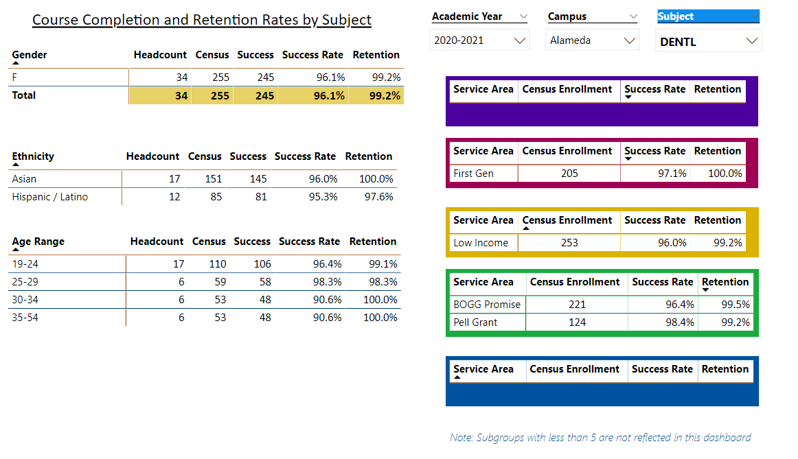

Describe any significant changes and discuss what the changes mean to your program. Consider whether performance gaps exist for disproportionality impacted students by using filters to disaggregate the data. Focus upon the most recent year and/or the years since your last comprehensive program review. Cite data points to support your reflection.

|  |
| --- |
| Due to our current health crisis with Covid 19. The dental industry has lost many longtime assistants due to retirement. With the recent changes to industry the demand for dental assistants is at an all-time high. The current changes mean that our students are in high demand and should be trained with the most current technology and equipment to meet the demand and needs of the community. |

Describe the department's progress on Student Learning Outcomes (SLOs) and/or Service Area Outcomes (SAOs) since the last Program Review/APU.

|  |
| --- |
| The dental dept continues to assess SLOs to ensure that we make necessary efforts to assist various learning styles. Each faculty member will continue to make adjustments as needed for student success. |

Describe the outcomes and accomplishments from previous year’s funded resource allocation request.

|  |  |  |  |
| --- | --- | --- | --- |
| **Brief description of funded request** | **Source (any additional award outside your base allocation)** | **Total Award Amount** | **Outcome/Accomplishment** |
| Covid Funds: to help purchase PPE needed to ensure student and staff safety. | N/A | N/A | The students were able to continue with in-person learning in a safe manner and productive manner. |
|  |  |  |  |
|  |  |  |  |

**Prioritized Resource Requests Summary**

In the boxes below, please add resource requests for your program. If there are no resource requested, leave the boxes blank.

|  |  |  |  |  |
| --- | --- | --- | --- | --- |
| **Resource Category** | **Description/Justification** | **Estimated Annual Salary Costs** | **Estimated Annual Benefits Costs** | **Total Estimated Cost** |
| **Personnel: Classified Staff** | N/A |  |  |  |
| **Personnel: Student Worker**  **(Third)** | A student worker will be beneficial to the DA department to assist with admin work, such as filing, answering phone call and assisting in lab. | $10,000 | N/A |  |
| **Personnel: Part Time Faculty**  **(Second)** | Due to the recent and upcoming retirement of adjunct faculty. Additional adjunct faculty is needed. | $55,000 | N/A |  |
| **Personnel: Full Time Faculty**  **(First)** | The DA department has only had one full time faculty. Additional full-time faculty is needed to meet the needs of our students | $80,000 |  |  |

|  |  |  |
| --- | --- | --- |
| **Resource Category** | **Description/Justification** | **Total Estimated Cost** |
| **Professional Development: Department wide PD needed** | Due to the ongoing changes and updates within the dental community, Professional development is vital and necessary for all staff members to stay current with Industry standards, rules and regulations. | $10,000.00 |
| **Professional Development: Personal/Individual PD needed** | As the Program director and Infection Control Instructor. It is imperative that I attend the Program Directors meeting and OSAP annual meeting to stay current with industry changes and infection control updates. | $6,000.00 |

**Prioritized Resource Requests Summary - Continued**

|  |  |  |
| --- | --- | --- |
| **Resource Category** | **Description/Justification** | **Total Estimated Cost** |
| **Supplies: Software** | Course 229 Practice Management needs new Dentrix Software. Current software is no longer being utilize in the industry. | $3,500 |
| **Supplies: Books, Magazines, and/or Periodicals** | N/A |  |
| **Supplies: Instructional Supplies** | Dental material is an ongoing need for the dental department to ensure that the student is being taught to industry standards. Many of the dental material being used are well beyond the expiration date (2002). | $8,000.00 |
| **Supplies: Non-Instructional Supplies** | N/A |  |
| **Supplies: Library Collections** | N/A |  |

|  |  |  |
| --- | --- | --- |
| **Resource Category** | **Description/Justification** | **Total Estimated Cost** |
| **Technology & Equipment: New** | Web Cameras. Current computers do not have cameras. Therefore, faculty cannot communicate or participate in zoom conference call or meeting while on campus. | $300.00 |
| **Technology & Equipment: Replacement** | Dental x-ray sensors(2)  . | $14,000.00 |

**Prioritized Resource Requests Summary - Continued**

|  |  |  |
| --- | --- | --- |
| **Resource Category** | **Description/Justification** | **Total Estimated Cost** |
| **Facilities: Classrooms** | N/A |  |
| **Facilities: Offices** | New updated computer is need in the faculty office and furniture | $10,000 |
| **Facilities: Labs** | Itero digital impression machine. The DA department is currently teaching alginate impression. While this technique is still in use in older office. Most offices are switching to a digital format. To ensure that our student is taught to current standards it is important that trained with the current technology. | $30, 000.00 |
| **Facilities: Other** | Lab sinks need repair or replacement lab A222 | $5,000.00 |

|  |  |  |
| --- | --- | --- |
| **Resource Category** | **Description/Justification** | **Total Estimated Cost** |
| **Library: Library materials** |  |  |
| **Library: Library collections** |  |  |

|  |  |  |
| --- | --- | --- |
| **Resource Category** | **Description/Justification** | **Total Estimated Cost** |
| **OTHER** |  |  |