**College of Alameda**

2021-22 Annual Program Update - ENGL

**Program Overview**

Please provide your program’s mission statement and program’s learning outcomes

|  |
| --- |
| The English Department’s mission is to serve the educational and career objectives of our community: We offer a range of classes addressing skills at the basic, developmental and transfer levels and are committed to presenting engaging mater al that addresses the varied interests and needs of our students. |

List your program faculty and/or staff

|  |
| --- |
| **Full-Time** **Part-Time Faculty**  Maurice Jones Juanita Alexander  Jay Rubin Michelle Little  Wanda Sabir Sandra Vaughn  Stefanie Ulrey Christopher Blood  Patricia Nelson Albert Chan  Peter Pappas Elizabeth Treadwell  Ann Chun |

Describe your current utilization of facilities, including labs and other space

|  |
| --- |
| Since March of 2020, because of Covid 19 pandemic, all English instruction has been online via the Canvas course management system and the Zoom videoconferencing platform. There has been no utilization of campus facilities. However, in Spring 2022, the department has scheduled some hybrid classes (35%-40% of course offerings) on campus in the new H-Building. |

List your program goals from your most recent Program Review or APU. Then, provide an update on the status of the goal. Has your program achieved the goal? Have any of your goals been revised or any still in progress? Lastly, make sure to discuss which College or District goal your program goal aligns to.

If no program goals exist or if this is your first program review, work to create 2-3 goals and align them with a College or District goal.

|  |  |
| --- | --- |
| **Program Goal** | To develop AD-T for English, offering an alternating schedule of the required literature courses. |
| Status: In-Progress or Complete? | Complete |
| Which college or district goal is aligned with your program goal? | **College Goal:** Advance CoA teaching and learning  **District Goal:** Advance Student Access, Equity, and Success |

|  |  |
| --- | --- |
| **Program Goal** | Re-evaluate the department’s SLOs |
| Status: In-Progress or Complete? | In-Progress |
| Which college or district goal is aligned with your program goal? | **College Goal:** Advance CoA teaching and learning  **District Goal:** Advance Student Access, Equity, and Success |

|  |  |
| --- | --- |
| **Program Goal** | Development of non-credit courses (and a certificate) |
| Status: In-Progress or Complete? | In-Progress |
| Which college or district goal is aligned with your program goal? | **College Goal:** Increase retention and persistence rates.  **District Goal:** Build programs of Distinction |

**Program Update**

Using the dashboards, review and reflect upon the data for your program.

[**Course Completion and Retention Rates – Instructional Dashboard**](https://app.powerbi.com/view?r=eyJrIjoiNjc2MDhiNTEtNTJhZi00MDM0LTk5NDItNTRiY2EzMGI1NTZiIiwidCI6ImVlYTE2YTE2LTQ4YWYtNDc3Yi05MTEzLTA1YjFjMDExMjNmZiIsImMiOjZ9&pageName=ReportSection86d6f65e2fb41a73da4d)

[**Course Completion and Retention Rates – Student Services Dashboard**](https://app.powerbi.com/view?r=eyJrIjoiNjk3NDJjOTItNzI5MS00MDhjLWJhN2EtZjcxNzU4OTBiZDBjIiwidCI6ImVlYTE2YTE2LTQ4YWYtNDc3Yi05MTEzLTA1YjFjMDExMjNmZiIsImMiOjZ9&pageName=ReportSection86d6f65e2fb41a73da4d)

[**Enrollment Trends and Productivity Dashboard**](https://app.powerbi.com/view?r=eyJrIjoiNWJlOWZmYTEtNTY0MC00MDhkLWE5OTAtYmJjZjIxNzJiNWViIiwidCI6ImVlYTE2YTE2LTQ4YWYtNDc3Yi05MTEzLTA1YjFjMDExMjNmZiIsImMiOjZ9&pageName=ReportSection86d6f65e2fb41a73da4d)

[**Degrees and Certificates Dashboard**](https://app.powerbi.com/view?r=eyJrIjoiZjU2M2M5MzItOTcwZi00Y2U1LWJmODUtYTc0YjlhZGI2ZDhjIiwidCI6ImVlYTE2YTE2LTQ4YWYtNDc3Yi05MTEzLTA1YjFjMDExMjNmZiIsImMiOjZ9&pageName=ReportSectionde32556e136b0a8caccd)

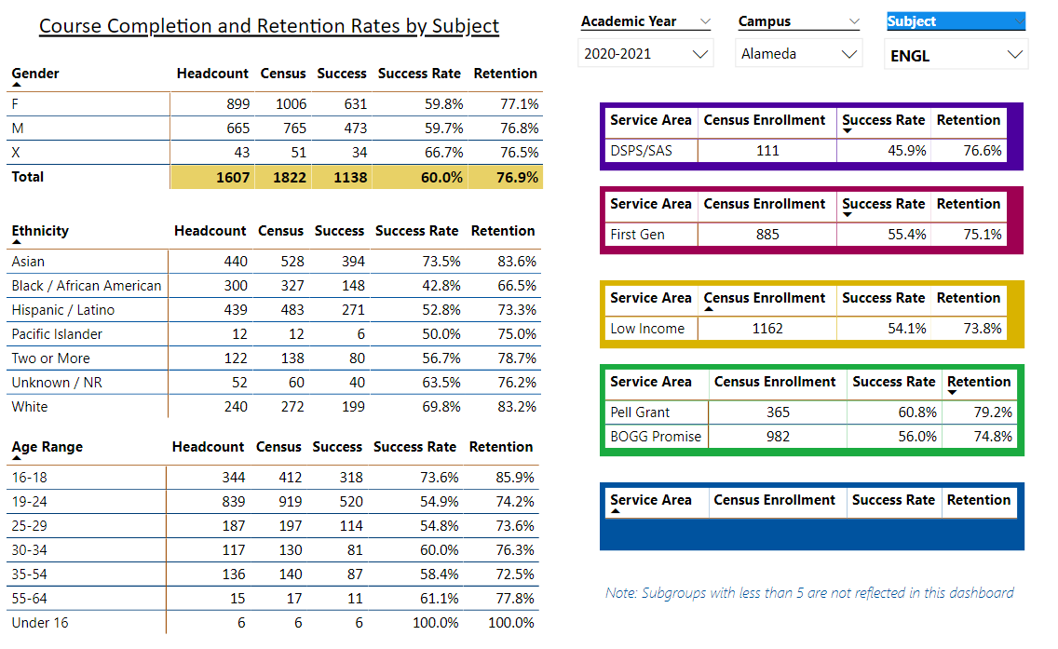

Describe any significant changes and discuss what the changes mean to your program. Consider whether performance gaps exist for disproportionality impacted students by using filters to disaggregate the data. Focus upon the most recent year and/or the years since your last comprehensive program review. Cite data points to support your reflection.

|  |  |  |  |  |  |  |  |  |  |  |  |  |  |  |  |
| --- | --- | --- | --- | --- | --- | --- | --- | --- | --- | --- | --- | --- | --- | --- | --- |
| 1. **Overall, over the last 3-5 years, enrollment and productivity have declined during the spring semester of each academic year**. Concerning specific course enrollment, there has been a fluctuation in enrollment. For example, enrollment in face-to-face English 1A courses declined in the spring semester; however, the online English 1A courses had higher enrollment in the spring than in the fall. The face-to-face English 5 courses had higher enrollment in the spring than in the fall and the online courses had higher enrollment in the fall than the spring. For English 1B which is taught exclusively online, the enrollment has fluctuated between fall and spring semesters. The upper-level literature courses English 10 and English 31 have been most productive during the summer and winter intersessions. The department may need to consider offering this course during these sessions.  The overall course completion rate for the English program is 60.4% (62.7% when MW and EW grades are excluded) which is below the college’s Institution-Set Standard. In addition, in the transfer level writing courses (English 1A, English1AS, and English 1B), the completion/success rate is significantly lower than the college’s standard of 67%. However, it is interesting to note that the following individual courses have higher completion rates than the college’s Institution-Set Standard:   |  |  |  | | --- | --- | --- | | **Course** | **Completion Rate** | **Completion Rate (Excluding MW and EW grades)** | | English 10A | 69.4% | 72.3% | | English 30B | 70.4% | 79.2% | | English 31 | 73.2% | 73.2% | | English 5 | 69.4% | 71.9% |   These courses have a lesser unit value and do not require as much work as English 1A, English 1AS, and English 1B. **Perhaps, these factors contribute to a higher student completion/success rate in these courses as opposed to the higher unit value and writing intensive transfer courses.**  In comparison to the college’s set standard completion rate, the completion rate for hybrid courses (both 51% or more online and for those that are 50% or less online) fluctuates; sometimes it is higher than 67%, and sometimes it is lower. There is no pattern indicating a specific conclusion.  Over the last three to five years, there have been no stark differences in completion rates between face-to-face, and Distance Education/hybrid courses. For all three instructional formats, the rates fluctuated until Spring 2020 when the completion rates for all three instructional formats started to exceed greatly 67%.  For any course, whether it is face-to face, hybrid, or online there is only one course outline of record and one set of SLOs. Assessing the overall effectiveness of Distance Education/hybrid courses should not be different from assessing the face-to-face format of the course.  The data shows that the completion rates for evening courses are higher than for courses taught during the day. Since the college has not decided when to resume on-campus instruction, the department has not fully examined and discussed the difference in completion rates between day and evening classes.  2. In comparison to the overall college course retention rate, the English course retention rate has fluctuated between 8% to 10% lower over the last three years. The data show that the competition rates for African Americans and Latinos, both females and males, are below the average English course completion rate. Prior to AB705, African American and Latino students comprised a good portion of the enrollment in basic skills courses. Now, with the implementation of AB 705, students can enroll directly into transfer level writing courses even if the writing level is below the transfer level. To support these students and others with completing their transfer level reading and writing requirements, the English Department created a new transfer level English course, English 1AS, a course that is equivalent to English 1A. English 1AS is English 1A with support. The support is through the inclusion of support services (counseling, mental health services, disabled support services, library services, etc.) in the course. Representatives from the various student support services visit the English 1AS class informing students of the different support services available to them to help them to be successful in English 1AS and in other areas where they are having challenges.  The English Department has also established a strong collaboration with the UMOJA Program, which is a first-year experience cohort program that is designed to help increase the retention, graduation, and transfer of African American students and other students outside of the African American community. One of the full-time English instructors completed the instructor training for the UMOJA Program and is the designated English instructor for the program. Each year this instructor teaches an UMOJA designated English 1A/English 1AS and English 5 funded by the English Department. The instructor uses a student-centered curriculum and instruction that address the academic needs of African American students. The department plans to maintain this collaboration with UMOJA and to encourage more instructors to receive training in establishing this type of learning community in their classes.  3. The data show that the completion rates for foster youth, veterans, and DSPS/SAS fall below the English course completion average. The English Department is addressing these trends in declining completion rates through the same programs and methods mentioned in the previous discussion on completion rates based on ethnicity and gender, for many of the foster youth are students of color. As for veterans, in the English 1AS classes, instructors have invited the counselor from Veteran Services to visit the class to inform students the available support services available to veterans. Concerning DSPS/SAS students, a few faculty attended a DSPS workshop on accessibility in online courses to assist in providing effective online instruction and to foster an inclusive online environment for DSPS/SAS students.  4. The data show that the completion rate for students in the 19-24-year-old age range falls below the average English course completion rate. One way the department has addressed this decline in completion rates is by participating in the college’s development of the Guided Pathways framework, an organizational strategy that “that provides all students with a set of clear course-taking patterns that promotes better enrollment decisions and prepares students for future success” (COA Guided Pathways Website). As part of this strategy, the English Department developed two-year program maps of sequenced required English courses and elective English and non-English courses that lead to an AA degree or an AD-T degree in English. These guided pathways are designed to provide clear information and focus to a student group that often enters college without clear goals for academic success. Working toward a clear and attainable goal may encourage students in this age group to persevere and complete successfully English courses. |
|  |

Describe the department's progress on Student Learning Outcomes (SLOs) and/or Service Area Outcomes (SAOs) since the last Program Review/APU.

|  |
| --- |
| The Student Learning Outcomes that were assessed since the last program review:   * Employ techniques of close textual reading, analysis, and interpretation of African American literature in its social contexts. * Develop critical appraisals that reflect an ability to assess ideas and themes from African American literature; support positions with secondary sources. * Demonstrate an appreciation of the relationship between African American literature and history through the discussion and written analysis. * Apply strategies for understanding and evaluating a range of professional and public writing and be able to express and synthesize the main ideas. * Assess clearly in writing the tools and materials in the workplace and in the community and be able to suggest changes to increase personal and institutional effectiveness.   Conduct research identifying relevant and accurate materials from a variety of sources, including databases, professional publications, and other applicable materials    Due to budgetary constraints and class cuts due to low enrollment, not all the program courses have been assessed. Out of the program courses that have been offered annually over the last three years, fifty percent have been assessed.  The English Department is just finishing the third year of the three-year SLO assessment cycle and will assess the scheduled courses that have been assessed yet. While we offer an AD-T and AA in English, it is difficult to develop and report on PLOs without a capstone course.  Although the English Department’s Program SLOs are mapped to the ILOs, to date the department has not participated in the assessment of ILOs.  The department needs ongoing assistance from the SLO coordinator in completing and documenting assessment tasks. |

Describe the outcomes and accomplishments from previous year’s funded resource allocation request.

|  |  |  |  |
| --- | --- | --- | --- |
| **Brief description of funded request** | **Source (any additional award outside your base allocation)** | **Total Award Amount** | **Outcome/Accomplishment** |
| The English department received just the base allocation. |  |  |  |
|  |  |  |  |
|  |  |  |  |

**Prioritized Resource Requests Summary**

In the boxes below, please add resource requests for your program. If there are no resource requested, leave the boxes blank.

|  |  |  |  |  |
| --- | --- | --- | --- | --- |
| **Resource Category** | **Description/Justification** | **Estimated Annual Salary Costs** | **Estimated Annual Benefits Costs** | **Total Estimated Cost** |
| **Personnel: Classified Staff** |  |  |  |  |
| **Personnel: Student Worker** |  |  |  |  |
| **Personnel: Part Time Faculty** |  |  |  |  |
| **Personnel: Full Time Faculty** | One more full-time faculty position would allow the department to be more (and more effectively) involved in all levels of campus committee work and decision-making, including redesign of the English program at College of Alameda. This would enhance the abilities of new learning communities and the Learning Resource Center to understand better and to meet effectively the needs of departments across the  curriculum and increase the diversity among faculty members. Additionally, more English faculty can serve more students and give the faculty the time to be involved in student clubs and activities. | $40,793  (Starting Salary) | $16,317.2 | $56, 317 |

|  |  |  |
| --- | --- | --- |
| **Resource Category** | **Description/Justification** | **Total Estimated Cost** |
| **Professional Development: Department wide PD needed** | The English Department would like to request professional development funds to hold a department retreat to reassess the different department needs and tasks. The department needs to develop a plan to address the declining enrollment, further implementation of AB705, SLO/PLO assessment, new course development, etc. The requested funds would be used to grant faculty a $500 stipend for participating in the retreat and to provide for food (lunch) during the retreat. | $7,000 |
| **Professional Development: Personal/Individual PD needed** |  |  |

**Prioritized Resource Requests Summary - Continued**

|  |  |  |
| --- | --- | --- |
| **Resource Category** | **Description/Justification** | **Total Estimated Cost** |
| **Supplies: Software** |  |  |
| **Supplies: Books, Magazines, and/or Periodicals** |  |  |
| **Supplies: Instructional Supplies** | The English Department will need instructional supplies (paper, pens, pencils, printer ink, highlighters, whiteboard markers, etc.) to deliver instruction. | $5,000 |
| **Supplies: Non-Instructional Supplies** |  |  |
| **Supplies: Library Collections** |  |  |

|  |  |  |
| --- | --- | --- |
| **Resource Category** | **Description/Justification** | **Total Estimated Cost** |
| **Technology & Equipment: New** | To prepare and deliver both face-to-face and remote instruction, the English Department requests ongoing technology to provide effective instruction (iPad Pro 12.9 tablets, Apple pencils, external large monitors, portable monitors, webcams, microphones for video conferencing and podcasting, portable wireless storage drives, USB hubs, various cables for connectivity, etc.) | $7,500 |
| **Technology & Equipment: Replacement** | To prepare and deliver both face-to-face and remote instruction, the English Department requests laptop and desktop upgrades | 12,000 |

**Prioritized Resource Requests Summary - Continued**

|  |  |  |
| --- | --- | --- |
| **Resource Category** | **Description/Justification** | **Total Estimated Cost** |
| **Facilities: Classrooms** | Consistent assignment of functional smart classrooms for all instructors requiring them to provide enhanced instruction. |  |
| **Facilities: Offices** | Dedicated offices for part-time faculty, for they are an integral part of our college community and should be provided with a space so they can prepare their classes and meet with their students. |  |
| **Facilities: Labs** |  |  |
| **Facilities: Other** |  |  |

|  |  |  |
| --- | --- | --- |
| **Resource Category** | **Description/Justification** | **Total Estimated Cost** |
| **Library: Library materials** | The English Department requests reserve copies of all assigned books for all English courses that are being taught in any given semester. The reserve copies will assist in providing students who cannot afford the cost of books access to the course. | The cost will vary. |
| **Library: Library collections** |  |  |

|  |  |  |
| --- | --- | --- |
| **Resource Category** | **Description/Justification** | **Total Estimated Cost** |
| **OTHER** |  |  |