**College of Alameda**

2021-22 Annual Program Update - ESOL

**Program Overview**

Please provide your program’s mission statement and program’s learning outcomes

|  |
| --- |
| The College of Alameda ESOL program serves non-native speakers of English who need to learn sufficient English to communicate effectively and overcome their difficulties in reading, writing, speaking and understanding English. Instruction in English is offered to facilitate ESOL students’ access to degree/transfer programs, academic programs, vocational programs and /or to prepare them for immediate employment. It is the goal of the program that students, upon completion of the program be able to participate meaningfully in American life. |

List your program faculty and/or staff

|  |
| --- |
| There are ten faculty members in ESOL department and only two of them are full time instructors.  **Full Time:** Christa Ferrero-Castaneda & Didem Ekici  **Part Time Faculty:** Brian Ng, Jennifer Lemper, Denise Urdang, Johanna Carranza, Anna Rodas, Nora Mitchell, Emma Donnelly, Kim-Shree Maufas |

Describe your current utilization of facilities, including labs and other space

|  |
| --- |
| Since the beginning of COVID 19 pandemic, ESOL department has been conducting classes online like many other programs in PCCD district. Before pandemic, most classrooms at College of Alameda comfortably accommodate the average ESOL class, both in terms of room size and of seating type (movable chairs with tablet desks) and capacity.  ESOL classes do not have labs and most of the classes are taking place in in "smart classroom' which have every imaginable educational technology, including access to internet. |

List your program goals from your most recent Program Review or APU. Then, provide an update on the status of the goal. Has your program achieved the goal? Have any of your goals been revised or any still in progress? Lastly, make sure to discuss which College or District goal your program goal aligns to.

If no program goals exist or if this is your first program review, work to create 2-3 goals and align them with a College or District goal.

|  |  |
| --- | --- |
| **Program Goal** | Educational Purpose:   The major purpose and goal of the ESOL program is to provide quality instruction in reading, writing, speaking and critical thinking. The ESOL program intends  to develop competency in students' understanding and use of  the English language  so  that  they  may  successfully enter  and  complete either a vocational or college level major and fully participate in the communities in which they live. |
| Status: In-Progress or Complete? | In progress |
| Which college or district goal is aligned with your program goal? | The Vision of College of Alameda is that we are a diverse, supportive, empowering learning community for seekers of knowledge. We are committed to providing a creative, ethical and inclusive environment in which students develop their abilities as thinkers, workers and citizens of the world.    As an ESOL program, we help students gain the basic skills in English so that they become engaged learners that seek knowledge as lifelong learners with critical thinking skills. |

|  |  |
| --- | --- |
| **Program Goal** | The most important goal for the coming year is to re-design the ESOL program and assessment process in order to comply with state mandate AB 705. AB 705 prevents the college from continuing to use the CELSA or any other standardized assessment in order to place ESOL students, so our department has formed an Onboarding Team in order to evaluate other assessment processes and pilot and  validate a new system that was fully adopted in Fall 2020. This team has worked closely with the Peralta ESOL Advisory Committee (PEAC) in order to run pilots of a guided self-placement exam that aims to create a more equitable, accessible, and student-driven placement process. Additionally, we are working with PEAC to discuss district-wide  adaptions to our program offerings that will accommodate the 3-year timeline that students with a stated goal of transfer have to complete pre-transfer level course. We have started implementing some changes including removing prerequisites of higher-level courses in our acceleration model, continuing to expand our non-credit program with mirror and support courses, and creating decision trees and other tools and protocols to support students in identifying the appropriate pathway for their chosen goal. This work parallels  some of the goals of Guided Pathways, in which several of our part-me instructors have been active participants. Currently, all of the projects associated with AB 705 mostly rely on the department chairs with some help from the part time instructors. |
| Status: In-Progress or Complete? | In progress/complete: Some of the AB-705 requirements such as ESOL onboarding site and GSP tool are done. Also, most of the course catalog updates were completed even though we have a few more courses to work on. Lastly, we added the writing support classes that was required by AB 705 for the first time, but they were cancelled because of the low enrollment. We will promote them more this semester. |
| Which college or district goal is aligned with your program goal? | College Goal: Design organizational, committee, & governance structures to support student success  District Goal In-Progress Design organizational, committee, & governance structures to support student success Advance Student Access, Equity, and Success |

|  |  |
| --- | --- |
| **Program Goal** | As ESOL department, we wanted to foster our relationships with our partners from the community and non-credit (bridge to credit) and non-credit classes were big steps towards that. The biggest achievement of the 2018-2019 academic year was that our department successfully piloted and implemented the first non-credit program at COA. In Fall 2019, we offered six sections of non-credit ESOL total: five sections taught at two community partner sites in the  Fruitvale District of Oakland and at Las Casas English as a Second Language and four sections over two terms at Spanish Speaking Citizens Foundation in addition to one evening section offered on-site at the college. These non-credit classes have made an impact on equity as it brought free, repeatable classes to the community where there were previously no college course offerings.  However, because of the large allocation cut we experienced in 2019-2020, we couldn’t continue to offer our Bridge to Credit classes. Also, contrary to other sister colleges in the district, we don’t have a designated non-credit coordinator to oversee the program. All these changes affected our non-credit programs and our partnership with the community.  In order to sustain the program, we need more allocations and a faculty member to be paid to continue to coordinate with the off-site partners, meet with PEAC to align non-credit curriculum, and advise the district about non-credit protocols, and support non-credit instructors. |
| Status: In-Progress or Complete? | In progress: we are in the process of searching for funding to be able to offer the sequence of non-credit classes. |
| Which college or district goal is aligned with your program goal? | College goal: Increase community and educational partnerships  District goal: Engage and Leverage partners |

**Program Update**

Using the dashboards, review and reflect upon the data for your program.

[**Course Completion and Retention Rates – Instructional Dashboard**](https://app.powerbi.com/view?r=eyJrIjoiNjc2MDhiNTEtNTJhZi00MDM0LTk5NDItNTRiY2EzMGI1NTZiIiwidCI6ImVlYTE2YTE2LTQ4YWYtNDc3Yi05MTEzLTA1YjFjMDExMjNmZiIsImMiOjZ9&pageName=ReportSection86d6f65e2fb41a73da4d)

[**Course Completion and Retention Rates – Student Services Dashboard**](https://app.powerbi.com/view?r=eyJrIjoiNjk3NDJjOTItNzI5MS00MDhjLWJhN2EtZjcxNzU4OTBiZDBjIiwidCI6ImVlYTE2YTE2LTQ4YWYtNDc3Yi05MTEzLTA1YjFjMDExMjNmZiIsImMiOjZ9&pageName=ReportSection86d6f65e2fb41a73da4d)

[**Enrollment Trends and Productivity Dashboard**](https://app.powerbi.com/view?r=eyJrIjoiNWJlOWZmYTEtNTY0MC00MDhkLWE5OTAtYmJjZjIxNzJiNWViIiwidCI6ImVlYTE2YTE2LTQ4YWYtNDc3Yi05MTEzLTA1YjFjMDExMjNmZiIsImMiOjZ9&pageName=ReportSection86d6f65e2fb41a73da4d)

[**Degrees and Certificates Dashboard**](https://app.powerbi.com/view?r=eyJrIjoiZjU2M2M5MzItOTcwZi00Y2U1LWJmODUtYTc0YjlhZGI2ZDhjIiwidCI6ImVlYTE2YTE2LTQ4YWYtNDc3Yi05MTEzLTA1YjFjMDExMjNmZiIsImMiOjZ9&pageName=ReportSectionde32556e136b0a8caccd)

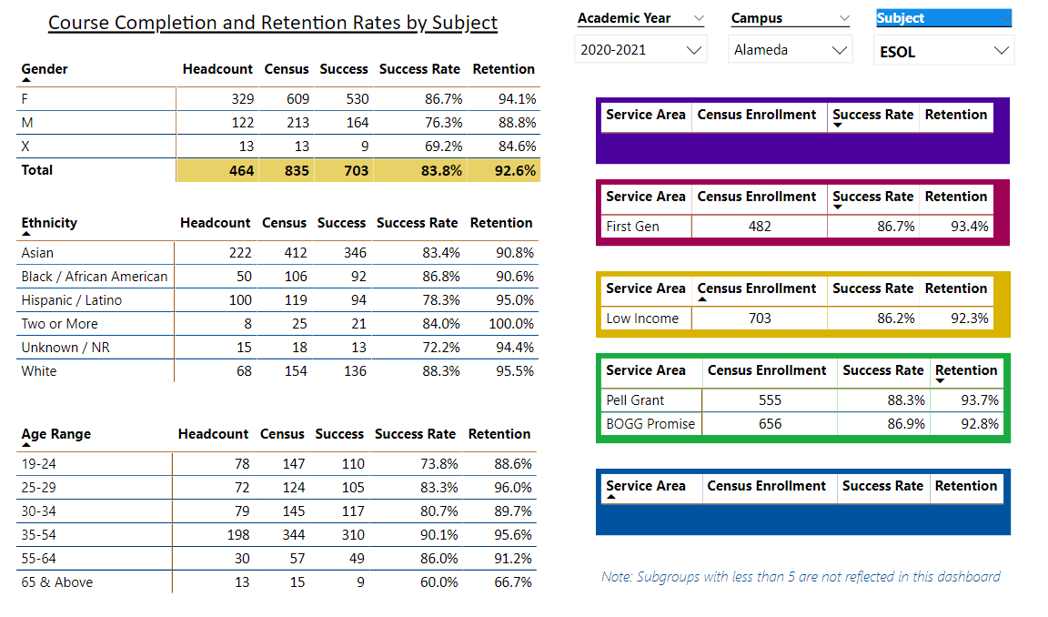

Describe any significant changes and discuss what the changes mean to your program. Consider whether performance gaps exist for disproportionality impacted students by using filters to disaggregate the data. Focus upon the most recent year and/or the years since your last comprehensive program review. Cite data points to support your reflection.

|  |
| --- |
| **Retention & Completion:**  The data shows that the completion rate (83.8) of ESOL department was higher than the average college-wide completion rate (71.5) for the 2020-2021 semester. When we look at the last three years, we observe that 2018-2019 completion rates (82.9%) decreased 3% during 2019-2020 academic year (79.9%) which might be related to rapid transition to distance education and shelter in place because of COVID 19. This decrease disappeared in 2020-2021 academic year and the completion rate had the highest score (83.8) in the last three years.  As for the retention rate, ESOL department had a higher rate (92.6%) than the average college retention rate (85.6%) for the 2020-2021 academic year. Contrary to the completion rate, the retention increased 3% (96.6%) compared to 2018-2019 academic year, but then displayed a slight decrease in (92.6 %) in 2020-2021 academic year.  **Enrollment & Productivity:**  The tremendous increase in the college productivity rates reflected on the enrollment and productivity percentages in the ESOL program as well. While the productivity decreased from 15.1 to 13.5 college wide between 2017-2018 and 2020-2021 academic years, we observed a similar decrease in the department productivity: decrease from 12.2 to 10.6 between 2019-2020 and 2020-2021 years. Similarly, the enrollment headcount decreased from 1249 to 868. |

Describe the department's progress on Student Learning Outcomes (SLOs) and/or Service Area Outcomes (SAOs) since the last Program Review/APU.

|  |
| --- |
| Our department is currently up to date in entering SLOs in Curricunet Meta for the 2020-2021 academic year. Just recently, the newly assigned COA SLO Coordinator Khalilah Beal-Uribe and the ESOL department chairs have met and changed the three-year plan for assessment. Dr. Beal Uribe joined one of our department meetings and informed ESOL faculty about the changes and mentioned that she will be the point of contact if any questions come up. Dr. Beal-Uribe will inform faculty every semester about the SLOs that need to be assessed in that specific semester. |

Describe the outcomes and accomplishments from previous year’s funded resource allocation request.

|  |  |  |  |
| --- | --- | --- | --- |
| **Brief description of funded request** | **Source (any additional award outside your base allocation)** | **Total Award Amount** | **Outcome/Accomplishment** |
| New full-time hire: Dr. Didem Ekici | NA |  | Share of department duties and planning. |
| Onboarding team that includes 4 part time faculty members. | NA |  | Creating onboarding website  Creating schedule planner  Office hours for student class registrations  Working in collaboration with college research team to share and analyze data  Brainstorming on the ideas for boosting our enrollment |
|  |  |  |  |

**Prioritized Resource Requests Summary**

In the boxes below, please add resource requests for your program. If there are no resource requested, leave the boxes blank.

|  |  |  |  |  |
| --- | --- | --- | --- | --- |
| **Resource Category** | **Description/Justification** | **Estimated Annual Salary Costs** | **Estimated Annual Benefits Costs** | **Total Estimated Cost** |
| **Personnel: Classified Staff** | Help with ESOL department projects, LRC coordination, ESOL web site maintenance and student OER resources, assist students during the new onboarding process, do marketing and reach out and to assist with other clerical duties for the department. |  |  | Need assistance from Dean or VPI |
| **Personnel: Student Worker** | Embedded tutors for new support courses and other courses in our department. Also, we need student workers that can help students register for their classes and use the new onboarding site. |  |  | Need assistance from Dean or VPI |
| **Personnel: Part Time Faculty** | We are requesting a part- time faculty member who would be working as an ESOL coach (approximately for 5-8 hours a week) who would be helping students choose their classes, navigating in the new ESOL onboarding website, and using our social media, and website and other tools to reach out and marketing.  A dedicated counselor (5-10 hours a week) focused on helping students in support classes that would result in more collaboration with student services for students required to take the support courses. |  |  | Need assistance from Dean or VPI |
| **Personnel: Full Time Faculty** | We just hired a new full-time faculty in August 2021 to replace the retiree Dr. Sedique Popal. However, another full-time faculty member who transferred to another discipline in 2017-2018 has not been replaced yet. Thus, we are requesting 1 full-time faculty member to fill this vacancy.  Over the last three years, the demands and needs of the department, instructors, and students have increased because of AB705 state mandate. We have had to provide adjunct faculty with stipends to share the department workload with the one full-time faculty member to comply with AB705. Such projects have included developing the self-guided placement tool, updating the course outlines, recruitment and outreach, faculty training, and attending district wide committee meetings. |  |  | Need assistance from Dean or VPI |

|  |  |  |
| --- | --- | --- |
| **Resource Category** | **Description/Justification** | **Total Estimated Cost** |
| **Professional Development: Department wide PD needed** | Faculty Stipends for SLO Training.  Online Teaching Training  Regional and State Conferences    AB705 implementation Guided Pathways Developing non-credit courses to be offered | $3,000-  $5,000 |
| **Professional Development: Personal/Individual PD needed** | CATESOL Conferences | $1,000-  $1,500 |

**Prioritized Resource Requests Summary - Continued**

|  |  |  |
| --- | --- | --- |
| **Resource Category** | **Description/Justification** | **Total Estimated Cost** |
| **Supplies: Software** | Some instructional software tools for online classes are necessary for an effective online instruction. Some of them are Padlet, Canva, screencastomatic, adobe spark, English language apps that require subscription etc. | $500-$900 |
| **Supplies: Books, Magazines, and/or Periodicals** | ESOL program needs some books and magazines written specifically for students who speak English as their additional language. For example, English to English dictionaries with visuals, bilingual books and dictionaries, English grammar books etc. | $300-$700 |
| **Supplies: Instructional Supplies** | Face to Face Instruction: White board markers, easel board, sticky notes, pens, folders    Remote Instruction: ear pods, headset, whiteboard,  document scanner | $1,500-  $2,000 |
| **Supplies: Non-Instructional Supplies** | Copy paper, cartridge, printer hardware tools (mouse, keyboard, usb hub, speaker, flash drive etx.) | $1,500-  $2,000 |
| **Supplies: Library Collections** | CD and DVDs that include videos and audios to improve listening and speaking skills for language learners, story books in different proficiency levels (beginner, intermediate, upper intermediate, advanced), books for high stake exams like TOEFL, IELTS etc. | $700-  $1,000 |

|  |  |  |
| --- | --- | --- |
| **Resource Category** | **Description/Justification** | **Total Estimated Cost** |
| **Technology & Equipment: New** | IPads (tablets) for faculty to use Notability and other applications for grading online writing assignments | $4,000-  $5,000 |
| **Technology & Equipment: Replacement** | Update laptops for ESOL faculty, (consider purchasing Mac Book Pros), printer/scanner for department | $5,000-  $6,000 |

**Prioritized Resource Requests Summary - Continued**

|  |  |  |
| --- | --- | --- |
| **Resource Category** | **Description/Justification** | **Total Estimated Cost** |
| **Facilities: Classrooms** | Smart classrooms that are conducive to ESOL teaching    Document projector | $1,000-  $2,000 |
| **Facilities: Offices** | Dedicated office space is needed for adjunct faculty. Currently more than 10-part timers share one space. Copy machine and scanner in the office space. | $3,000-  $5,000 |
| **Facilities: Labs** | Dedicated space for ESOL Lab with ESOL software programs and tutors to assist ESOL students with assignments. | $3,000-  $5,000 |
| **Facilities: Other** | Dedicated Office Space with computers to develop an “ESOL Center” in which our students can receive help with on-boarding and advised into our classes. This center will also serve as an instructional center for classes and individual instruction/tutoring, as well as a library/resource center for our instructors. | $3,000-  $5,000 |

|  |  |  |
| --- | --- | --- |
| **Resource Category** | **Description/Justification** | **Total Estimated Cost** |
| **Library: Library materials** | ESOL English Dictionaries | $300-  $500 |
| **Library: Library collections** | ESOL Adapted short stories  Digital instructional tools for computer-based listening and speaking | $200-  $400 |

|  |  |  |
| --- | --- | --- |
| **Resource Category** | **Description/Justification** | **Total Estimated Cost** |
| **OTHER** | Funding for faculty to attend regional and state CATESOL conferences and to support professional development opportunities for faculty.  Reimbursement for professional development classes. | $1,000-  $2,000 |