College of Alameda

2021-22 Annual Program Update - GEOG

# Program Overview

Please provide your program’s mission statement and program’s learning outcomes

The mission of the Geography Department is to teach our diverse student community to understand the natural and cultural environments of the region and around the world, to be critical consumers of environmental advocacy, and to appreciate the beauty and wonder of the planet and its diversity.

The department directly supports the College of Alameda's mission, which is: To serve the educational needs of its diverse community by providing comprehensive and flexible programs and resources that empower students to achieve their goals. In order to support this mission, we (a) provide a variety of courses and dynamic scheduling options in coordination with other departments and disciplines within the Peralta Community College District, (b) create ethical and inclusive learning environments, (c) support the needs of all students and advocate for those programs and offices designed to help meet those needs, and (d) encourage involvement and investment outside of the classroom by supporting and engaging in a variety of programs and initiatives at College of Alameda and the larger community.

The Geography Department provides specialized in-­‐person and virtual educational field trip opportunities to expand students' geographic knowledge and skills. Participating students experience California's unique atmospheric, oceanic, volcanic, tectonic, fluvial, geologic, glacial, hydrothermal and biological features. According to the Bureau of Labor Statistics the projected 10-­‐year (2012-­‐2022) job growth for Geographers is 22% or higher. Most of this growth will occur within the sub-­‐field of Geographic Informa1on Systems (GIS). GIS is so1ware designed to capture, manage, analyze, and display all forms of geographically referenced information. GIS allows us to view, understand, ques1on, interpret, and visualize our world in ways that reveal relationships, 1patterns, and trends in the form of maps, globes, reports, and charts. This technology provides cost saving from greater efficiency, better decision making, improved communication, improved records keeping, and management of spa1al problems. Understanding and utilizing this technology is becoming increasingly important as it benefits organizations of all sizes and in almost every industry.

Since there is a growing interest in Geography and an awareness of the economic and strategic value of GIS, our department has committed to offer a GIS Certificate Program in addition to the recently developed Associate of Arts in Geography Transfer Degree (AA-­‐T). Program Learning Outcomes for the ADT and A.A. degree in Geography are: 1) Describe the spatial organization of the world’s peoples, nations, cultural environments; 2) Demonstrate knowledge of global physical and environmental processes and develop an appreciation of landscapes; 3) Demonstrate an understanding of how human activities impact the physical environment.

List your program faculty and/or staff

Cady Carmichael (Full-­‐time Geography faculty; Department Co-­‐Chair) Jeremy Patrich (Part-­‐time Geography faculty)

Aubrey Rose (Part-­‐time Geography faculty) Chevonn Herbert (STEAM Division Staff Assistant)

Describe your current utilization of facilities, including labs and other space

Since we have been primarily online during the pandemic (as of March 2020), our utilization of campus facilities has diminished. Additionally, the College of Alameda administration has removed the historic Geography classroom (D-­‐222) space, as well the faculty office space in the C-­‐ building, from our use. This was done during the Summer and Fall 2021 semesters without notice or consultation of the department and chairs. Currently, Geography faculty and CoA Administration are discussing and determining which alternative space would best suit the needs of the department and our students. H-­‐222, has been suggested, which may be a viable option. Certain activities, such as lab exercises, require larger equipment, running water, space to move around the room to varying “stations”, and collaboration amongst students using table as opposed to desks. An ideal space that would allow for these activities does not currently exist on the College campus.

List your program goals from your most recent Program Review or APU. Then, provide an update on the status of the goal. Has your program achieved the goal? Have any of your goals been revised or any still in progress? Lastly, make sure to discuss which College or District goal your program goal aligns to.

If no program goals exist or if this is your first program review, work to create 2-­3 goals and align them with a College or District goal.

|  |  |
| --- | --- |
| **Program Goal** | Student learning outcomes (SLOs) for all Geography courses have been assessed (2020 APU). |
| Status: In-­Progress or Complete? | In-­‐Progress; the department has created a plan to assess the remaining SLOs for GEOG 1, 1L, 2, 3. & 14. This will take place during the Fall 2021 and Spring 2022 semesters. The remaining SLOs for the new courses (GEOG 15 & 18) will be assessed Spring 2022 and Fall 2022 respectively. |
| Which college or district goal is aligned with your program goal? | Establish integrated planning and evaluation system (College Goal); Build Programs of Distinction (District Goal). |

|  |  |
| --- | --- |
| **Program Goal** | Establish and offer course(s) in Geographic Information Systems (GIS) and World Regional Geography (2020 APU). |
| Status: In-­Progress or Complete? | Complete; GEOG 14: Introduction to Geographic Information Systems (GIS) and GEOG 3: World Regional Geography are now approved courses and have both been offered at least one semester. These courses are integrated into our department planning schedule. |
| Which college or district goal is aligned with your program goal? | Advance CoA Teaching and Learning (College Goal); Build Programs of Distinction (District Goal). |

|  |  |
| --- | --- |
| **Program Goal** | Expand other/additional course offerings, such as Environmental Geography, Climatology,  Weather and Climate, and California Geography will be submitted for approval on an ongoing basis (2020 APU). |
| Status: In-­Progress or Complete? | Both Complete and In-­‐Progress; GEOG 15: Introduction to Weather and Climate and GEOG 18: California Geography are both approved and active courses. GEOG 18 will be offered during the Spring 2022 semester and GEOG 15 will be offered during the Fall 2022 semester. Additional courses will be submitted for approval on an ongoing basis. |
| Which college or district goal is aligned with your program goal? | Advance CoA Teaching and Learning (College Goal); Build Programs of Distinction (District Goal). |

# Program Update

Using the dashboards, review and reflect upon the data for your program.

**Course Completion and Retention Rates – Instructional Dashboard Course Completion and Retention Rates – Student Services Dashboard Enrollment Trends and Productivity Dashboard**

**Degrees and Certificates Dashboard**

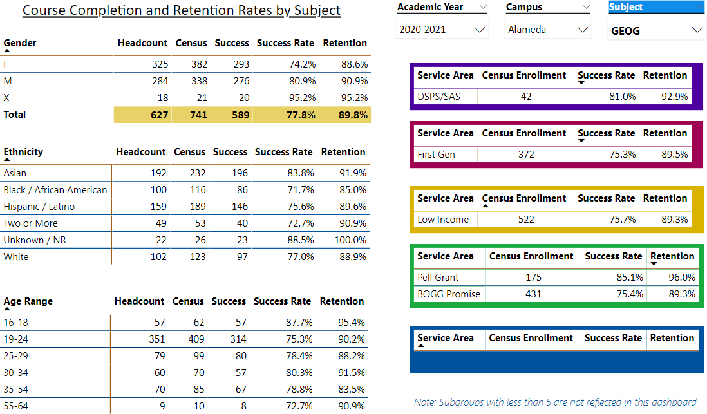

Consider whether performance gaps exist for disproportionality impacted students by using filters to disaggregate the data. Focus upon the most recent year and/or the years since your last comprehensive program review. Cite data points to support your reflection.

The Geography Program continues to have high course completion and retention rates. Both success rates and course retention rates have increased since the last APU – by 2.8% and 5.8% respectively. The overall success and retention rates, as well as productivity, are also higher than the average rates for College of Alameda. While overall enrollment at College of Alameda has declined, census enrollment and FTES has increased in the Geography Program in comparison with last years data.

Significant improvement has been made in the success and retention rates among Black/African American and Hispanic/Latino students since the last APU. Among Black/African American students, success rates have increased 21.7% and retention rates have increased 18%. Among Hispanic/Latino students, success rates have increased 7.6% and retention rates have increased 10.6%. These rates are still lower than the success and retention rates among Asian and White students, but the gap has significantly decreased since the last APU. The department and College have made tremendous efforts to connect students with available support systems and programs. Continuing discussions, ongoing program assessment, and improvements to course curriculum and communication with students are necessary to ensure that overall student success and accomplishment of student goals is equitable. Since the majority of our students plan on transferring, a visible and measurable commitment to student support and achievement is essential. The Geography Department is committed to continue to work with student support services and outreach, as well as the larger guided pathways framework to address these gaps.

Describe the department's progress on Student Learning Outcomes (SLOs) and/or Service Area Outcomes (SAOs) since the last Program Review/APU.

SLO assessment is needed for GEOG 1, 1L, 2, 3, & 14. Faculty within the department have discussed and created an ongoing plan for assessment. All remaining SLOs will be assessed during the Fall 2021 and Spring 2022 semesters.

The new assessment sequence will begin using courses offered in Fall 2022. SLO 1 will be assessed in all courses offered Fall 2022. SLO 2 will be assessed in all courses offered in the 2022-­‐2023 academic year, and SLO 3 will be assessed in all courses in the 2023-­‐2024 academic year. This will ensure all SLOs continue to be assessed within the three-­‐year cycle at least once during the academic year in which the courses are offered.

request.

|  |  |  |  |
| --- | --- | --- | --- |
| **Brief description of funded request** | **Source (any additional award outside your base**  **allocation)** | **Total Award Amount** | **Outcome/Accomplishment** |
| Instructional Supplies |  | $6,815.00  (lottery funds) | Replacement, increase, and expansion in supplies for lecture and lab activities. |
| ArcGIS software license |  | $2,000 | Geography faculty were able to create and add new lecture and lab mapping content to their courses. Additionally, GEOG 14: Introduction to Geographic Information Systems requires the use of this software. |
|  |  |  |  |

In the boxes below, please add resource requests for your program. If there are no resource requested, leave the boxes blank.

|  |  |  |  |  |
| --- | --- | --- | --- | --- |
| **Resource Category** | **Description/Justification** | **Estimated Annual Salary Costs** | **Estimated Annual Benefits Costs** | **Total Estimated Cost** |
| **Personnel: Classified Staff** |  |  |  |  |
| **Personnel: Student Worker** |  |  |  |  |
| **Personnel: Part Time Faculty** | As the Geography Department continues to grow and expand its offerings, an additional part-­‐time faculty member is needed to help meet demand and expand our face to face offerings. | $15,000 | Unknown | Unknown |
| **Personnel: Full Time Faculty** |  |  |  |  |

|  |  |  |
| --- | --- | --- |
| **Resource Category** | **Description/Justification** | **Total Estimated Cost** |
| **Professional Development: Department wide PD needed** |  |  |
| **Professional Development: Personal/Individual PD needed** |  |  |

|  |  |  |
| --- | --- | --- |
| **Resource Category** | **Description/Justification** | **Total Estimated Cost** |
| **Supplies: Software** | Upgraded and continued funding of the ArcGIS so7ware license is critical to the offering of GEOG 14 as well as providing faculty with the opportunity to integrate mapping components into their courses. | $2,000 |
| **Supplies: Books, Magazines, and/or Periodicals** |  |  |
| **Supplies: Instructional Supplies** | At least $1,000 is needed to replace instructional supplies for lecture and lab activities. | $1,000 |
| **Supplies: Non-­Instructional Supplies** |  |  |
| **Supplies: Library Collections** |  |  |

|  |  |  |
| --- | --- | --- |
| **Resource Category** | **Description/Justification** | **Total Estimated Cost** |
| **Technology & Equipment: New** |  |  |
| **Technology & Equipment: Replacement** |  |  |

|  |  |  |
| --- | --- | --- |
| **Resource Category** | **Description/Justification** | **Total Estimated Cost** |
| **Facilities: Classrooms** | Currently, there is no longer a designated classroom and storage space for the Geography Department. D-­‐222, the former space, is haphazardly housing all of the equipment and supplies needed to offer several face to face lecture and lab courses. A similar, preferably larger, space is needed to  accommodate lecture and lab activities. | Unknown |
| **Facilities: Offices** |  |  |
| **Facilities: Labs** | (Same as ‘Classrooms’ section above) Currently, there is no longer a designated classroom and storage space for the Geography Department. D-­‐ 222, the former space, is haphazardly housing all of the equipment and supplies needed to offer several face to face lecture and lab courses. A similar, preferably larger, space is needed to accommodate lecture and lab  activities. | Unknown |
| **Facilities: Other** |  |  |

|  |  |  |
| --- | --- | --- |
| **Resource Category** | **Description/Justification** | **Total Estimated Cost** |
| **Library: Library materials** |  |  |
| **Library: Library collections** |  |  |

|  |  |  |
| --- | --- | --- |
| **Resource Category** | **Description/Justification** | **Total Estimated Cost** |
| **OTHER** |  |  |