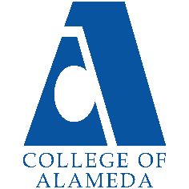
College of Alameda
2021-22 Annual Program Update – GEOL

Program Overview
Please provide your program’s mission statement and program’s learning outcomes
Geology addresses rocks, volcanoes, glaciers, landslides, earthquakes, etc. all in the context of the relatively new theory of plate tectonics describing how the Earth works. The geology of California is special since we live on the active San Andreas transform plate boundary (hence the earthquakes) which evolved from the previously existing subduction zone plate boundary (responsible for the California Coast Ranges and the Sierra Nevada). Our mission includes:
1) Preparing students for transfer and careers in the Earth Sciences.
2) Stimulating student curiosity about how the Earth works (earthquakes, volcanoes, tsunamis, hurricanes etc.) and why California is such an interesting place.
3) Providing students with evidence about Earth processes so they can make informed choices about using resources.
Program Learning Outcomes for the GEOL ADT, GEOL A.S. and GEOL Certificate of Achievement are:
- Demonstrate understanding of the scientific method as it relates to Earth Science
- Demonstrate analytical and critical thinking skills required to understand Geological processes in the past and present with respect to future problems and solutions.
- Describe and communicate physical and chemical Earth processes in preparation for transfer and/or employment in Geology or related fields.

List your program faculty and/or staff
Steve Self, P/T faculty member, primary GEOL courses instructor
Faculty in closely related disciplines:
Peter Olds (F/T), Chemistry
Cady Carmichael (F/T) , Geography

Describe your current utilization of facilities, including labs and other space
Geology courses have been taught in Room 160 at the Science Annex (860 Atlantic) prior to COVID-19 restrictions, but as we return to in-person classes, we hope to use H-222 as our primary lecture room.

As the Geology program expands, we will need a laboratory space for lab classes that support our lecture classes. We anticipate being able to use specimens from the Geography program at CoA, as soon as a dedicated Geography Laboratory space is decided by CoA Administrators. We highly recommend using H-222 as the dedicated Geography/Geology lecture and laboratory room, as this space would provide room for storage of the GEOG/GEOL specimens, maps and teaching supplies.

List your program goals from your most recent Program Review or APU. Then, provide an update on the status of the goal. Has your program achieved the goal? Have any of your goals been revised or any still in progress? Lastly, make sure to discuss which College or District goal your program goal aligns to.
If no program goals exist or if this is your first program review, work to create 2-3 goals and align them with a College or District goal.
Program Goal | Develop an integrated Earth Science Program (Geology, Geography and Chemistry) to support STEM student success.
Status: In-Progress or Complete? | In progress. New GEOL courses have been approved, along with new GEOL ADT, A.S. and Certificate of Achievement. There is high interest from students who fill all GEOL sections offered, but the GEOL programs are hampered by low FTEF allocations that restrict course offering opportunities.
Which college or district goal is aligned with your program goal? | Advance student access, equity and success. Advance COA teaching and learning. Build programs of distinction.

Program Goal | Support and enhance student diversity in STEM courses by addressing inequities and achievement gaps in Earth Sciences.
Status: In-Progress or Complete? | In progress. This ongoing goal is seeing improvement, particularly in Geology courses as we use more Open Education Resources (OER) in instruction and seek to employ instructors of ethnic, differently-abled and gender diversity.
Which college or district goal is aligned with your program goal? | CoA Mission Statement: The mission of College of Alameda is to serve the educational needs of its diverse community by providing comprehensive and flexible programs and resources that empower students to achieve their goals.

Program Goal | Develop analytical and critical thinking skills required to understand Earth Science processes in the past and present with respect to future problems and solutions.
Status: In-Progress or Complete? | In progress. This is an ongoing endeavor to prepare students to be responsible citizens and stewards of Earth resources today and tomorrow.
Which college or district goal is aligned with your program goal? | Institutional Learning Outcome number 5:  Accept personal, civic, social and environmental responsibility in order to become a productive local and global community member.

Program Update
Using the dashboards, review and reflect upon the data for your program.
Course Completion and Retention Rates – Instructional Dashboard
Course Completion and Retention Rates – Student Services Dashboard
Enrollment Trends and Productivity Dashboard
Degrees and Certificates Dashboard

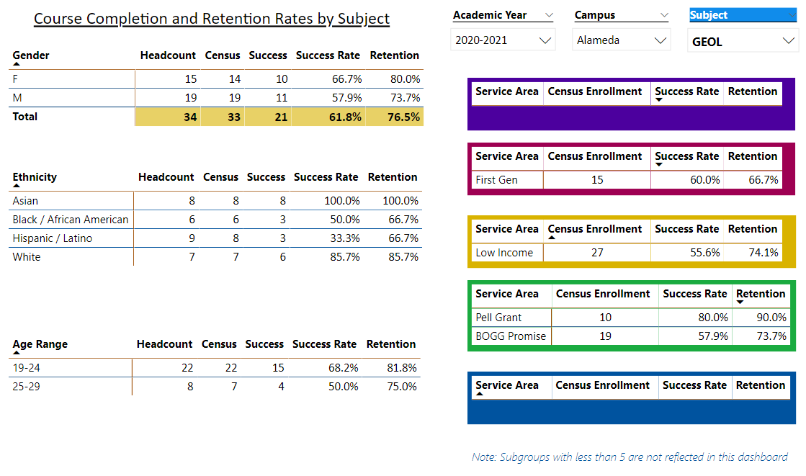

Describe any significant changes and discuss what the changes mean to your program. Consider whether performance gaps exist for disproportionality impacted students by using filters to disaggregate the data. Focus upon the most recent year and/or the years since your last comprehensive program review. Cite data points to support your reflection.
Overall retention and success rates appear to have fallen significantly in Geology courses from 2019-2020 to 2020-2021, but prior years show high rates of student success and student retention. We strongly suspect that the primary reason for the drop in student success and retention this year is that the ongoing COVID-19 pandemic forced students to take Geology classes online. Online instruction is not the best modality for teaching this hands-on subject.

The Geology program at CoA is relatively new and needs time to develop as an integrated part of the Earth Science program. There is evidence of enrollment increase over the past four years (12-14 students enrolled and passed in 2018, increasing to 34 students enrolled in fall 2021), which demonstrates increasing interest in this subject.

The number of students enrolled in the single course offered in 2020-2021 (Geology 10) is reasonable for a single class, but too small to extract meaningful institutional trends and statistics.

Describe the department's progress on Student Learning Outcomes (SLOs) and/or Service Area Outcomes (SAOs) since the last Program Review/APU.
GEOL 10 is the only Geology course being offered at CoA at the moment, but we anticipate offering GEOL 3 and GEOL 3L in the near future for the first time. GEOL 10 in in the process of assessing SLO 1 in fall 2021, with plans to assess this SLO again in spring 2022 to quantify improvements that result from implementing strategies identified in fall 2021 for increasing student success.

Describe the outcomes and accomplishments from previous year’s funded resource allocation request.
Brief description of funded request | Source (any additional award outside your base allocation) | Total Award Amount | Outcome/Accomplishment
Geology funds were used to purchase hand lenses, rock hammers and specimen containers for student use during field trips. | Lottery funds | $156. | Students enjoyed and learned from observing rocks and minerals in the field.

Prioritized Resource Requests Summary
In the boxes below, please add resource requests for your program. If there are no resource requested, leave the boxes blank.
Resource Category | Description/Justification | Estimated Annual Salary Costs | Estimated Annual Benefits Costs | Total Estimated Cost
Personnel: Classified Staff  Coordinator for Physical Sciences Laboratories | This essential position needs to be filled immediately. Physical  Sciences (including Earth Sciences) has been without a Lab Coordinator since Mitra retired earlier in 2021. | $60,000 + | unknown | per District HR
Personnel: Student Worker  3-5 geology student workers and/or additional Instructional Assistants | -tutoring students  -helping students in lab  -helping lab tech with lab setup and cleanup  -help students during review and problem solving sessions.  -help faculty with field trip logistics | unknown
Personnel: Part Time Faculty  At least one additional P/T faculty member to teach additional Geology courses | Teach Geology 1, 2, 3/3L, 10, 18, and 22, as well as to supervise GEOL 49 independent study. | unknown
Personnel: Full Time Faculty

Resource Category | Description/Justification | Total Estimated Cost
Professional Development: Department wide PD needed

Professional Development: Personal/Individual PD needed | Meetings and conferences: Faculty need to stay current in their fields of expertise and research. Travel and registration fees for these meetings need to be covered by COA. | $5,000
Prioritized Resource Requests Summary - Continued

Resource Category | Description/Justification | Total Estimated Cost
Supplies: Software | ESRI Arc-GIS license shared with Geography. | varies
Supplies: Books, Magazines, and/or Periodicals | Journal subscriptions to Geology, Geochemistry, Earth and Planetary Science Letters, Journal of Geophysical Research, etc. | $500 +
Supplies: Instructional Supplies | Rock sample collections, mineral sample collections, thin section sets, bathymetric map of the world, faulting models etc. | $1000 per funding cycle
Supplies: Non-Instructional Supplies

Supplies: Library Collections

Resource Category | Description/Justification | Total Estimated Cost
Technology & Equipment: New | Use of CoA 15-passenger vans for field trips | unknown
Technology & Equipment: Replacement | Petrographic microscopes for student use, scanning electron microscope to be shared with Chemistry (please see CHEM APU). | to be advised
Prioritized Resource Requests Summary - Continued

Resource Category | Description/Justification | Total Estimated Cost
Facilities: Classrooms | Dedicated smart-room classroom for lecture and laboratory classes, to be shared with Geography programs in the H-building until the new Science Building is built.
Facilities: Offices | Office space to be provided for GEOL instructor to hold in-person office hours and meet with students outside of the classroom.
Facilities: Labs | Dedicated smart-room classroom for laboratory classes, to be shared with Geography programs in the H-building until the new Science Building is built.
Facilities: Other | Dedicated, locking storage room for Geology specimens, maps and teaching supplies. Can be shared with Geography program that has yet to be allocated a permanent space prior to our eventual relocation to the new Science Building still to be constructed.

Resource Category | Description/Justification | Total Estimated Cost
Library: Library materials

Library: Library collections

Resource Category | Description/Justification | Total Estimated Cost
OTHER

