**College of Alameda**

2021-22 Annual Program Update - HIST

**Program Overview**

Please provide your program’s mission statement and program’s learning outcomes

|  |
| --- |
| It is the Mission of College of Alameda to serve the educational needs of its diverse community by providing comprehensive and flexible programs and resources that empower students to achieve their goals. The primary function of the History Department is to help matriculate students to four-year colleges and other degree programs. A significant portion of the program is designed to offer a wide-ranging interpretation of the history of. The Americas from the various civilizations of Meso-America and the North American continent(Aztecs, Mayas, and Incas) to the present. In addition, the department has a long and storied history of offering courses that reflect the diversity of our student population. The history department has offered courses in Latin American History, Mexican American History, the History of Mexico, Asian History and the History of the Vietnam War. The History Department is also leading the college effort to offer courses online. At the moment, all CSU, UC, and IGETC transferable courses are offered online. We offer sections of 7A, 7B, 19, and 8A and 8B online. The History department at the College of Alameda will continue to be innovative and visionary in the courses that are offered, and the methods delivered. |

List your program faculty and/or staff

|  |
| --- |
| Ed Loretto  Meredith Story  Jeffrey Sanceri |

Describe your current utilization of facilities, including labs and other space

|  |
| --- |
| Students use the writing lab, but other than that we use no other facilities. There was a faculty member who has been considering using the FabLab, but the global pandemic/COVID-19 outbreak has prevented any official forward movement on this front.  We hope to use the new Liberal arts building for our in-person classrooms, but most of what we are teaching is still online. |

List your program goals from your most recent Program Review or APU. Then, provide an update on the status of the goal. Has your program achieved the goal? Have any of your goals been revised or any still in progress? Lastly, make sure to discuss which College or District goal your program goal aligns to.

**If no program goals exist or if this is your first program review, work to create 2-3 goals and align them with a College or District goal.**

|  |  |
| --- | --- |
| **Program Goal** |  |
| Status: In-Progress or Complete | In-Progress: to continue to support online learning and offerings |
| Which college or district goal is aligned with your program goal? | All of them. |

|  |  |
| --- | --- |
| **Program Goal** |  |
| Status: In-Progress or Complete? | In-Progress: continue to support faculty teaching online |
| Which college or district goal is aligned with your program goal? | All of them. |

|  |  |
| --- | --- |
| **Program Goal** |  |
| Status: In-Progress or Complete? | Overall, our Enrollment trend is very steady, and has been since we as a department began offering more sections online. In the past three years we have seen enrollment decline as a college. Our department has not. Every indication is pointing towards a continuation of this steady trend of enrollment. One area that has experienced a steady decline is the continued erosion of the number of sections we are allowed to offer. |
| Which college or district goal is aligned with your program goal? |  |

**Program Update**

Using the dashboards, review and reflect upon the data for your program.

[**Course Completion and Retention Rates – Instructional Dashboard**](https://app.powerbi.com/view?r=eyJrIjoiNjc2MDhiNTEtNTJhZi00MDM0LTk5NDItNTRiY2EzMGI1NTZiIiwidCI6ImVlYTE2YTE2LTQ4YWYtNDc3Yi05MTEzLTA1YjFjMDExMjNmZiIsImMiOjZ9&pageName=ReportSection86d6f65e2fb41a73da4d)

[**Course Completion and Retention Rates – Student Services Dashboard**](https://app.powerbi.com/view?r=eyJrIjoiNjk3NDJjOTItNzI5MS00MDhjLWJhN2EtZjcxNzU4OTBiZDBjIiwidCI6ImVlYTE2YTE2LTQ4YWYtNDc3Yi05MTEzLTA1YjFjMDExMjNmZiIsImMiOjZ9&pageName=ReportSection86d6f65e2fb41a73da4d)

[**Enrollment Trends and Productivity Dashboard**](https://app.powerbi.com/view?r=eyJrIjoiNWJlOWZmYTEtNTY0MC00MDhkLWE5OTAtYmJjZjIxNzJiNWViIiwidCI6ImVlYTE2YTE2LTQ4YWYtNDc3Yi05MTEzLTA1YjFjMDExMjNmZiIsImMiOjZ9&pageName=ReportSection86d6f65e2fb41a73da4d)

[**Degrees and Certificates Dashboard**](https://app.powerbi.com/view?r=eyJrIjoiZjU2M2M5MzItOTcwZi00Y2U1LWJmODUtYTc0YjlhZGI2ZDhjIiwidCI6ImVlYTE2YTE2LTQ4YWYtNDc3Yi05MTEzLTA1YjFjMDExMjNmZiIsImMiOjZ9&pageName=ReportSectionde32556e136b0a8caccd)

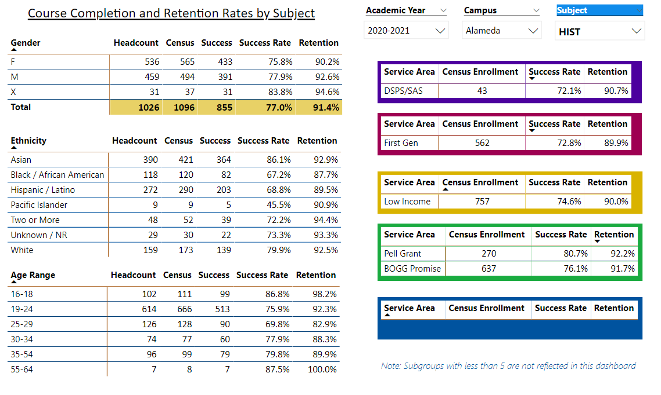

Describe any significant changes and discuss what the changes mean to your program. Consider whether performance gaps exist for disproportionality impacted students by using filters to disaggregate the data. Focus upon the most recent year and/or the years since your last comprehensive program review. Cite data points to support your reflection.

|  |
| --- |
| Overall, our Enrollment trend is very steady, and has been since we as a department began offering more sections online. In the past three years we have seen enrollment decline as a college. Our department has not. Every indication is pointing towards a continuation of this steady trend of enrollment. One area that has experienced a steady decline is the continued erosion of the number of sections we are allowed to offer. |

Describe the department's progress on Student Learning Outcomes (SLOs) and/or Service Area Outcomes (SAOs) since the last Program Review/APU.

|  |
| --- |
| Our progress on Student Learning outcomes (SLOs) is pretty darn good overall.  Our SLOs are up to date for all courses because our department is regularly assessing them on a 3-year cycle.  The SLOs as outlined in the previous Program Review were a degree of mastery in the discipline of History, and that students demonstrate a degree of proficiency in historically based critical thinking. Student assignments, exams, and projects are all historical and they all have critical thinking components. |

Describe the outcomes and accomplishments from previous year’s funded resource allocation request.

|  |  |  |  |
| --- | --- | --- | --- |
| **Brief description of funded request** | **Source (any additional award outside your base allocation)** | **Total Award Amount** | **Outcome/Accomplishment** |
| We don’t get funded for things in our department. | Jeff spends a lot of money on notebooks and pens |  | Good overall. |
|  |  |  |  |
|  |  |  |  |

**Prioritized Resource Requests Summary**

In the boxes below, please add resource requests for your program. If there are no resource requested, leave the boxes blank.

|  |  |  |  |  |
| --- | --- | --- | --- | --- |
| **Resource Category** | **Description/Justification** | **Estimated Annual Salary Costs** | **Estimated Annual Benefits Costs** | **Total Estimated Cost** |
| **Personnel: Classified Staff** |  |  |  |  |
| **Personnel: Student Worker** |  |  |  |  |
| **Personnel: Part Time Faculty** |  |  |  |  |
| **Personnel: Full Time Faculty** |  |  |  |  |

|  |  |  |
| --- | --- | --- |
| **Resource Category** | **Description/Justification** | **Total Estimated Cost** |
| **Professional Development: Department wide PD needed** |  |  |
| **Professional Development: Personal/Individual PD needed** |  |  |

**Prioritized Resource Requests Summary - Continued**

|  |  |  |
| --- | --- | --- |
| **Resource Category** | **Description/Justification** | **Total Estimated Cost** |
| **Supplies: Software** | Software for teaching | $800 |
| **Supplies: Books, Magazines, and/or Periodicals** | Books for teaching | $400 |
| **Supplies: Instructional Supplies** | Same as last year | $400 |
| **Supplies: Non-Instructional Supplies** | Same as last year | $400 |
| **Supplies: Library Collections** |  | $250 |

|  |  |  |
| --- | --- | --- |
| **Resource Category** | **Description/Justification** | **Total Estimated Cost** |
| **Technology & Equipment: New** | Same as last year, as needed | $400 |
| **Technology & Equipment: Replacement** | Same as last year, as needed | Total: $2,450.00 |

**Prioritized Resource Requests Summary - Continued**

|  |  |  |
| --- | --- | --- |
| **Resource Category** | **Description/Justification** | **Total Estimated Cost** |
| **Facilities: Classrooms** |  |  |
| **Facilities: Offices** |  |  |
| **Facilities: Labs** |  |  |
| **Facilities: Other** |  |  |

|  |  |  |
| --- | --- | --- |
| **Resource Category** | **Description/Justification** | **Total Estimated Cost** |
| **Library: Library materials** |  |  |
| **Library: Library collections** |  |  |

|  |  |  |
| --- | --- | --- |
| **Resource Category** | **Description/Justification** | **Total Estimated Cost** |
| **OTHER** |  |  |