**College of Alameda**

2021-22 Annual Program Update - HUMAN

**Program Overview**

Please provide your program’s mission statement and program’s learning outcomes

|  |
| --- |
| Program Overview Humanities is an interdisciplinary field that involves the study of creative human thought and expression. The main objective of studying Humanities at College of Alameda is to examine significant cultural artifacts, enduring artistic creations, and touchstone ideas and beliefs from a variety of scholarly and personal perspectives. As an integral part of general education, Humanities encourages students to examine diverse forms of creativity and innovation to gain perspective on their own lives and the world around them. COA courses in the Humanities  typically explore such fields as the visual arts, literature, media, popular culture, folklore, storytelling, humor, games, religion, music, dance, cuisine, fashion, tourism, and technology. Program Learning Outcomes Upon completion of this program a student will be able to:   * Increase critical understanding of the aesthetics of human-made environments. * Analyze selected works of creative expression in relation to various historical and cultural contexts. * Synthesize elements from a wide range of disciplines to appreciate and evaluate artworks, ideas, and performances from around the world. |

List your program faculty and/or staff

|  |
| --- |
| Dr. Matthew Goldstein  Dr. Cassie Lipowitz  Dr. Lisa Arellano |

Describe your current utilization of facilities, including labs and other space

|  |
| --- |
| The department utilizes "smart classrooms" on campus equipped with an interactive whiteboard, digital projector, and document camera. However, the department switched to 100% online course offerings due to the COVID campus closure and shelter in place order and relied solely on online resources. In Spring 2022, the department’s course offerings will include hybrid instruction as part of the return-to-campus plan. |

List your program goals from your most recent Program Review or APU. Then, provide an update on the status of the goal. Has your program achieved the goal? Have any of your goals been revised or any still in progress? Lastly, make sure to discuss which College or District goal your program goal aligns to.

If no program goals exist or if this is your first program review, work to create 2-3 goals and align them with a College or District goal.

|  |  |
| --- | --- |
| **Program Goal** | Continue SLO assessments and stay current every year. |
| Status: In-Progress or Complete? | Complete  We continue to remain up to date on SLO assessment. |
| Which college or district goal is aligned with your program goal? | College Goal: Data-Driven Decision Making  District Goal: Build Programs of Distinction |

|  |  |
| --- | --- |
| **Program Goal** | Expand the number of courses offered. This will allow our department to increase our reach and allow students to use our courses to meet diverse personal and academic goals. |
| Status: In-Progress or Complete? | In-Progress  We offered HUM60 Intro to LGBTQ Studies for the first time in Spring 2021. We plan to continue offering it and request assistance from our Public Information Officer (PIO) for help marketing the course. |
| Which college or district goal is aligned with your program goal? | College: Advance CoA teaching and learning  District: Advance Student Access, Equity, and Success |

|  |  |
| --- | --- |
| **Program Goal** | Increase faculty access to technology and digital teaching tools. |
| Status: In-Progress or Complete? | Complete  The technology in the new Liberal Studies and Language Arts building allows faculty to access the newest technology and teaching tools. We strongly recommend that the college engage faculty as we explore technology and the potential for future hyflex instruction. |
| Which college or district goal is aligned with your program goal? | College: Advance CoA teaching and learning  District: Advance Student Access, Equity, and Success |

**Program Update**

Using the dashboards, review and reflect upon the data for your program.

[**Course Completion and Retention Rates – Instructional Dashboard**](https://app.powerbi.com/view?r=eyJrIjoiNjc2MDhiNTEtNTJhZi00MDM0LTk5NDItNTRiY2EzMGI1NTZiIiwidCI6ImVlYTE2YTE2LTQ4YWYtNDc3Yi05MTEzLTA1YjFjMDExMjNmZiIsImMiOjZ9&pageName=ReportSection86d6f65e2fb41a73da4d)

[**Course Completion and Retention Rates – Student Services Dashboard**](https://app.powerbi.com/view?r=eyJrIjoiNjk3NDJjOTItNzI5MS00MDhjLWJhN2EtZjcxNzU4OTBiZDBjIiwidCI6ImVlYTE2YTE2LTQ4YWYtNDc3Yi05MTEzLTA1YjFjMDExMjNmZiIsImMiOjZ9&pageName=ReportSection86d6f65e2fb41a73da4d)

[**Enrollment Trends and Productivity Dashboard**](https://app.powerbi.com/view?r=eyJrIjoiNWJlOWZmYTEtNTY0MC00MDhkLWE5OTAtYmJjZjIxNzJiNWViIiwidCI6ImVlYTE2YTE2LTQ4YWYtNDc3Yi05MTEzLTA1YjFjMDExMjNmZiIsImMiOjZ9&pageName=ReportSection86d6f65e2fb41a73da4d)

[**Degrees and Certificates Dashboard**](https://app.powerbi.com/view?r=eyJrIjoiZjU2M2M5MzItOTcwZi00Y2U1LWJmODUtYTc0YjlhZGI2ZDhjIiwidCI6ImVlYTE2YTE2LTQ4YWYtNDc3Yi05MTEzLTA1YjFjMDExMjNmZiIsImMiOjZ9&pageName=ReportSectionde32556e136b0a8caccd)

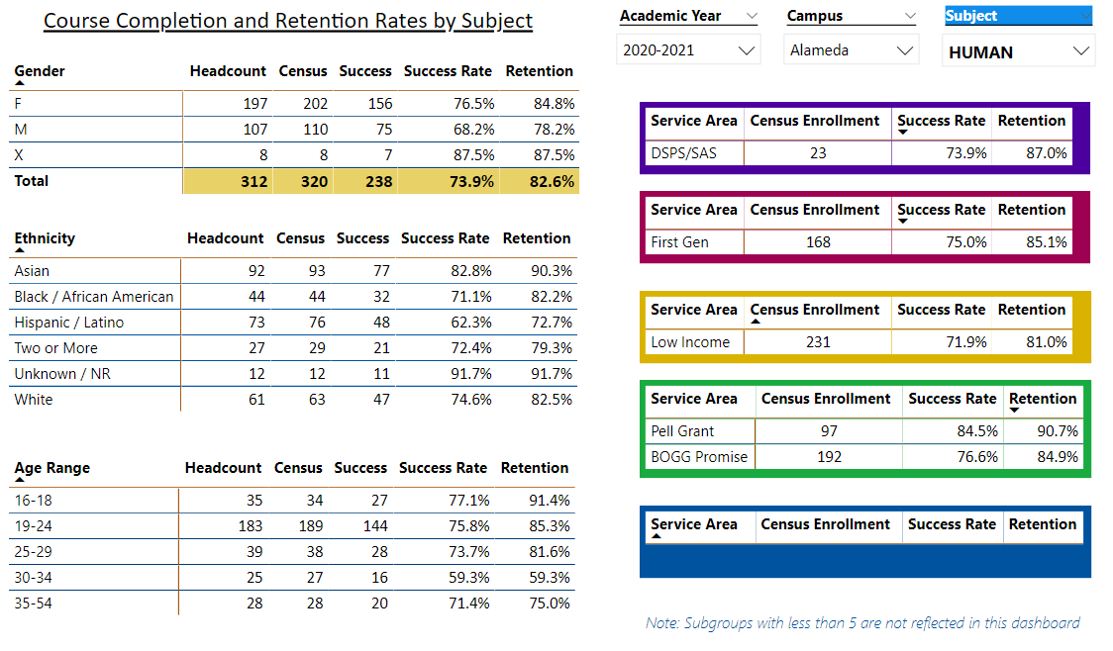

Describe any significant changes and discuss what the changes mean to your program. Consider whether performance gaps exist for disproportionality impacted students by using filters to disaggregate the data. Focus upon the most recent year and/or the years since your last comprehensive program review. Cite data points to support your reflection.

|  |
| --- |
| The move to all-virtual instruction necessitated by the Covid-19 pandemic was the most notable change for Humanities at CoA—as presumably it was for all disciplines across the college and, for that matter, across the wider education world. Technology challenges, as has been widely noted, are especially acute among underserved communities; the digital divide remains unclosed, and some of the discrepancies in success and retention rates among various ethnic and demographic categories are doubtless related to this fundamental lack of equipment and access. Although drawn from a somewhat small sample size, HUMAN data suggest, e.g., that Latinx success and retention (62.3% and 72.7%, respectively) are the most in need of amelioration among ethnic classifications; over all, however, students ages 30-34, whose success and retention rates (both 59.3%) are strikingly lower than other age groups’, seem most in need of intervention. Looking into this thirtysomething anomaly—investigating into how jobs and families, say, may affect this group more than others—would be a worthwhile undertaking for the cluster.  The scourge of phantom and fake students hit the discipline hard during the fall 2021 term. HUMAN 2, 13A, 40, and 60 saw enrollment drops of as many as 22 “students” (in the case of HUMAN 2) once A&R was alerted, per procedures set out by Dr. Siri Brown’s Aug. 17, 2021, memo, “Fraudulent Applications: The Faculty Role.” The result of the district’s late push to strip rosters of phony students was that legitimate students had little or no time to sign up for classes that under normal circumstances have historically shown robust enrollment. HUMAN 1, which benefits from early signups by special-enrollment students from the campus magnet high school, was protected from the phenomenon; had measures been taken sooner by the state and district to address the issue, there’s every reason to suppose that all five of CoA’s HUMAN offerings would likewise have neared full enrollment. It’s imperative for the health of the discipline—and for the health of the college generally—that departments and clusters demonstrably harmed by the fraud-caused drop in enrollment not see reductions in their FTEF allocations or class offerings on account of security breaches outside the control of faculty or actual students. |

Describe the department's progress on Student Learning Outcomes (SLOs) and/or Service Area Outcomes (SAOs) since the last Program Review/APU.

|  |
| --- |
| All SLO data and analysis is updated in Curricunet. Lead Humanities Faculty Dr. Matthew Goldstein works with faculty to keep SLO’s up to date and collaboration on methods to implement the results. |

Describe the outcomes and accomplishments from previous year’s funded resource allocation request.

|  |  |  |  |
| --- | --- | --- | --- |
| **Brief description of funded request** | **Source (any additional award outside your base allocation)** | **Total Award Amount** | **Outcome/Accomplishment** |
| N/A |  |  |  |
|  |  |  |  |
|  |  |  |  |

**Prioritized Resource Requests Summary**

In the boxes below, please add resource requests for your program. If there are no resource requested, leave the boxes blank.

|  |  |  |  |  |
| --- | --- | --- | --- | --- |
| **Resource Category** | **Description/Justification** | **Estimated Annual Salary Costs** | **Estimated Annual Benefits Costs** | **Total Estimated Cost** |
| **Personnel: Classified Staff** | N/A |  |  |  |
| **Personnel: Student Worker** | N/A |  |  |  |
| **Personnel: Part Time Faculty** | N/A |  |  |  |
| **Personnel: Full Time Faculty** | N/A |  |  |  |

|  |  |  |
| --- | --- | --- |
| **Resource Category** | **Description/Justification** | **Total Estimated Cost** |
| **Professional Development: Department wide PD needed** | Intensive training in hyflex pedagogy, including technical, performative, and DEI-related dimensions | $2,500 |
| **Professional Development: Personal/Individual PD needed** | N/A |  |

**Prioritized Resource Requests Summary - Continued**

|  |  |  |
| --- | --- | --- |
| **Resource Category** | **Description/Justification** | **Total Estimated Cost** |
| **Supplies: Software** | N/A |  |
| **Supplies: Books, Magazines, and/or Periodicals** | N/A |  |
| **Supplies: Instructional Supplies** | Typical instructional supplies for online and in-person instruction. | $1000 |
| **Supplies: Non-Instructional Supplies** | Typical office supplies for department use. | $500 |
| **Supplies: Library Collections** | Far less limited access to Kanopy and other film-streaming services | $10,000 |

|  |  |  |
| --- | --- | --- |
| **Resource Category** | **Description/Justification** | **Total Estimated Cost** |
| **Technology & Equipment: New** | N/A |  |
| **Technology & Equipment: Replacement** | N/A |  |

**Prioritized Resource Requests Summary - Continued**

|  |  |  |
| --- | --- | --- |
| **Resource Category** | **Description/Justification** | **Total Estimated Cost** |
| **Facilities: Classrooms** | Technology to support hyflex instruction. I do not have an IT background but according to University of San Diego’s website, some of the technology required for hyflex instruction might include:   * 2 HD cameras with optional pan, tilt, and zoom options * 2 microphones to capture the instructor and student voice * Touch screen monitor with pen tool on the side of the monitor * Document camera (that can also be used as a camera input) * Updated podium control panel to choose camera shots | ~$6,000* per classroom  *This is my best guess at a ballpark range, but IT would be the experts in this area in making estimates. |
| **Facilities: Offices** | N/A |  |
| **Facilities: Labs** | N/A |  |
| **Facilities: Other** | N/A |  |

|  |  |  |
| --- | --- | --- |
| **Resource Category** | **Description/Justification** | **Total Estimated Cost** |
| **Library: Library materials** | N/A |  |
| **Library: Library collections** | N/A |  |

|  |  |  |
| --- | --- | --- |
| **Resource Category** | **Description/Justification** | **Total Estimated Cost** |
| **OTHER** | N/A |  |