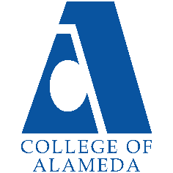College of Alameda

# 2021-22 Annual Program Update - MUSIC

## Program Overview

Please provide your program’s mission statement and program’s learning outcomes

The primary mission of the College of Alameda Music Department is to provide pathways to broader understanding of the influence of diverse cultures on musical expression. We offer courses for the aspiring performer/musician as well as for those seeking to better understand the inner workings of the music industry and its history. Our staff is comprised of experienced professionals who are committed to the personal growth and development of each and every student and bring both academic integrity and first-hand experience to the classroom.

List your program faculty and/or staff

Full Time: Glen Pearson

Part Time: Silvester Henderson

Describe your current utilization of facilities, including labs and other space

G-118, G-119 Music G-118 is used as the piano teaching lab, as well as the resource for voice and music theory; it contains 24 digital pianos. Music G-119 is used as the department's lecture classroom, as well as ensemble rehearsal and performance presentation space.

List your program goals from your most recent Program Review or APU. Then, provide an update on the status of the goal. Has your program achieved the goal? Have any of your goals been revised or any still in progress? Lastly, make sure to discuss which College or District goal your program goal aligns to.

If no program goals exist or if this is your first program review, work to create 2-3 goals and align them with a College or District goal.

|  |  |
| --- | --- |
| **Program Goal** | Creation/Launch of Certificated Program in Gospel/Faith based music studies and performance |
| Status: In-Progress or Complete? | MUSIC Certificates of Achievement in Gospel  Music Performance/Studies and Jazz Studies/Popular Music Performance were CIPD approved during the Fall 2020 semester. However, there remains the challenge of receiving the necessary allotment of FTEF in order to successfully launch these Certificates. |
| Which college or district goal is aligned with your program goal? | Community outreach and creation of alliances/partnerships leading to internship, apprenticeship, and employment opportunities for CoA CTE/Vocational program students. |

|  |  |
| --- | --- |
| **Program Goal** |  |
| Status: In-Progress or Complete? |  |
| Which college or district goal is aligned with your program goal? |  |

|  |  |
| --- | --- |
| **Program Goal** |  |
| Status: In-Progress or Complete? |  |
| Which college or district goal is aligned with your program goal? |  |

## Program Update

Using the dashboards, review and reflect upon the data for your program.

**Course Completion and Retention Rates – Instructional Dashboard Course Completion and Retention Rates – Student Services Dashboard Enrollment Trends and Productivity Dashboard**

**Degrees and Certificates Dashboard**

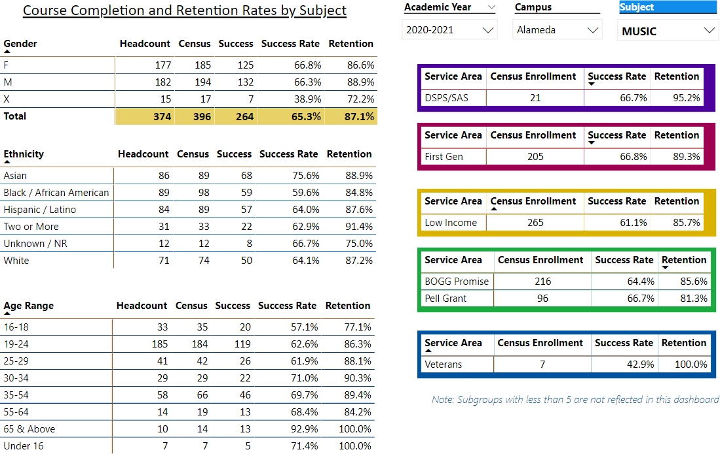

Describe any significant changes and discuss what the changes mean to your program. Consider whether performance gaps exist for disproportionality impacted students by using filters to disaggregate the data. Focus upon the most recent year and/or the years since your last comprehensive program review. Cite data points to support your reflection.

In reviewing program information for Music, there is a decrease in the overall retention rate for 2020-2021 compared to 2019-2020. The overall rate of 87.1% for 2020-2021 represents a decrease of 1% over the previous report for 2019-20. I'm of the opinion and belief, as I'm certain are others, that this downturn can be best attributed to the onset and impact of the COVID pandemic. Hopefully, the previous positive momentum resulting from the music department’s efforts to elevate enrollment and productivity through increased community outreach and visibility can be recovered.

Previous performance/retention gaps for traditionally disadvantaged and disproportionately served students show a surprisingly slight decline; the course completion/retention rate for African American students for 2020- 2021 shows at 84.8% compared to 85% for 2019-2020; the course retention rate for Hispanic/Latino students for 2020-2021 shows to be 87.6% compared to 88.4% for 2019-2020. I’m certain these changes can be attributed to impacts on the economy and job market stemming from the pandemic, along with other related factors.

Describe the department's progress on Student Learning Outcomes (SLOs) and/or Service Area Outcomes (SAOs) since the last Program Review/APU.

SLO’s for all music area courses are current and in alignment with all requirements.

Describe the outcomes and accomplishments from previous year’s funded resource allocation request.

|  |  |  |  |
| --- | --- | --- | --- |
| **Brief description of funded request** | **Source (any additional award outside your base**  **allocation)** | **Total Award Amount** | **Outcome/Accomplishment** |
| **Funding in support of performance presentation opportunities for Vocal and Piano studies students, along with the presentation of guest performers and lecturers in conjunction with creating transfer opportunities and relationships with four year institutions** | **$0** | **$0** | **Supportive funding was initially provided by the College for 2017- 18, with a pledge of an increase, but were for unexplained reasons, withdrawn.**  **Subsequent support for performance presentations has come from Professor Henderson's own personal resources.** |
|  |  |  |  |
|  |  |  |  |

|  |  |  |  |
| --- | --- | --- | --- |
|  |  |  |  |

## Prioritized Resource Requests Summary

In the boxes below, please add resource requests for your program. If there are no resource requested, leave the boxes blank.

|  |  |  |  |  |
| --- | --- | --- | --- | --- |
| **Resource Category** | **Description/Justification** | **Estimated Annual Salary**  **Costs** | **Estimated Annual Benefits**  **Costs** | **Total Estimated Cost** |
| **Personnel: Classified Staff** |  |  |  |  |
| **Personnel: Student Worker** | Embedded Tutors for the four online/hybrid formatted GE music course offerings. This is also of particular importance when considering an anticipated increase in productivity for the Music Department. | Cost for tutors at 3hrs per week estimated at  $6500.00  per semester |  | $13,000.00  per academic year |
| **Personnel: Part Time Faculty** |  |  |  |  |
| **Personnel: Full Time Faculty** |  |  |  |  |

|  |  |  |
| --- | --- | --- |
| **Resource Category** | **Description/Justification** | **Total**  **Estimated Cost** |
| **Professional Development: Department wide PD needed** | Support for conferences, workshops, and seminars in conjunction with Certificated music programs/curriculums in Gospel Music Studies and Contemporary Music Studies and Performance. | $10,000.00  per year |
| **Professional Development: Personal/Individual PD needed** |  |  |

**Prioritized Resource Requests Summary - Continued**

|  |  |  |
| --- | --- | --- |
| **Resource Category** | **Description/Justification** | **Total Estimated**  **Cost** |
| **Supplies: Software** | Audio and visual editing software (Logic, Filmora 9, ProTools, etc.) along with annual upgrades and licensing, for use in the creation of student performance presentations and individual and group projects | $5000.00  per year |
| **Supplies: Books, Magazines, and/or Periodicals** |  |  |
| **Supplies: Instructional Supplies** | Paper, manuscript, pens, pencils, whiteboard markers and erasers, batteries, copier cartridges, thumb drives, etc. | $1200 per academic year |

|  |  |  |
| --- | --- | --- |
|  |  |  |
| **Supplies: Non- Instructional Supplies** |  |  |
| **Supplies: Library Collections** |  |  |

|  |  |  |
| --- | --- | --- |
| **Resource Category** | **Description/Justification** | **Total**  **Estimated Cost** |
| **Technology & Equipment: New** | 24 Mac/Apple laptop computers, along with a server and accompanying hardware and interfaces, to facilitate the proposed incorporation of music technology as part of the CTE component for the approved Certificates of  Achievement in Gospel Music Performance/Studies and Jazz Studies/Popular Music Performance. | $80,000.00 |
| **Technology & Equipment: Replacement** |  |  |

**Prioritized Resource Requests Summary - Continued**

|  |  |  |
| --- | --- | --- |
| **Resource Category** | **Description/Justification** | **Total Estimated**  **Cost** |
| **Facilities: Classrooms** | Upgrade of desks and lighting in the main lecture/rehearsal/performance space (G-119) for the music department. | $40,000.00 |
| **Facilities: Offices** |  |  |

|  |  |  |
| --- | --- | --- |
|  |  |  |
| **Facilities: Labs** |  |  |
| **Facilities: Other** |  |  |

|  |  |  |
| --- | --- | --- |
| **Resource Category** | **Description/Justification** | **Total Estimated**  **Cost** |
| **Library: Library materials** |  |  |
| **Library: Library collections** |  |  |

|  |  |  |
| --- | --- | --- |
| **Resource Category** | **Description/Justification** | **Total Estimated**  **Cost** |
| **OTHER** |  |  |