**College of Alameda**

2021-22 Annual Program Update - PHIL

**Program Overview**

Please provide your program’s mission statement and program’s learning outcomes

|  |
| --- |
| Philosophy is a discipline that examines fundamental questions about everyday life and the natural world.  Philosophy classes at College of Alameda will prepare students to:   * Demonstrate knowledge of the major questions, central methods, issues, figures, and arguments in the core areas of philosophy and its history. * Use formal and informal logic to identify, construct, analyze, evaluate, and respond to arguments. * Deal with value questions with clarity, fairness, and open-mindedness. * Make connections with philosophical traditions and everyday life, including their professional, family, and social lives. * Clearly articulate ideas and arguments in writing and speech.   By studying philosophy, students will gain wisdom, clarity, and awareness about a wide variety of philosophical issues that arise within different cultural and his |

List your program faculty and/or staff

|  |
| --- |
| David Peterson (part time) |

Describe your current utilization of facilities, including labs and other space

|  |
| --- |
| The Philosophy Department utilizes "smart classrooms" on campus equipped with an interactive whiteboard, digital projector, and document camera. However, the department switched to 100% online course offerings due to the COVID campus closure and shelter in place order and relied solely on online resources. |

List your program goals from your most recent Program Review or APU. Then, provide an update on the status of the goal. Has your program achieved the goal? Have any of your goals been revised or any still in progress? Lastly, make sure to discuss which College or District goal your program goal aligns to.

If no program goals exist or if this is your first program review, work to create 2-3 goals and align them with a College or District goal.

|  |  |
| --- | --- |
| **Program Goal** | Continue SLO assessments and stay current every year. This will allow our department to meet accreditation standards. |
| Status: In-Progress or Complete? | Complete |
| Which college or district goal is aligned with your program goal? | College Goal: Data-Driven Decision Making  District Goal: Build Programs of Distinction |

|  |  |
| --- | --- |
| **Program Goal** | Expand the number of courses offered. This will allow our department to increase our reach and allow students to use our courses to meet diverse personal and academic goals. |
| Status: In-Progress or Complete? | In-Progress |
| Which college or district goal is aligned with your program goal? | College: Advance CoA teaching and learning  District: Advance Student Access, Equity, and Success |

|  |  |
| --- | --- |
| **Program Goal** | Increase faculty access to technology and digital teaching tools. |
| Status: In-Progress or Complete? | Complete |
| Which college or district goal is aligned with your program goal? | College: Advance CoA teaching and learning  District: Advance Student Access, Equity, and Success |

**Program Update**

Using the dashboards, review and reflect upon the data for your program.

[**Course Completion and Retention Rates – Instructional Dashboard**](https://app.powerbi.com/view?r=eyJrIjoiNjc2MDhiNTEtNTJhZi00MDM0LTk5NDItNTRiY2EzMGI1NTZiIiwidCI6ImVlYTE2YTE2LTQ4YWYtNDc3Yi05MTEzLTA1YjFjMDExMjNmZiIsImMiOjZ9&pageName=ReportSection86d6f65e2fb41a73da4d)

[**Course Completion and Retention Rates – Student Services Dashboard**](https://app.powerbi.com/view?r=eyJrIjoiNjk3NDJjOTItNzI5MS00MDhjLWJhN2EtZjcxNzU4OTBiZDBjIiwidCI6ImVlYTE2YTE2LTQ4YWYtNDc3Yi05MTEzLTA1YjFjMDExMjNmZiIsImMiOjZ9&pageName=ReportSection86d6f65e2fb41a73da4d)

[**Enrollment Trends and Productivity Dashboard**](https://app.powerbi.com/view?r=eyJrIjoiNWJlOWZmYTEtNTY0MC00MDhkLWE5OTAtYmJjZjIxNzJiNWViIiwidCI6ImVlYTE2YTE2LTQ4YWYtNDc3Yi05MTEzLTA1YjFjMDExMjNmZiIsImMiOjZ9&pageName=ReportSection86d6f65e2fb41a73da4d)

[**Degrees and Certificates Dashboard**](https://app.powerbi.com/view?r=eyJrIjoiZjU2M2M5MzItOTcwZi00Y2U1LWJmODUtYTc0YjlhZGI2ZDhjIiwidCI6ImVlYTE2YTE2LTQ4YWYtNDc3Yi05MTEzLTA1YjFjMDExMjNmZiIsImMiOjZ9&pageName=ReportSectionde32556e136b0a8caccd)

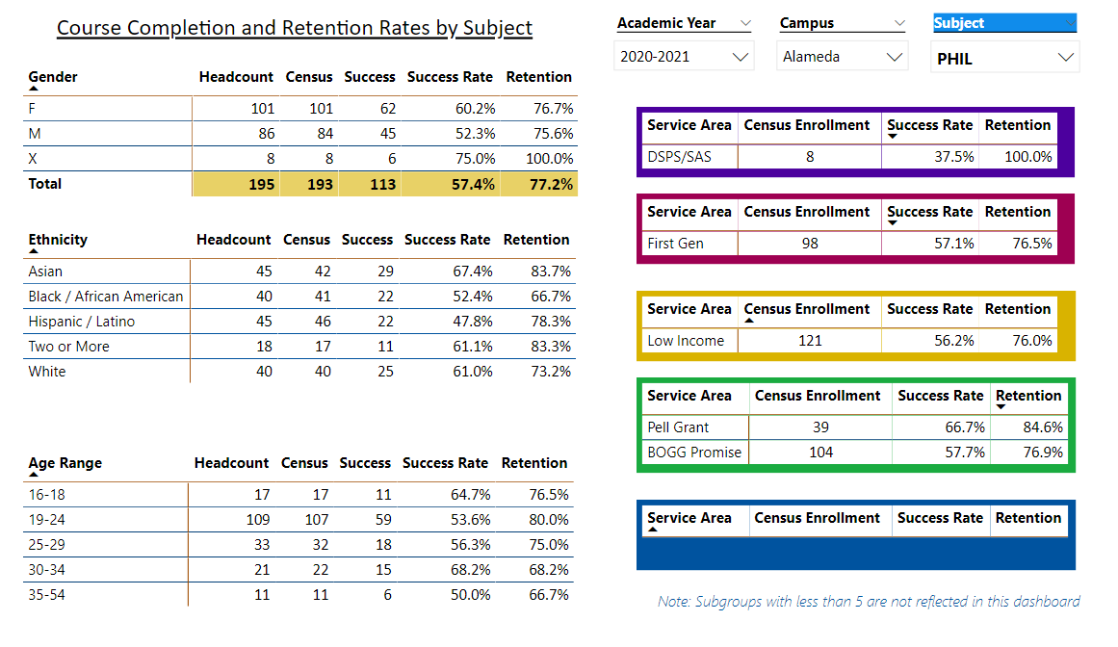

Describe any significant changes and discuss what the changes mean to your program. Consider whether performance gaps exist for disproportionality impacted students by using filters to disaggregate the data. Focus upon the most recent year and/or the years since your last comprehensive program review. Cite data points to support your reflection.

|  |
| --- |
| As noted in previous APUs for the last several years, enrollment in Philosophy continues to decline. The Philosophy Department is comprised of a single part-time faculty member that keeps classes afloat. We’ve started offering Philosophy courses during intersessions, which has provided a boost in enrollment. However, the one section of Philosophy we did have on the schedule for Fall 2021 was cancelled due to low enrollment. This is the first time in several years that they college did not offer a single Philosophy course.  It goes without arguing that a comprehensive college should not be without a Philosophy department or program. Significant resources need to be put into this department to create the growth it needs to be sustained. Most notably, a full-time faculty member that can create and grow a program from the ground up. This work cannot happen with a single part-time faculty member or department chair that also oversees 4 other departments in the cluster alone. |

Describe the department's progress on Student Learning Outcomes (SLOs) and/or Service Area Outcomes (SAOs) since the last Program Review/APU.

|  |
| --- |
| All SLO data and analysis is updated in Curricunet. |

Describe the outcomes and accomplishments from previous year’s funded resource allocation request.

|  |  |  |  |
| --- | --- | --- | --- |
| **Brief description of funded request** | **Source (any additional award outside your base allocation)** | **Total Award Amount** | **Outcome/Accomplishment** |
| N/A – we did not have any resources allocation requests last year. |  |  |  |
|  |  |  |  |
|  |  |  |  |

**Prioritized Resource Requests Summary**

In the boxes below, please add resource requests for your program. If there are no resource requested, leave the boxes blank.

|  |  |  |  |  |
| --- | --- | --- | --- | --- |
| **Resource Category** | **Description/Justification** | **Estimated Annual Salary Costs** | **Estimated Annual Benefits Costs** | **Total Estimated Cost** |
| **Personnel: Classified Staff** | N/A |  |  |  |
| **Personnel: Student Worker** | N/A |  |  |  |
| **Personnel: Part Time Faculty** | N/A |  |  |  |
| **Personnel: Full Time Faculty** | 1 Full-Time Faculty | $100,000 | ???  I do not know what benefits cost | $100,000 |

|  |  |  |
| --- | --- | --- |
| **Resource Category** | **Description/Justification** | **Total Estimated Cost** |
| **Professional Development: Department wide PD needed** | N/A |  |
| **Professional Development: Personal/Individual PD needed** | N/A |  |

**Prioritized Resource Requests Summary - Continued**

|  |  |  |
| --- | --- | --- |
| **Resource Category** | **Description/Justification** | **Total Estimated Cost** |
| **Supplies: Software** | N/A |  |
| **Supplies: Books, Magazines, and/or Periodicals** | N/A |  |
| **Supplies: Instructional Supplies** | Typical instructional supplies for online and in-person instruction. | $500 |
| **Supplies: Non-Instructional Supplies** | Typical office supplies for department use. | $250 |
| **Supplies: Library Collections** | N/A |  |

|  |  |  |
| --- | --- | --- |
| **Resource Category** | **Description/Justification** | **Total Estimated Cost** |
| **Technology & Equipment: New** | N/A |  |
| **Technology & Equipment: Replacement** | N/A |  |

**Prioritized Resource Requests Summary - Continued**

|  |  |  |
| --- | --- | --- |
| **Resource Category** | **Description/Justification** | **Total Estimated Cost** |
| **Facilities: Classrooms** | Technology to support hyflex instruction. I do not have an IT background but according to University of San Diego’s website, some of the technology required for hyflex instruction might include:   * 2 HD cameras with optional pan, tilt, and zoom options * 2 microphones to capture the instructor and student voice * Touch screen monitor with pen tool on the side of the monitor * Document camera (that can also be used as a camera input) * Updated podium control panel to choose camera shots | ~$6,000* per classroom  *This is my best guess at a ballpark range, but IT would be the experts in this area in making estimates. |
| **Facilities: Offices** | N/A |  |
| **Facilities: Labs** | N/A |  |
| **Facilities: Other** | N/A |  |

|  |  |  |
| --- | --- | --- |
| **Resource Category** | **Description/Justification** | **Total Estimated Cost** |
| **Library: Library materials** | N/A |  |
| **Library: Library collections** | N/A |  |

|  |  |  |
| --- | --- | --- |
| **Resource Category** | **Description/Justification** | **Total Estimated Cost** |
| **OTHER** | N/A |  |