**College of Alameda**

2021-22 Annual Program Update - PHYS

**Program Overview**

Please provide your program’s mission statement and program’s learning outcomes

|  |
| --- |
| The mission of the Physics Department at College of Alameda is to integrate problem-solving with a firm conceptual foundation and laboratory exercises. Students spend time working with other students in class, discussing physics concepts and solving problems together.  We provide comprehensive and flexible programs that empower students to achieve their goals. For example, many students enroll in Physics 10, which is offered as an online course, to satisfy prerequisites for Allied Health programs. Most students enroll in the Physics 4A-4B-4C sequence to satisfy prerequisites for engineering and physical sciencese. |

List your program faculty and/or staff

|  |
| --- |
| Andrew Park  Ben Stahl (currently inactive)  Andrew Fittingoff  Dietmar Krauss-Varban |

Describe your current utilization of facilities, including labs and other space

|  |
| --- |
| We use ATLAN 100 for Physics lab (hybrid for Fall 2021; returning to in-person instruction for Spring 2022) and ATLAN 101 for storage of all necessary equipment for lab and lecture demos.  With exclusive use of ATLAN 100, facility needs of all Physics courses (4A, 4B, 4C, and 10) are currently met. |

List your program goals from your most recent Program Review or APU. Then, provide an update on the status of the goal. Has your program achieved the goal? Have any of your goals been revised or any still in progress? Lastly, make sure to discuss which College or District goal your program goal aligns to.

If no program goals exist or if this is your first program review, work to create 2-3 goals and align them with a College or District goal.

|  |  |
| --- | --- |
| **Program Goal** | Obtain detailed enrollment data for PHYS 10 district-wide |
| Status: In-Progress or Complete? | Complete (data provided by college researcher; next step *still* is to initiate PHYS 10 curriculum update in a way that is supported by the enrollment data) |
| Which college or district goal is aligned with your program goal? | College Goal 7: Data-Driven Decision Making  College Goal 6: Teaching and Learning |

|  |  |
| --- | --- |
| **Program Goal** | Continue to maintain Physics lab equipment |
| Status: In-Progress or Complete? | In-Progress |
| Which college or district goal is aligned with your program goal? | College Goal 6: Teaching and Learning |

|  |  |
| --- | --- |
| **Program Goal** | Hold a ConferZoom meeting for discipline faculty during the semester |
| Status: In-Progress or Complete? | In-Progress |
| Which college or district goal is aligned with your program goal? | College Goal 6: Teaching and Learning |

|  |  |
| --- | --- |
| **Program Goal** | Continue evaluating effectiveness of online mode of lecture instruction for PHYS 10 and PHYS 4 and seek ways to improve it. |
| Status: In-Progress or Complete? | In-Progress |
| Which college or district goal is aligned with your program goal? | College Goal 6: Teaching and Learning |

|  |  |
| --- | --- |
| **Program Goal** | Start Offering PHYS 3A and PHYS 3B (new goal for AY 2021-2022), with an aim of replacing PHYS 4A-4B-4C offering with PHYS 3A-3B offering. |
| Status: In-Progress or Complete? | In-Progress |
| Which college or district goal is aligned with your program goal? | College Goal 6: Teaching and Learning  College Goal 7: Data-Driven Decision Making |

**Program Update**

Using the dashboards, review and reflect upon the data for your program.

[**Course Completion and Retention Rates – Instructional Dashboard**](https://app.powerbi.com/view?r=eyJrIjoiNjc2MDhiNTEtNTJhZi00MDM0LTk5NDItNTRiY2EzMGI1NTZiIiwidCI6ImVlYTE2YTE2LTQ4YWYtNDc3Yi05MTEzLTA1YjFjMDExMjNmZiIsImMiOjZ9&pageName=ReportSection86d6f65e2fb41a73da4d)

[**Course Completion and Retention Rates – Student Services Dashboard**](https://app.powerbi.com/view?r=eyJrIjoiNjk3NDJjOTItNzI5MS00MDhjLWJhN2EtZjcxNzU4OTBiZDBjIiwidCI6ImVlYTE2YTE2LTQ4YWYtNDc3Yi05MTEzLTA1YjFjMDExMjNmZiIsImMiOjZ9&pageName=ReportSection86d6f65e2fb41a73da4d)

[**Enrollment Trends and Productivity Dashboard**](https://app.powerbi.com/view?r=eyJrIjoiNWJlOWZmYTEtNTY0MC00MDhkLWE5OTAtYmJjZjIxNzJiNWViIiwidCI6ImVlYTE2YTE2LTQ4YWYtNDc3Yi05MTEzLTA1YjFjMDExMjNmZiIsImMiOjZ9&pageName=ReportSection86d6f65e2fb41a73da4d)

[**Degrees and Certificates Dashboard**](https://app.powerbi.com/view?r=eyJrIjoiZjU2M2M5MzItOTcwZi00Y2U1LWJmODUtYTc0YjlhZGI2ZDhjIiwidCI6ImVlYTE2YTE2LTQ4YWYtNDc3Yi05MTEzLTA1YjFjMDExMjNmZiIsImMiOjZ9&pageName=ReportSectionde32556e136b0a8caccd)

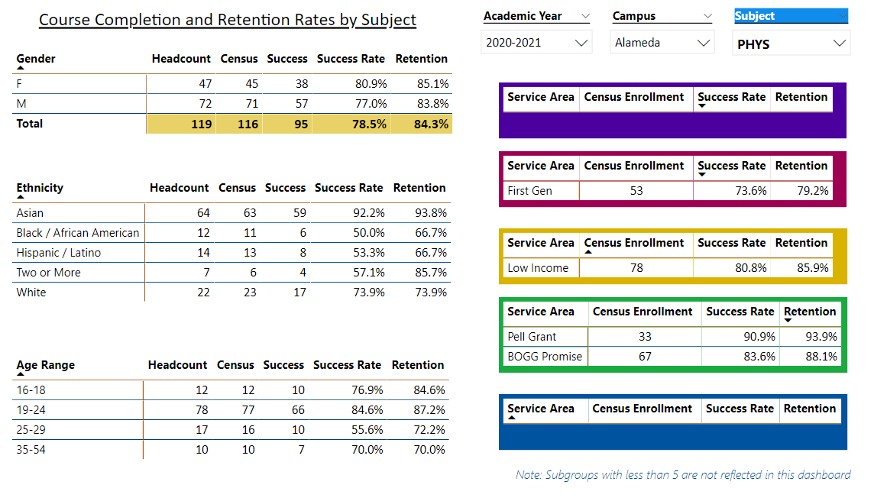

Describe any significant changes and discuss what the changes mean to your program. Consider whether performance gaps exist for disproportionality impacted students by using filters to disaggregate the data. Focus upon the most recent year and/or the years since your last comprehensive program review. Cite data points to support your reflection.

|  |
| --- |
| Patterns identified in previous APUs remain: AfrAm student success rates are low (50%, compared against department average of 78.5%) and Hispanic student success rates are low (53.3% compared against the same average). As noted before, low retention rates are driving these numbers; a better support structure for students in PHYS are needed.  Success rates for 25-29 age group is lowest at 55.6%. Given the small sample size, it may be a one off thing (in previous APUs, success rate for 35-54 age group was lowest). |

Describe the department's progress on Student Learning Outcomes (SLOs) and/or Service Area Outcomes (SAOs) since the last Program Review/APU.

|  |
| --- |
| PHYS 10 was last assessed Spring 2020.  PHYS 4A will be assessed Spring 2021 and Fall 2021.  PHYS 4B was last assessed Fall 2020.  PHYS 4C was last assessed Spring 2020.  PHYS 10L was last assessed Spring 2019 (not offered again since). |

Describe the outcomes and accomplishments from previous year’s funded resource allocation request.

|  |  |  |  |
| --- | --- | --- | --- |
| **Brief description of funded request** | **Source (any additional award outside your base allocation)** | **Total Award Amount** | **Outcome/Accomplishment** |
| N/A | N/A | N/A | N/A |
|  |  |  |  |
|  |  |  |  |

**Prioritized Resource Requests Summary**

In the boxes below, please add resource requests for your program. If there are no resource requested, leave the boxes blank.

|  |  |  |  |  |
| --- | --- | --- | --- | --- |
| **Resource Category** | **Description/Justification** | **Estimated Annual Salary Costs** | **Estimated Annual Benefits Costs** | **Total Estimated Cost** |
| **Personnel: Classified Staff**  N/A |  |  |  |  |
| **Personnel: Student Worker**  N/A |  |  |  |  |
| **Personnel: Part Time Faculty**  Maintain existing staffing level | Physics course offering currently operates at core courses only; any cuts will impact core programming |  |  |  |
| **Personnel: Full Time Faculty**  Maintain existing staffing level | Physics course offering currently operates at core courses only; any cuts will impact core programming |  |  |  |

|  |  |  |
| --- | --- | --- |
| **Resource Category** | **Description/Justification** | **Total Estimated Cost** |
| **Professional Development: Department wide PD needed**  N/A | No estimated costs for informal PD that continues to take place. |  |
| **Professional Development: Personal/Individual PD needed**  N/A | Individual PD requests will go through the PD committee. |  |

**Prioritized Resource Requests Summary - Continued**

|  |  |  |
| --- | --- | --- |
| **Resource Category** | **Description/Justification** | **Total Estimated Cost** |
| **Supplies: Software**  N/A | Most current needs are met through free/open-source resources. |  |
| **Supplies: Books, Magazines, and/or Periodicals**  N/A | Most current needs are met through free/open-source resources. |  |
| **Supplies: Instructional Supplies**  Maintain existing lottery/IELM allocation | Existing lottery/IELM allocation is used for ongoing (small) repairs of lab equipment as well as re-stocking and purchasing trial quantities of new demos. |  |
| **Supplies: Non-Instructional Supplies**  N/A |  |  |
| **Supplies: Library Collections**  N/A | Current library collection is up to date. |  |

|  |  |  |
| --- | --- | --- |
| **Resource Category** | **Description/Justification** | **Total Estimated Cost** |
| **Technology & Equipment: New**  Maintain existing lottery/IELM allocation | Existing lottery/IELM allocation is used for ongoing (small) repairs of lab equipment as well as re-stocking and purchasing trial quantities of new demos. |  |
| **Technology & Equipment: Replacement**  Maintain existing lottery/IELM allocation | Existing lottery/IELM allocation is used for ongoing (small) repairs of lab equipment as well as re-stocking and purchasing trial quantities of new demos. |  |

**Prioritized Resource Requests Summary - Continued**

|  |  |  |
| --- | --- | --- |
| **Resource Category** | **Description/Justification** | **Total Estimated Cost** |
| **Facilities: Classrooms**  ATLAN 100 | Please keep ATLAN 100 (the physics lab) available for Physics use. In the rare events when it is absolutely necessary to schedule non-Physics programming in ATLAN 100, please consult Physics faculty to minimize disruptions to Physics programming that rely on ATLAN 100. |  |
| **Facilities: Offices**  ATLAN 102 | The attached office to ATLAN 100 is the only office space available to Physics faculty, outside of the generally shared office spaces. |  |
| **Facilities: Labs**  ATLAN 100 | Please keep ATLAN 100 (the physics lab) available for Physics use. In the rare events when it is absolutely necessary to schedule non-Physics programming in ATLAN 100, please consult Physics faculty to minimize disruptions to Physics programming that rely on ATLAN 100. |  |
| **Facilities: Other**  N/A |  |  |

|  |  |  |
| --- | --- | --- |
| **Resource Category** | **Description/Justification** | **Total Estimated Cost** |
| **Library: Library materials**  N/A | Existing resources are currently sufficient. |  |
| **Library: Library collections**  N/A | Existing resources are currently sufficient. |  |

|  |  |  |
| --- | --- | --- |
| **Resource Category** | **Description/Justification** | **Total Estimated Cost** |
| **OTHER**  N/A |  |  |