College of Alameda

2021-22 Annual Program Update - POSCI

**APU Date: November 14th 2021** (Date of last Comprehensive Program Review **February 2021)**

## Program Overview

1. **Political Science** *& Community Change and Urban Leadership (CCUL) Guided-Pathway Program ~~*

**Cluster**: HIST-PSYCH-AFRAM-SOC-MLAT-POSCI – **Co-Chairs** Ed Loretto and Sarah Peterson-Guada

1. POSCI APU completed by **Robert J. Brem**, MA, MC, NCC ~ Lead Faculty
2. The mission of College of Alameda is to *serve the educational needs of its diverse community by providing comprehensive and flexible programs and resources that empower students to achieve their goals.*

The vision and mission of the ***“****Politics” program/Department* at College of Alameda: ***We envision our students as engaged persons, workers, and citizens enabled to lead in the creation of a world that is: Socially Just, Environmentally and Economically sustainable, and Psychologically Fulfilling***.

We aim to fulfill this vision in our mission of 1) offering Associate of Arts Degrees in Political Science and a Certificate of Proficiency and Achievement; and 2) programmatically emphasizing community engagement, future consciousness, and transformational leadership in creating social change. *We aim to empower our students in building their capacity to effectively engage with the 21st Century Modern World System as citizens, workers, and persons*. An emphasis is placed on highlighting how politics is relevant to the lives of students as whole persons in their day-to-day world of lived and shared reality. Overall, we fulfill this commitment by facilitating learning experiences for the people we serve in

* 1. the expansion of foundational knowledge of the socio-political world,
  2. increasing their proficiency with critical political thinking to be better able to engage their “knowledge in use” skills, and
  3. building their capacity for personal psycho-social political efficacy.

In these efforts, we seek to be a “signature program” of “distinctive difference.” with resultant comparative advantage being a “strange attracter” magnet to be

a force in being - significant compelling reason – drawing students to choose COA over other competitors in our greater catchment area.

1. List of our program faculty and/or staff – **in order of seniority**:
2. Robert J Brem f/t split assignment 60% in POSCI and 40% in PSYCH; **CCUL Co-Coordinator, POSCI Lead Faculty**
3. Ron Lomax p/t (semi-retired – teaches one section per semester)
4. Judith Hurtado-Ortiz p/t
5. Hasmik Geghamyan p/t **CCUL Co-Coordinator** for law and violence prevention
6. Sarah Oddie p/t
7. Calvin Williams p/t currently inactive - violence prevention
8. Describe your current utilization of facilities, including labs and other space

In the context of Covid 19 shelter in place patterns, though we have moved into our “new” offices in the new building on campus, we are not using this space fully. The lead faculty member tends to be on campus twice weekly, teaching Zoom from there, however, due to medical necessity (increased disability), teaching remotely permanently is his future status. However, our p/t faculty will voluntarily resume in-person teaching in Spring 2022, enabling 50% of our classes to be in-person. All other work is home based, using Zoom for instruction and professional meetings and events. Campus works spaces are used as department home base from which instructional materials and supplies are distributed.

## Program goals from most recent Program Review or APU.

* + With update on the status of the goal and degree of achievement.
  + Goal revisions and progress
  + Relationship to College & District goals with which our program goals align.

|  |  |  |  |
| --- | --- | --- | --- |
| **COA GOALS** | **PCCD GOALS** | **Progress on goal attainment** | **Explanation and Comments** |
| **A: Advance Student Access, Equity, and Success COA – POSCI/CCUL meets this goal with:**   1. Innovative Learning Outcomes and Basic Skills integration efforts 2. Expansion of program and courses offerings (including a unique CTE- POSCI series of stackable certificates; and a law program aimed at traditionally underserved populations). | * 1. **Student Access:** Increase enrollment for programs and course offerings in the essential areas of basic skills/ESOL, CTE and transfer to achieve the District target of 19,355 RES FTES.   2. **Student Success:** Increase students’ participation in SSSP eligible activities by 50%, with specific emphasis on expanding orientations, assessments, academic advising and student educational plans.   3. **Student Success:** Using baseline data, increase student engagement in activities such as student governance, student life activities, Student leadership development, service-learning programs, learning communities, student employment, etc.   4. **Student Equity Planning:** Address the achievement gap through fully developing and implementing the student success and equity plans at each campus. | Efforts are iterative and aimed at on-going improvement | Institutional challenges and key personnel issues slowed progress in the context of perhaps overly optimistic timelines and social ligatures.  Covid 19 SIP issues have temporarily made these efforts less robust than might be possible otherwise  Project management plan and timeline extended. |

|  |  |  |  |
| --- | --- | --- | --- |
| **COA GOALS** | **PCCD GOALS** | **Progress on goal attainment** | **Explanation and Comments** |
| **B: Engage and Leverage Partners**  **COA – POSCI/CCUL meets this goal with:**   1. Our Innovative partnerships efforts with CSU East Bay, APC, WISR, and Alameda County. 2. Our outreach efforts towards Area High Schools for recruitment (including ARISE, LWA, Fremont, AUSD, OUSD, AIM). 3. Outreach and partnerships with East Bay Community Based Organizations (primary partner: *Centro Legal* de la *Raza, Alameda Point Collaborative, East Bay Cohousing, Sierra Club, etc.*) | **B.1 Partnerships:** Develop a District-wide database that represents our current strategic partnerships and relationships.  **B.2. Partnerships:** Expand partnerships with K-12 institutions, community-based organizations, four-year institutions, local government, and regional industries and businesses. | Efforts are iterative and aimed at on-going improvement  Granting these efforts have yielded little progress over past decade; these efforts have been on hold until we decide what future path we will seek to trod. | Complicated negotiations have taken longer than anticipated with little results.  Covid 19 SIP issues have made these partnerships less robust than might be possible otherwise.  **We are engaged in reflective reality testing as to whether CCUL as an initiative should come to an end** |
| **C: Build Programs of Distinction**  **COA – POSCI/CCUL meets this goal with**:  The Community Change and Urban Leadership Initiative is in itself a potentially world class program – **if it were to receive sufficient institutional support** and a fair chance at testing implementation success estimates.  We also took the lead in developing a new interdisciplinary certificate programs in Gender/Queer studies. And will offer our new course in that program in Fall 2023. We had intended to expand offerings in these areas, as this strategy is a path to a niche realm of success for COA-POSCI/CCUL. | * 1. **Student Success:** Develop a District-wide first year experience/student success program.   2. **Student Success:** Develop an innovative student success program at each college. | Efforts are iterative and aimed at on-going improvement  Granting these efforts have yielded little progress over past decade; these efforts have been on hold until we decide what future path we will seek to trod. | Complicated negotiations have taken longer than anticipated with little results.  Covid 19 SIP issues have temporarily made these efforts less robust than might be possible otherwise  **We are engaged in reflective reality testing as to whether CCUL as an initiative should come to an end**  The Queer studies program will continue, as will we offer the courses, we have offered in the past, but these will be solely under the rubric of POSCI and not CCUL and Pathway to Law School |

|  |  |  |  |
| --- | --- | --- | --- |
| **D: Strengthen Accountability, Innovation and Collaboration**  **COA – POSCI/CCUL meets this goal with**:   1. The departmental engagement with Student Government on a mentoring basis, and the creation of student leadership courses and trainings. 2. Our partnerships offer this opportunity. 3. Alameda Point Collaborative Service- Learning initiative | * 1. **Service Leadership:** Provide professional development opportunities for faculty, staff and administrators that lead to better service to our students and colleagues.   2. **Institutional Leadership and Governance:** Evaluate and update policies and administrative procedures and the PBIM participatory governance structure. | Efforts are iterative and aimed at on-going improvement  The Alameda Point Collaborative Service-Learning initiative never got rebooted despite numerous efforts. | Complicated negotiations have taken longer than anticipated with little results.  Covid 19 SIP issues have temporarily made these efforts less robust than might be possible otherwise  **We are engaged in reflective reality testing as to whether CCUL as an initiative should come to an end** |

**~~~~~~~~~~~~~~~~~~~~~~~~~~~~~~~~~~~~~~~~~~~~~~~~~~~~~~~~~~~~~~~~~~~~~~~~~~~~~~~~~~~~~~**

1. 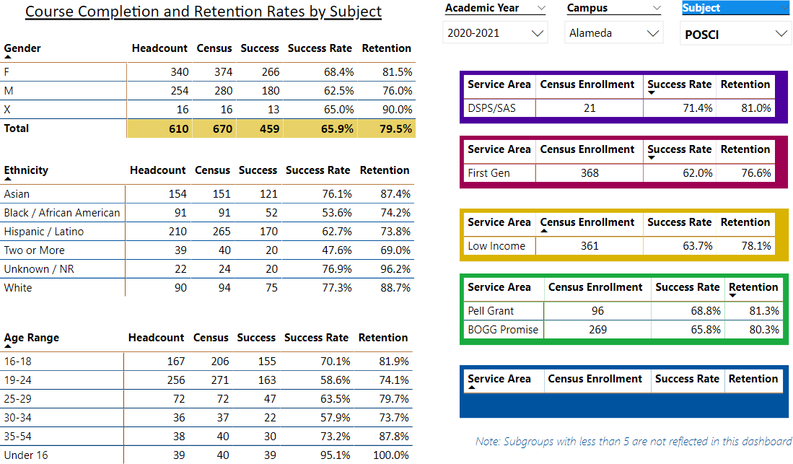**Program Update**

# Course Completion and Retention Rates

POSCI completion and retention rates compare favorably to these rates for other departments at the college.

As for how we seek to increase success for all of our students is by engaging in more one on one office hour coaching consultations which has been made much more practical in the Zoom age as we can all meet from different locations. We have grace periods for assignments to enable flexibility for due dates. And we are willing to be flexible if students reach out for extensions or to chat about academic stress in context of their lives. . This is aimed at making our department more compassionate in being supportive of students in doing their work.

* 1. Enrollment Trends and Productivity

There are really no “significant”

changes here to discuss

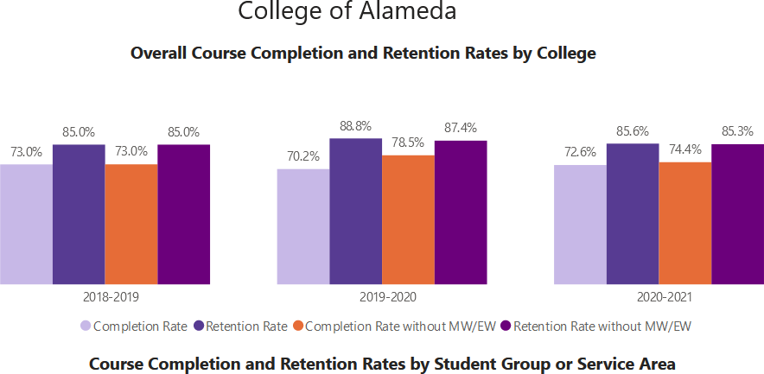

### Political Science

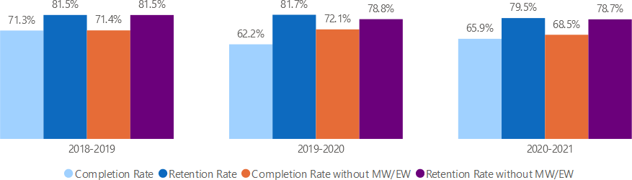

**COA POSCI Department Census Enrollment and Productivity**

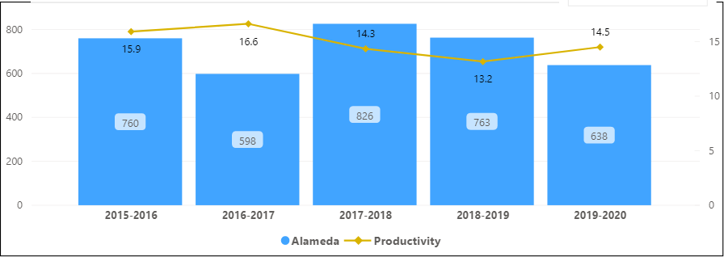

~~~

## COA POSCI Department figures by Term 2016 to 2020

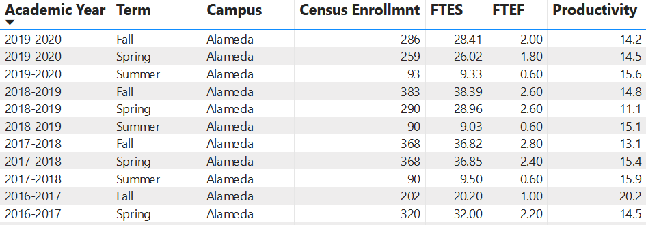

**COA POSCI Course Enrollment by time of day – 2015 to 2020**

**College Subject Year Time of Day Census Enrollment Total FTES Total FTEF Productivity**

|  |  |  |  |  |  |  |  |
| --- | --- | --- | --- | --- | --- | --- | --- |
| Alameda | POSCI | 2015-2016 | DAY | 620 | 62.16 | 3.52 | 17.7 |
| Alameda | POSCI | 2015-2016 | EVENING | 140 | 13.99 | 1.27 | 11 |
| Alameda | POSCI | 2016-2017 | DAY | 532 | 53.24 | 3 | 17.8 |
| Alameda | POSCI | 2016-2017 | EVENING | 66 | 6.6 | 0.6 | 11 |
| Alameda | POSCI | 2017-2018 | DAY | 728 | 73.43 | 5 | 14.7 |
| Alameda | POSCI | 2017-2018 | EVENING | 97 | 9.7 | 0.8 | 12.1 |
| Alameda | POSCI | 2018-2019 | DAY | 698 | 69.88 | 5.2 | 13.4 |
| Alameda | POSCI | 2018-2019 | EVENING | 65 | 6.5 | 0.6 | 10.8 |
| Alameda | POSCI | 2019-2020 | DAY | 602 | 59.97 | 4 | 15 |
| Alameda | POSCI | 2019-2020 | EVENING | 36 | 3.79 | 0.4 | 9.5 |

We believe courses are scheduled in a manner that meets student needs and demands. We know this anecdotally by asking our students – this information is then shared in department meetings about scheduling

~~~

# Degrees and Certificates from 2017 to 2021

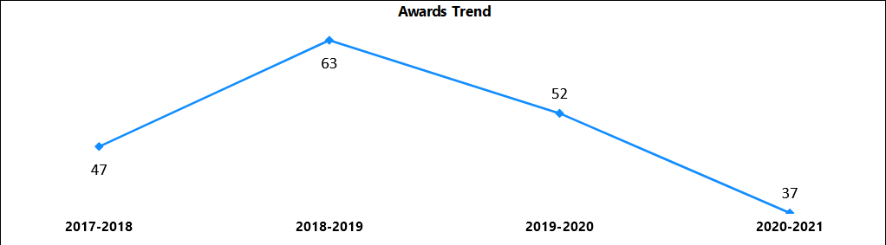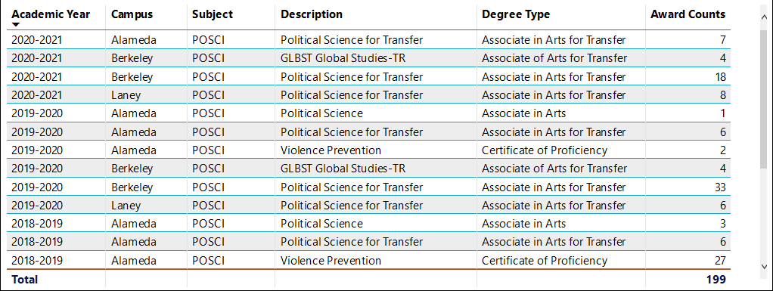

***All Peralta POSCI Departments*** Despite serious competitive disadvantages, COA continues to lead the district in certificates awarded (through violence prevention) and ***we are actually the second most productive department in terms of total number of degrees and certificates awarded district wide. BCC = 103*** *AA*

#### *COA = 73*

*31 AA Degrees*

*42 VP Certificates*

#### *Laney = 23 AA*

***Merritt*** *has no program*

***Total = 199***

## 4 Effective and innovative teaching strategies used by faculty to increase student learning and engagement.

* We seek to engage in regular department meetings to discuss and share best practices in terms of pedagogy and assessment.
* We seek to develop and share resources using our joint Canvas LMS resource depository.
* We seek to engage in a continuous improvement praxis cycle to inform ongoing revisions of pedagogy, course design, and content. As this is a “political science” department, we have had to contextualize our efforts very intentionally with content informed by the state of the discipline in response to unfolding events in the 21st century modern world system.
* We seek to engage in ***“deliberate practice”*** (including ***process evaluation based*** continuing education relative to pedagogical proficiency) in efforts to improve ***“deliberate performance,”***
  + Which is aimed at improving implementation of course design and content and learning facilitation,
  + All aimed at improving effectiveness in facilitating student engagement and learning.

## How is technology used by the department

* + We have engaged in training to engage with state-of-the art course design in transitioning all course content to Canvas and using best practices in Zoom synchronous instruction performance
  + We are expanding **OER** – no cost text models.
    - This includes loading all relevant course materials for students on the Canvas LMS to offer ease of access at all times to students.
  + We are exploring the use of various means by which to improve performance in learning facilitation including
    - Possible use of **Perusall** to enable group reading and shared editing and note experiences (in process) and –
    - In response to the utterly inadequate capabilities of **Curriqunet** to deliver any “data informed” analysis capabilities for learning assessment, (at personal cost) we are exploring the use of ***Ziplet*** to facilitate meaningful learning assessment to facilitate a process evaluation (*rather than “outcomes”*) model of continuous improvement in pedagogy, course design, and content.

# How does the discipline, department, or program maintain the integrity and consistency of academic standards with all methods of delivery, including face to face, hybrid, and Distance Education courses?

* + We engage in regular department meetings to discuss and share best practices in terms of pedagogy and assessment.
  + We have developed and shared resources using our joint Canvas LMS resource depository.
  + We have engaged in a continuous improvement praxis cycle to inform ongoing revisions of pedagogy, course design, and content. As this is a “political science” department, we need to contextualize our efforts very intentionally with content informed by the state of the discipline in response to unfolding events in the 21st century modern world system.
  + We also have engaged in ***“deliberate practice”*** (including continuing education relative to pedagogical proficiency) in efforts to improve ***“deliberate performance,”***
    - Which yields improved implementation of course design and content and learning facilitation,
    - All aimed at improved effectiveness in facilitating student engagement and learning.

**Summary**: We used the Covid 19-time to convert our courses to a more online format in Canvas (LMS), our progress has been slow; we still intend to have **all development on programs and courses (including deactivations) competed / up to date by the end of the 2021-2022 academic year**.

Overs past few years, we had sought to carve out possible programmatic expansion and success areas relative to the competitive “Peralta” market. However, in context of insufficient district level enrollment management, enrollment drops, insufficient efforts expand dual enrollments (especially with ASUD), and a record of over decade of evidence of institutional incapacity; we are going to contract our program to be more focused on what we do well and what our market will bear. With the death of Alameda county supervisor Wilma Chan, continuing diminishment of Alameda County training center capacity, usual problem of loss of key staff, and the fact that BCC is crafting a program which directly competes with our own law and public policy initiatives (against which we cannot compete), we are ceasing our efforts to craft a new program offerings in AA degree for Alameda County employees in Public Administration, and/or certificates in Emergency Management & Law.

1. **Student Learning Assessment Indexes** (“outcomes”) **& Political Science Department PLO Assessment Plan**

A) We seek to use an EFF (Education For {your} Future) ~ Learning Matrix in which we have an overall learning goal at which we aim: ***Facilitating “Agency” ~~*** which is achieved in a **synergy of three learning assessment indexes** (or “outcomes”) **Note, our learning assessment protocol is a point of pride but still in development due to problems with software to operationalize. We are still working on this**…

**Index of Knowledge Mastery *allows you to see or perceive and understand the world more clearly***, through the lens of the larger principles of the discipline of political science and the social-theoretical-philosophical world view.

This involves demonstrating a degree of mastery of the state of the discipline of political science {theoretical and practical knowledge of the historical background and the foundational principles of government and governance (using description, definition, summarization, and explanation )}; and a working knowledge of these in use; with respect to inter-relatedness of humans in the environment, engaging with people from diverse backgrounds, and in understanding and acknowledging the significance of daily individual and social actions relative to global issues and the emergence of our shared future.

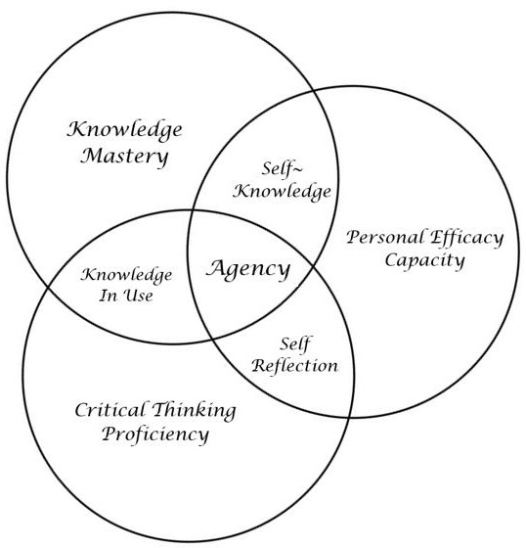**Index of Critical Thinking Proficiency** allows you to analyze problems or events in the world more effectively.

This involves demonstrating a degree of proficiency at the life skills of critical political thinking and futures consciousness to better access, evaluate, and interpret ideas found in political philosophy and theory and information enabling people so disciplined to communicate effectively, reach conclusions, and solve problems as citizens - part of the governance structure of a political world - such that they may apply these in their professional pursuits should they choose a path of public service or community leadership, of simply community participants.

**Index of Self-Efficacy Capacity** allows you to be more effective at being you, at taking actions to make your goals in life become more probable.

This involves demonstrating a degree of capacity to assume responsibility – consistent with democratic republican values - in the application of socio-political concepts explored in this learning experience (class, classes, program) in a meaningful manner to a person’s own self defined reality in the public, private, and social sectors; 1) as part of their everyday life as engaged citizens in the 21st century modern world system; and 2) do so in the context of global environmental (and other) challenges.

B] **Discussions**

### Were there any obstacles experienced during assessment? What worked well? (Mainly based on evidence in the report, attach other evidence as necessary)

Any honest discussion of obstacles to assessment has to start with acknowledging the inadequacy of both the models or means used by most

professionals in assessing so called “learning outcomes,” and the inadequacy of **currIQūnet** as a “repository” of any data. Most courses use

inadequate definitions of outcomes as opposed to exit skills. Exit skills are more discreet “learning points” which define what is learned inside a course and upon which a grade is rendered. Exit skills then, or objectives, are in fact indicators which construct the indexes which are the outcomes.

Outcomes are what one can do with what they learned “in” a class “out there” in the world of lived and shared reality. The mistake made by most evaluators is they confuse exit skills with outcomes and wholly miss the point and whatever it is they think they are assessing are not outcomes… This is complicated by the reality that most faculty are not attending the learning assessment in a valid or reliable fashion and in fact most often end up just entering the results of their gradebooks into **currIQūnet**, and they are done with it. And to make it all more inadequate, **currIQūnet** is not a data

base! It is merely and only a “text box repository” and as such there is no capacity for any data analysis. So, it is not possible to be data driven, as this

whole process yields no actionable “information” (which is the result of data analysis).

* So, obstacle one was to solve these problems. We spent the past few years perfecting a model to do so of which only a brief glimpse was offered in this report.
* Then we had to locate an adequate and tested and yet affordable analysis software application. We found one in **Ziplet** (we were working with **MyOutcomes** but they could not delver), with which we are experimenting now. **This has been the crucial problem we face getting this part of the protocol operational**.
* We are working with Ziplet to create new application to apply this tool to classroom teaching and are piloting this model in the spring of 2022.
* With the model thus far, we have arrived at our first actionable data and have used it to improve our pedagogy, course design, and content.

### What percent of your programs have been assessed? (mainly based on evidence in the report, attach other evidence as necessary; note: a complete program assessment means all Program Learning Outcomes (PLOs) have been assessed for that program)

We made a major advancement on our work in crafting and using the ***EFF Learning matrix protocol*** and are working with **Ziplet** to do adapt this application to our needs to engage in **actual data analysis** (not provided for in **currIQūnet**)!

* + Our model is a ***process evaluation model*** - which is more valid and reliable than an ***outcomes evaluation*** - which integrates information in an ongoing fashion in real time to improve our pedagogy, course design, and content.
  + We meet on a regular basis and share these best practices to do this.
  + In this process, we used the past year (Covid 19 Zoom/Canvas teaching)
    - To improve every course we teach, subjected to intense modifications based upon our professional development workshops (on Zoom and online excellence), and
    - Converting courses 100% integrating these ideas, following our model of learning assessment process evaluation integration.
    - So, every course has been improved via process evaluation praxis implementation.

1. **Collaboration and Assessment -** How our department worked together on assessment & planning.
2. **Collaboration and Leadership Roles**: We are a shared leadership department and discuss all efforts as a team, once a semester – sometimes twice – and when possible, meet in smaller work teams to discuss particular projects under the CCUL aegis. The part time status of every team member does make this challenging.
3. 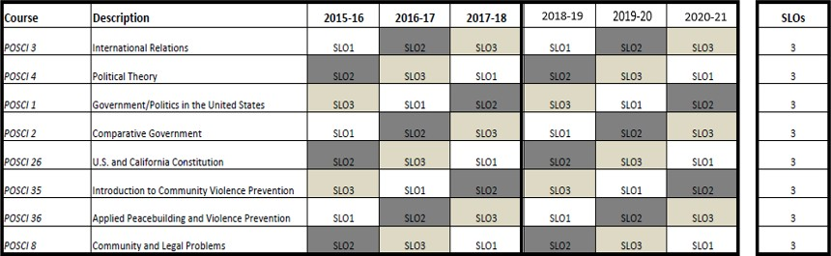**Data Analysis***:* We meet on a regular basis and share these best practices to do this. Referencing **section, A** above, relative to Learning outcome assessment; to support being actually “data driven “in learning outcomes assessment **data analysis**; we seek funds for licensing of actual software – ***Ziplet*** - to meet this goal of non-fictive data analysis.
4. **Things learned from assessment** – Our action plan – ***process evaluation praxis model*** – by definition is a continuous learning cycle guiding pedagogy, course design, and content improvements. We note that assessing “outcomes” cannot be validly engaged upon at the end a class; and certainly not with the vast majority of assessment instruments used. Minimally it would need long term follow up assessment (e.g., focus groups and surveys) to see if the actual predicted outcomes of learning “in here” were in evidence “out there,” after students have gone on to other life events and can now (with time passed) in retrospect see how what they learned “in here” actually matters “out there.” That would be real outcomes assessment. However, we have piloted some instruments designed to get at more valid, reliable, and actionable information than conventional course evaluation instruments are capable of yielding. And, since this is administered after the semester and explicitly solicits feedback (numerical and narrative).
   * We know from there is evidence of improved student learning from the following weekly and end of semester solicitations:
     + Narrative feedback from students
     + (Our early piloting of) Likert scale driven data collection,
     + (A piloted) after course Survey Monkey course evaluation
   * So, yes, the department team has used this information to improve student learning and curriculum?
   * However, we have also learned that when we try to engage anyone outside of our department either at invited district wide POSCI meetings, or staff development day training events, very few people attend and then show little interest in seeking information to apply it to their work. In fact, one faculty member noted that a conventional **currIQūnet** workshop, which was scheduled at the same time as ours, was a waste of time and amounted to merely showing how one may enter data in that program… which as we noted in **section A** above, is in itself a fictive data analysis effort.

## Describe the outcomes and accomplishments from previous year’s funded resource allocation request.

Other that than the yearly dues of $5,000 the college pays to CalLaw to be a part of the State **Pathway to law program**, we have received no other funding in the past year. Frankly, this project has never really been able to deliver on its promise. Every effort to secure the types of institutional support which would be required to make this program – and CCUL of which this program is apart – live up to its original vision has met with insufficient success. Without going into any detail here in terms of history, this conclusion was predicted when, against the advice of the department (due to our conclusion where would be insufficient institutional support to make it “a go”), the college proceeded to seek this project out and it was largely due to the CCUL design that we were successful in this bid. Therefore, we proceeded with the program and achieved some successes. However, we were never really able to make it work on main campus (students simply did not want to register for it and/or come to COA campus), and to this day, the only remnants of this project are in offering our core law class in the COA and POSCI dual enrollment program. This is also the case with our **violence prevention program**. We note that when we did on occasion in the early years of the CCUL program have sufficient institutional and

community partner support, both of these programs were showing great promise. Yet, loses of personnel at both COA and with our community partners led to diminishing returns on investment.

This all said, we do have a good may students compete that course in our partnership with the **Centro Legal de la Raza law academy**, and we did complete the curriculum process to have a **Law School Pathway Certificate of Achievement** (one of the few in the state). On paper we have the numbers of students to make us look successful, yet very few have requested the unofficial certificate from CalLaw. However, perhaps with the new certificate, we may be able to change this. To this end, we really need two things. 1) a functioning public outreach marketing campaign (to recruit students) from the college, and a substantive effort to make dual enrollment a reality with AUSD and OUSD (this is where the real hope of enrolment for COA lay); we note that currently such outreach and relationship building capacity is simply non-sufficient at COA; and 2) we need a funded ***“faculty***

***champion”*** as the lead POSCI faculty member is no longer able to function in this due to disability reasons. We are discussing which of our p/t faculty might be able to do this for us in a funded (stipend) capacity. However, without these there is really no way to proceed with the CCUL program or pathway to law in a way which justifies our dues to CalLaw.

## Prioritized Resource Requests Summary – nothing new requested; What we wish to continue: Personnel: Student Worker:

We seek to continue with our Federal Work Study student worker. They help with clerical, data entry, editing, and light lifting work as needed. Federal Work Study. No cost to college of division

## Personnel: Stipends Funding:

This is to increase the effectiveness of our aims, we would need funding to pay our part time faculty for their non-instructional time to engage in outreach and liaison work, in partnership with the COA dual enrollment and PR personnel

* + In terms of having the staff you have and not that which you need; the division dean and lead faculty noted that in the past we found the faculty who were assigned these tasks did not always have the skill sets to do these tasks.
  + However, we brought on a new faculty member who we believe does have the requisite skills sets to do these “jobs” for us. However, Covid short circuited these efforts. And our aim here is out-reach to craft new program offerings in AA degree cohorts for Alameda County employees in Public Administration, and/or certificates in Emergency Management and Law.

***We’re not sure where we are situated in terms of functioning once again, with Covid still unfolding, we also wonder if have access to the minimal CCUL funding we received prior to Covid 19 from office of the President*** in this budget climate. However, those funds did enable CCUL to be **administered and function at a minimal level**; relative to our: 1) extant dual enrollment, 2) community partnerships programming & outreach & expansion efforts, 3) our special events projects (again as part of partnerships), and 4) curriculum development. This is where we would seek to operate in the future. Any future for CCUL is dependent upon this. If it’s not possible, we do understand, then we will move to deactivate any further CCUL initiatives and merely offer courses as a good POSCI department.

## Technology & Equipment:

* + So far, we have paid for **MyOutcomes** subscription ($200/year) and **Ziplet** out of pocket, in future we would like to be reimbursed for this.
  + We could use access to competent video creation facilities & editing capacity to support online infrastructure effectiveness (cost?).

## Professional Development or Other Request:

We would appreciate funding to enable us to attend conferences on community engagement with the larger world of the

greater East Bay to draw attention to our work here which would serve to enhance our efforts at being a “signature program” of “distinctive difference” with resultant comparative advantage being a “strange attracter” magnet to be a force in being - significant compelling reason – drawing students

## Instructional Supplies:

* + Our usual funding is mostly sufficient. It would be helpful if there were more flexibility in what we can use those funds to purchase. We have found illogical restrictions on what could be purchased so constraining we never were able to use what money we did have.
  + We have found the narrowing of the definitions – and creating the distinction between instructional and non-instructional - means we are limited one what we can purchase. From our perspective, whatever supports us in doing our job is

“instructional” supplies.