**College of Alameda**

2021-22 Annual Program Update - PSYCH

**Program Overview**

Please provide your program’s mission statement and program’s learning outcomes

|  |
| --- |
| In studying psychology at College of Alameda, you will learn from supportive faculty that recognize the mind-body-heart connection as core to the transformation of self, community, and our planet. We encourage students to examine their own psychological issues and develop a keen understanding of who they are and what they will bring to their work with others by emphasizing cognitive and emotional development through self-reflection, academic rigor and experiential practice. The COA psychology department prizes itself on having students apply theories to their own lives so that the information is understandable, useful, and illuminating.  PLO 1: Apply multiple schools of psychology (e.g. psychodynamic, behavioral, cognitive, humanistic, biological, and transpersonal) to living situations.  PLO 2: Demonstrate effective communication and interpersonal relationship skills rooted in psychological perspectives and exhibiting an awareness of psychological dynamics in inter-relationship.  PLO 3: Increase awareness of self, others, and the environment in order to have greater agency and authentic expression. |

List your program faculty and/or staff

|  |
| --- |
| Sarah Peterson-Guada  Elham Chishty  Hana Husain  A’sharee Brown  Robert Brem |

Describe your current utilization of facilities, including labs and other space

|  |
| --- |
| Currently, due to the pandemic, our department primarily teaches on-line, both asynchronistic and synchronistic classes. We do also offer in-person courses in the high schools with our dual enrollment collaboration with OUSD. In spring 2022, we will need large classrooms as some faculty will be returning to the classroom so that everyone feels comfortable and safe. |

List your program goals from your most recent Program Review or APU. Then, provide an update on the status of the goal. Has your program achieved the goal? Have any of your goals been revised or any still in progress? Lastly, make sure to discuss which College or District goal your program goal aligns to.

If no program goals exist or if this is your first program review, work to create 2-3 goals and align them with a College or District goal.

|  |  |
| --- | --- |
| **Program Goal** | Consistency in basic mission of goals that reflect Departmental vision of holistic pedagogy alongside attunement of curriculum to Institutional Learning Outcomes, Program Learning Outcomes and Student Leaning Outcome. |
| Status: In-Progress or Complete? | Complete. Our pedagogy is holistic, we’ve updated SLOs, which also reflect our PLOs that are tied to how we teach psychology. These also reflect the overall ILOs of COA. |
| Which college or district goal is aligned with your program goal? |  |

|  |  |
| --- | --- |
| **Program Goal** | Emphasis on diversity in the curriculum and department and emphasis on inclusivity, equity and justice in the classroom in efforts to bridge the learning gaps that exist among students. |
| Status: In-Progress or Complete? | In-Progress. Our department has made great strides in diversifying the material that is presented to our students in terms of images that are used in PowerPoint presentations as well as articles that are included in course material.  Likewise, we continue to diversify our faculty so that more of our students see themselves in their teachers along with creating a broader lens from which psychology is taught. Our new hires include A’sharee Brown who is African-American and Ida Ahmadi, who is Persian-American and identifies as “they/them,” which is another level of diversity that our growing gender non-conforming population can feel mirrored and supported by, and broaden everyone’s definition of what it means to be “human,” “normal,” and other psychological themes such as “identity,” “resilience,” “trauma,” “self-acceptance,” “navigating family issues,” among others!  Likewise, A’sharee and Sarah are in the process of adopting a course that is currently offered at Merritt and Laney entitled “The Psychology of African-Americans.” Sarah has spoken to African-American History and Ethnic Studies Department leads about this adoption and he is in support of it. We intend to have the course cross-listed in African-American Studies as well as Psychology with A’sharee as our instructor.  Also, each faculty member that we hire and that teaches in our department is committed to teaching a non-colonized form of psychology where we welcome and integrate wisdom from other cultures and students’ experiences, as well as expanding students’ understanding of the history of Western Psychology and how can we rewrite the narrative to be more inclusive and representative of our diverse populations where mental health is tailored to each culture based on their unique needs, traditions and values.  While we have made great strides, because social justice and inclusivity are such a priority to our department, I have put the status as “In-Progress.” |
| Which college or district goal is aligned with your program goal? |  |

|  |  |
| --- | --- |
| **Program Goal** | Being involved with other departments to create some coursework that can overlap so there is continuity among some courses particularly in the liberal arts/sciences and even hard sciences. |
| Status: In-Progress or Complete? | In-Progress. As mentioned above, we will cross list The Psychology of African-Americans course with the African-American Studies Department. Also, perhaps, with our program mapping, there will be more opportunities to collaborate. |
| Which college or district goal is aligned with your program goal? |  |

**Program Update**

Using the dashboards, review and reflect upon the data for your program.

[**Course Completion and Retention Rates – Instructional Dashboard**](https://app.powerbi.com/view?r=eyJrIjoiNjc2MDhiNTEtNTJhZi00MDM0LTk5NDItNTRiY2EzMGI1NTZiIiwidCI6ImVlYTE2YTE2LTQ4YWYtNDc3Yi05MTEzLTA1YjFjMDExMjNmZiIsImMiOjZ9&pageName=ReportSection86d6f65e2fb41a73da4d)

[**Course Completion and Retention Rates – Student Services Dashboard**](https://app.powerbi.com/view?r=eyJrIjoiNjk3NDJjOTItNzI5MS00MDhjLWJhN2EtZjcxNzU4OTBiZDBjIiwidCI6ImVlYTE2YTE2LTQ4YWYtNDc3Yi05MTEzLTA1YjFjMDExMjNmZiIsImMiOjZ9&pageName=ReportSection86d6f65e2fb41a73da4d)

[**Enrollment Trends and Productivity Dashboard**](https://app.powerbi.com/view?r=eyJrIjoiNWJlOWZmYTEtNTY0MC00MDhkLWE5OTAtYmJjZjIxNzJiNWViIiwidCI6ImVlYTE2YTE2LTQ4YWYtNDc3Yi05MTEzLTA1YjFjMDExMjNmZiIsImMiOjZ9&pageName=ReportSection86d6f65e2fb41a73da4d)

[**Degrees and Certificates Dashboard**](https://app.powerbi.com/view?r=eyJrIjoiZjU2M2M5MzItOTcwZi00Y2U1LWJmODUtYTc0YjlhZGI2ZDhjIiwidCI6ImVlYTE2YTE2LTQ4YWYtNDc3Yi05MTEzLTA1YjFjMDExMjNmZiIsImMiOjZ9&pageName=ReportSectionde32556e136b0a8caccd)

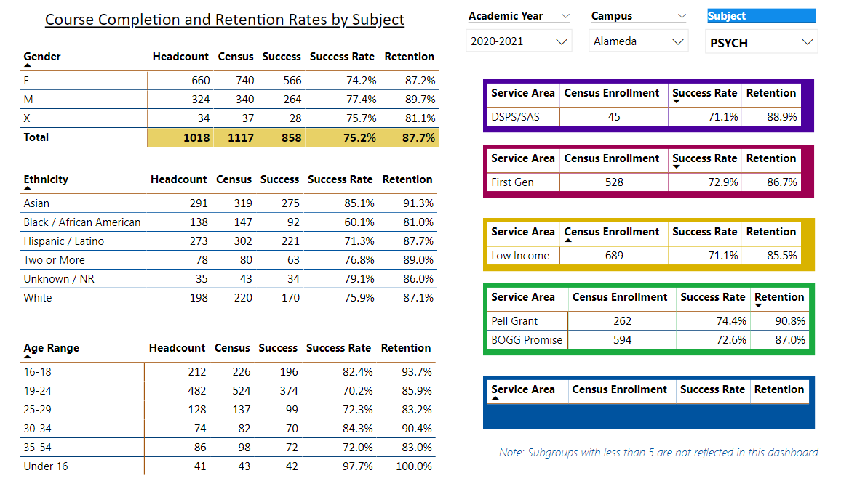

Describe any significant changes and discuss what the changes mean to your program. Consider whether performance gaps exist for disproportionality impacted students by using filters to disaggregate the data. Focus upon the most recent year and/or the years since your last comprehensive program review. Cite data points to support your reflection.

|  |
| --- |
| Upon reflecting over the data, the department’s retention rate is consistently high (above 80% across ethnicity, gender and age). There are various reasons unique within the psychology department that would best explain these high percentages. First and foremost, our faculty prides itself in creating personal and meaningful connections between the subject of psychology and the personal and unique challenges our students face. Our faculty prides itself in continual self-development and growth alongside learning about various methodologies and pedagogical practices that would reach the student in multitude of ways. We have a diverse faculty body with wealth of experience both practical (in therapeutic settings) and academic that is able to understand and empathize with students struggles and challenges.  This contributes to positive rapport and translates well in success and retention rates.  Upon reflecting over the success rate, Black/African Americans have 60.1% success rate, followed by Hispanic/Latino with 71.3%. These success rates are clearly unacceptable in our department. There needs to be a cross-departmental/district-wide open conversation about strategies to reduce the learning and success gap among various populations. Our students need to be seen and need to relate to the material. Therefore, our department has had numerous conversations on embracing and encouraging psychological schools of thoughts that come from non-Western views. We are in conversation about ways to bring about not just western notions of psychology, but also Asian, African, Latinx, Islamic and Native American understanding of psychology.  Likewise, based on our new category of “X” gender identity, more students are identifying as “gender non-conforming.” As human beings expand beyond traditional categories, it is important that students see themselves in faculty and material that reflects this more expansive identify. We are currently in the process of hiring a faculty member that identifies as “they/them” and gender non-conforming. They will first teach through the dual-enrollment high school program, which is a great start because the gender fluidity is particularly heightened in our younger generations that are adopting the idea that “boxing” ourselves in categories can be limiting and as more people express themselves authentically, gender identity will naturally expand as well. With this being said, based on the data for our “X” gender identity students, we have a retention rate of 81.1%. Perhaps, with the hiring of our new faculty member who is gender non-conforming, as well as the rest of the faculty being increasingly aware of this growing population and is a form of human diversity, that we can take it upon ourselves to educate ourselves on how to reach more students within the LGBTQ+ community and ensure that these students feel heard and welcomed as well!  Furthermore, there should be more conversation centered around understanding the unique needs of each student, so students feel visible in the classroom. More conversation needs to be centered around creating a diverse platform for instruction not just instructional material. In other words, our faculty have had conversations based on multiple intelligence theory and the various ways to teach using a holistic, multi-dimensional model to education. Addressing these concerns is vital in restoring faith within the student about their abilities and strengths. |

Describe the department's progress on Student Learning Outcomes (SLOs) and/or Service Area Outcomes (SAOs) since the last Program Review/APU.

|  |
| --- |
| Our Student Learning Outcome Assessment Coordinator for our Department is Elham Chishty. She has helped our faculty with questions and concerns regarding the assessment process and data inputting. She has held meetings centered around conversations specifically designed to address the needs of assessment along with strategizing most effective ways to assess using a multi-dimensional, and holistic model. Every student and every teacher process information differently and therefore it is vital to adopt multiple tools within our toolbelt to assist with increasing diversity and variety of learning styles. We have assessed more classes than in the past and have developed an assessment plan for the school year cycle. We have assessed Psychology 1A, 1B, 12, 7A, 7B, 12, and 3 We currently plan on creating another 3-year assessment map for the following 3 years.  Elham is also in conversation with COA SLO Coordinator to ensure the psychology department is up-to-date with all course assessments. |

Describe the outcomes and accomplishments from previous year’s funded resource allocation request.

|  |  |  |  |
| --- | --- | --- | --- |
| **Brief description of funded request** | **Source (any additional award outside your base allocation)** | **Total Award Amount** | **Outcome/Accomplishment** |
| Air pods |  | Discipline Supplies Budget; no other funding | Instructors teaching remotely were able to record videos wire-free as well as hold office hours and classes without wires getting in the way. |
| Wireless, ergonomic keyboards |  | Discipline Supplies Budget; no other funding | Instructors teaching remotely were able to type more ergonomically to ensure the health of hands and arms due to high amount of typing. |
| Laptop stands |  | Discipline Supplies Budget; no other funding | Instructors teaching remotely are able to have lap top screen at a more natural eye level to ensure proper neck and back posture while grading and typing. |

**Prioritized Resource Requests Summary**

In the boxes below, please add resource requests for your program. If there are no resource requested, leave the boxes blank.

|  |  |  |  |  |
| --- | --- | --- | --- | --- |
| **Resource Category** | **Description/Justification** | **Estimated Annual Salary Costs** | **Estimated Annual Benefits Costs** | **Total Estimated Cost** |
| **Personnel: Classified Staff** |  |  |  |  |
| **Personnel: Student Worker** |  |  |  |  |
| **Personnel: Part Time Faculty** |  |  |  |  |
| **Personnel: Full Time Faculty** |  |  |  |  |

|  |  |  |
| --- | --- | --- |
| **Resource Category** | **Description/Justification** | **Total Estimated Cost** |
| **Professional Development: Department wide PD needed** |  |  |
| **Professional Development: Personal/Individual PD needed** |  |  |

**Prioritized Resource Requests Summary - Continued**

|  |  |  |
| --- | --- | --- |
| **Resource Category** | **Description/Justification** | **Total Estimated Cost** |
| **Supplies: Software** |  |  |
| **Supplies: Books, Magazines, and/or Periodicals** |  |  |
| **Supplies: Instructional Supplies** | Blue tooth speakers; more air pods; journals; post-its | $1,500-$2,000 |
| **Supplies: Non-Instructional Supplies** |  |  |
| **Supplies: Library Collections** |  |  |

|  |  |  |
| --- | --- | --- |
| **Resource Category** | **Description/Justification** | **Total Estimated Cost** |
| **Technology & Equipment: New** |  |  |
| **Technology & Equipment: Replacement** |  |  |

**Prioritized Resource Requests Summary - Continued**

|  |  |  |
| --- | --- | --- |
| **Resource Category** | **Description/Justification** | **Total Estimated Cost** |
| **Facilities: Classrooms** |  |  |
| **Facilities: Offices** |  |  |
| **Facilities: Labs** |  |  |
| **Facilities: Other** |  |  |

|  |  |  |
| --- | --- | --- |
| **Resource Category** | **Description/Justification** | **Total Estimated Cost** |
| **Library: Library materials** |  |  |
| **Library: Library collections** |  |  |

|  |  |  |
| --- | --- | --- |
| **Resource Category** | **Description/Justification** | **Total Estimated Cost** |
| **OTHER** |  |  |