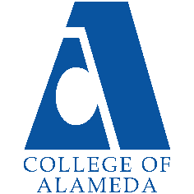College of Alameda

2021-22 Annual Program Update - SOC

# Program Overview

Please provide your program’s mission statement and program’s learning outcomes

The mission of the COA Sociology Department is to prepare our students to successfully succeed academically as sociology transfer students and to be able to think critically as workers and citizens. Through our array of lower division sociology courses that provide training in research methods and exposure to classic and cutting-edge research, students build a solid foundation for sociological success.

The Sociology Department has the following Program Learning Outcomes:

1. Define core concepts of sociology (sociological theories, social structures, culture, social inequality and stratification, race/ethnicity, gender, and globalization). [Foundational knowledge in sociology]
2. Apply a working sociological imagination to everyday life with a commitment to social justice and equality in our diverse world. [Critical Sociological Thinking]
3. Successfully transfer to a four-year college/university with robust sociological training. [Personal Enrichment & Lifelong Learning – Sociological Efficacy]

List your program faculty and/or staff

Sabeen Sandhu Ph.D. MPH (FT)

Jody Campbell MA (Joint Appointment w/African American Studies) Richard Harris MA (PT)

Giselle Hendrie MA (PT) Araceli Quezada MA (PT)

Olga Fish (Joint Appointment w/Business)

Describe your current utilization of facilities, including labs and other space

Due to the COVID-19 pandemic (campus closure), the department utilizes the technological/virtual facilities available at COA and the PCCD. All our course offerings have been distance education courses for the past academic year. Prior to this (and now) virtually the department and students enrolled in courses utilized the campus computer labs (now software available through the Peralta Portal), the college library, classrooms, and common space on campus for observations, discussion, and study. Our department currently utilizes a considerable

amount of webspace like the CANVAS LMS, range of LTIs like Padlet, FlipGrid, Pronto, Voice Thread, ConferZoom, Turn-it-In, Honor Lock, Name Coach, and Ally to name a few. Beginning in Spring 2022, the Sociology department plans to offer 40 percent of courses face-to-face and will once again utilize the campus space of classrooms, library, and computer labs, as well as common space for observations and discussion.

List your program goals from your most recent Program Review or APU. Then, provide an update on the status of the goal. Has your program achieved the goal? Have any of your goals been revised or any still in progress? Lastly, make sure to discuss which College or District goal your program goal aligns to.

If no program goals exist or if this is your first program review, work to create 2-3 goals and align them with a College or District goal.

|  |  |
| --- | --- |
| **Program Goal** | Define core concepts of sociology (sociological theories, social structures, culture, social inequality and stratification, race/ethnicity, gender, and globalization). [Foundational knowledge in sociology] |
| Status: In-Progress or Complete? | Met w/graduates of 2020-2021 academic year  SLO data from the last academic year indicates that students are exceeding success benchmarks.  In-Progress for next cohort of students 2021-2022 |
| Which college or district goal is aligned with your program goal? | Aligned to COA ILOs:   1. solve problems and make decision in life and work using critical thinking, quantitative reasoning, community resources, and civil engagement. 2. Use technology and written and oral communication to discover, develop, and relate critical ideas in multiple environments. 3. Exhibit aesthetic reflection to promote, participate and contribute to human development, expression, creativity, and curiosity. 4. Engage in respectful interpersonal communications, acknowledging ideas and values of diverse individuals that represent different ethnic, racial, cultural, and gender expressions. 5. Accept personal, civic, social and environmental responsibility in order to become a productive local and global community member. |

|  |  |
| --- | --- |
| **Program Goal** | Apply a working sociological imagination to everyday life with a commitment to social justice and equality in our diverse world. [Critical Sociological Thinking] |
| Status: In-Progress or Complete? | Met w/graduates of 2020-2021 academic year  SLOs of SOC courses indicate that students are exceeding the benchmarks for success and linked to this PLO.  In-Progress for next cohort of students 2021-2022 |

|  |  |
| --- | --- |
| Which college or district goal is aligned with your program goal? | Aligned to COA ILOs:   1. solve problems and make decision in life and work using critical thinking, quantitative reasoning, community resources, and civil engagement. 2. Use technology and written and oral communication to discover, develop, and relate critical ideas in multiple environments. 3. Exhibit aesthetic reflection to promote, participate and contribute to human development, expression, creativity, and curiosity. 4. Engage in respectful interpersonal communications, acknowledging ideas and values of diverse individuals that represent different ethnic, racial, cultural, and gender expressions. 5. Accept personal, civic, social and environmental responsibility in order to become a productive local and   global community member. |

|  |  |
| --- | --- |
| **Program Goal** | Successfully transfer to a four-year college/university with robust sociological training. [Personal Enrichment & Lifelong Learning – Sociological Efficacy] |
| Status: In-Progress or Complete? | Met w/graduates of 2020-2021 academic year  Despite the COVID-19 pandemic, degree awards increased slightly from 24 to 37, of which were for AA-Ts, indicating students are transferring to four-year institutions.  In-Progress for next cohort of students 2021-2022 |
| Which college or district goal is aligned with your program goal? | Aligned to COA ILOs:   1. solve problems and make decision in life and work using critical thinking, quantitative reasoning, community resources, and civil engagement. 2. Use technology and written and oral communication to discover, develop, and relate critical ideas in multiple environments. 3. Exhibit aesthetic reflection to promote, participate and contribute to human development, expression, creativity, and curiosity. 4. Engage in respectful interpersonal communications, acknowledging ideas and values of diverse individuals that represent different ethnic, racial, cultural, and gender expressions. 5. Accept personal, civic, social and environmental responsibility in order to become a productive local and global community member. |

# Program Update

Using the dashboards, review and reflect upon the data for your program.

**Course Completion and Retention Rates – Instructional Dashboard Course Completion and Retention Rates – Student Services Dashboard Enrollment Trends and Productivity Dashboard**

**Degrees and Certificates Dashboard**

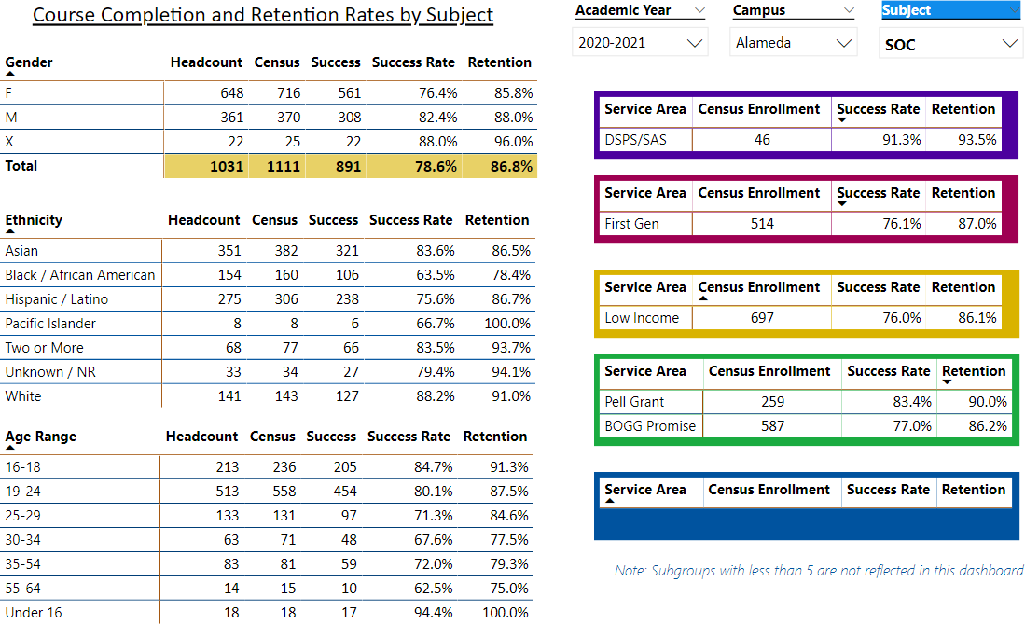

Describe any significant changes and discuss what the changes mean to your program. Consider whether performance gaps exist for disproportionality impacted students by using filters to disaggregate the data. Focus upon the most recent year and/or the years since your last comprehensive program review. Cite data points to support your reflection.

Based on data from the past four years, enrollment in the Sociological department has **declined** after ticking up in 2019-2020. Between last year and the current year, enrollment declined by **16.5%** (which is greater than the overall college decline of 13.7%). This may be due to the pandemic and the loss of students common across all community colleges. Despite this, the department participated in an enrollment management summit to offer a wider variety of course modes and times for the Spring 2022 semester including hybrid, face-to-face, online, as well as late start courses.

There is a negative relationship between age and retention rates, although the retention rates of the department are still above 75 percent. This may be due to intervening variables related to labor market and parenting obligations of this age-group. The fully online mode of our courses due to the pandemic may also impact this age group. The largest group of students that our department serves continues to be traditional 19–24-year-old who have a high retention rate of

87.5 percent, despite growing research on the YOLO identity of this age cohort (Roose 2021).

Enrollment data reveals that women continue to be impacted and have lower success rates than men. Women’s overall success rates are approximately two-percent lower than men, although this is the result of sample size. Women make up 63% of sociology students, compared to 35% men.

Last year the department identified a loss of Black Women students (see point gap analysis Sociology Program Review 2020). This academic year, greater outreach is provided to women of color who are also parents. The department now has three instructors who completed the Peralta Equity Rubric online course training that may provide an array of options to complete course requirements and improve success/retention rates. However, there are factors that are structural and beyond the instructor-student level of intervention – a pandemic and a lack of affordable childcare. Perhaps the federal child tax credits, California state pre-K for all, and guaranteed income programs in the city of Oakland may improve this tragic loss of students. If COA provided free and/or low cost childcare during classes of parents, this might increase enrollment and overall success/completion rates.

Describe the department's progress on Student Learning Outcomes (SLOs) and/or Service Area Outcomes (SAOs) since the last Program Review/APU.

The Sociology Department continues to engage in regular assessment of Student Learning Outcomes. This past semester the following SLOs were assessed, and data indicated that students met or exceeded benchmark standards:

1. SOC 2 SLO #3
2. SOC 3 SLO #2
3. SOC 5 SLO #3
4. SOC 120 SLO #1
5. SOC 120 SLO #4

Additionally, reflection presents additional areas to perfect learning and bridge any potential learning gaps for students underperforming and equity.

Describe the outcomes and accomplishments from previous year’s funded resource allocation request.

|  |  |  |  |
| --- | --- | --- | --- |
| **Brief description of funded request** | **Source (any additional award outside your base allocation)** | **Total Award Amount** | **Outcome/Accomplishment** |
| 3 Apple Pencils to Assist with Grading  IPADS for Department | COA Department Supplies & Equipment Funding | $2,291 | Accomplished  Expedited Grading w/use of iPads & iPencil |
| Membership Renewals to the ASA Membership to PADLET | COA Department Supplies & Equipment Funding | Accomplished Contributed to disciplinary currency for faculty |
| Flash Drives & Replacement Power Cords | COA Department Supplies & Equipment Funding | Accomplished  Basic requirements to fulfill academic duties |

# Prioritized Resource Requests Summary

In the boxes below, please add resource requests for your program. If there are no resource requested, leave the boxes blank.

|  |  |  |  |  |
| --- | --- | --- | --- | --- |
| **Resource Category** | **Description/Justification** | **Estimated Annual Salary Costs** | **Estimated Annual**  **Benefits Costs** | **Total Estimated Cost** |
| **Personnel: Classified Staff** |  |  |  |  |
| **Personnel: Student Worker** | Student worker to help with hybrid course online students while lecturing  face-to-face | Per student worker rate | Priceless | Per student worker rate |
| **Personnel: Part Time Faculty** | Retain 5 Part-Time Instructor (each teach one to two courses) | Per Contract | Priceless | Per Contract |
| **Personnel: Full Time Faculty** | Due to a significant decline in enrollment, the | Per Contract | Priceless | Per Contract |
|  | department will hold off |  |  |  |
|  | on requesting an |  |  |  |
|  | additional full-time |  |  |  |
|  | faculty member. If |  |  |  |
|  | enrollment increases in |  |  |  |
|  | Spring and Fall 2022, if |  |  |  |
|  | may be beneficial to hire |  |  |  |
|  | an additional full-time |  |  |  |
|  | instructor in the future. |  |  |  |

|  |  |  |
| --- | --- | --- |
| **Resource Category** | **Description/Justification** | **Total Estimated**  **Cost** |
| **Professional Development: Department wide PD needed** | Additional Training on LTIs – especially on how to provide student support  Additional Training on Equity or raising difficult dialogues in course content. | Cost of third-party trainer |

|  |  |  |
| --- | --- | --- |
| **Professional Development: Personal/Individual PD needed** | Additional Training on Enrollment Management Additional Training on Online Instruction | Cost of  Extra Service |

**Prioritized Resource Requests Summary - Continued**

|  |  |  |
| --- | --- | --- |
| **Resource Category** | **Description/Justification** | **Total Estimated**  **Cost** |
| **Supplies: Software** | SPSS Faculty Subscription | $260 |
| **Supplies: Books, Magazines, and/or Periodicals** | ASA Membership Renewals for full Department ($246 @ 6 faculty) | $1476 |
| **Supplies: Instructional Supplies** | Office Supplies for Online Classroom Use | $300 |
| **Supplies: Non-Instructional Supplies** | Flash Drives | $300 |
| **Supplies: Library Collections** | Video & Journal Subscriptions | $1000 |

|  |  |  |
| --- | --- | --- |
| **Resource Category** | **Description/Justification** | **Total**  **Estimated Cost** |
| **Technology & Equipment: New** | Facebook Portal  To help with hybrid course instruction | $179 |
| **Technology & Equipment: Replacement** | We ordered 3 iPads for the department, but only received one. It would be useful for our team to have them to expedite grading and communication  w/students | $660 |

**Prioritized Resource Requests Summary - Continued**

|  |  |  |
| --- | --- | --- |
| **Resource Category** | **Description/Justification** | **Total**  **Estimated Cost** |
| **Facilities: Classrooms** | Personal Microphones  Mask wearing during lecture muffles sound For clarity of instruction | $75 per faculty ($375) |
| **Facilities: Offices** | None |  |
| **Facilities: Labs** | None |  |
| **Facilities: Other** | None |  |

|  |  |  |
| --- | --- | --- |
| **Resource Category** | **Description/Justification** | **Total Estimated**  **Cost** |
| **Library: Library materials** | None – noted above |  |
| **Library: Library collections** | None |  |

|  |  |  |
| --- | --- | --- |
| **Resource Category** | **Description/Justification** | **Total**  **Estimated Cost** |
| **OTHER** | None |  |