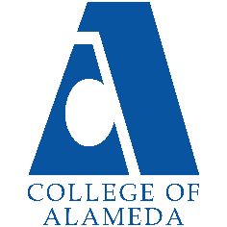
College of Alameda
2022-23 Annual Program Update – Anthropology

Program Overview
Please provide your program’s mission statement and program’s learning outcomes
Anthropology courses at College of Alameda offer students the opportunity to study humankind from biological, historic, prehistoric and cultural perspectives. Anthropology introduces students to ways to investigate and understand humanity in ways that are personally enriching and have practical application in their lives.

Program Learning Outcomes for Anthropology ADT and A.A. are:
1) Explain core concepts of Anthropology, including biological, socio-cultural and archaeological aspects of the discipline.
2) Demonstrate an understanding of the scientific methods (skills) used by contemporary anthropologists.
3) Apply holistic perspective to discuss appreciation for the genetic and cultural diversity of humans in the past and present, around the world.

List your program faculty and/or staff
Jayne Smithson, lead faculty (F/T)
Carlos Bazua Morales (P/T)
Nicole Buyagawan (P/T)
David Leitner (P/T)
Karen Oeh (P/T)
Iolani Sodhy-Gereben (P/T)

Describe your current utilization of facilities, including labs and other space
The Anthropology Programs (ANTHR) are housed in CoA main campus, D-Building, room D-115. Lecture and lab classes are held in this room. The extensive lab materials collection is secured in this dedicated room. The ANTHR faculty office is located next door, in D-115A.

The enrollment in ANTHR lab classes is limited to a maximum of 35 students per lab section by the size, configuration and available seats in the room (D-115). Continuing to hold ANTHR lecture classes in this room limits in-person enrollment to 35 students per section.
ANTHR needs to have an additional lecture room available so lecture class enrollment caps can be increased to 40+ per lecture class. Lecture and lab classes are not linked.
List your program goals from your most recent Program Review or APU. Then, provide an update on the status of the goal. Has your program achieved the goal? Have any of your goals been revised or any still in progress? Lastly, make sure to discuss which College or District goal your program goal aligns to.
If no program goals exist or if this is your first program review, work to create 2-3 goals and align them with a College or District goal.
FPU 2020-2021 Program Goal,  APU 2021-2022 Program Goal | Integrate a robust and thriving Anthropology Program into the curriculum at CoA.
Status: In-Progress or Complete? | This goal has been achieved. CoA offers an Associate of Arts in Anthropology transfer degree and a local Associate of Arts degree. Physical Anthropology and Physical Anthro Laboratory courses are specified as satisfying the biological science transfer requirements in 30 programs at CoA. Cultural Anthropology is recommended as a course to satisfy social science requirements in multiple programs. Archaeology, Magic, Religion and Witchcraft, Sex and Gender, and Forensic Anthropology satisfy local degree and Cal-GETC GE Breadth and transfer requirements. ANTHR core courses 1, 1L, 2 and 3 are C-ID articulated. Anthropology classes have high enrollment and high retention rates, which further solidify the position of this program as an integral part of CoA curriculum.
Which college or district goal is aligned with your program goal? | The College of Alameda Vision Statement centers on  - Academic Excellence  - Budgetary Competence, and  - Community Engagement  All of these ideals are reflected throughout the Anthropology Program, particularly in Community Engagement, where “a coherent and integrated pattern of learning experiences (to) prepare students (as) educated persons with a broad range of knowledge to evaluate and appreciate the physical environment, the culture, and the society in which they live; to be able to examine the values inherent in proposed solutions to major social problems; and to be able to participate effectively in their resolution.”

FPU 2020-2021 Program Goal,  APU 2021-2022 Program Goal | Engage students in lively discussions (in-class and online) about course materials and applications of course content in real-life situations.
Status: In-Progress or Complete? | This ongoing goal of the CoA Anthropology Program has been met successfully every year for the past 5+ years. ANTHR classes include in-person and online discussion components to encourage robust conversations that often carry on outside of class time and after course instruction has ended, according to numerous reports from current and former students.
Which college or district goal is aligned with your program goal? | Institutional Learning Outcomes include  4. Engage in respectful interpersonal communications, acknowledging ideas and values of diverse individuals that represent different ethnic, racial, cultural, and gender expressions.

FPU 2020-2021 Program Goal,  APU 2021-2022 Program Goal | Provide interdisciplinary cross-over learning opportunities and dialog to strengthen and support student success.
Status: In-Progress or Complete? | This ongoing goal of the CoA Anthropology Program has been met successfully every year for the past 5+ years. Anthropology faculty and students continue to engage with other disciplines on campus as part of the Anthropology tenets of applying scientific rigor, holistic perspective and cultural relativism to all studies.
Which college or district goal is aligned with your program goal? | The College of Alameda Vision Statement expands to include areas that are addressed in the Anthropology Program at CoA:  - Foundational Knowledge and Learning – college courses that prepare people for transfer to higher levels of education or simply to understand our place in the world and the world in and of itself  - Critical Thinking and Applied Skills – an overall set of life “survival” skills necessary to be a productive, employed, and effective citizen including applied learning in the areas of Career and Technical Education (CTE)  - Personal Enrichment and Efficacy – college courses that develop the life skill sets for pursuing well-being and an enhanced quality of life

Program Update
Using the dashboards, review and reflect upon the data for your program.
Course Completion and Retention Rates – Instructional Dashboard
Course Completion and Retention Rates – Student Services Dashboard
Enrollment Trends and Productivity Dashboard
Degrees and Certificates Dashboard

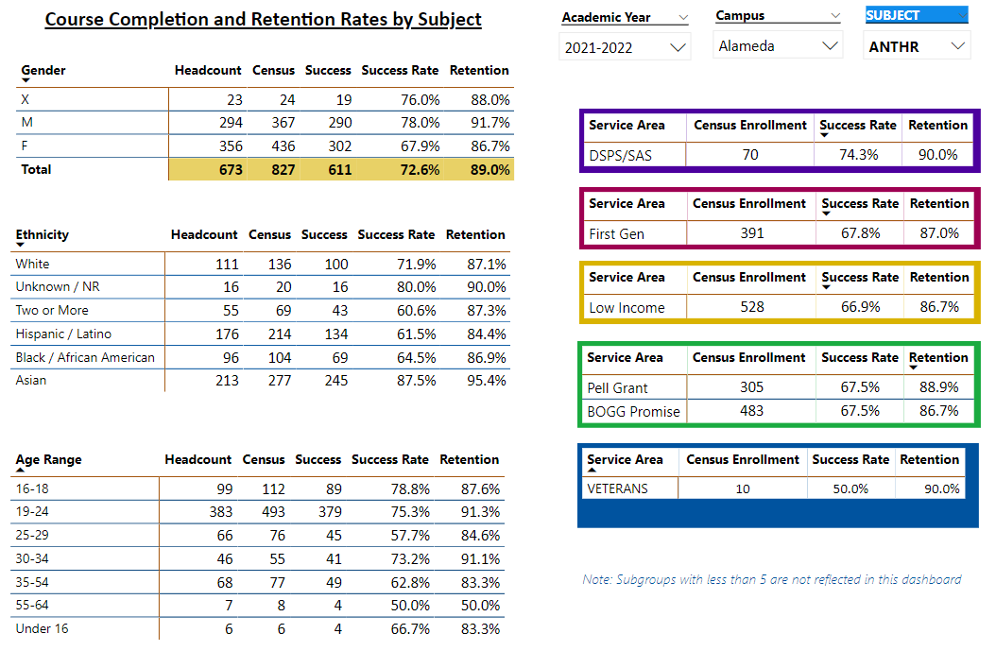

Describe any significant changes and discuss what the changes mean to your program. Consider whether performance gaps exist for disproportionality impacted students by using filters to disaggregate the data. Focus upon the most recent year and/or the years since your last comprehensive program review. Cite data points to support your reflection.
Unfortunately, the data provided is skewed because of the inability of the system to disaggregate “fake” students from the totals. The data provided for comparison shows a drop in ANTHR course enrollment, completion and retention rates across the board, which is NOT supported out by grade records and rosters meticulously kept by all CoA ANTHR instructors over the past year. ANTHR class sections were hard hit by the “fake” student crisis in 2021-2022 as the culprits infiltrated the enrollment systems and targeted disciplines alphabetically. Fake students who enrolled in ANTHR sections last year were removed as soon as possible, but enough “fake” students stayed enrolled after Census Day to skew the course enrollment, completion and retention statistics provided for this fall 2022 APU report submitted 11/1/2022.

Actual rosters and grade records kept by ANTHR faculty in all classes for 2021-2022 academic year show the same robust retention rates in all categories when compared to previous years: over 90% retention rates in all categories and over 75% - 80% student success rates in all classes. For comparison: ANTHR student retention and success rates are well above CoA averages.

ANTHR is an acknowledged leader in enrollment management that leads to consistently high rates of student retention and student success. The consistent high success rates and consistently high productivity of ANTHR classes is largely the result of carefully balanced and consistent scheduling in cooperation with lead faculty members at the other Peralta colleges. Changing or “messing” with this schedule set-up is highly likely to damage the success rates of CoA ANTHR classes.

Post-pandemic enrollment trends are in the process of being tracked. As noted by CoA Administrators at the highest levels, we do not know what students want, so offering a variety of course delivery modes is appropriate. ANTHR has been and will continue to meet student needs by actively researching enrollment trends in real time. It is clear from existing data at other community colleges in the Bay Area (Diablo Valley College, Las Positas College, City College of San Francisco, in additional to a review of enrollment data at CoA and the rest of Peralta District) that student retention is high in asynchronous online classes. There is one other mode of class content delivery that needs to be taken into account: hybrid classes.

The unexpected observation from analysis of data gathered above shows a student preference for hybrid courses: students attend in person sessions one day per week and complete asynchronous work for the remainder of the week to make up the class-time requirements in that class.

ANTHR fall 2022 class schedule has been proposed to address the documented student preference for hybrid classes, but these proposals are being met with resistance from the current Dean of STEM. This resistance to being flexible about meeting student preferences is not ideal.
Describe the department's progress on Student Learning Outcomes (SLOs) and/or Service Area Outcomes (SAOs) since the last Program Review/APU.
All ANTHR courses offered at CoA are assessed every semester for course SLOs. ANTHR has reported SLO assessments every semester in CurriQunet for the past four years. Each SLO for every ANTHR course offered at CoA have been assessed at least twice over the past four years. The following pattern of ANTHR SLO assessments was established five years ago in TaskStream, continued in CurriQunet, and codified in the SLO schedule created by J. Smithson and F. Nguyen Le under the direction of VPI Don Miller in a report for the recent ACCJC accreditation site visit.

ANTHR SLO assessments have proven to be useful for demonstrating consistently high achievement rates of student success in all ANTHR courses over the past five years.

ANTHR courses have three SLOs each. The SLO assessment schedule for ANTHR courses follows:
SLO 1 for each ANTHR course offered was assessed in fall 2019 and again in spring 2020 to measure improvement in student success as a result of changes implemented from one semester to the next.
SLO 2 for each ANTHR course offered was assessed in fall 2020 and again in spring 2021 to measure improvement in student success as a result of changes implemented from one semester to the next.
SLO 3 for each ANTHR course offered was assessed in fall 2021 and again in spring 2022 to measure improvement in student success as a result of changes implemented from one semester to the next.

The ANTHR three-year pattern of SLO assessments will continue in fall 2022 and for the foreseeable future:

SLO 1 will be assessed in each ANTHR course offered at CoA in fall 2022 and again in spring 2023 to measure improvement in student success as a result of changes implemented from one semester to the next.

Describe the outcomes and accomplishments from previous year’s funded resource allocation request.
Brief description of funded request (requests funded by Lottery money allocated to ANTHR for 2021-2022) | Source (any additional award outside your base allocation) | Total Award Amount | Outcome/Accomplishment
Instructional supplies | No outside resources | $4,874.00 allocated  ($4,857.62 spent) | Replacement specimens and supplies purchased as required for Anthropology Lab exercises.
No IELM funds allocated to ANTHR for 2021-2022

ANTHR does not receive any additional funding from any source.

Prioritized Resource Requests Summary
In the boxes below, please add resource requests for your program. If there are no resource requested, leave the boxes blank.
Resource Category | Description/Justification | Total Estimated Cost
Personnel: Classified Staff

Personnel: Student Worker

Personnel: Part Time Faculty | Immediate need for one additional part-time Biological Anthropology lecture and lab instructor to cover the full-time instructor’s banked load leave for spring 2023 semester. An ideal instructor has been identified, interviewed, hired and scheduled to cover three of the F/T instructor’s five class assignments for spring 2023. The current interim Dean of STEM appears to be questioning this already made decision. This is a problem, to be addressed at a meeting on 11/3/2022 with ANTHR lead faculty, VPI and Dean STEM.  The F/T instructor’s remaining two class assignments will be covered by existing ANTHR part-time faculty members.
Personnel: Full Time Faculty | Please be aware that there may be a need to hire a replacement F/T Anthropology instructor by spring 2025. Reasons for this notation can be discussed with the current F/T faculty member Jayne Smithson if there is any interest in doing so.

Resource Category | Description/Justification | Total Estimated Cost
Professional Development: Department wide PD needed
Professional Development: Personal/Individual PD needed | Attendance at Curriculum Institute in July 2023, to be funded from 2022-2023 budget as prepayment for this activity is required by May 2023. Estimated cost includes registration fees ($600) plus hotels and travel expenses ($750) not including cost of meals. | $1,350.00
Supplies: Software

Supplies: Books, Magazines, and/or Periodicals
Supplies: Instructional Supplies | New and replacement osteological elements and specimens required for Anthropology Lab exercises. Current assemblage is in need of specific specimen replacements and new purchases (itemized list and cost-breakdown available). | $2,937.70  (from $7,937.70 2022-2023 Lottery funds allocation)
Supplies: Non-Instructional Supplies

Supplies: Library Collections | The Anthropology instructional support materials at CoA Library were culled extensively in 2018 to remove outdated materials. ANTHR courses at CoA need for the CoA Library to purchase replacement and updated print materials for program support. | $5,000,00 (from $7,937.70 2022-2023 Lottery funds allocation)
Technology & Equipment | 1) New equipment for ANTHR program in D-115 will be purchased and installed in fall 2022, using IELM funds allocated for this purpose.  2) Technology needs:  D-115 was renovated for classroom instruction in fall 2022 with a jerry-rigged overhead projector/computer interface and one small, inadequate separate speaker unit. The current make-shift overhead, computer and sound interface combination in D-115 is not tenable long-term and is currently inconvenient and inadequate for student learning. The speaker is completely inadequate for a classroom of this size and cannot be heard above the noise from the forced air circulation ducts. The “smart-classroom” equipment in D-115 needs to be replaced or upgraded to be sustainable for student instruction. | 1) $800.00 (from $3,800 IELM funds allocated in fall 2022.)  2) Unknown IT upgrade and installation costs to be covered by General Funds.
Library: Library materials/collections | Please see notes above in “Supplies: Library Collections” section. Additional ANTHR funds from IELM allocation to be made available to CoA Library for materials/collections purchases to support ANTH programs at CoA. | $3,000 (from $3,800 IELM funds allocated in fall 2022.)
Facilities: Classrooms/Labs | ANTHR needs to have access to an additional, larger lecture classroom if in-person lecture class enrollment caps are to be raised to 40+ students per lecture class. This request was made also in the ANTHR 2021-2022 APU.
Facilities: Offices
Other

