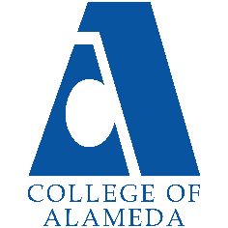
College of Alameda
2022-23 Annual Program Update – English as a Second Language

Program Overview
Please provide your program’s mission statement and program’s learning outcomes
The College of Alameda ESOL program serves non-native speakers of English who need to learn sufficient English to communicate effectively and overcome their difficulties in reading, wring, speaking and understanding English. Instruction in English is offered to facilitate ESOL students’ access to degree/transfer programs, academic programs, vocational programs and /or to prepare them for immediate employment. It is the goal of the program that students, upon completion of the program be able to participate meaningfully in American life.

List your program faculty and/or staff
Full Time Faculty:
Didem Ekici
Christa Ferrero Castaneda

Part Time Faculty:
Denise Urdang
Nora Mitchell
Jennifer Lemper
Johanna Carranza
Brian Ng

Describe your current utilization of facilities, including labs and other space
The co-chairs of the department, Christa Ferrero Castaneda and Didem Ekici, have their own office in the H building.
This semester the department approximately 30% of the courses for the department are offered in person. Most of our courses currently remain in an online modality.

ESOL classes do not have labs and all in person classes are taking place in in "smart classroom' in the H Building. These smart classrooms are equipped with the necessary technology required to teach.

List your program goals from your most recent Program Review or APU. Then, provide an update on the status of the goal. Has your program achieved the goal? Have any of your goals been revised or any still in progress? Lastly, make sure to discuss which College or District goal your program goal aligns to.
If no program goals exist or if this is your first program review, work to create 2-3 goals and align them with a College or District goal.
Program Goal | Educational Purpose: The major purpose and goal of the ESOL program is to provide quality instruction in reading, writing, speaking and critical thinking. The ESOL program intends  to develop competency in students' understanding and use of  the English language so that they may successfully enter and complete either a vocational or college level major and fully participate in the communities in which they live.
Status: In-Progress or Complete? | In progress.
Which college or district goal is aligned with your program goal? | Currently the vision of College of Alameda is that we are a diverse, supportive, empowering learning community for seekers of knowledge. We are committed to providing a creative, ethical and inclusive environment in which students develop their abilities as thinkers, workers and citizens of the world.  As an ESOL program, we help students gain the basic skills in English so that they become engaged learners that seek knowledge as lifelong learners with critical thinking skills.

Program Goal | Last year’s main goal was to re-design the ESOL program and assessment process to comply with state mandate AB 705.
Status: In-Progress or Complete? | Guided self-placement assessment tool update, Contract will be at the Oct. 25th board meeting for approval.
Which college or district goal is aligned with your program goal? | College Goal: Design organizational, committee, & governance structures to support student success  District Goal In-Progress Design organizational, committee, & governance structures to support student success Advance Student Access, Equity, and Success

Program Goal | In collaboration PEAC, our district ESOL advisory committee, we are currently working on updating course outlines of records to have uniform course requisites district wide.
Status: In-Progress or Complete? | In progress.
Which college or district goal is aligned with your program goal? | College Goal: Design organizational, committee, & governance structures to support student success.  District Goal: (In-Progress) Design organizational, committee, & governance structures to support student success Advance Student Access, Equity, and Success.

Program Update
Using the dashboards, review and reflect upon the data for your program.
Course Completion and Retention Rates – Instructional Dashboard
Course Completion and Retention Rates – Student Services Dashboard
Enrollment Trends and Productivity Dashboard
Degrees and Certificates Dashboard

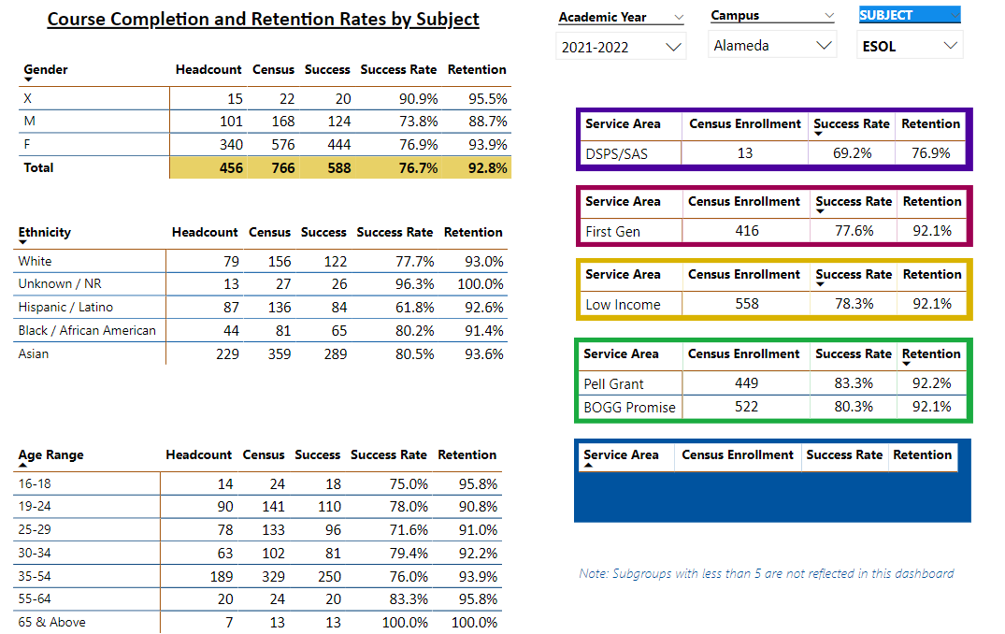

Describe any significant changes and discuss what the changes mean to your program. Consider whether performance gaps exist for disproportionality impacted students by using filters to disaggregate the data. Focus upon the most recent year and/or the years since your last comprehensive program review. Cite data points to support your reflection.
Retention & Completion:
The data shows that the completion rate of 76.8% for the ESOL department was higher than the average college-wide completion rate 71.6% for the 2021-202 academic year.

The data shows that the retention rate of 92.8% for the ESOL department was higher than the average college-wide retention rate of 84.7% for the 2021-2022 academic year.

Enrollment & Productivity:
The data shows that the ESOL department has experienced declining enrollment which is consistent with enrollment at College of Alameda and the District.

The data shows the productivity of the department has decreased to 8.6. This is also consistent with the enrollment decline.

Describe the department's progress on Student Learning Outcomes (SLOs) and/or Service Area Outcomes (SAOs) since the last Program Review/APU.
Our department is currently up to date in entering SLOs in Curricunet Meta for the 2021-2022 academic year.

The department chairs have met and developed a three-year assessment plan for the ESOL department. This information is available for all ESOL faculty in the ESOL folder in SharePoint.

Describe the outcomes and accomplishments from previous year’s funded resource allocation request.
Brief description of funded request | Source (any additional award outside your base allocation) | Total Award Amount | Outcome/Accomplishment

Prioritized Resource Requests Summary
In the boxes below, please add resource requests for your program. If there are no resource requested, leave the boxes blank.
Resource Category | Description/Justification | Total Estimated Cost
Personnel: Classified Staff | ESOL enrollment support  Help with ESOL department projects, LRC coordination, ESOL web site maintenance and student OER resources, Marketing and reach out and to assist with other clerical duties for the department. | Need assistance from Dean or VPI
Personnel: Student Worker | Embedded tutors for support courses and other courses in our department. Also, we need student workers that can help students register for their classes and use the guided self-placement tool. | Need assistance from Dean or VPI
Personnel: Part Time Faculty | A part time faculty who would be working as an ESOL coach (approximately for 5-8 hours a week) who would be helping students choose their classes, navigating in the new ESOL onboarding website, and using our social media, and website and other tools to reach out and marketing.  A dedicated counselor (5-10 hours a week) focused on helping students in support classes that would result in more collaboration with student services for students required to take the support courses. | Need assistance from Dean or VPI
Personnel: Full Time Faculty | Over the last three years, the demands and needs of the department, instructors, and students have increased because of AB705 state mandate. We have had to provide adjunct faculty with stipends to share the department workload with the one full-time faculty member to comply with AB705. Such projects have included developing the self-guided placement tool, updating the course outlines, recruitment and outreach, faculty training, and attending district wide committee meetings. | Need assistance from Dean or VPI

Resource Category | Description/Justification | Total Estimated Cost
Professional Development: Department wide PD needed | Faculty Stipends for SLO Training.  Online Teaching Training  Regional and State Conferences | $3,000-  $5,000
Professional Development: Personal/Individual PD needed | CATESOL Conferences | $1,000-  $1,500
Supplies: Software | Some instructional software tools for online classes are necessary for an effective online instruction. Some of them are Padlet, Canva, Adobe spark, English language apps that require subscription etc. | $500-$900
Supplies: Books, Magazines, and/or Periodicals | ESOL program needs some books and magazines written specifically for students who speak English as their additional language. For example, English to English dictionaries with visuals, bilingual books and dictionaries, English grammar books etc. | $300-$700
Supplies: Instructional Supplies | Face to Face Instruction: White board markers, easel board, sticky notes, pens, folders  Remote Instruction: ear pods, headset, whiteboard,  document scanner | $1,500-  $2,000
Supplies: Non-Instructional Supplies | Copy paper, cartridge, printer hardware tools (mouse, keyboard, usb hub, speaker, flash drive etx.) | $1,500-  $2,000
Supplies: Library Collections | CD and DVDs that include videos and audios to improve listening and speaking skills for language learners, story books in different proficiency levels (beginner, intermediate, upper intermediate, advanced), books for high stake exams like TOEFL, IELTS etc. | $700-  $1,000
Technology & Equipment | IPads (tablets) for faculty to use Notability and other applications for grading online writing assignments | $4,000-  $5,000
Library: Library materials/collections | ESOL English Dictionaries  ESOL Adapted short stories  Digital instructional tools for computer-based listening and speaking | $500-$1200
Facilities: Classrooms/Labs | Computer Lab/Writing Lab for ESOL students  Dedicated space for ESOL Lab with ESOL software programs and tutors to assist ESOL students with assignments | $5000
Facilities: Offices | Office space for part time faculty  Dedicated office space is needed for adjunct faculty. Currently more than 10-part timers share one space. Copy machine and scanner in the office space. | $5000
Other | Dedicated Office Space with computers to develop an “ESOL Center” in which our students can receive help with on-boarding and advised into our classes. This center will also serve as an instructional center for classes and individual instruction/tutoring, as well as a library/resource center for our instructors. | $5000

