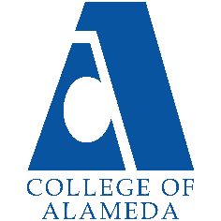
College of Alameda
2022-23 Annual Program Update – Ethnic Studies

Program Overview
Please provide your program’s mission statement and program’s learning outcomes
- Ethnic studies, is the interdisciplinary study of difference—chiefly race, ethnicity, and nation, but also sexuality, gender, and other such markings—and power, as expressed by the state, by civil society, and by individuals. It is the critical and interdisciplinary study of race, ethnicity, and indigeneity with a focus on the experiences and perspectives of people of color within and beyond the United States.

Ethnic Studies Program: has the following Program Learning Outcomes:
1. Define core concepts of Ethnic Studies (multicultural theories, social structures, culture,
social inequality, and stratification, race/ethnicity, gender, and globalization).
[Foundational knowledge in ethnic studies]
2. Apply critical race theory to everyday life with a commitment to social
justice and equality in our diverse world. [Critical Thinking]
3. Successfully transfer to a four-year college/university with well-rounded ethnic studies training.[Personal Enrichment & Lifelong Learning – Sociological Efficacy]

List your program faculty and/or staff
Jody Campbell
Hillary walker
Mitchel Wu
Araceli Quezada

Describe your current utilization of facilities, including labs and other space
Due to the COVID-19 pandemic (campus closure), the department utilizes the
technological/virtual facilities available at COA and the PCCD. All our course offerings have been
distance education courses for the past academic year. Prior to this (and now) virtually the
department and students enrolled in courses utilized the campus computer labs (now software
available through the Peralta Portal), the college library, classrooms, and common space on
campus for observations, discussion, and study. Our program currently utilizes a considerable amount of web space like the CANVAS LMS, range of LTIs like Padlet, Flip Grid, Pronto, Voice
Thread, Confer Zoom, Turn-it-In, Honor Lock, Name Coach, and Ally to name a few. Beginning in Spring 2023, the Ethnic Studies Program plans to offer 50 percent of courses face-to-face and will once again utilize the campus space of classrooms, library, and computer labs, as well as
common space for observations and discussion.

List your program goals from your most recent Program Review or APU. Then, provide an update on the status of the goal. Has your program achieved the goal? Have any of your goals been revised or any still in progress? Lastly, make sure to discuss which College or District goal your program goal aligns to.
If no program goals exist or if this is your first program review, work to create 2-3 goals and align them with a College or District goal.
Program Goal | Define core concepts of Ethnic studies. (sociological theories, social structures, culture, social inequality and stratification,  race/ethnicity, gender, and globalization).  [Foundational knowledge in Ethnic studies]
Status: In-Progress or Complete? | In Progress.
Which college or district goal is aligned with your program goal? | Aligned to COA ILOs:  (1) solve problems and make decision in life and work using  critical thinking, quantitative reasoning, community resources,  and civil engagement.  (2) Use technology and written and oral communication to  discover, develop, and relate critical ideas in multiple  environments.  (3) Exhibit aesthetic reflection to promote, participate and  contribute to human development, expression, creativity, and  curiosity.  (4) Engage in respectful interpersonal communications,  acknowledging ideas and values of diverse individuals that  represent different ethnic, racial, cultural, and gender  expressions.  (5) Accept personal, civic, social and environmental  responsibility in order to become a productive local and  global community member.

Program Goal | Apply Ethnic studies to everyday life with  a commitment to social justice and equality in our diverse  world. [Critical Multicultural Thinking]
Status: In-Progress or Complete? | In Progress.
Which college or district goal is aligned with your program goal? | Aligned to COA ILOs:  (1) solve problems and make decision in life and work using  critical thinking, quantitative reasoning, community resources,  and civil engagement.  (2) Use technology and written and oral communication to  discover, develop, and relate critical ideas in multiple  environments.  (3) Exhibit aesthetic reflection to promote, participate and  contribute to human development, expression, creativity, and  curiosity.  (4) Engage in respectful interpersonal communications,  acknowledging ideas and values of diverse individuals that  represent different ethnic, racial, cultural, and gender  expressions.  (5) Accept personal, civic, social and environmental  responsibility in order to become a productive local and  global community member.

Program Goal | Successfully transfer to a four-year college/university with  robust multicultural training. [Personal Enrichment & Lifelong  Learning – Sociological Efficacy]
Status: In-Progress or Complete? | In Progress.
Which college or district goal is aligned with your program goal? | Aligned to COA ILOs:  (1) solve problems and make decision in life and work using  critical thinking, quantitative reasoning, community resources,  and civil engagement.  (2) Use technology and written and oral communication to  discover, develop, and relate critical ideas in multiple  environments.  (3) Exhibit aesthetic reflection to promote, participate and  contribute to human development, expression, creativity, and  curiosity.  (4) Engage in respectful interpersonal communications,  acknowledging ideas and values of diverse individuals that  represent different ethnic, racial, cultural, and gender  expressions.  (5) Accept personal, civic, social and environmental  responsibility in order to become a productive local and  global community member.

Program Update
Using the dashboards, review and reflect upon the data for your program.
Course Completion and Retention Rates – Instructional Dashboard
Course Completion and Retention Rates – Student Services Dashboard
Enrollment Trends and Productivity Dashboard
Degrees and Certificates Dashboard

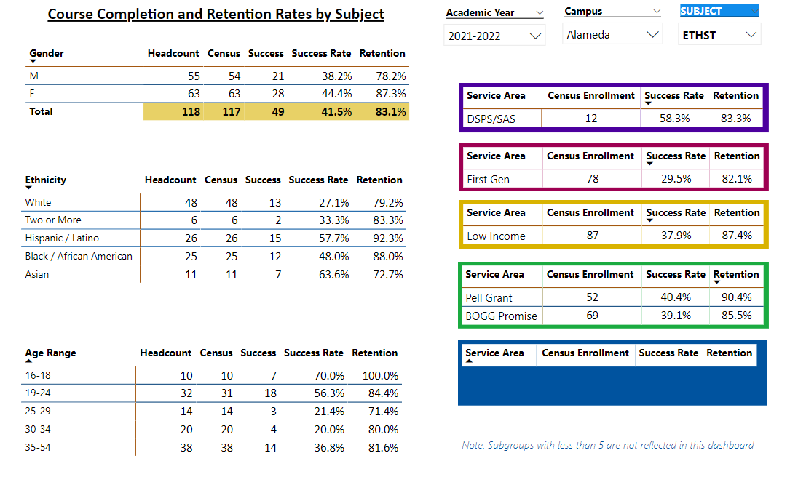

Describe any significant changes and discuss what the changes mean to your program. Consider whether performance gaps exist for disproportionality impacted students by using filters to disaggregate the data. Focus upon the most recent year and/or the years since your last comprehensive program review. Cite data points to support your reflection.
We are a new program, offering our first class in 2021. We currently have an 81% overall retention rate. However, our retention rates for Black 88.0% and Latino/X students 92.3%.

Describe the department's progress on Student Learning Outcomes (SLOs) and/or Service Area Outcomes (SAOs) since the last Program Review/APU.
The Ethnic studies program continues to engage in regular assessment of Student Learning
Outcomes. This past semester the following SLOs were assessed, and data indicated that
students met or exceeded benchmark standards. This is our very first program review.

Describe the outcomes and accomplishments from previous year’s funded resource allocation request.
Brief description of funded request | Source (any additional award outside your base allocation) | Total Award Amount | Outcome/Accomplishment
Apple Pencils to Assist with  Grading. IPADS for Department.  Headsets, microphones, cameras. | COA Department  Supplies &  Equipment  Funding | 3,000 | Some vital equipment was not delivered.
Flash Drives, HDMI & Power  Cords. | COA Department  Supplies &  Equipment  Funding |  | Only some items arrived.
Flash Drives & Replacement Power Cords. | COA Department  Supplies &  Equipment  Funding |  | Some item received.

Prioritized Resource Requests Summary
In the boxes below, please add resource requests for your program. If there are no resource requested, leave the boxes blank.
Resource Category | Description/Justification | Total Estimated Cost
Personnel: Classified Staff

Personnel: Student Worker | Student worker to help with hybrid course online students while lecturing face-to-face | Per student  worker rate.
Personnel: Part Time Faculty | Retain 3 Part-Time Instructors. | Per contract.
Personnel: Full Time Faculty | Due to a significant decline in enrollment, the department will hold off on requesting an additional full-time faculty member. If enrollment increases in  Spring and Fall 2023, it may be beneficial to hire an additional full-time instructor in the future. | Per contract.

Resource Category | Description/Justification | Total Estimated Cost
Professional Development: Department wide PD needed | Additional Training on LTIs – especially on how to  provide student support Additional Training on Equity or raising difficult dialogues in course content. | Cost of third party trainer.
Professional Development: Personal/Individual PD needed | Additional Training on Enrollment Management  Additional Training on Online Instruction. | Cost of extra service.
Supplies: Software | Microsoft Suits and Updates adobe updates. | 500.00
Supplies: Books, Magazines, and/or Periodicals | Text Books Articles, Videos, subscriptions. | 1,000
Supplies: Instructional Supplies | Ink, Paper Pins, Markers, folders, antibacterial items, masks. | 1,000
Supplies: Non-Instructional Supplies | Flash drives, headsets (noise canceling), Desks, bookshelves, chairs, keyboards, mice. | 500.00
Supplies: Library Collections | PBS Videos Learning Guides. | 500.00
Technology & Equipment | Headsets, microphones, cameras, tablets, laptops. | 1,000
Library: Library materials/collections | Reserve text and articles. | 250.00
Facilities: Classrooms/Labs | Personal Microphones  Mask wearing during lecture muffles sound  For clarity of instruction | 250.00
Facilities: Offices | Cleaners, Lysol wipes, water, gloves, antibacterial soap and dispensers masks. | 250.00
Other | Food snacks, refreshments students and staff. | 250.00

