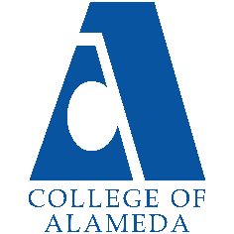
College of Alameda
2022-23 Annual Program Update – Geography

Program Overview
Please provide your program’s mission statement and program’s learning outcomes
The mission of the Geography Department is to teach our diverse student community to understand the natural and cultural environments of the region and around the world, to be critical consumers of environmental advocacy, and to appreciate the beauty and wonder of the planet and its diversity.

The department directly supports the College of Alameda's mission, which is: To serve the educational needs of its diverse community by providing comprehensive and flexible programs and resources that empower students to achieve their goals. In order to support this mission, we (a) provide a variety of courses and dynamic scheduling options in coordination with other departments and disciplines within the Peralta Community College District, (b) create ethical and inclusive learning environments, (c) support the needs of all students and advocate for those programs and offices designed to help meet those needs, and (d) encourage involvement and investment outside of the classroom by supporting and engaging in a variety of programs and initiatives at College of Alameda and the larger community.

The Geography Department provides specialized in-person and virtual educational field trip opportunities to expand students' geographic knowledge and skills. Participating students experience California's unique atmospheric, oceanic, volcanic, tectonic, fluvial, geologic, glacial, hydrothermal and biological features. According to the Bureau of Labor Statistics the projected 10-year (2012-2022) job growth for Geographers is 22% or higher. Most of this growth will occur within the sub-field of Geographic Information Systems (GIS). GIS is software designed to capture, manage, analyze, and display all forms of geographically referenced information. GIS allows us to view, understand, question, interpret, and visualize our world in ways that reveal relationships, patterns, and trends in the form of maps, globes, reports, and charts. This technology provides cost saving from greater efficiency, better decision making, improved communication, improved records keeping, and management of spatial problems. Understanding and utilizing this technology is becoming increasingly important as it benefits organizations of all sizes and in almost every industry.

Since there is a growing interest in Geography and an awareness of the economic and strategic value of GIS, our department has committed to offer a GIS Certificate Program in addition to the recently developed Associate of Arts in Geography Transfer Degree (AA-T). Program Learning Outcomes for the ADT and A.A. degree in Geography are: 1) Describe the spatial organization of the world’s peoples, nations, cultural environments; 2) Demonstrate knowledge of global physical and environmental processes and develop an appreciation of landscapes; 3) Demonstrate an understanding of how human activities impact the physical environment.

List your program faculty and/or staff
Cady Carmichael (Full time Geography faculty; Department Co-Chair)
Jeremy Patrich (Part time Geography faculty)
Aubrey Rose (Part time Geography faculty)
Cameron Denney (Part Time Geography Faculty
Chevonn Herbert (STEAM Division Staff Assistant)

Describe your current utilization of facilities, including labs and other space
Since we have been primarily online during the pandemic (as of March 2020), our utilization of campus facilities has diminished. Additionally, the College of Alameda administration removed the historic Geography classroom (D-222) space, as well as the faculty office space in the C-building, from use. This was done without notice or consultation of the department and chairs. Since this occurred, the Department Chairs and CoA Administration have discussed and determined which alternative space would best suit the needs of the department and our students. It was decided that D113 and D114 would be vacated and modified for ideal use by both the Geography and Geology departments. This space is anticipated to be ready for in-person classes for the Spring 2023 term.

List your program goals from your most recent Program Review or APU. Then, provide an update on the status of the goal. Has your program achieved the goal? Have any of your goals been revised or any still in progress? Lastly, make sure to discuss which College or District goal your program goal aligns to.
If no program goals exist or if this is your first program review, work to create 2-3 goals and align them with a College or District goal.
Program Goal | Student learning outcomes (SLOs) for all Geography courses have been assessed (2020 APU).
Status: In-Progress or Complete? | In-Progress; the department has created a plan to assess the remaining SLOs for GEOG 1, 1L, 2, 3. & 14. This will take place during the Fall 2022 and Spring 2023 terms. The remaining SLOs for the new courses (GEOG 15 & 18) will be assessed Spring 2023 and Fall 2023 respectively.
Which college or district goal is aligned with your program goal? | Establish integrated planning and evaluation system (College Goal); Build Programs of Distinction (District Goal).

Program Goal | Establish and offer course(s) in Geographic Information Systems (GIS) and World Regional Geography (2020 APU).
Status: In-Progress or Complete? | Complete; GEOG 14: Introduction to Geographic Information Systems (GIS) and GEOG 3: World Regional Geography are now approved courses and have both been offered at least one semester. These courses are integrated into our department planning schedule.
Which college or district goal is aligned with your program goal? | Advance CoA Teaching and Learning (College Goal); Build Programs of Distinction (District Goal).

Program Goal | Expand other/additional course offerings, such as Environmental Geography, Climatology, Weather and Climate, and California Geography will be submitted for approval on an ongoing basis (2020 APU).
Status: In-Progress or Complete? | Both Complete and In-Progress; GEOG 15: Introduction to Weather and Climate and GEOG 18: California Geography are both approved and active courses. GEOG 18 has been offered one semester and is integrated into our department planning schedule. GEOG 15 will be offered during the Spring 2023 semester. Additional courses will be submitted for approval on an ongoing basis.
Which college or district goal is aligned with your program goal? | Advance CoA Teaching and Learning (College Goal); Build Programs of Distinction (District Goal).

Program Goal (New Goal) | Participate in STEM outreach, recruitment efforts, and student service partnerships to expand student awareness of our course offerings and science-based careers
Status: In-Progress or Complete? | In Progress
Which college or district goal is aligned with your program goal? | Advance CoA Teaching and Learning (College Goal); Build Programs of Distinction (District Goal).

Program Update
Using the dashboards, review and reflect upon the data for your program.
Course Completion and Retention Rates – Instructional Dashboard
Course Completion and Retention Rates – Student Services Dashboard
Enrollment Trends and Productivity Dashboard
Degrees and Certificates Dashboard

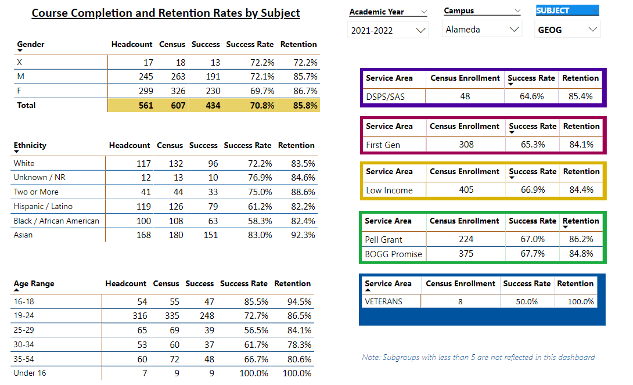

Describe any significant changes and discuss what the changes mean to your program. Consider whether performance gaps exist for disproportionality impacted students by using filters to disaggregate the data. Focus upon the most recent year and/or the years since your last comprehensive program review. Cite data points to support your reflection.
The Geography Program continues to have overall high course completion and retention rates, however, these have decreased slightly since the last APU (2021-2022) – by 7% and 4% respectively. This may be the result of the inability of the system to differentiate “fake” students from the totals and therefore “skew” the data. The fake student issue in 2021/2022 has resulted in decreases in enrollment, retention, and completion rates in many disciplines. The overall GEOG course completion and retention rates, as well as productivity, are higher than the average rates for College of Alameda.

As discussed in the 2021-2022 APU, significant improvements were made in the success and retention rates among Black/African American and Hispanic/Latino students. Among Black/African American students, the success rate increased by 21.7% and the retention rate increased 18%. Among Hispanic/Latino students, the success rate increased 7.6% and the retention rate increased 10.6%. These rates are still lower than the success and retention rates among Asian and White students, but the gap decreased significantly since the previous APU. In looking at the data above, retention rates among all ethnicities is over 82%. Asian students have a slightly higher retention rate at 92.3%. Retention rates are also high (above 84%) when looking at different service areas such as SAS, low income, etc. The success rates among all subgroups has declined since the last APU. Black/African American students, Hispanic/Latino students, student age 25 and above, and students that fall into subgroups (i.e., SAS, first generation, low income, Pell Grant recipient, BOGG Promise, and veterans) all have seen declines in success rates – all below 70%. This is a significant and unfortunate decline since the gains that occurred in these areas the previous year.

These gaps need to be addressed college-wide and within our Geography courses. The department and College have made, and will continue to make, tremendous efforts to connect students with available support systems and programs. Continuing discussions within our shared governance structure, ongoing program assessment, and improvements to course curriculum and communication with students are necessary to ensure that overall student success and accomplishment of student goals is equitable. Since the majority of our students plan on transferring, a visible and measurable commitment to student support and achievement is essential. The Geography Department is committed to continue to work with student support services and outreach, as well as the larger guided pathways framework to address these gaps.

Describe the department's progress on Student Learning Outcomes (SLOs) and/or Service Area Outcomes (SAOs) since the last Program Review/APU.
SLO assessment is needed for GEOG 1, 1L, 2, 3, & 14. Faculty within the department have discussed and created an ongoing plan for assessment. All remaining SLOs will be assessed during the Fall 2022 and Spring 2023 semesters.

The new assessment sequence will begin using courses offered in Fall 2022. SLO 1 will be assessed in all courses offered Fall 2022. SLO 2 will be assessed in all courses offered in the 2022-2023 academic year, and SLO 3 will be assessed in all courses in the 2023-2024 academic year. This will ensure all SLOs continue to be assessed within the three-year cycle at least once during the academic year in which the courses are offered.

Describe the outcomes and accomplishments from previous year’s funded resource allocation request.
Brief description of funded request | Source (any additional award outside your base allocation) | Total Award Amount | Outcome/Accomplishment
Instructional Supplies | N/A | $5,901.16 (lottery funds) | Replacement, increase, and expansion in supplies for lecture and lab activities.

Prioritized Resource Requests Summary
In the boxes below, please add resource requests for your program. If there are no resource requested, leave the boxes blank.
Resource Category | Description/Justification | Total Estimated Cost
Personnel: Classified Staff

Personnel: Student Worker

Personnel: Part Time Faculty | As the Geography Department continues to grow and expand its offerings, an additional part-time faculty member is needed to help meet demand and expand our face to face and potential hybrid offerings. | $15,000 - $30,000
Personnel: Full Time Faculty

Resource Category | Description/Justification | Total Estimated Cost
Professional Development: Department wide PD needed
Professional Development: Personal/Individual PD needed
Supplies: Software | Upgraded and continued funding of the ArcGIS software license is critical to the offering of GEOG 14 as well as providing faculty with the opportunity to integrate mapping components into their courses. | $2,000
Supplies: Books, Magazines, and/or Periodicals

Supplies: Instructional Supplies | At least $1,000 is needed to maintain and/or replace instructional supplies for lecture and lab activities. | $1,000
Supplies: Non-Instructional Supplies

Supplies: Library Collections

Technology & Equipment | A new overhead projector, computer, and speaker system are needed in the new D113 and D114 classrooms to provide in-person instruction. | Unknown IT upgrade and installation costs
Library: Library materials/collections

Facilities: Classrooms/Labs

Facilities: Offices

Other

