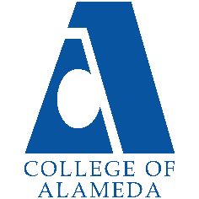
College of Alameda
2022-23 Annual Program Update - HLTOC

Program Overview
Please provide your program’s mission statement and program’s learning outcomes
The mission of College of Alameda is to serve the educational needs of its diverse community by providing comprehensive and flexible programs and resources that empower students to achieve their goals.

There are 3 SLO’s for HLTOC:
SLO 1: Knowledge of body structures: Students can recognize different body structures and describe them using medical terminology.
SLO 2: Pathologies and diseases: Students can differentiate between various pathological conditions and diseases using medical terminology.
SLO 3: Surgical terms: Students can summarize surgical techniques and explain surgical terms using medical terminology.

List your program faculty and/or staff
Naren Davé

Describe your current utilization of facilities, including labs and other space
Online Canvas courses

List your program goals from your most recent Program Review or APU. Then, provide an update on the status of the goal. Has your program achieved the goal? Have any of your goals been revised or any still in progress? Lastly, make sure to discuss which College or District goal your program goal aligns to.
If no program goals exist or if this is your first program review, work to create 2-3 goals and align them with a College or District goal.
Program Goal
Status: In-Progress or Complete? | N/A
Which college or district goal is aligned with your program goal? | N/A

Program Goal
Status: In-Progress or Complete? | N/A
Which college or district goal is aligned with your program goal? | N/A

Program Goal
Status: In-Progress or Complete? | N/A
Which college or district goal is aligned with your program goal? | N/A

Program Update
Using the dashboards, review and reflect upon the data for your program.
Course Completion and Retention Rates – Instructional Dashboard
Course Completion and Retention Rates – Student Services Dashboard
Enrollment Trends and Productivity Dashboard
Degrees and Certificates Dashboard

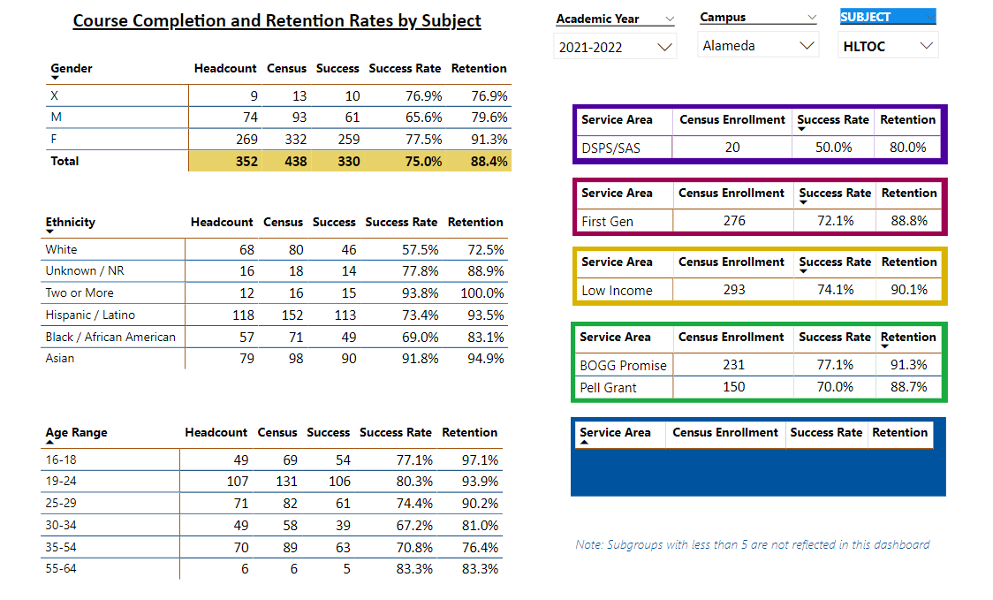

Describe any significant changes and discuss what the changes mean to your program. Consider whether performance gaps exist for disproportionality impacted students by using filters to disaggregate the data. Focus upon the most recent year and/or the years since your last comprehensive program review. Cite data points to support your reflection.
The HLTOC program has been offering courses since 1992. The discipline’s course retention rate is 88.4% for 2021-22, which is much higher than College of Alameda’s. There was a performance gap between ethnicities. White students had a retention rate of 72.5% and Black/African American students had a retention rate of 83.1%. All other ethnicities had a retention rate in the high 80s and 90s.

HLTOC began offering dual enrollment courses in 2016-17 and has continued to expand on these courses.

Describe the department's progress on Student Learning Outcomes (SLOs) and/or Service Area Outcomes (SAOs) since the last Program Review/APU.
SLO 1. Knowledge of body structures: Students can recognize different body structures and describe them using medical terminology.
SLO 2: Pathologies and diseases: Students can differentiate between various pathological conditions and diseases using medical terminology.
SLO 3: Surgical terms: Students can summarize surgical techniques and explain surgical terms using medical terminology

Over 330 students have passed HLTOC courses successfully. These students have met these student-learning outcomes and these outcomes will continue to be assessed with future students.

Describe the outcomes and accomplishments from previous year’s funded resource allocation request.
Brief description of funded request | Source (any additional award outside your base allocation) | Total Award Amount | Outcome/Accomplishment
Request of funds to hire teaching assistants | Strong workforce funds | $15k | This allowed the program to hire teaching assistants to support our courses.
Instructional equipment and supplies | General fund | $5k | This allowed us to purchase instructional equipment and supplies.
N/A | N/A | N/A | N/A

Prioritized Resource Requests Summary
In the boxes below, please add resource requests for your program. If there are no resource requested, leave the boxes blank.
Resource Category | Description/Justification | Total Estimated Cost
Personnel: Classified Staff

Personnel: Student Worker | To hire more teaching assistants
Personnel: Part Time Faculty
Personnel: Full Time Faculty

Resource Category | Description/Justification | Total Estimated Cost
Professional Development: Department wide PD needed
Professional Development: Personal/Individual PD needed
Supplies: Software

Supplies: Books, Magazines, and/or Periodicals

Supplies: Instructional Supplies

Supplies: Non-Instructional Supplies

Supplies: Library Collections

Technology & Equipment

Library: Library materials/collections

Facilities: Classrooms/Labs

Facilities: Offices

Other

