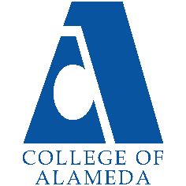
College of Alameda
2022-23 Annual Program Update - Music

Program Overview
Please provide your program’s mission statement and program’s learning outcomes
The primary mission of the College of Alameda Music Department is to provide pathways to understanding and recognition of the boundless influence of diverse cultures on musical expression. We offer courses for the aspiring performer/musician as well as those seeking to better understand the inner workings of the music industry, along with its history. Our staff is comprised of experienced professionals who are committed to the personal growth and development of every student and bring both academic integrity and first-hand experience to the learning environment.

List your program faculty and/or staff
Full Time (Tenured): Glen Pearson
Part Time (Adjunct): Silvester Henderson

Part Time (Adjunct): David Chong

Describe your current utilization of facilities, including labs and other space
The music department facilities are currently comprised of two primary areas; G-119 serves as the department’s lecture classroom, as well as ensemble rehearsal and small performance/recital presentation space. G-118 contains 24 digital pianos and serves as the piano teaching lab and resource facility for group and individual study of voice, as well as music theory.

List your program goals from your most recent Program Review or APU. Then, provide an update on the status of the goal. Has your program achieved the goal? Have any of your goals been revised or any still in progress? Lastly, make sure to discuss which College or District goal your program goal aligns to.
If no program goals exist or if this is your first program review, work to create 2-3 goals and align them with a College or District goal.
Program Goal | Launch of CIPD Approved Certificated Programs in Gospel/Faith based music studies and performance, and Jazz Studies/Popular Music performance
Status: In-Progress or Complete? | Having been hampered for a time by the COVID pandemic, the department has resumed its efforts to implement our approved Certificated Programs/Cirriculums. While performance-based courses have begun to resume, there remains the challenge of securing the necessary allotment of FTEF in order to provide all required Certificate related courses.
Which college or district goal is aligned with your program goal? | Community outreach and creation of alliances/partnerships leading to internship, apprenticeship, and employment opportunities for CoA CTE/Vocational program students.

Program Goal
Status: In-Progress or Complete?
Which college or district goal is aligned with your program goal?

Program Goal
Status: In-Progress or Complete?
Which college or district goal is aligned with your program goal?

Program Update
Using the dashboards, review and reflect upon the data for your program.
Course Completion and Retention Rates – Instructional Dashboard
Course Completion and Retention Rates – Student Services Dashboard
Enrollment Trends and Productivity Dashboard
Degrees and Certificates Dashboard

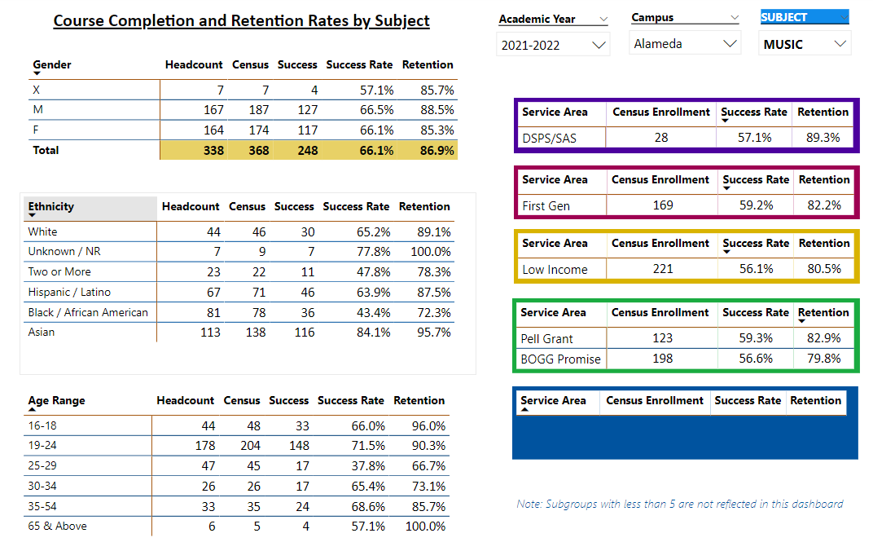

Describe any significant changes and discuss what the changes mean to your program. Consider whether performance gaps exist for disproportionality impacted students by using filters to disaggregate the data. Focus upon the most recent year and/or the years since your last comprehensive program review. Cite data points to support your reflection.
While there is an overall decrease reflected in the retention rates for Music for 2022-23 compared to 2021-22, the cumulative rate by gender of 86.9% for 2022-23 represents a decrease of only 0.2% over the previous reported rate for 2021-22 of 87.1%. When considering the impact of the COVID pandemic on enrollment, I find this to be impressive.
However, in examining previous and recent performance/retention rates for traditionally disadvantaged and disproportionately served students there is a significant decline; most significant is the course completion/retention rate for African American students for 2022-23 compared to 2020-21, which is 72.3% versus 84.8%, a decrease of 12.5%; however, the rate for Hispanic/Latino students for the same comparative period shows 87.6% compared to 87.5%, a decrease of only 0.1%. The most immediate question, when comparing the data between these two groups, is what makes for the significant gap in the decline of completion/retention rates between these two traditionally underserved communities? Is one perhaps more motivated/resilient when it comes to navigating obstacles brought on by a world-wide pandemic?

Considering that the Music department has just begun to reinvigorate its program goals, the impact of the current data remains to be seen.

Describe the department's progress on Student Learning Outcomes (SLOs) and/or Service Area Outcomes (SAOs) since the last Program Review/APU.
SLO’s for all music area courses are current and in alignment with all requirements.

Describe the outcomes and accomplishments from previous year’s funded resource allocation request.
Brief description of funded request | Source (any additional award outside your base allocation) | Total Award Amount | Outcome/Accomplishment
Funding in support of performance presentation opportunities for Vocal and Piano studies students, along with the presentation of guest performers and lecturers in conjunction with creating transfer opportunities and relationships with four-year institutions | $0 | $0 | Supportive funding was initially provided by the College for the 2017- 18 academic year, with a pledge of incremental increases; however, for unknown reasons, the pledged support was withdrawn. Subsequent support for performance presentations has come from the personal resources of Professor Silvester Henderson and myself.

Prioritized Resource Requests Summary
In the boxes below, please add resource requests for your program. If there are no resource requested, leave the boxes blank.
Resource Category | Description/Justification | Total Estimated Cost
Personnel: Classified Staff

Personnel: Student Worker | Embedded Tutors for the four online/hybrid formatted GE music course offerings. This is also of particular importance when considering an anticipated increase in productivity for the Music Department. | $13,000.00 per academic year
Personnel: Part Time Faculty
Personnel: Full Time Faculty

Resource Category | Description/Justification | Total Estimated Cost
Professional Development: Department wide PD needed | Support for conferences, workshops, and seminars in conjunction with Certificated music programs/curriculums in Gospel Music Studies and Contemporary Music Studies and Performance. | $10,000.00 per year
Professional Development: Personal/Individual PD needed
Supplies: Software | Audio and visual editing software (Logic, Filmora 9, ProTools, etc.) along with annual upgrades and licensing, for use in the creation of student performance presentations and individual and group projects | $5000.00 per year
Supplies: Books, Magazines, and/or Periodicals

Supplies: Instructional Supplies | Paper, manuscript, pens, pencils, whiteboard markers and erasers, batteries, copier cartridges, thumb drives, etc. | $1200 per academic year
Supplies: Non-Instructional Supplies

Supplies: Library Collections

Technology & Equipment | 24 Mac/Apple laptop computers, along with a server and accompanying hardware and interfaces, to facilitate the proposed incorporation of music technology as part of the CTE component for the approved Certificates of Achievement in Gospel Music Performance/Studies and Jazz Studies/Popular Music Performance. | $80,000.00
Library: Library materials/collections

Facilities: Classrooms/Labs | Upgrading of desks and lighting in the main lecture/rehearsal/performance space (G-119) for the music department. | $20,000.00
Facilities: Offices

Other

