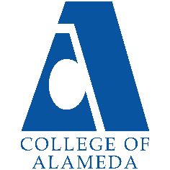
College of Alameda
2022-23 Annual Program Update – Psychology

Program Overview
Please provide your program’s mission statement and program’s learning outcomes
In studying psychology at College of Alameda, you will learn from supportive faculty that recognize the mind-body-heart connection as core to the transformation of self, community, and our planet. We encourage students to examine their own psychological issues and develop a keen understanding of who they are and what they will bring to their work with others by emphasizing cognitive and emotional development through self-reflection, academic rigor and experiential practice. The COA psychology department prizes itself on having students apply theories to their own lives so that the information is understandable, useful, and illuminating.

PLO 1: Apply multiple schools of psychology (e.g. psychodynamic, behavioral, cognitive, humanistic, biological, and transpersonal) to living situations.

PLO 2: Demonstrate effective communication and interpersonal relationship skills rooted in psychological perspectives and exhibiting an awareness of psychological dynamics in inter-relationship.

PLO 3: Increase awareness of self, others, and the environment in order to have greater agency and authentic expression.

List your program faculty and/or staff
Sarah Peterson-Guada
Elham Chishty
Hana Husain
A’sharee Brown
Ida Ahmadi
Robert Brem

Describe your current utilization of facilities, including labs and other space
Currently, due to COVID-19, our department has primarily taught asynchronous online classes for the past two years. This semester, fall 2022, we offer one in-person class with a few synchronistic Zoom classes. Next semester, we will offer more in-person classes, primarily with the hybrid format to allow some in-person contact and instruction, along with an online component to ease students’ and instructor’s transition to being in-person again. We continue with our dual enrollment program next semester with OUSD.

List your program goals from your most recent Program Review or APU. Then, provide an update on the status of the goal. Has your program achieved the goal? Have any of your goals been revised or any still in progress? Lastly, make sure to discuss which College or District goal your program goal aligns to.
If no program goals exist or if this is your first program review, work to create 2-3 goals and align them with a College or District goal.
Program Goal | Consistency in basic mission of goals that reflect Departmental vision of holistic pedagogy alongside attunement of curriculum to Institutional Learning Outcomes, Program Learning Outcomes and Student Leaning Outcome.
Status: In-Progress or Complete? | Complete. Our pedagogy is holistic, we’ve updated SLOs, which also reflect our PLOs that are tied to how we teach psychology. These also reflect the overall ILOs of COA.
Which college or district goal is aligned with your program goal? | Problem solving and civic responsibility.

Program Goal | Emphasis on diversity in the curriculum and department and emphasis on inclusivity, equity and justice in the classroom in efforts to bridge the learning gaps that exist among students.
Status: In-Progress or Complete? | In-Progress. Our department has made great strides in diversifying the material that is presented to our students in terms of images that are used in PowerPoint presentations as well as articles that are included in course material.  Likewise, we continue to diversify our faculty so that more of our students see themselves in their teachers along with creating a broader lens from which psychology is taught. Our new hires include A’sharee Brown who is African-American and Ida Ahmadi, who is Persian-American and identifies as “they/them,” which is another level of diversity that our growing gender non-conforming population can feel mirrored and supported by, and broaden everyone’s definition of what it means to be “human,” “normal,” and other psychological themes such as “identity,” “resilience,” “trauma,” “self-acceptance,” “navigating family issues,” among others!  Likewise, Sarah worked with A’sharee Brown and Jody Campbell, our African-American and Ethnic Studies Department leads to create course “Psychology of Liberation: Blacks and African-Americans,” which has already been submitted to the Curriculum Committee. Likewise, the course is designed to satisfy California’s Ethnic Studies undergraduate requirement.  Also, each faculty member that we hire and that teaches in our department is committed to teaching a non-colonized form of psychology where we welcome and integrate wisdom from other cultures and students’ experiences, as well as expanding students’ understanding of the history of Western Psychology and how can we rewrite the narrative to be more inclusive and representative of our diverse populations where mental health is tailored to each culture based on their unique needs, traditions and values.  Likewise, we created a non-credit certification program entitled: “Certificate of Accomplishment in Transformational Psychology” which contains six of our more popular classes and will be offered to the community free of charge. This supports our mission with equity because people with less financial resources will still be able to build their skill set because non-credit courses are free. Also, seniors, unhoused and formerly incarcerated people, among others, may also use this non-credit degree as a way to learn and ease their way into the academic environment without the pressure of receiving a grade.  This semester is our first semester offering Psychology 11 – Transpersonal Psychology that extends Western Psychology to include Eastern Psychology among other mystical aspects of other cultures and emphasizes that we are spiritual beings having a human experience instead of human beings having a spiritual experience.  While we have made great strides, in expanding our curriculum, because social justice, inclusivity and accessibility are such a priority to our department, I have put the status as “In-Progress.”
Which college or district goal is aligned with your program goal? | Creativity, diversity, and civic responsibility.

Program Goal | Being involved with other departments to create some coursework that can overlap so there is continuity among some courses particularly in the liberal arts/sciences and even hard sciences.
Status: In-Progress or Complete? | In-Progress. As mentioned above, we will cross list The Psychology of Liberation: Black and African-Americans course with the African-American Studies Department. Also, perhaps, with our program mapping, there will be more opportunities to collaborate.
Which college or district goal is aligned with your program goal? | Problem solving, communication and technology, creativity, and civic responsibility.

Program Update
Using the dashboards, review and reflect upon the data for your program.
Course Completion and Retention Rates – Instructional Dashboard
Course Completion and Retention Rates – Student Services Dashboard
Enrollment Trends and Productivity Dashboard
Degrees and Certificates Dashboard

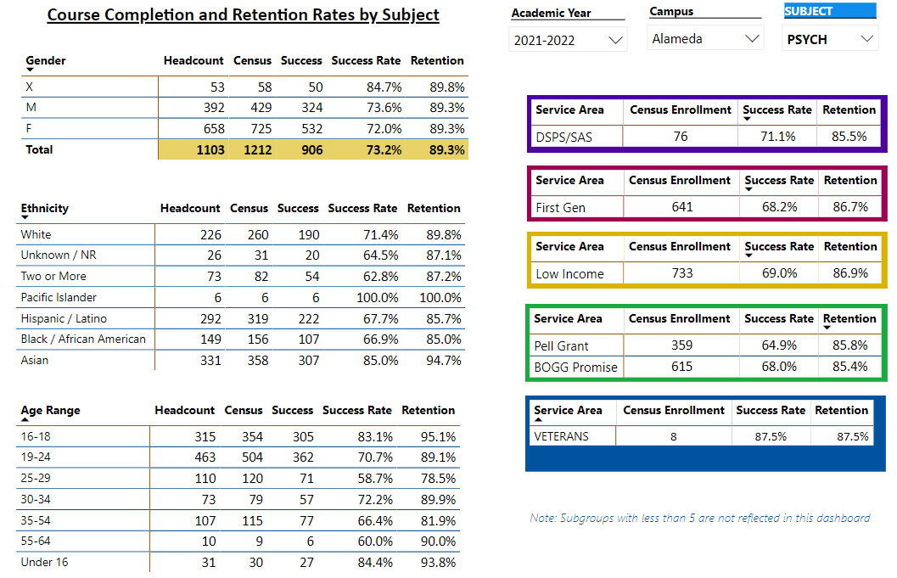

Describe any significant changes and discuss what the changes mean to your program. Consider whether performance gaps exist for disproportionality impacted students by using filters to disaggregate the data. Focus upon the most recent year and/or the years since your last comprehensive program review. Cite data points to support your reflection.
Our department’s retention rate for every group, including gender, ethnicity, DSPS, First Gen, low income, Pell grant, BOGG Promise, and veterans is all above 80%. The only group that has a lower retention rate of 78.5% is the 25-29 year old age group. This could be because people at this age are committing themselves to their work and being financially independent. As a result, they have start off with wanting to get ahead in their careers by attending school, and then feel overwhelmed and drop classes to continue to work.

While our department’s retention rate is consistently above 80%, our success rate for Latinx and Black students as well as those that identify as mixed is in the 60% range. Likewise, First Gen, low income, Pell grant, and BOGG Promise students all have success rates in the 60s percentile. Furthermore, students between the ages of 25-29 have a success rate of 58.7%, which is our lowest success rate throughout our department. Reasons we see this reflected in the data could involve multiple factors that can be taken into consideration. Perhaps these students do not feel represented in a college community and/or have other factors playing a part (i.e., jobs, SES stresses, other stresses) and our department has taken measures to create a context, knowledge base and pedagogy that curtails multiple learning systems and the inclusion of diversity and equity in its focus. We try to make our students aware of the services and resources the college can offer them to support them in their pursuits. More measures should of course be put into practice to ensure that all students are being met and feel heard and represented in the courses. We try to address these concerns in departmental meetings/division meetings.

Describe the department's progress on Student Learning Outcomes (SLOs) and/or Service Area Outcomes (SAOs) since the last Program Review/APU.
Our department continues to provide data and we as a whole strive to assess our Student Learning Outcomes. Our student learning outcomes have mirrored the Program Learning Outcomes and the Institutional Learning outcomes in the sense that students are mastering understanding from multiple knowledge bases while applying to intra and interpersonal relational skills. Our department as a whole have striven to meet the goals and should goals not be met, it is taken up and adapted in the course curriculum soon after. We pride ourselves in the holistic model of education where the entirety of the student/human experience is acknowledged and understood. This is most surely reflected in our SLOs.

Describe the outcomes and accomplishments from previous year’s funded resource allocation request.
Brief description of funded request | Source (any additional award outside your base allocation) | Total Award Amount | Outcome/Accomplishment

Prioritized Resource Requests Summary
In the boxes below, please add resource requests for your program. If there are no resource requested, leave the boxes blank.
Resource Category | Description/Justification | Total Estimated Cost
Personnel: Classified Staff

Personnel: Student Worker

Personnel: Part Time Faculty
Personnel: Full Time Faculty

Resource Category | Description/Justification | Total Estimated Cost
Professional Development: Department wide PD needed
Professional Development: Personal/Individual PD needed
Supplies: Software

Supplies: Books, Magazines, and/or Periodicals

Supplies: Instructional Supplies

Supplies: Non-Instructional Supplies

Supplies: Library Collections

Technology & Equipment

Library: Library materials/collections

Facilities: Classrooms/Labs

Facilities: Offices

Other

