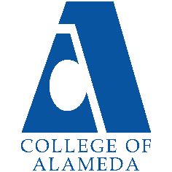
College of Alameda
2022-23 Annual Program Update – World Languages

Program Overview
Please provide your program’s mission statement and program’s learning outcomes
The Mission of the World Languages department at College of Alameda that consists of Spanish, Vietnamese, Cantonese, and German is to help students develop communicative and cultural competence in these languages and the countries in which they are spoken. Students work on developing proficiency in listening, speaking, wring, and reading in the target language, in addition to developing cultural knowledge of the speaking countries and communities. Courses are conducted in the target language and much class me is dedicated to task-based, communicative activities.

List your program faculty and/or staff
Cynthia Weiss, Adjunct Faculty Spanish
Allen Tam, Adjunct Faculty- Chinese (Cantonese)
Khoi Tong, Adjunct Faculty- Vietnamese

Describe your current utilization of facilities, including labs and other space
World Languages department has been conducting classes online like many other programs in PCCD district. Before pandemic, most classrooms at College of Alameda comfortably accommodate the average Spanish, Chinese and Vietnamese classes, both in terms of room size and of seating type (movable chairs with tablet desks) and capacity.

Spanish, Chinese or Vietnamese classes do not have labs and most of the classes are taking place in in "smart classroom' which have every imaginable educational technology, including access to internet.

List your program goals from your most recent Program Review or APU. Then, provide an update on the status of the goal. Has your program achieved the goal? Have any of your goals been revised or any still in progress? Lastly, make sure to discuss which College or District goal your program goal aligns to.
If no program goals exist or if this is your first program review, work to create 2-3 goals and align them with a College or District goal.
Program Goal | Ensuring all students that have enrolled in a world language course can complete a certificate, degree or transfer to a four-year university
Status: In-Progress or Complete? | In-progress
Which college or district goal is aligned with your program goal? | College Goal: Increase retention and persistence rates  District Goal: Advance Student Access, Equity, and Success

Program Goal
Status: In-Progress or Complete?
Which college or district goal is aligned with your program goal?

Program Goal
Status: In-Progress or Complete?
Which college or district goal is aligned with your program goal?

Program Update
Using the dashboards, review and reflect upon the data for your program.
Course Completion and Retention Rates – Instructional Dashboard
Course Completion and Retention Rates – Student Services Dashboard
Enrollment Trends and Productivity Dashboard
Degrees and Certificates Dashboard

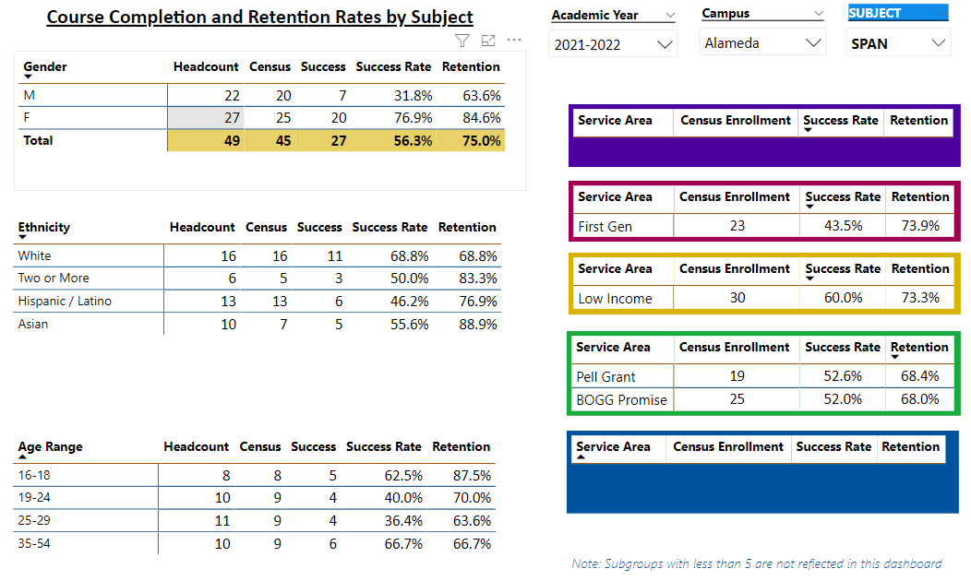

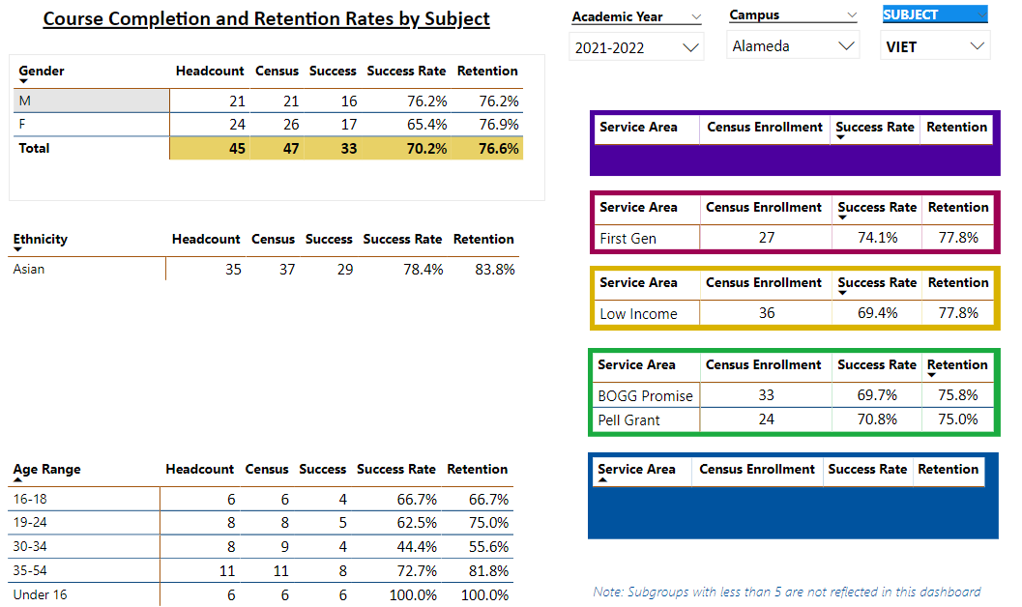

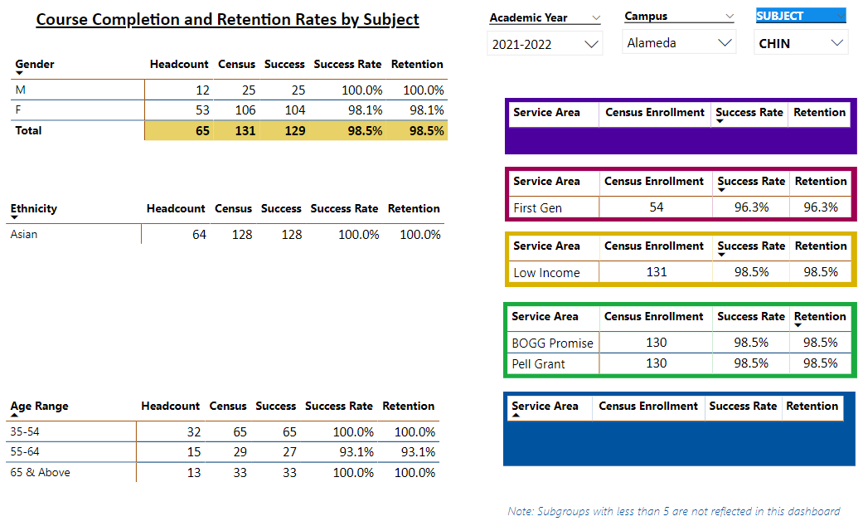

Describe any significant changes and discuss what the changes mean to your program. Consider whether performance gaps exist for disproportionality impacted students by using filters to disaggregate the data. Focus upon the most recent year and/or the years since your last comprehensive program review. Cite data points to support your reflection.
Retention & Completion:
Chinese: The data shows that the completion rate (98.5%) of Chinese department was higher than the average college-wide completion rate (70.7%) for the 2021-2022 academic year. The data shows that the retention rate (98.5%) of Chinese department was higher than the average college-wide retention rate (84%) for the 2021-2022 academic year

Spanish: Overall Spanish completion rates (56.3 %) was lower than the average college-wide completion rate (70.7%) for the 2021-2021 academic year. . The data shows that the retention rate (75%) of Spanish department was slightly lower than the average college-wide completion rate (84%) for the 2021-2022 academic year

Vietnamese: According to the data, the completion rate (70.2%) of Vietnamese program was slightly lower than the average college-wide completion rate (70.7%) for the 2021-2022 academic year. The retention rate (76.8%) of Vietnamese program was lower than the average college-wide retention rate (84%) for the 2021-2022 academic year.

Enrollment & Productivity:
The enrollment and the productivity percentages of Chinese, Spanish and Vietnamese were a little bit different than the overall college productivity rates. The college’s productivity rate is 11.0. Spanish had a productivity of 12.5, Chinese had a productivity of 16.9 and Vietnamese had a productivity of 12.

There is a decrease in enrollment at PCCD. The Spanish and Vietnamese programs have also experienced a decline in enrollment. The Chinese program has experienced a consistent enrollment.

Describe the department's progress on Student Learning Outcomes (SLOs) and/or Service Area Outcomes (SAOs) since the last Program Review/APU.
Student learning outcomes are in the process of being assessed.

Describe the outcomes and accomplishments from previous year’s funded resource allocation request.
Brief description of funded request | Source (any additional award outside your base allocation) | Total Award Amount | Outcome/Accomplishment

Prioritized Resource Requests Summary
In the boxes below, please add resource requests for your program. If there are no resource requested, leave the boxes blank.
Resource Category | Description/Justification | Total Estimated Cost
Personnel: Classified Staff

Personnel: Student Worker

Personnel: Part Time Faculty
Personnel: Full Time Faculty

Resource Category | Description/Justification | Total Estimated Cost
Professional Development: Department wide PD needed
Professional Development: Personal/Individual PD needed
Supplies: Software

Supplies: Books, Magazines, and/or Periodicals

Supplies: Instructional Supplies

Supplies: Non-Instructional Supplies

Supplies: Library Collections

Technology & Equipment

Library: Library materials/collections

Facilities: Classrooms/Labs

Facilities: Offices

Other

