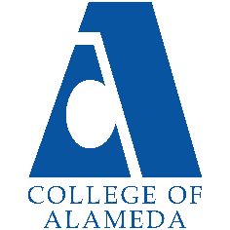
College of Alameda
2023-24 Annual Program Update

Program Overview
Please provide your program’s mission statement and program’s learning outcomes
The mission of the Astronomy Department at College of Alameda is to introduce students to the Universe and insight into its mysteries. Students will learn how observations have shaped theories of basic astronomical phenomena and the evolution of the Universe.
We provide comprehensive and flexible programs that empower students to achieve their goals through offering of online and face-to-face sections of introductory astronomy.

[No degrees and certificates within ASTR]

List your program faculty and/or staff.
Andrew Park – full-timer in PHYS and ASTR
Andrew Fittingoff
Stephen Asztalos
Araceli Lopez-Garibay
Amanda Truitt

Describe your current utilization of facilities, including labs and other space.
In-person ASTR lecture classes are scheduled in similar matter as other CoA in-person classes (shared classrooms in H building or Science Annex). Available lecture demos for ASTR are stored in PHYS stockroom within ATLAN 100.

List your program goals from your most recent Program Review or APU. Then, provide an update on the status of the goal. Has your program achieved the goal? Have any of your goals been revised or are any still in progress? Lastly, make sure to discuss which College or District goal your program goal aligns to.
If no program goals exist or if this is your first program review, work to create 2-3 goals and align them with a College or District goal.
Program Goal | Maintain or Increase ASTR 1/10 offering, and maintain/procure supplies and equipment for ASTR lecture demos.
Status: In-Progress or Complete? | In-Progress: ASTR offering is stable and slightly increasing when intersession is taken into account.
Which college or district goal is aligned with your program goal? | College Goal 2: Provide quality educational and student support services that result in equitable student access to educational opportunities and success in earning a degree or certificate.

Program Goal | Regular online ASTR/PHYS faculty meeting during semester; hold the first meeting by February 2023
Status: In-Progress or Complete? | In-Progress: We held the first meeting on March 10, 2023; we should be holding another meeting in October 2023
Which college or district goal is aligned with your program goal? | College Goal 5: Foster an inclusive and caring culture that thrives on diversity and promotes social justice and equity.

Program Goal | As part of regular online ASTR/PHYS faculty meeting, discuss assessments and possible improvement of pedagogy and improved assessments
Status: In-Progress or Complete? | In-Progress: Need to agenda-ize for next meeting
Which college or district goal is aligned with your program goal? | College Goal 2: Provide quality educational and student support services that result in equitable student access to educational opportunities and success in earning a degree or certificate.

Program Goal | Evaluate feasibility of offering ASTR lab section at CoA, in coordination of Merritt’s ASTR lab section; short update by May 2023
Status: In-Progress or Complete? | In-Progress: Talked about it briefly at the March 2023 meeting; need to continue monitoring progress
Which college or district goal is aligned with your program goal? | College Goal 1: Develop and offer curriculum and learning that is innovative, with industry standards and labor market demands.
Program Update
Using the dashboards, review and reflect upon the data for your program.
Course Completion and Retention Rates – Instructional Dashboard
Course Completion and Retention Rates – Student Services Dashboard
Enrollment Trends and Productivity Dashboard
Degrees and Certificates Dashboard

Course Completion and Retention Rates
Success rates have dropped in the past year (2022-2023) compared to the previous year (2021-2022, at around 70%). Most of the change seems to be related to challenges of bringing in-person instruction back.
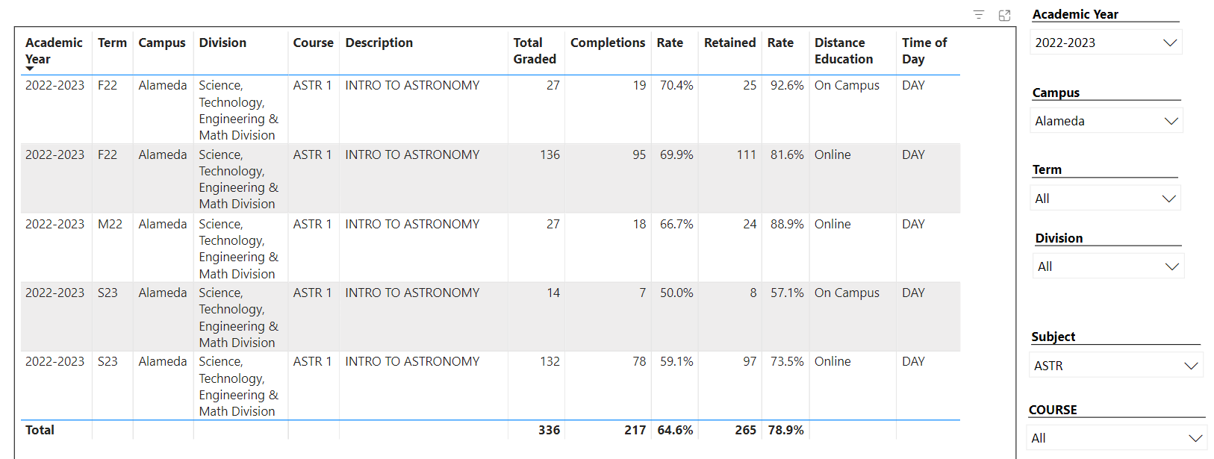

We will continue to monitor and take any corrective steps necessary.

Enrollment Trends
Enrollment trend for ASTR looks good. Our enrollment is at the highest it has been in four years, and while productivity is not as high as it used to be, it is on an upward trend compared to previous year (we will continue to monitor and try to ensure that it continues this trend).
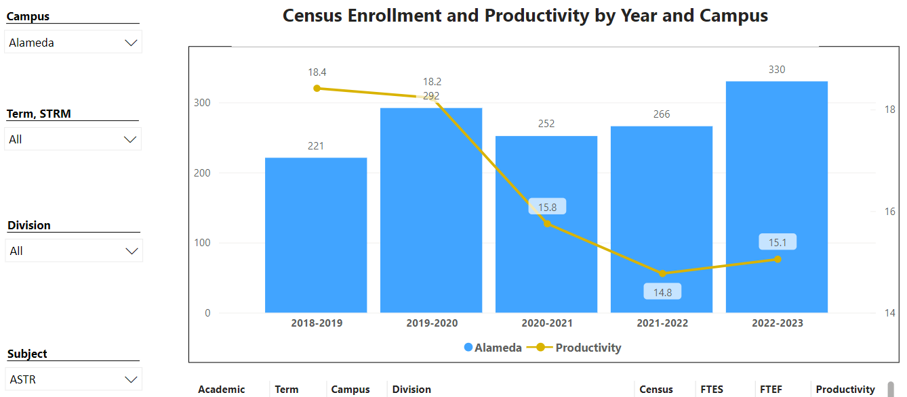

Degrees and Certificates
ASTR has no degrees or certificates, although we would welcome inclusion in contributing to program reviews and APUs for degrees and certificates that contain ASTR courses for physical science general education requirements.

Describe any significant changes and discuss what the changes mean to your program. Consider whether performance gaps exist for disproportionality impacted students by using filters to disaggregate the data. Focus upon the most recent year and/or the years since your last comprehensive program review. Cite data points to support your reflection.
The only “significant change” is bringing back in-person instruction since COVID pandemic. We are committed to maintaining at least one section of ASTR 1 (or ASTR 10) in-person, in order to serve those students who need in-person instruction.

Describe the department's progress on Student Learning Outcomes (SLOs) and/or Service Area Outcomes (SAOs) since the last Program Review/APU.
Latest SLO assessment completed is still from Fall 2019. We do need institutional support for part-time faculty completing SLO assessments. The full-time faculty (Andrew Park) normally would have completed an SLO assessment, but he has not taught an ASTR 1 (or ASTR 10) course in a while.

Describe the outcomes and accomplishments from previous year’s funded resource allocation request. If your program did not receive any allocations, leave the boxes blank.
Brief description of funded request | Source (any additional award outside your base allocation) | Total Award Amount | Outcome/Accomplishment
ASTR lecture demos need continued maintenance. | [this was base allocation] | Around $500? (base allocation) | Keeping astronomy/physics demos stocked

Prioritized Resource Requests Summary
In the boxes below, please add resource requests for your program. If there are no resources requested, leave the boxes blank.
Resource Category | Description/Justification | Total Estimated Cost
Personnel: Classified Staff

Personnel: Student Worker

Personnel: Part Time Faculty | ASTR courses are in demand, and about half of our course sections being offered in Fall 2022 are in intersession. We would like to offer more courses in regular session, or possibly second 8-week session. | ??
Personnel: Full Time Faculty

Resource Category | Description/Justification | Total Estimated Cost
Professional Development: Department wide PD needed | Support for department-wide meeting and SLO assessment efforts is needed. We would like to request a small stipend payment for time part-time faculty spend on assessing SLOs and attend department-wide meeting to discuss SLO assessment results. | $500 - $1000 for all PT faculty participating
Professional Development: Personal/Individual PD needed | Individual faculty will request through PD committee.
Supplies: Software

Supplies: Books, Magazines, and/or Periodicals

Supplies: Instructional Supplies | ASTR lecture demos need continued maintenance. | $500
Supplies: Non-Instructional Supplies

Supplies: Library Collections

Technology & Equipment | There are spaces on CoA campus that can be used to host astronomical observation opportunity (“Star Party”). We need new equipment, specifically telescope, to make this possible. The budget requested here is for entry-level telescopes and accessories capable of observing planets and their features (moons of Jupiter and rings of Saturn). | $2500
Library: Library materials/collections

Facilities: Classrooms/Labs

Facilities: Offices

Other

