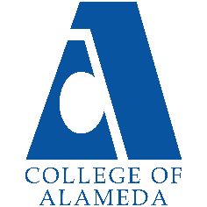
College of Alameda
2023-24 Annual Program Update

Program Overview
Please provide your program’s mission statement and program’s learning outcomes
Peralta Community College District Mission Statement:

We are a collaborative community of colleges. Together, we provide educational leadership for the East Bay, delivering programs and services that sustainably enhance the region’s human, economic, environmental, and social development. We empower our students to achieve their highest aspirations. We develop leaders who create opportunities and transform lives. Together with our partners, we provide our diverse students and communities with equitable access to the educational resources, experiences, and life-long opportunities to meet and exceed their goals. In part, the Peralta Community College District provides accessible, high quality, educational programs and services to meet the following needs of our multi-cultural communities:

• Articulation agreements with a broad array of highly respected Universities;

• Achievement of Associate Degrees of Arts and Science, and certificates of achievement;

• Acquisition of career-technical skills that are compatible with industry demand;

• Promotion of economic development and job growth;

• Foundational basic skills and continuing education;

• Lifelong learning, life skills, civic engagement, and cultural enrichment;

• Early college programs for community high school students;

• Supportive, satisfying, safe and functional work environment for faculty and staff; and

• Preparation for an environmentally sustainable future

The Mission of College of Alameda to serve the educational needs of its diverse community by providing comprehensive and flexible programs and resources that empower students to achieve their goals

Program Mission:

The Business Discipline's mission is closely aligned to COA's Mission: To serve the educational needs of its diverse community by providing comprehensive and flexible programs and resources

that empower students to achieve their goals. The Business Discipline strives to accomplish this mission by offering courses to students:

· Seeking to transfer to a four year institution, or

· Enhance their existing job skills, or

· Aspiring to become Entrepreneurs/Small business managers.

List your program faculty and/or staff.
1. Olga Fish

2. Carolyn Johnson

3. Rochelle Olive

Part-time:

1. P. J Shelton

2. Long Nguyen

3. Alta Erdenbaatar

Describe your current utilization of facilities, including labs and other space.
The Business Department has successfully implemented smart classrooms, which facilitate a seamless integration between traditional face-to-face and online learning modalities. For the upcoming academic year, we plan to offer classes in a hybrid modality, with the assumption that we will continue to utilize these smart classrooms.

List your program goals from your most recent Program Review or APU. Then, provide an update on the status of the goal. Has your program achieved the goal? Have any of your goals been revised or are any still in progress? Lastly, make sure to discuss which College or District goal your program goal aligns to.
If no program goals exist or if this is your first program review, work to create 2-3 goals and align them with a College or District goal.
Program Goal | Continue to complete assessment per each semester and make quality improvement to the scheduling, courses and services provided to students in reference to their successful completion of Accounting/Business
Status: In-Progress or Complete? | In-Progress
Which college or district goal is aligned with your program goal? | College Goal: Increase retention and persistence rates

Program Goal
Status: In-Progress or Complete? | In-Progress
Which college or district goal is aligned with your program goal? | College Goal: empower students to achieve their goals.

Program Goal
Status: In-Progress or Complete? | In-Progress

Program Update
Using the dashboards, review and reflect upon the data for your program.
Course Completion and Retention Rates – Instructional Dashboard
Course Completion and Retention Rates – Student Services Dashboard
Enrollment Trends and Productivity Dashboard
Degrees and Certificates Dashboard

Course Completion and Retention Rates
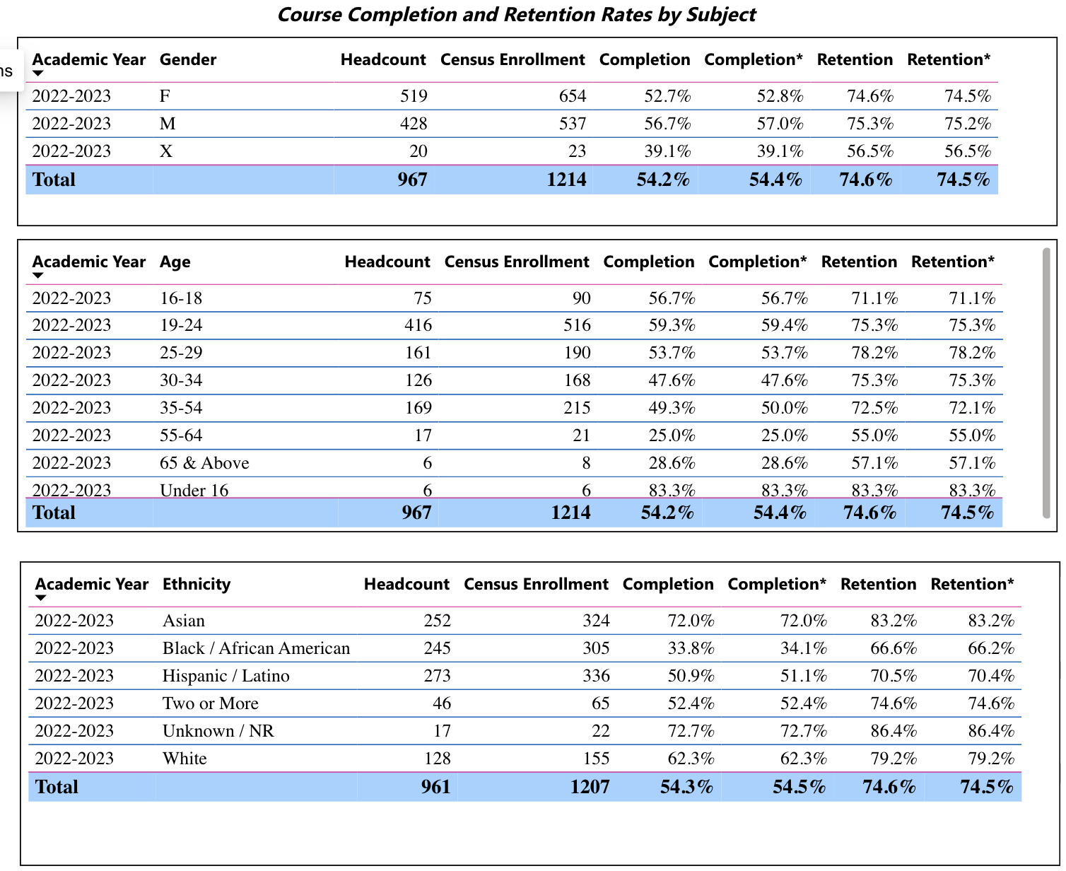

Enrollment Trends
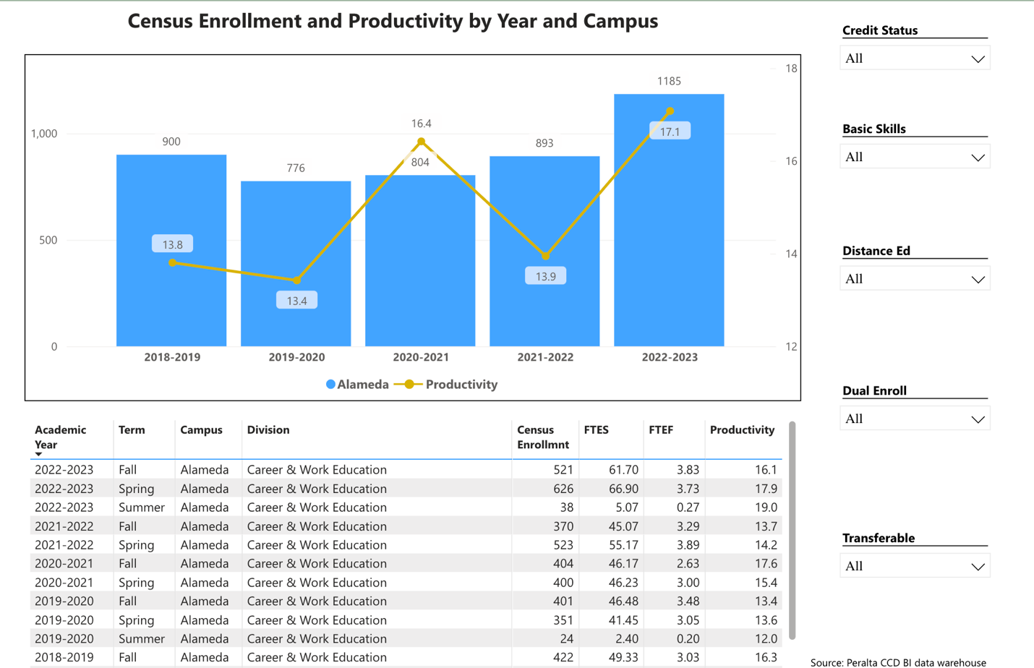

Enrollment increased by 4% in 2022-2023 compare to previous academic year.

Degrees and Certificates
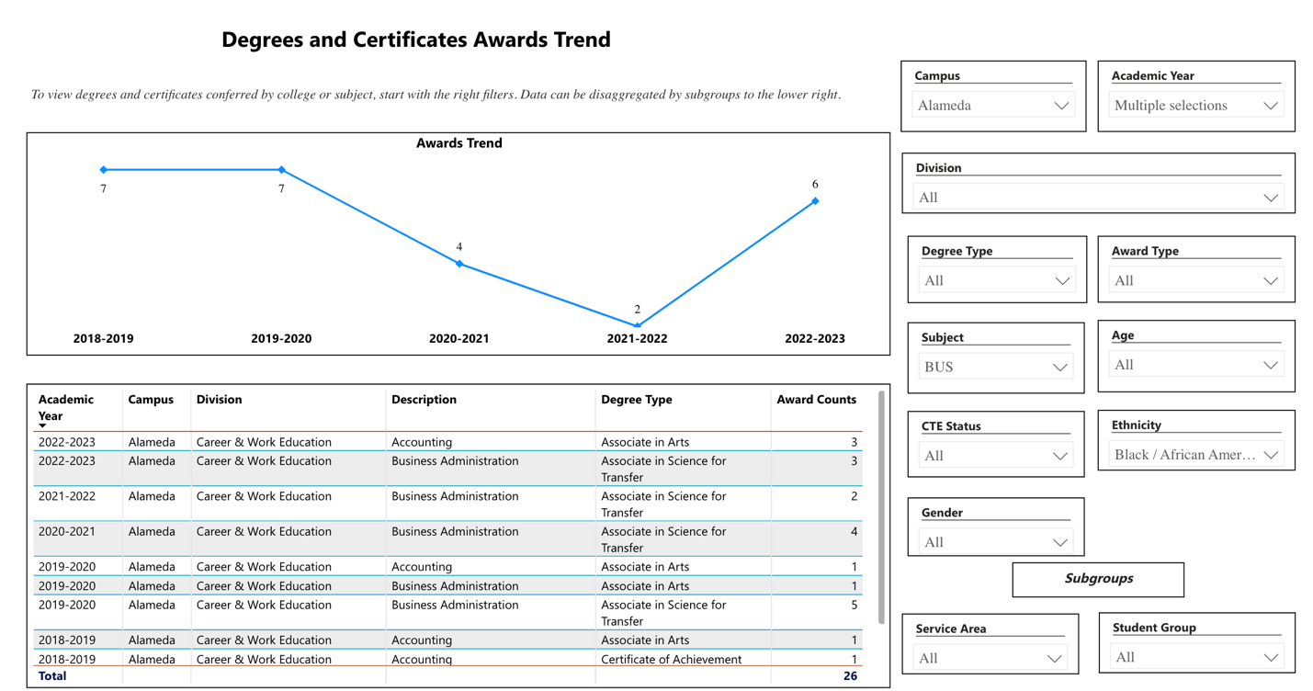

Decrees and certificates trend is positive compare to previous academic year.

Describe any significant changes and discuss what the changes mean to your program. Consider whether performance gaps exist for disproportionality impacted students by using filters to disaggregate the data. Focus upon the most recent year and/or the years since your last comprehensive program review. Cite data points to support your reflection.
In the academic year 2022-23, the retention rate for courses within our discipline stands at 74.5%, surpassing the College of Alameda's average. Notably, there is an observed performance disparity of 12% among different ethnic groups. Specifically, White students exhibited a retention rate of 79%, while Black/African American students had a retention rate of 66.2%, and Hispanic/Latino students had a retention rate of 70.4%. On the other hand, students from all other ethnic backgrounds maintained notably higher retention rates, typically in the high 80s and 90s.

Describe the department's progress on Student Learning Outcomes (SLOs) and/or Service Area Outcomes (SAOs) since the last Program Review/APU.
SLO’s have assessed 40% with the intent that the remaining 60% will be assessed this year.

Describe the outcomes and accomplishments from previous year’s funded resource allocation request. If your program did not receive any allocations, leave the boxes blank.
Brief description of funded request | Source (any additional award outside your base allocation) | Total Award Amount | Outcome/Accomplishment
N/A

Prioritized Resource Requests Summary
In the boxes below, please add resource requests for your program. If there are no resources requested, leave the boxes blank.
Resource Category | Description/Justification | Total Estimated Cost
Personnel: Classified Staff | N/A
Personnel: Student Worker | N/A
Personnel: Part Time Faculty | N/A
Personnel: Full Time Faculty | N/A

Resource Category | Description/Justification | Total Estimated Cost
Professional Development: Department wide PD needed | To attend professional conferences $5K per faculty (6 faculty are in BUS department) | $30K
Professional Development: Personal/Individual PD needed | To attend professional conferences $5K per faculty (6 faculty are in BUS department) | $30K
Supplies: Software

Supplies: Books, Magazines, and/or Periodicals | WSJ subscription for faculty and students | $200
Supplies: Instructional Supplies | This allowed us to purchase instructional equipment and supplies. | $5000
Supplies: Non-Instructional Supplies | N/A
Supplies: Library Collections | N/A
Technology & Equipment | Computers, Laptops, Ipads per faculty as needed $5K per faculty | $30K
Library: Library materials/collections | N/A
Facilities: Classrooms/Labs | N/A
Facilities: Offices | N/A
Other

