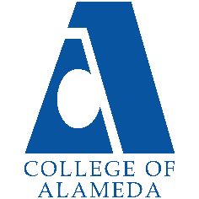
College of Alameda
2023-24 Annual Program Update

Program Overview
Please provide your program’s mission statement and program’s learning outcomes
The objectives of the Dance Department include providing introductory courses that meet requirements of Associate of Arts (AA) degrees (including Dance Certificate of Achievement), courses geared toward a wide variety of dance techniques, dance history, and dance choreography transfer courses to four-year Universities and Colleges, and prerequisites for premier professional dance schools such as, Mills College, NYU, UC Berkeley, Cal-Arts, Cal-State Long Beach, UC Irvine, and Duke University.

List your program faculty and/or staff.
Danny Nguyen
Abbie Ackerman

Describe your current utilization of facilities, including labs and other space.
Dance studio G-111 is a single, large 3,400 square feet studio which can be utilized as a performance studio at least twice a year like other colleges (i.e. Mills, CCSF, Foothill, and Contra Costa). The performance capabilities have been moderately improved by adding some portable stage lights, side curtains (“Wings”) and back curtains to cover the mirrors when the department holds a performance.

G-111 needs seating for about 150-person audience, such as bleachers in the back of the studio, preferably collapsible to make them easy to store out of the way during classes and make ready for use with performances.

We may attract more attention if we post a large sign (COA Dance Department) right outside the street-side walls of G-111.

List your program goals from your most recent Program Review or APU. Then, provide an update on the status of the goal. Has your program achieved the goal? Have any of your goals been revised or are any still in progress? Lastly, make sure to discuss which College or District goal your program goal aligns to.
If no program goals exist or if this is your first program review, work to create 2-3 goals and align them with a College or District goal.
Program Goal | Prepare students to start at a variety of dance levels, from very basic to professional level.
Status: In-Progress or Complete? | In-Progress
Which college or district goal is aligned with your program goal? | Goal 2: Provide quality educational and student support services that result in equitable student access to educational opportunities and success in earning a degree or certificate.

Program Goal | Challenge students to reach higher and farther than they think they can.
Status: In-Progress or Complete? | In-Progress
Which college or district goal is aligned with your program goal? | Goal 5: Foster an inclusive and caring culture that thrives on diversity and promotes social justice and equity.

Program Goal | Prepare students to teach beginning level dance at private dance studios and public schools.
Status: In-Progress or Complete? | In-Progress
Which college or district goal is aligned with your program goal? | Goal 1: Develop and offer curriculum and learning that is innovative, with industry standards and labor market demands.

Program Update
Using the dashboards, review and reflect upon the data for your program.
Course Completion and Retention Rates – Instructional Dashboard
Course Completion and Retention Rates – Student Services Dashboard
Enrollment Trends and Productivity Dashboard
Degrees and Certificates Dashboard

Course Completion and Retention Rates
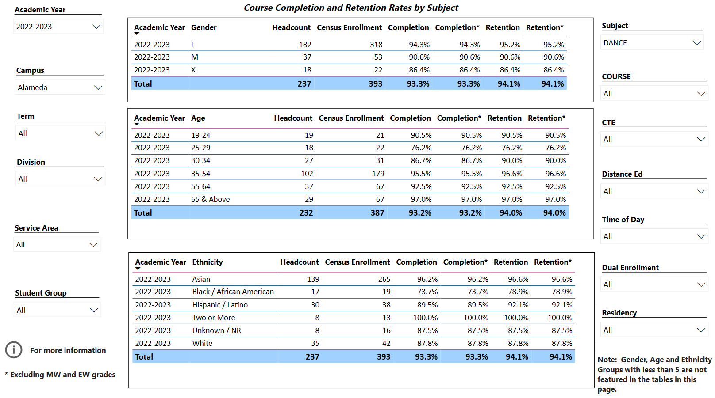

Traditionally our course completion success rates have been higher than the standard set by the College and we continue to maintain a very high success rate.

Enrollment Trends
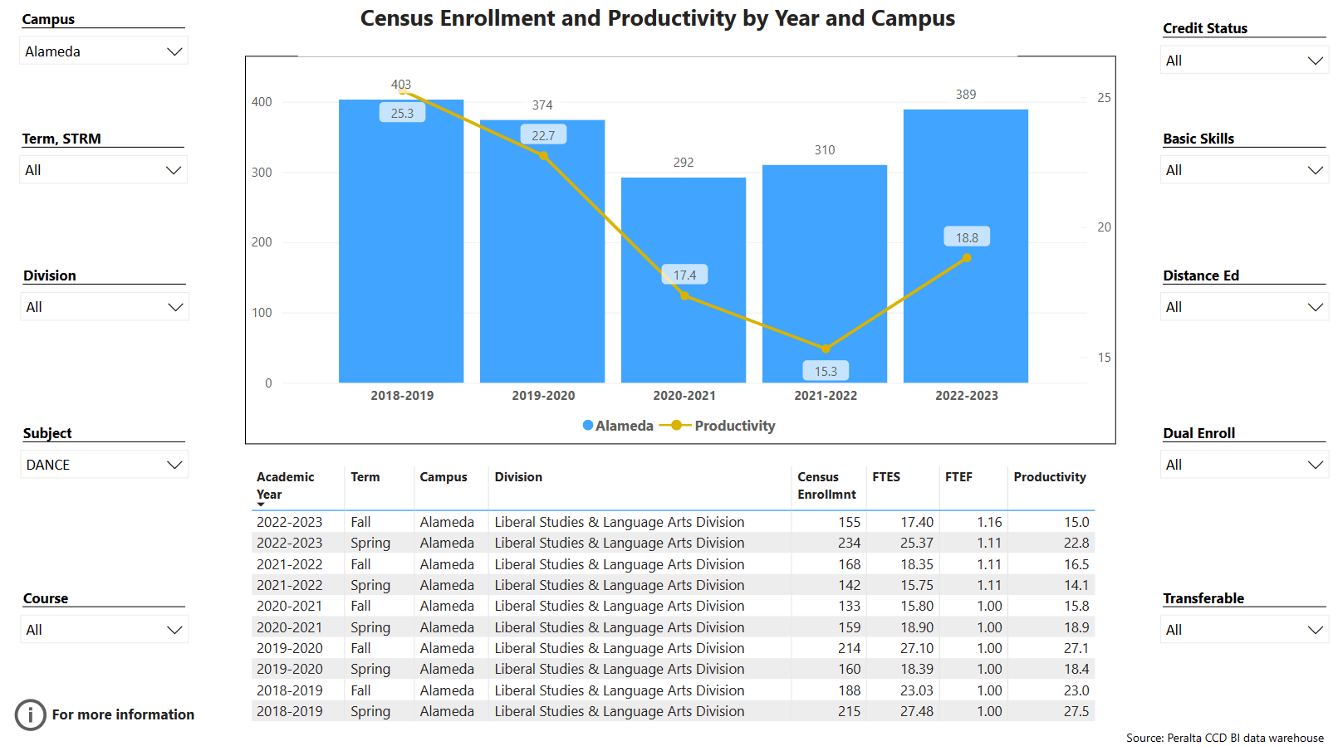
Dance Department enrollment trends for years prior to the 2021-2022 COVID-19 pandemic had been on a steady rise. Returning from COVID-19, enrollment had already started to increase in 2021-2022, and we are on our way to recovering pre-COVID enrollment and productivity trends.

Degrees and Certificates
A.A. Degree in Dance and Dance Certificate of Achievement were approved by CoA Curriculum Committee in Spring 2022 and the programs were implemented in Spring 2023. We need help advising students in meeting requirements for the A.A. degree and/or the certificate.

Describe any significant changes and discuss what the changes mean to your program. Consider whether performance gaps exist for disproportionality impacted students by using filters to disaggregate the data. Focus upon the most recent year and/or the years since your last comprehensive program review. Cite data points to support your reflection.
There have been no significant changes since the last program review.

Describe the department's progress on Student Learning Outcomes (SLOs) and/or Service Area Outcomes (SAOs) since the last Program Review/APU.
The DANCE department continues to keep up with SLO assessments and participate in ongoing assessment in cooperation with the college community. The dance program is aligned with the college vision.

Describe the outcomes and accomplishments from previous year’s funded resource allocation request. If your program did not receive any allocations, leave the boxes blank.
Brief description of funded request | Source (any additional award outside your base allocation) | Total Award Amount | Outcome/Accomplishment
Portable speakers, screen and projector, and more portable lights |  | ~ $15,000 | The new equipment was purchased, installed and / or made ready for use, and has already been put into use during Fall 2023 semester.

Prioritized Resource Requests Summary
In the boxes below, please add resource requests for your program. If there are no resources requested, leave the boxes blank.
Resource Category | Description/Justification | Total Estimated Cost
Personnel: Classified Staff

Personnel: Student Worker

Personnel: Part Time Faculty | Funding a part- or full-time classical musical accompanist, with deep knowledge of music as it relates to dance
Personnel: Full Time Faculty

Resource Category | Description/Justification | Total Estimated Cost
Professional Development: Department wide PD needed
Professional Development: Personal/Individual PD needed
Supplies: Software

Supplies: Books, Magazines, and/or Periodicals

Supplies: Instructional Supplies | Gaffer tape, glow-tape, masking tape, duct tape, Velcro removable ties | ~ $800
Supplies: Non-Instructional Supplies

Supplies: Library Collections

Technology & Equipment

Library: Library materials/collections

Facilities: Classrooms/Labs | [Funding] Since COA does not have a theater, it has been a long-standing Dance Department goal to renovate the existing studio such that a more traditional stage space for performance, teaching, and rehearsal might be utilized. Consider adding about 150-seat collapsible theater seats or bleachers in the back of the studio, which would come right up to the entrance.
Facilities: Offices

Other | Continue leading and advising student community dance club(s) at COA, to give students an opportunity to get together and gain performance experience, build confidence, outside the classroom environment.

