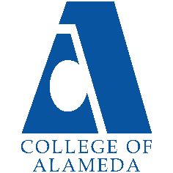
College of Alameda
2023-24 Annual Program Update

Program Overview
Please provide your program’s mission statement and program’s learning outcomes
The COA Diesel and Truck Mechanics Programs provide students of all experience levels with comprehensive knowledge and skills covering Diesel Engines and Truck Mechanics and Chassis Systems. Through lecture and hands-on lab courses, students will learn the skills required to troubleshoot and repair mechanical, electrical and electronic systems in diesel engines and trucks. Students will learn to use computers to diagnose equipment and research information. Students will be trained to operate shop machinery and equipment as well as select and use precision tools involved in the repair and maintenance of mechanical and electronic systems.

List your program faculty and/or staff.
John Taylor and Blair Norton as Co-Chairs and full-time instructors
Si Yazid Kahil as part-time instructor

Describe your current utilization of facilities, including labs and other space.
Current utilization is Monday through Thursday Mornings from approximately 7 AM to 1 PM.
Monday through Thursday evenings from approximately 4:30 PM to 10: 15 PM.
Intermittent contract education CCDET diesel emissions classes offered on Fridays and some Saturdays each semester. Special functions such as our Electric School Bus Train the Trainer sessions on Saturdays; our last one held on Saturday, October 29, 2022.
We held our first summer offering for an introductory diesel mechanics course in summer of 2022. We repeated that summer course this summer, 2023 as well.
We also offered a pre-apprentice course in the afternoons through a grant program, but that grant has now completed. As a result, some of our former pre-apprentice students were hired with full-time jobs at local union shops and are now attending our regular semester apprenticeship classes. We intermittently offer forklift training on an as needed basis in the afternoons.

List your program goals from your most recent Program Review or APU. Then, provide an update on the status of the goal. Has your program achieved the goal? Have any of your goals been revised or are any still in progress? Lastly, make sure to discuss which College or District goal your program goal aligns to.
If no program goals exist or if this is your first program review, work to create 2-3 goals and align them with a College or District goal.
Program Goal | The design and construction of our new facility
Status: In-Progress* | The facility work has broken ground. We attended the groundbreaking ceremony in Spring of 2023, after several delays. *We have serious concerns about the faithful continuation of the interior furnishing as it was resourced in the original plan. Please see the last entry titled: Other: New Transportation Facility Progress and Concerns in the Prioritized Resource Requests Summary section.
Which college or district goal is aligned with your program goal? | Develop and Manage Resources to Advance Our Mission

Program Goal | Develop partnerships with Industry related educational opportunities:
Complete | Our work with Peterbilt University has paid off. We now have current students enrolled into the online learning program, with the potential for job offers for those that apply themselves with this opportunity. We also held a field trip for students in Spring 2023 at Peterbilt in San Leandro. It was very successful with multiple students expressing interest, staying to talk about potential jobs with Peterbilt personnel, and signing up for Peterbilt University program.
Which college or district goal is aligned with your program goal? | Develop and Manage Resources to Advance Our Mission

Program Goal (New goal) | Become the new referee station for the new California Heavy Duty Truck Emissions IM Testing Program in this sector.
Status: In-Progress or Complete? | In progress through the contracted State Colleges of UC Riverside and Fresno State with the California Air Resources Board. We just received a contract draft for this project on 10-13-23. We have submitted it to our Dean for commencing the review process with Administration, District, and Legal. We’ve already laid the groundwork for our Part-time faculty to manage this station and are looking forward to the opportunities to intern some of our students for this new station.
Which college or district goal is aligned with your program goal? | Develop and Manage Resources to Advance Our Mission

Program Goal (New goal) | A limited agreement with a new Alameda start-up company
Status: In-Progress | We developed a new relationship with Nobel Thermodynamics in the City of Alameda. We are writing to support their efforts with grant funding for their work in reducing emissions with their experimental engines projects.  They are conducting presentations for our engines classes with the experimental technology concepts and testing results with their engine lab in Richmond. They also have an internship position for one of our students at that engine lab.  Our next in-class presentation is scheduled for the evening engine class on Tuesday, 10/24/23. All DMECH students are invited.
Which college or district goal is aligned with your program goal? | Develop and Manage Resources to Advance Our Mission

Program Update
Using the dashboards, review and reflect upon the data for your program.
Course Completion and Retention Rates – Instructional Dashboard
Course Completion and Retention Rates – Student Services Dashboard
Enrollment Trends and Productivity Dashboard
Degrees and Certificates Dashboard

Course Completion and Retention Rates
Comparisons of Completion and retention rates for DMECH with the District and COA in general
reveal the following:
The screen captures below these comments were utilized to emphasize this information
District wide averages for completion rates are 69.55% and retention rates are 83.55%.
College CE Course Completion rates averaged for the year were 73.2% and Retention Rates were 84.7%.
(CE listed at the top of the table for spring 23, and 3 lines below that for Fall 22 at COA.)
DMECH totals for the year were 78.4% completion and 80.7% Retention.
We exceeded the averages of the District Completion rates by +8.85% and the College CE Completion rates
By +5.2%.
The District retention rates were +2.85% higher than our average.
The College retention rates were +4.0%
Regarding these retention rates, those students who completed our program were dedicated in their choice of pursuing this field for their intended careers.
Of the lower percentage regarding retention, we are one of the few areas of study where students enroll due to being given a choice of going to work after high school or continuing with some type of classes as an alternative to work, while they figure it out. Many from underprivileged households.
Some not knowing what they want to do, except that they do not wish to pursue a 4-year degree. They enroll in these courses, thinking that it will be easy and that they can do labs instead of doing college level work and coast along for the 2 years while earning a certificate.
Once they enter our program, they coast along until they are failing and can’t make up all of the assigned work and evaluations that they’ve neglected and failed, until it’s too late.
This happens even with coaching, reminders, extensions, and warnings about the consequences.
At least 90% of those students that are guaranteed failure do not even drop themselves, but rely on our faculty to issue a Withdrawal at Attendance Verification to protect them from receiving a failure record on their permanent transcripts, with all of them having received coaching and consultations on an individual basis with their faculty, prior to that date.
We actually feel very lucky and rewarded when we are able to turn a few of them around and convince them to put more effort into their courses to succeed. We strive to save all of them.
Helping them to succeed can make such a huge difference in their futures, it also helps the Department, the College, and the District, and the local community and employers in our area, and raises the potential for issuing more certifications.
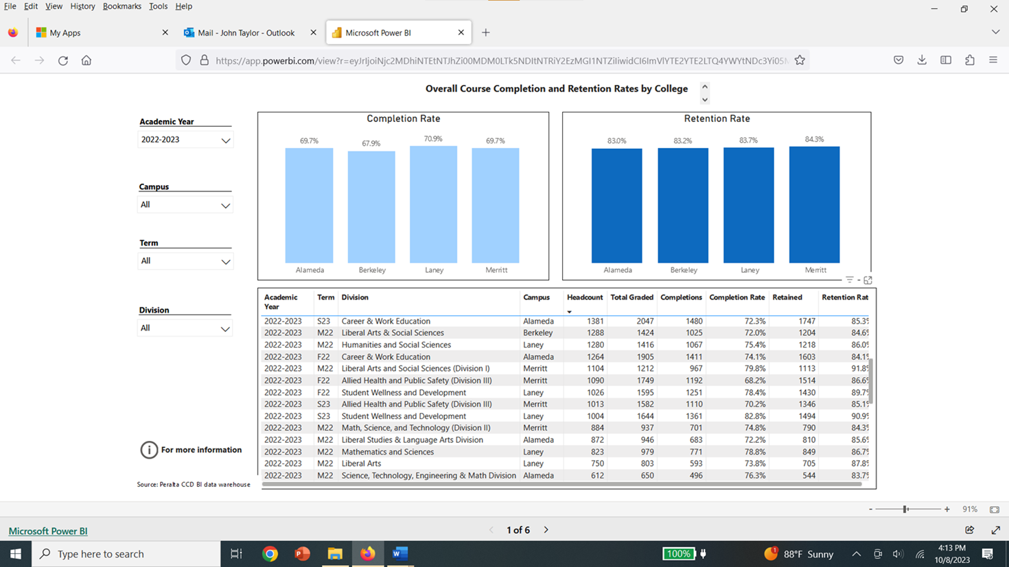

Page 3 by subject Selection DMECH Capture:
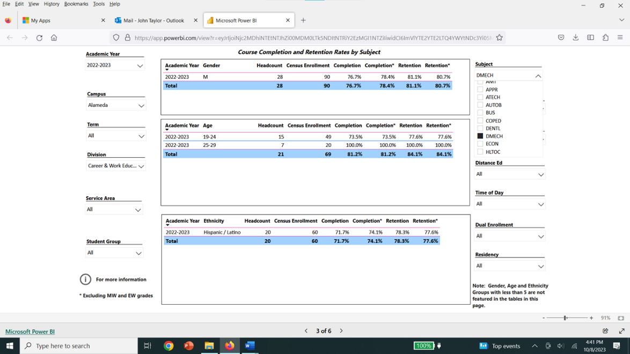

By DMECH individual classes:
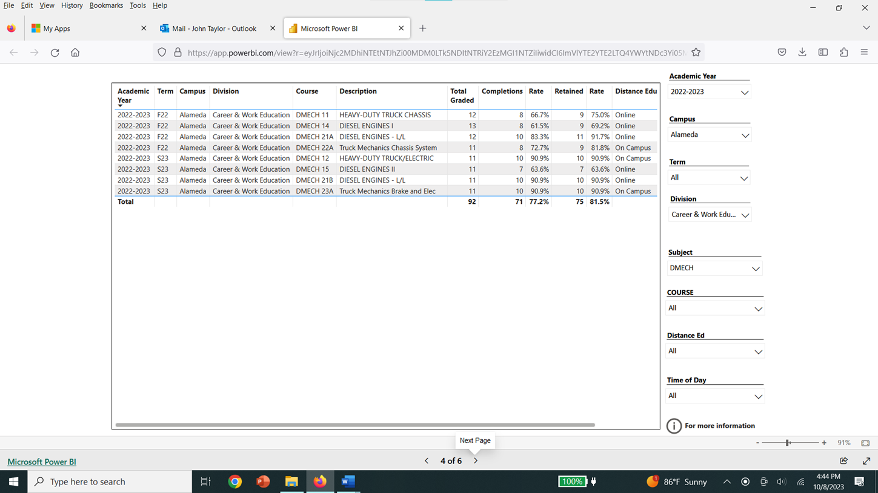

Enrollment Trends
Enrollment stats’ finally bottomed out for our program, near the end of the Pandemic, year 2021 – 2022.
We are now seeing the trend reversing with last year. And this year our numbers are improving further in a positive direction. We feel confident that this upward trend will continue with all of the work we are doing regarding recruiting, word of mouth, contract education, hosting tours, conducting field trips, arranging internships, inviting industry guest speakers, designing and building our new facility, securing grant funding for new equipment and tools, etc. Whenever we discover any opportunities to promote, enhance, and represent our program, we are dedicated and jump at those chances to improve and exceed our enrollment opportunities.

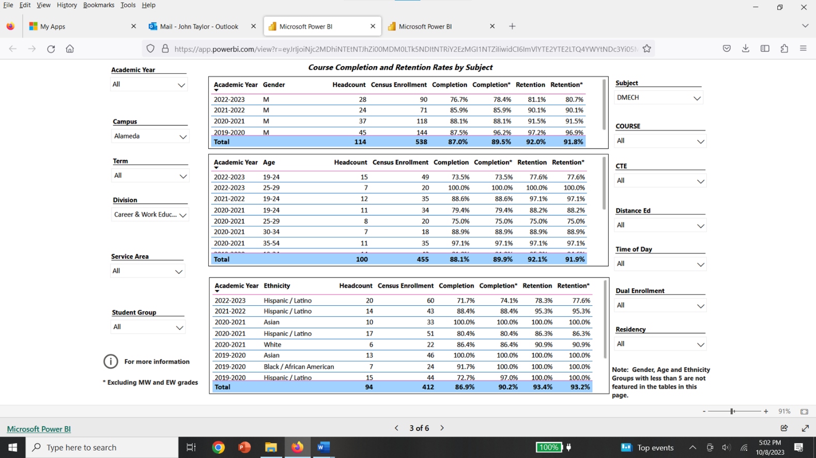

Degrees and Certificates
Our certificate levels have been dropping since the pandemic, as were the District and the College. Many of our students could not apply for their certificates due to the two extra welding and air conditioning courses necessary for their certificates that weren’t being offered at COA or the district, due to course cutbacks, or that didn’t fit their schedules, since we offer both Morning and Evening scheduling in our department.
Those students are now taking those required classes at surrounding colleges and receiving course substitution cards for their efforts. One of my students from last spring who completed our core classes that semester just ordered his official transcripts this week for his application for his DMECH certificate. I had already signed and submitted his course substitution request.
I helped him to understand the transcript process after slightly inadequate instruction given to him via email from the district.

Describe any significant changes and discuss what the changes mean to your program. Consider whether performance gaps exist for disproportionality impacted students by using filters to disaggregate the data. Focus upon the most recent year and/or the years since your last comprehensive program review. Cite data points to support your reflection.
We’ve modified our classes from mandating Online only instruction via zoom and canvas for lectures and Hybrid courses with our labs. We’re back to 100% in person for lectures and labs, with hybrid items to complement our labs, and with the beneficial use of canvas for more efficient student management of studies and delivery of materials and assignments, announcements, etc.
We feel that for our CE courses, students perform better, and enrollment is enhanced with in-person classes. We are slowly climbing in enrollment with these changes, as reflected in the included tables above, although other factors with the pandemic and the economy and Statewide enrollment issues could also be part of the equation that affected these statistics.

Describe the department's progress on Student Learning Outcomes (SLOs) and/or Service Area Outcomes (SAOs) since the last Program Review/APU.
Our students that finish our courses score relatively high in their learning outcomes, based on our written tests with embedded questions and our performance testing for their hands-on skills.

Describe the outcomes and accomplishments from previous year’s funded resource allocation request. If your program did not receive any allocations, leave the boxes blank.
Brief description of funded request | Source (any additional award outside your base allocation) | Total Award Amount | Outcome/Accomplishment
Professional Development: Department wide P.D. needed  to attend the NWDIC diesel instructors conference in Oregon in the beginning of March, spring of 2023 | Professional Development funds were requested for at least one faculty member | $0* | * We didn’t receive funding from PD for this but wish to include this comment for future consideration with Peralta regulations and professional development rules regarding deadlines.  If it’s possible to fund this trip and get approval with the board in 30 days, for an out of state trip, (which we did,) why can’t Professional Development be done in the same time frame, once they meet and approve the requests? The Conference notice and invitation didn’t come out sooner so we couldn’t request until we had it.  Although we knew the conference would be sometime that spring in that location, we didn’t have the other information to start the process.  “The time frame for the upcoming conference is not possible given the out-of-state location and Peralta processes. A 90-day period is needed.” We attended the NWDIC in March 2023. Funds were drawn from fund 11, cost center 255, project 35, account 23. Travel and arrangements were flawless in their delivery. The poor training video with no expense report instruction for after the expense requests and funding, and lack of adequate training, (which wasn’t available until 2 months later,) in the new People-soft system for travel requests, and for the filing of the final travel reports after the trip were more difficult, time consuming, filled with glitches and insufficient funds after receiving the funding codes, submissions not completing, and delays in being reimbursed for our faculty. This was a horrible, time consuming experience of trial and error with extensive delays!
Professional Development: Personal/Individual PD needed. |  | $350 | The spring 2023 CAT conference for 3 instructors at Evergreen College in San Jose. We attended the conference on Saturday, April 29^{th,} 2023.

Prioritized Resource Requests Summary
In the boxes below, please add resource requests for your program. If there are no resources requested, leave the boxes blank.
Resource Category | Description/Justification | Total Estimated Cost
Personnel: Classified Staff

Personnel: Student Worker | Tool room / equipment helpers for 4 classes over the two semesters for our current lab courses. | $15,000
Personnel: Part Time Faculty
Personnel: Full Time Faculty | A replacement full time faculty for one of our tenured faculty who will be retiring at the end of this current school year, spring 2024.  We have an apprentice program agreement with the East Bay Machinist’s Union.  All 4 of our core lecture classes are part of that apprenticeship program with them.  They enroll new and existing apprentices in each of those courses, each semester. The apprentices are combined with our generic DMECH students into one class with two separate course codes for each lecture course.  This agreement substantially enhances our enrollment in our program. More so for our evening courses, which alternate each school year, since most apprentices are working a day shift and attend classes at night.  Our 4 core classes, along with our accompanying lab classes, are required for our generic students to earn their certificate or an AS degree in this field. It’s imperative that we have all 4 classes available each year, by offering both the morning and evening rotational scheduling so that students can complete their 4-semester course requirements within 2 years.  They can do this by attending mornings or evenings and stay on the same track, while most of them are working in this industry with internships, apprenticeships, and other part- or full-time employment positions.  To cut back would be disastrous to our students, the apprentices, and severely limit our growing enrollment trend, now that the pandemic’s effects are dissipating. The lab classes that accompany our core lecture classes are designed to mirror the content covered in the lecture classes, and develop the hands-on skills necessary for our students to perform and thrive in this industry. Cutting our core offerings would also upset the relationships we’ve built with our industry partners if students had to request re-scheduling each year due to courses being cut. This would also result in less certificates being issued each year. | $90,000

Resource Category | Description/Justification | Total Estimated Cost
Professional Development: Department wide PD needed | Attend the upcoming Spring 2024 CAT conference in Northern California.  So far, no college has been willing to host the 2024 Northwest Diesel Instructor’s Conference. The designated college had to back out and there are no bids so far to replace and host next year’s event. | $350 for all 3 faculty combined.
Professional Development: Personal/Individual PD needed
Supplies: Software | Subscriptions to manufacturer related software such as Cummins, Freightliner, Volvo, Mitchell, etc. | $5,000
Supplies: Books, Magazines, and/or Periodicals

Supplies: Instructional Supplies | Oil, gasket sets, fasteners, small parts, replacement sensors, and thread repair kits. | $8,000
Supplies: Non-Instructional Supplies | Printing toner, paper, batteries, replacement work lights and miscellaneous small tools. | $2,500
Supplies: Library Collections

Technology & Equipment | We are still trying to acquire a set of mobile Heavy Duty Vehicle Lifts for our Department. We’ve been requesting this for about 11 years now. This was the only equipment we asked for when discussing equipment for our new facility. Our one drive on-hoist is old, limits our capabilities, and restricts us to only one fixed bay with no options to lift vehicles in other bays or the work yard. This is a very inefficient use of space. The lift system we’re requesting has been our industry standard for over 30 years. | $85,000 - $90,000
Library: Library materials/collections
Facilities: Classrooms/Labs | A new facility is currently being built. Except for maintaining the existing facility at Building E, in an operational state, with functioning heat, compressed air, power, lighting, water, and air quality, we are not recommending any expense in improvements for this existing facility, except for improvements that can be transferred from the old facility to the new one.  We’d like to repeat our request for a new portable lift system here as well. | $85,000 - $90,000  (See highlighted section next page.)
Facilities: Offices | Same as above. We are not recommending any expense in improvements for this existing facility.
Other: New Transportation Facility Progress and Concerns | For the new Transportation Technology building currently under construction, we have worked with Snap-On Tools Corporation and the entire design team to design, plan, and furnish our new facility. They designed our cabinetry, classroom, storage, and shop fixtures and layout at no cost with the agreement that we utilize their superior equipment for this design. Their fixtures are specifically designed for the tools, equipment, Heavy components, etc. that we utilize in our departments, and especially with our Heavy Duty Truck and Diesel Mechanics; DMECH Department.  We want to emphasize that altering this plan and attempting to change suppliers and start over with the design, will not only lead to potential costly delays, but also to an inferior product that won’t withstand the tough requirements necessary for our program. Nor would the new facility look nearly as professional for our students, and our potential students touring from our local high schools, and our industry supporters, our advisory committee members, parents, and local agencies that we are developing partnerships with. | Delays slowing the construction schedule leading to potential cost overruns from original quotes.

