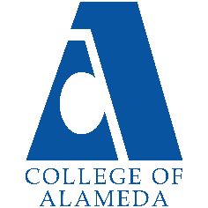
College of Alameda
2023-24 Annual Program Update

Program Overview
Please provide your program’s mission statement and program’s learning outcomes

Program Overview
Humanities is an interdisciplinary field that involves the study of creative human thought and expression. The main objective of studying Humanities at College of Alameda is to examine significant cultural artifacts, enduring artistic creations, and touchstone ideas and beliefs from a variety of scholarly and personal perspectives. As an integral part of general education, Humanities encourages students to examine diverse forms of creativity and innovation to gain perspective on their own lives and the world around them. COA courses in the Humanities
typically explore such fields as the visual arts, literature, media, popular culture, folklore, storytelling, humor, games, religion, music, dance, cuisine, fashion, tourism, and technology.

Program Learning Outcomes
Upon completion of this program a student will be able to:
- Increase critical understanding of the aesthetics of human-made environments.
- Analyze selected works of creative expression in relation to various historical and cultural contexts.
- Synthesize elements from a wide range of disciplines to appreciate and evaluate artworks, ideas, and performances from around the world.

List your program faculty and/or staff.
Dr. Matthew Goldstein
Dr. Cassie Lipowitz
Dr. Lisa Arellano

Describe your current utilization of facilities, including labs and other space.
The department utilizes classrooms on campus equipped with modern instructional technologies such as an interactive whiteboard, digital projector, and document camera. However, the department primarily relies upon online resources through the Canvas learning management system as many classes remain online.

List your program goals from your most recent Program Review or APU. Then, provide an update on the status of the goal. Has your program achieved the goal? Have any of your goals been revised or are any still in progress? Lastly, make sure to discuss which College or District goal your program goal aligns to.
If no program goals exist or if this is your first program review, work to create 2-3 goals and align them with a College or District goal.

Program Goal | Continue SLO assessments and stay current every year.
Status: In-Progress or Complete? | Complete: We continue to remain up to date on SLO assessment.
Which college or district goal is aligned with your program goal? | College Goal: Data-Driven Decision Making  District Goal: Build Programs of Distinction

Program Goal | Expand the number of courses offered. This will allow our department to increase our reach and allow students to use our courses to meet diverse personal and academic goals.
Status: In-Progress or Complete? | In-Progress: We successfully offered HUM60 Intro to LGBTQ Studies for the second year in a row. We plan to continue offering it and request assistance from our Public Information Officer (PIO) for help marketing the course.
Which college or district goal is aligned with your program goal? | College: Advance CoA teaching and learning  District: Advance Student Access, Equity, and Success

Program Goal | Increase faculty access to technology and digital teaching tools.
Status: In-Progress or Complete? | Complete: The technology in the new Liberal Studies and Language Arts building allows faculty to access the newest technology and teaching tools. We strongly recommend that the college engage faculty as we explore technology and the potential for future hyflex instruction.
Which college or district goal is aligned with your program goal? | College: Advance CoA teaching and learning  District: Advance Student Access, Equity, and Success

Program Update
Using the dashboards, review and reflect upon the data for your program.
Course Completion and Retention Rates – Instructional Dashboard
Course Completion and Retention Rates – Student Services Dashboard
Enrollment Trends and Productivity Dashboard
Degrees and Certificates Dashboard

Course Completion and Retention Rates
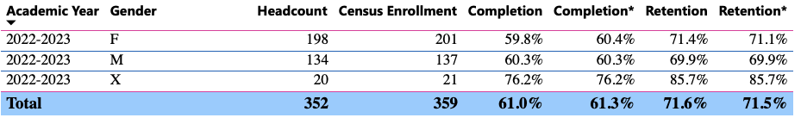
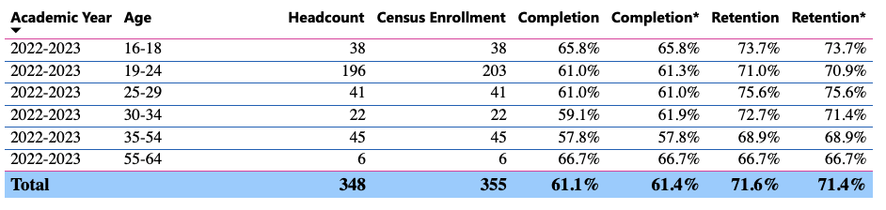
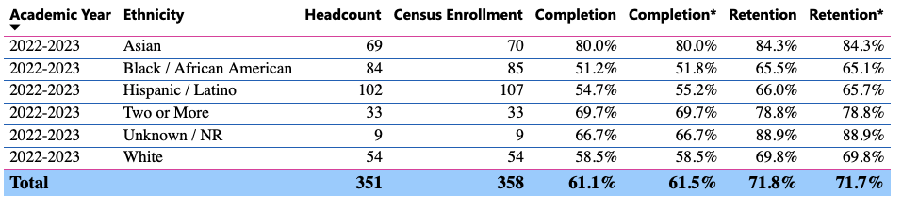
The general trend toward online instruction continues to affect completion and retention rates, particularly among underserved communities; the digital divide yawns, and differences in relevant success metrics likely spring from uneven distribution of equipment, access, and training. Although a small sample, HUMAN data point to lower than average Latinx and African American completion rates. Taken together these two groups represent over half the total HUMAN enrollment, so addressing student needs—by, e.g., making more tutoring and tech access/training available—would likely go some way toward improving outcomes.

Enrollment Trends
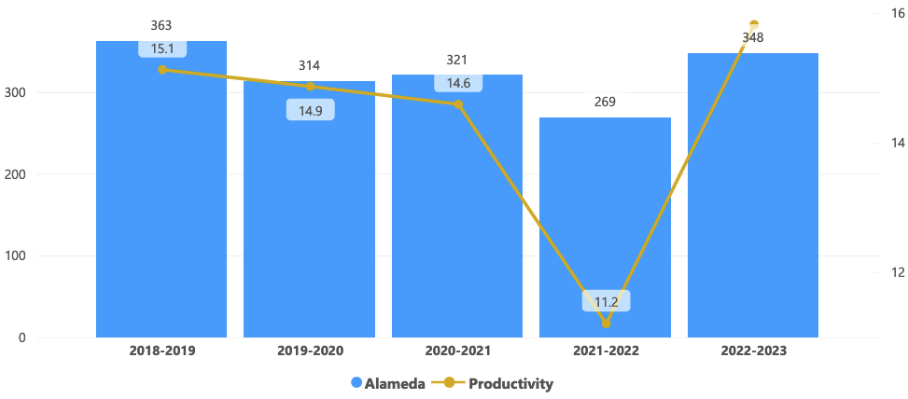

Humanities enrollment has largely mirrored college-wide trends, with declines experienced during the roughest periods of COVID-19 restrictions, and increases starting to gather steam as restrictions have been lifted. Productivity—never a particularly useful metric for determining pedagogical integrity, intellectual rigor, or student-support effectiveness—appears to have risen beyond pre-pandemic levels.

Degrees and Certificates
Humanities offers an AA degree.

Describe any significant changes and discuss what the changes mean to your program. Consider whether performance gaps exist for disproportionality impacted students by using filters to disaggregate the data. Focus upon the most recent year and/or the years since your last comprehensive program review. Cite data points to support your reflection.
The regular offering of queer studies has added depth and breadth to CoA’s HUMAN discipline; still, completion rates for HUMAN 60 have for the most part followed those of other courses on offer. African American completion stood at an anomalous 28.6% in the one spring 2023 section of HUMAN 60, but it’s a figure that, owing to a vanishingly small sample size (7), may or may not be especially significant (the seven white students in a spring 2023 section of HUMAN 13A likewise completed at 28.6%). The need for increased access to tutoring an technology—as well as hands-on instruction in Canvas and online learning—again is apparent, all the more so for students on the wrong side of the digital divide.

Describe the department's progress on Student Learning Outcomes (SLOs) and/or Service Area Outcomes (SAOs) since the last Program Review/APU.
All SLO data and analysis are updated in CurrIQunet. Lead Humanities instructor Matthew Goldstein works with faculty to keep SLOs up to date and to develop methods to implement the results.

Describe the outcomes and accomplishments from previous year’s funded resource allocation request. If your program did not receive any allocations, leave the boxes blank.
Brief description of funded request | Source (any additional award outside your base allocation) | Total Award Amount | Outcome/Accomplishment

Prioritized Resource Requests Summary
In the boxes below, please add resource requests for your program. If there are no resources requested, leave the boxes blank.
Resource Category | Description/Justification | Total Estimated Cost
Personnel: Classified Staff

Personnel: Student Worker

Personnel: Part Time Faculty
Personnel: Full Time Faculty

Resource Category | Description/Justification | Total Estimated Cost
Professional Development: Department wide PD needed
Professional Development: Personal/Individual PD needed
Supplies: Software

Supplies: Books, Magazines, and/or Periodicals

Supplies: Instructional Supplies | Typical instructional supplies for online and in-person instruction. | $1000
Supplies: Non-Instructional Supplies | Typical office supplies for department use. | $500
Supplies: Library Collections

Technology & Equipment

Library: Library materials/collections

Facilities: Classrooms/Labs

Facilities: Offices

Other

