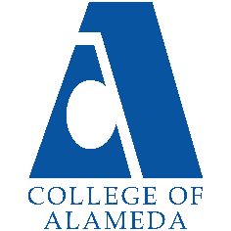
College of Alameda
2023-24 Annual Program Update

Program Overview
Please provide your program’s mission statement and program’s learning outcomes
It is the Mission of College of Alameda to serve the educational needs of its diverse community by providing comprehensive and flexible programs and resources that empower students to achieve their goals. Mission statement: The COA Mathematics department strives to inspire learners to build mathematical skills, make connections [between mathematics and the world], and contribute to society.

List your program faculty and/or staff
Khalilah Beal-Uribe
Vanson Nguyen
Richard Kaeser
Farzan Riazati
Philip Bui
Sue Broxholm
Mike Ghiselli
Chad Eric Montgomery
Gina Karunaratne
Emmanuel Herrera
Chris Wu
Thao Nguyen
Olesia Parasiuk-Zasun

Describe your current utilization of facilities, including labs and other space
Smart rooms
Office space
UMOJA space in collaboration with UMOJA

List your program goals from your most recent Program Review or APU. Then, provide an update on the status of the goal. Has your program achieved the goal? Have any of your goals been revised or any still in progress? Lastly, make sure to discuss which College or District goal your program goal aligns to.
If no program goals exist or if this is your first program review, work to create 2-3 goals and align them with a College or District goal.

Program Goal | Revisit mission statement and (Program) SLO’s
Status: In-Progress or Complete? | In progress
Which college or district goal is aligned with your program goal? | Advance COA teaching and learning  Strengthen data-driven/informed decision making

Program Goal | Develop departmental programming for math majors
Status: In-Progress or Complete? | In progress
Which college or district goal is aligned with your program goal? | Advance COA teaching and learning  Increase access to college programs/coursework through collaboration with other PCCD colleges in redesigning college schedules and offerings

Program Goal | Engage department faculty through renewed training and collaboration for online teaching, teaching evaluations, and an internal assessment tool.
Status: In-Progress or Complete? | In progress
Which college or district goal is aligned with your program goal? | Advance COA teaching and learning  Increase community & educational partnerships

Program Update
Using the dashboards, review and reflect upon the data for your program.
Course Completion and Retention Rates – Instructional Dashboard
Course Completion and Retention Rates – Student Services Dashboard
Enrollment Trends and Productivity Dashboard
Degrees and Certificates Dashboard

Course Completion and Retention Rates
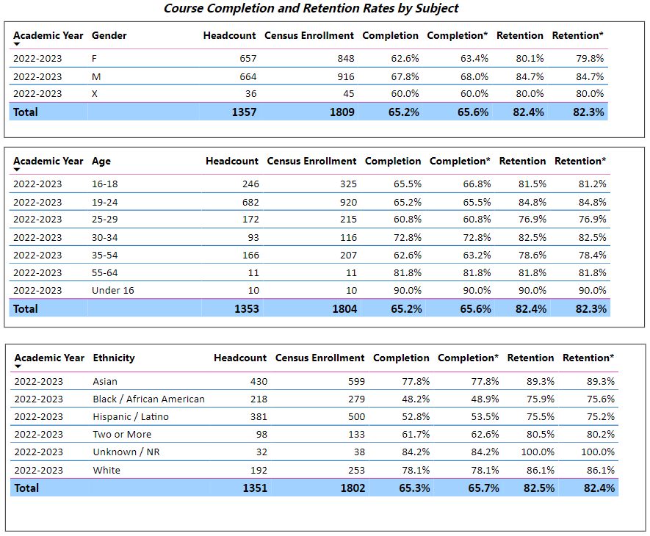
Major equity gaps exist in completion for Black and Latinx students. Another metric important to the department is throughput which is not captured here. Throughput counts the number of students who complete transfer level course within the first year. AB705 looks to increase throughput, but success rates are expected to fall.

Enrollment Trends
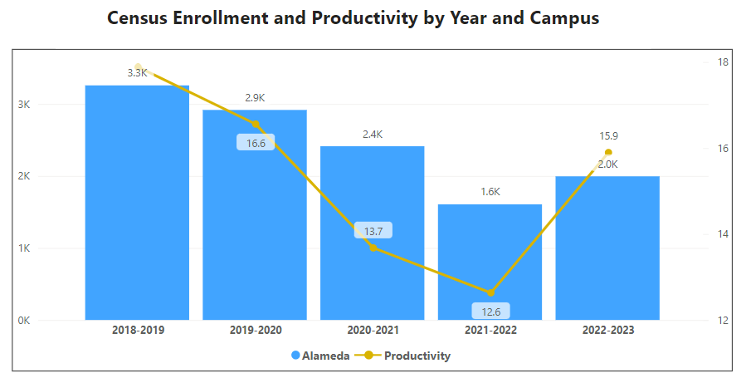

Productivity and enrollment have bounced back over the past year after a few years of decline. As the department has initially offered many courses with an in-person component, students were choosing to enroll in online courses and that’s a reason why enrollment dropped.

Degrees and Certificates
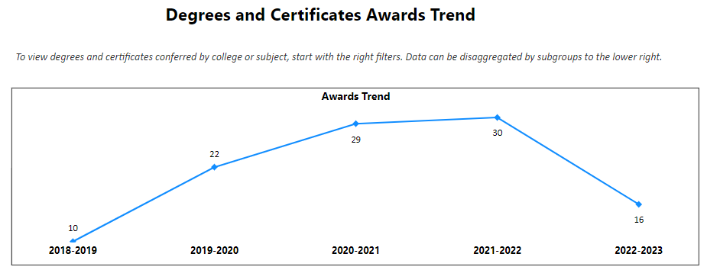
Most students who need the full sequence of Calculus are transfer bound and do not pursue an Associate’s degree since they are ultimately seeking Bachelor’s degree attainment at minimum. The overall numbers are low and the department has goals to create programming to increase these numbers.

With the lower enrollment in 2021-22 academic year, we expected the number of awards to drop in 2022-23.
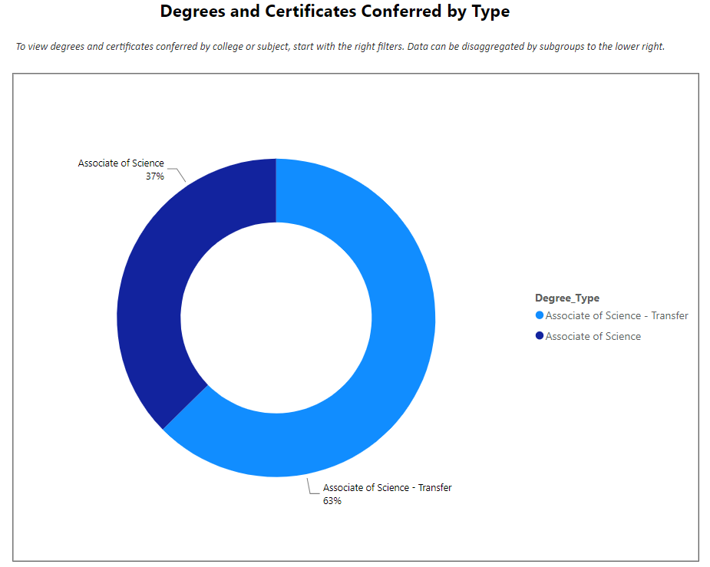

Describe any significant changes and discuss what the changes mean to your program. Consider whether performance gaps exist for disproportionality impacted students by using filters to disaggregate the data. Focus upon the most recent year and/or the years since your last comprehensive program review. Cite data points to support your reflection.
Overall, retention improved across ethnic backgrounds with the exception of a 2.7% point drop in Latinx retention from last year to this year. The success rate equity gap continues to exist for Black and Latinx students, however the advent of AB705 may have contributed to that. The data isn’t captured in the dashboards, but we suspect more students, especially from disproportionately impacted populations, have had more access to complete transfer level math and consequently have done so.

Moving forward, we will be implementing the new AB1705 bill which means we will create co-requisite courses for Math 16A, Math 3A and possibly Math 3B in conjunction with the rest of the math departments across the district. We expect lower success rates, but higher numbers of students completing the math course needed in their program map.

Describe the department's progress on Student Learning Outcomes (SLOs) and/or Service Area Outcomes (SAOs) since the last Program Review/APU.
The department is in year 3 of the 3 year cycle and will update some SLO’s of courses: Math 15, 3A, 3F. The department has an SLO workgroup that meets regularly. The group plans and generates SLO’s for the department with the consultation of faculty who teach the courses and will administer the SLO’s.
Course | Title | 2021-2022 | 2022-2023 | 2023-2024
Math 1 | Pre-Calculus | SLO 2 | SLO 3 | SLO 1
Math 3A | Calculus 1 | SLO 1 | SLO 2 | SLO 3
Math 3B | Calculus 2 | SLO 3 | SLO 2 | SLO 1
Math 3C | Calculus 3 | SLO 1 | SLO 2 | SLO 3
Math 3E | Linear Algebra | SLO 2 | SLO 1 | SLO 3
Math 3F | Differential Equations | SLO 2 | SLO 3 | SLO 1
Math 13 | Intro to Statistics | SLO 1 | SLO 3 | SLO 2
Math 15 | Math for Liberal Arts | SLO 2 | SLO 1 | SLO 3
Math 16A | Calculus for Business and Life/Social Sciences | SLO 3 | SLO 2 | SLO 1
Math 50 | Trigonometry | SLO 3 | SLO 1 | SLO 2
Math 203 | Intermediate Algebra | SLO 1 | SLO 3 | SLO 2
Math 213 | Support for Statistics | SLO 1 | SLO 3 | SLO 2
Math 215 | Support for Trigonometry | SLO 3 | SLO 1 | SLO 2
Math 216 | Support for Pre-Calculus | SLO 2 | SLO 3 | SLO 1
Math 225 | Mathematics for Technicians | SLO 3 | SLO 2 | SLO 1

Describe the outcomes and accomplishments from previous year’s funded resource allocation request. If your program did not receive any allocations, leave the boxes blank.
Brief description of funded request | Source (any additional award outside your base allocation) | Total Award Amount | Outcome/Accomplishment
Set of classroom laptops |  | 0
Professional development |  | 0
Embedded tutors to assist with calculators, excel and other mathematics review |  | Local Measure passed | Very few faculty have used embedded tutors. Of the ones that have, the faculty reported positive experiences.

Prioritized Resource Requests Summary
In the boxes below, please add resource requests for your program. If there are no resources requested, leave the boxes blank.
Resource Category | Description/Justification | Total Estimated Cost
Personnel: Classified Staff

Personnel: Student Worker

Personnel: Part Time Faculty
Personnel: Full Time Faculty

Resource Category | Description/Justification | Total Estimated Cost
Professional Development: Department wide PD needed
Professional Development: Personal/Individual PD needed
Supplies: Software

Supplies: Books, Magazines, and/or Periodicals

Supplies: Instructional Supplies

Supplies: Non-Instructional Supplies

Supplies: Library Collections

Technology & Equipment

Library: Library materials/collections

Facilities: Classrooms/Labs

Facilities: Offices | Need space on campus for all of the PT faculty who teach in person.
Other

