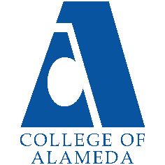
College of Alameda
2023-24 Annual Program Update - MUSIC

Program Overview
Please provide your program’s mission statement and program’s learning outcomes
The College of Alameda Music Department's primary mission is to provide pathways to understanding and recognition of the boundless influence of diverse cultures on musical heritage and expression. We offer courses for the aspiring performer/musician as well as those seeking to better understand the inner workings of the music industry, along with its history. Our staff is comprised of experienced professionals who are committed to the personal growth and development of every student and bring both academic integrity and first-hand experience to the academic environment.

List your program faculty and/or staff.
Full Time (Tenured): Glen Pearson
Part Time (Adjunct): Silvester Henderson

Part Time (Adjunct): David Chong

Describe your current utilization of facilities, including labs and other space.
The music department facilities are currently comprised of two primary areas; G-119 serves as the department’s lecture classroom, as well as ensemble rehearsal and small performance/recital presentation space. G-118 contains 24 digital pianos and serves as the piano teaching lab and resource facility for group and individual study of voice, as well as music theory.

List your program goals from your most recent Program Review or APU. Then, provide an update on the status of the goal. Has your program achieved the goal? Have any of your goals been revised or are any still in progress? Lastly, make sure to discuss which College or District goal your program goal aligns to.
If no program goals exist or if this is your first program review, work to create 2-3 goals and align them with a College or District goal.
Program Goal
Status: In-Progress or Complete? | Still seeking the implementation of proposed CTE music curriculum
Which college or district goal is aligned with your program goal? | The Music Department's program goals are consistent with both CoA and district goals of workforce development through CTE programs

Program Update
Using the dashboards, review and reflect upon the data for your program.
Course Completion and Retention Rates – Instructional Dashboard
Course Completion and Retention Rates – Student Services Dashboard
Enrollment Trends and Productivity Dashboard
Degrees and Certificates Dashboard

Course Completion and Retention Rates
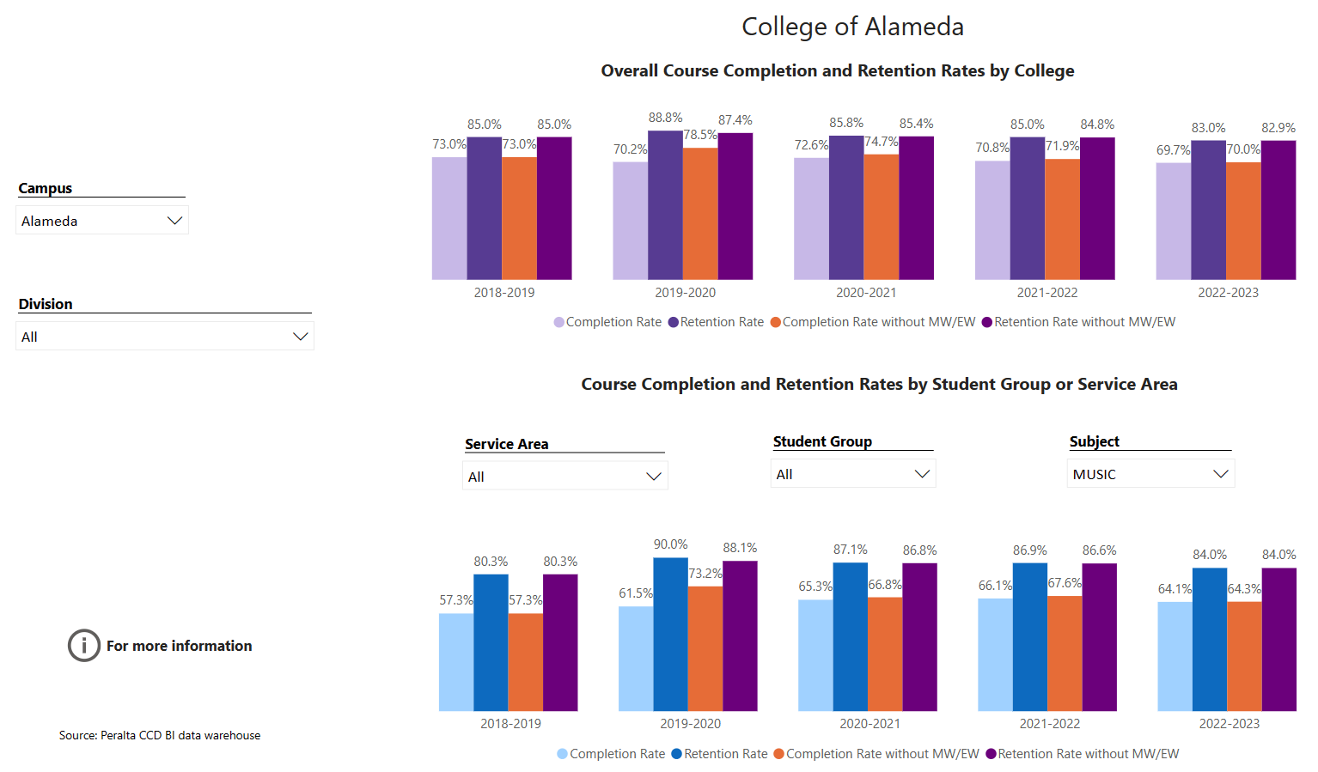

Breakdown by student populations (2022-2023)
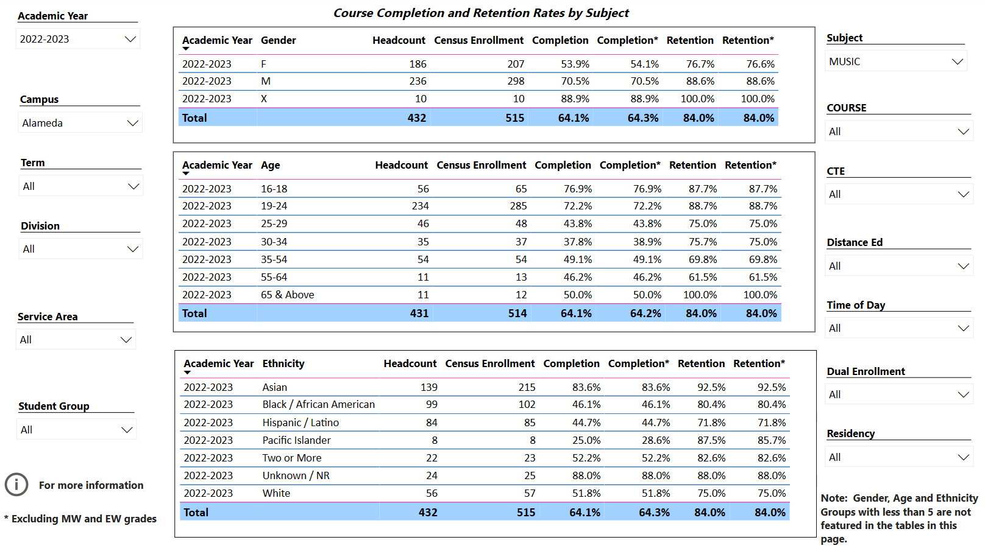

Enrollment Trends
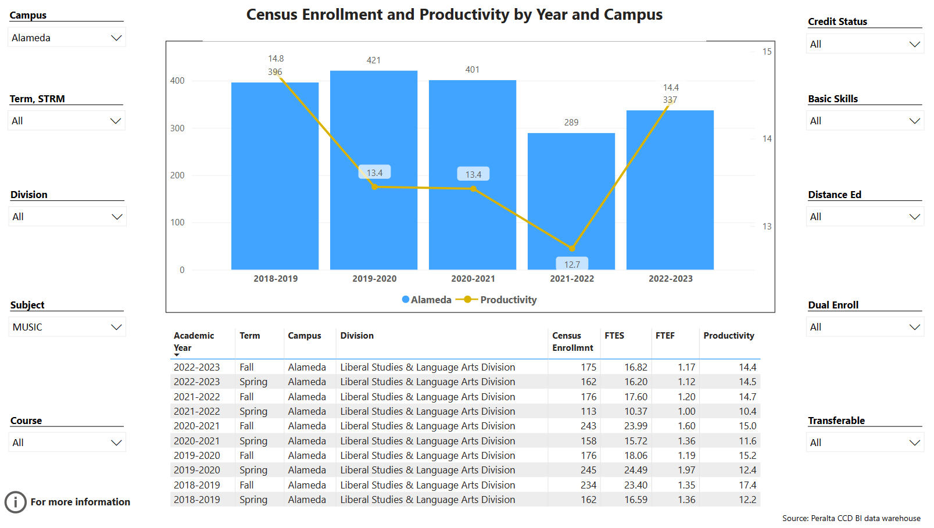

Degrees and Certificates
No degrees or certificates completed 2018-2023

Describe any significant changes and discuss what the changes mean to your program. Consider whether performance gaps exist for disproportionality impacted students by using filters to disaggregate the data. Focus upon the most recent year and/or the years since your last comprehensive program review. Cite data points to support your reflection.
While there is a slight decrease in retention rates for Music for 2022-23 compared to 2021-22, the cumulative rate by gender of 86.9% for 2022-23 represents a decrease of only 0.2% over the previous reported rate for 2021-22 of 87.1%. When considering the impact of the COVID pandemic on enrollment, I find this to be impressive.
However, in examining previous and recent performance/retention rates for traditionally disadvantaged and disproportionately served students there is an increase; most significant is the course completion/retention rate for African American students for 2022-23 compared to 2021-22, which is 72.3% versus 80.4%, an increase of 8.1%; however, the rate for Hispanic/Latino students for the same comparative period shows 71.8% compared to 87.5%, a decrease of 15.7%. The question that comes to mind is what makes for the significant gap in the decline of completion/retention rates between these two traditionally underserved communities? Are there factors relating to the COVID pandemic continuing to impact these groups?

Considering that the Music department has begun to reinvigorate its program goals and objectives, the impact of the current data remains to be seen.

Describe the department's progress on Student Learning Outcomes (SLOs) and/or Service Area Outcomes (SAOs) since the last Program Review/APU.
SLO’s for all music area courses are current and in alignment with all requirements.

Describe the outcomes and accomplishments from previous year’s funded resource allocation request. If your program did not receive any allocations, leave the boxes blank.
Brief description of funded request | Source (any additional award outside your base allocation) | Total Award Amount | Outcome/Accomplishment
Funding in support of performance presentation opportunities for Vocal and Piano studies students, along with the presentation of guest performers and lecturers in conjunction with creating transfer opportunities and relationships with four-year institutions | $0 | $0 | Supportive funding was initially provided by the College for the 2017- 18 academic year, with a pledge of incremental increases; however, giving consideration to the interruptions stemming from the COVID pandemic, in line with the desire to reinvigorate on Campus activities, the music department wishes to return to on Campus participation, presentations and performances.

Prioritized Resource Requests Summary
In the boxes below, please add resource requests for your program. If there are no resources requested, leave the boxes blank.
Resource Category | Description/Justification | Total Estimated Cost
Personnel: Classified Staff | Embedded Tutors for the four online/hybrid formatted GE music course offerings. This is also of particular importance when considering an anticipated increase in productivity for the Music Department | $13,000.00 per academic year
Personnel: Student Worker

Personnel: Part Time Faculty | An additional part-time faculty member is needed. | $20,000.00 per academic year
Personnel: Full Time Faculty

Resource Category | Description/Justification | Total Estimated Cost
Professional Development: Department wide PD needed | Support for Conferences, workshops, and seminars in conjunction with Certificated music programs/curriculums in Faith Based Music Studies and Performance. | $10,000.00 per year
Professional Development: Personal/Individual PD needed
Supplies: Software | Audio and visual editing software (Logic, Filmora 9, ProTools, etc.) along with annual upgrades and licensing, for use in the creation of student performance presentations, both group and individual. | $5000.00 per year
Supplies: Books, Magazines, and/or Periodicals

Supplies: Instructional Supplies | Paper, manuscript, pens, pencils, whiteboard markers, erasers and cleaner; batteries, copier paper and cartridges, thumb drives and cables. | $1200 per academic year
Supplies: Non-Instructional Supplies

Supplies: Library Collections

Technology & Equipment | 24 Mac/Apple laptop computers, along with a server and accompanying hardware and interfaces to facilitate the proposed incorporation of music technology as part of the approved CTE curriculum for Music. | $80,000.00
Library: Library materials/collections

Facilities: Classrooms/Labs

Facilities: Offices

Other | Funding for maintenance and repair of department instruments and equipment. | $10,000.00 per academic year

