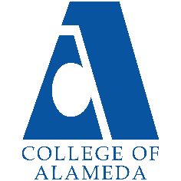
College of Alameda
2023-24 Annual Program Update

Program Overview
Please provide your program’s mission statement and program’s learning outcomes
The mission of the Physics Department at College of Alameda is to integrate problem-solving with a firm conceptual foundation and laboratory exercises. Students spend time working with other students in class, discussing physics concepts and solving problems together.

[No degrees and certificates within PHYS]

List your program faculty and/or staff.
Andrew Park
Stephen Asztalos
(Below are ASTR instructors, who also have FSA in PHYS.)
Andrew Fittingoff
Araceli Lopez-Garibay
Amanda Truitt

Describe your current utilization of facilities, including labs and other space.
All facilities needs for PHYS, inclusive of scheduling of in-person lab and lecture classes, are met through the exclusive use of ATLAN 100. Attached smaller rooms inside ATLAN 100 serve both as office space and lab equipment/lecture demo storage. Classes are scheduled within the limitation of a single classroom availability.

List your program goals from your most recent Program Review or APU. Then, provide an update on the status of the goal. Has your program achieved the goal? Have any of your goals been revised or are any still in progress? Lastly, make sure to discuss which College or District goal your program goal aligns to.
If no program goals exist or if this is your first program review, work to create 2-3 goals and align them with a College or District goal.
Program Goal | Continue to maintain Physics lab equipment
Status: In-Progress or Complete? | In-Progress: … as it always will be
Which college or district goal is aligned with your program goal? | College Goal 2: Provide quality educational and student support services that result in equitable student access to educational opportunities and success in earning a degree or certificate.

Program Goal | Regular online ASTR/PHYS faculty meeting during semester; hold the first meeting by February 2023
Status: In-Progress or Complete? | In-Progress: We held the first meeting on March 10, 2023; we should be holding another meeting in October 2023
Which college or district goal is aligned with your program goal? | College Goal 5: Foster an inclusive and caring culture that thrives on diversity and promotes social justice and equity.

Program Goal | As part of regular online ASTR/PHYS faculty meeting, continue evaluating effectiveness of online mode of lecture instruction for PHYS 10 and PHYS 4 and seek ways to improve it.
Status: In-Progress or Complete? | In-Progress: Need to agenda-ize for next meeting
Which college or district goal is aligned with your program goal? | College Goal 2: Provide quality educational and student support services that result in equitable student access to educational opportunities and success in earning a degree or certificate.

Program Goal | Start Offering, by Spring 2024 or Fall 2024, PHYS 3A and PHYS 3B (new goal for AY 2021-2022), with an aim of replacing PHYS 4A-4B-4C offering with PHYS 3A-3B offering.
Status: In-Progress or Complete? | In-Progress (updated with timeline);  PHYS 3A/3B are in CoA catalog; as of Fall 2023, we are still waiting on UC articulation.
Which college or district goal is aligned with your program goal? | College Goal 1: Develop and offer curriculum and learning that is innovative, with industry standards and labor market demands.

Program Update
Using the dashboards, review and reflect upon the data for your program.
Course Completion and Retention Rates – Instructional Dashboard
Course Completion and Retention Rates – Student Services Dashboard
Enrollment Trends and Productivity Dashboard
Degrees and Certificates Dashboard

Course Completion and Retention Rates
Overall success metrics for PHYS 4 are fine (within reason for PHYS 4A, 4B, and 4C for past year); we need to look for ways to improve success metrics for PHYS 10.
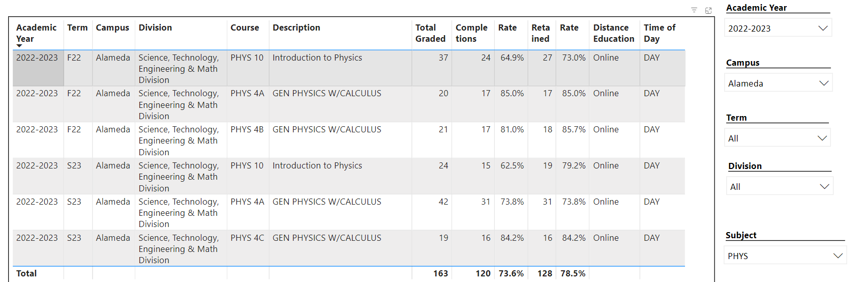

Enrollment Trends
While CoA’s enrollment trends for PHYS is healthy (in any case, better than last year),
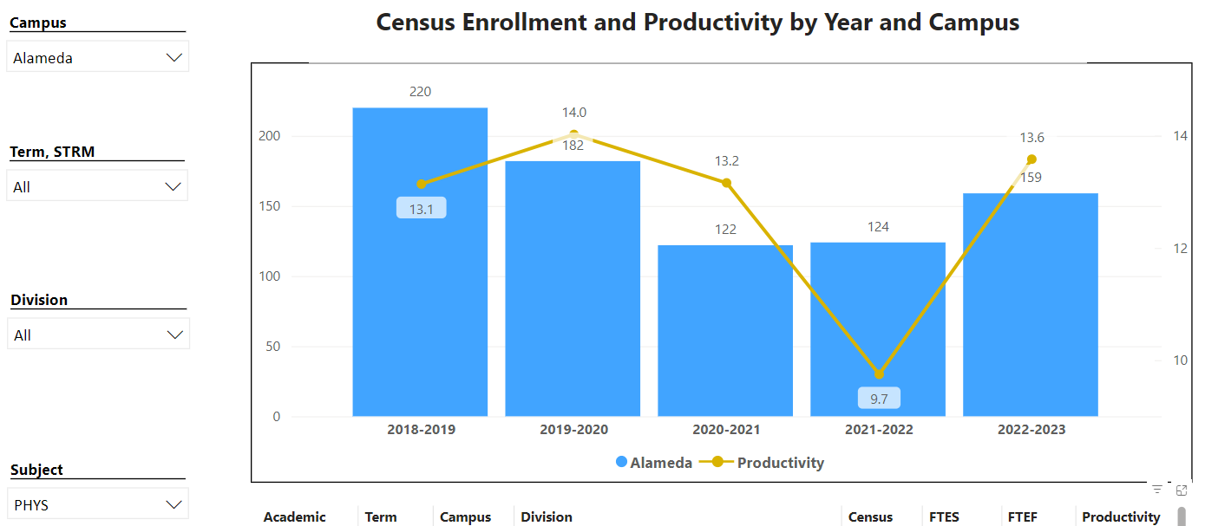
… we believe this improvement is driven rather by a decline in Laney’s Physics program (see below).
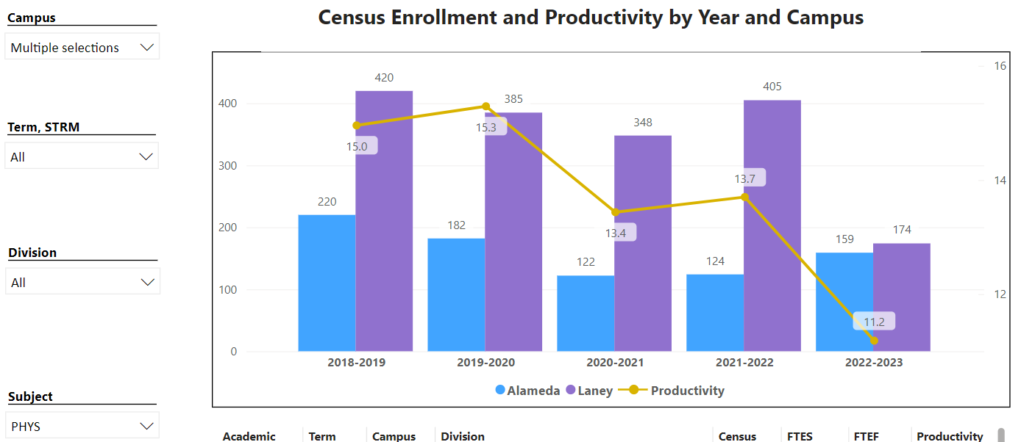

Fundamental structure for PHYS 4 at CoA hasn’t changed, and we are still on track to switch over to PHYS 3 series (possibly continue offering PHYS 4A, if that helps with enrollments in PHYS 4B and 4C at our sister colleges).

Degrees and Certificates
PHYS has no degrees or certificates, although we would welcome inclusion in contributing to program reviews and APUs for degrees and certificates that contain PHYS courses, either for physical science general education requirements or as an optional elective.

Describe any significant changes and discuss what the changes mean to your program. Consider whether performance gaps exist for disproportionality impacted students by using filters to disaggregate the data. Focus upon the most recent year and/or the years since your last comprehensive program review. Cite data points to support your reflection.
No significant changes since the last program review; full return of in-person labs have been good, both for instructional quality and possibly enrollment.

Describe the department's progress on Student Learning Outcomes (SLOs) and/or Service Area Outcomes (SAOs) since the last Program Review/APU.
Using saved student data, backlog of SLO assessments have been entered for PHYS 4A, 4B, and 4C, and we are fully up to date on those assessments. PHYS 10 has been a bit behind as the sole full-time faculty hasn’t had a chance to teach the class in a while.

Describe the outcomes and accomplishments from previous year’s funded resource allocation request. If your program did not receive any allocations, leave the boxes blank.
Brief description of funded request | Source (any additional award outside your base allocation) | Total Award Amount | Outcome/Accomplishment
New equipment (specifically smart carts) needed to fully furnish Physics lab. | [funded via base equipment allocation] | $1,500 | The new set of smart carts have been here for a couple months; we are working on re-writing lab manuals to use this better equipment over the older one.

Prioritized Resource Requests Summary
In the boxes below, please add resource requests for your program. If there are no resources requested, leave the boxes blank.
Resource Category | Description/Justification | Total Estimated Cost
Personnel: Classified Staff
Personnel: Student Worker
Personnel: Part Time Faculty | The sole full-timer in PHYS is currently regularly overloaded. When transition to PHYS 3A/3B is complete, one of these sections should be taught by a part-time faculty. | ??
Personnel: Full Time Faculty

Resource Category | Description/Justification | Total Estimated Cost
Professional Development: Department wide PD needed | Support for department-wide meeting and SLO assessment efforts is needed. We would like to request a small stipend payment for time part-time faculty spend on assessing SLOs and attend department-wide meeting to discuss SLO assessment results. | $500 - $1000 for all PT faculty participating (this is same as the request in ASTR, not to be duplicated)
Professional Development: Personal/Individual PD needed
Supplies: Software
Supplies: Books, Magazines, and/or Periodicals
Supplies: Instructional Supplies | Physics lab requires ongoing maintenance, both for repair and replacement of existing lab activities and for designing and offering new lab activities. We request continued supplies funding. | $1000
Supplies: Non-Instructional Supplies
Supplies: Library Collections

Technology & Equipment | New equipment (e.g. modern oscilloscopes; Windows 10 laptops that can connect to smart carts via bluetooth, etc.) needed to fully furnish Physics lab. | $5000
Library: Library materials/collections

Facilities: Classrooms/Labs | We request continued exclusive use of ATLAN 100 for Physics purposes (Physics lecture/lab classes) only. | $0
Facilities: Offices | We request continued exclusive use of ATLAN 100 for Physics, so that Physics full-timer can access ATLAN 102 (office space inside ATLAN 100) at predictable times. | $0
Other

