**College of Alameda**

2020-21 Program Review – Computer Information Systems

**Program Overview**

Please provide your program’s mission statement.

|  |
| --- |
|  |

List your program faculty and/or staff

|  |
| --- |
| Peter Ha |

List your program goals from your most recent Program Review or APU. Then, provide an update on the status of the goal. Has your program achieved the goal? Have any of your goals been revised or any still in progress? Lastly, make sure to discuss which College or District goal your program goal aligns to.

If no program goals exist or if this is your first program review, work to create 2-3 goals and align them with a College or District goal.

|  |  |
| --- | --- |
| **Program Goal** | New full-time faculty |
| Status: In-Progress or Complete? | In-progress |
| Which college or district goal is aligned with your program goal? | COA |

|  |  |
| --- | --- |
| **Program Goal** | Complete and move into new building |
| Status: In-Progress or Complete? | In-Progress |
| Which college or district goal is aligned with your program goal? | COA |

|  |  |
| --- | --- |
| **Program Goal** | Sponsorship with vendors |
| Status: In-Progress or Complete? | In-progress |
| Which college or district goal is aligned with your program goal? | COA |

Describe your current utilization of facilities, including labs and other space

|  |
| --- |
| Currently, lectures are on Zoom, pre-pandemic we’ve used B203 for lectures. Lectures includes; PowerPoint presentations, visuals via online video’s or footage taken from class. Written tests are also conducted in B203.  Lab takes place in B107. Depending on what class, (AutoB16,12,49,30,40) we would operate MIG welders, plastic welders, grinders, drills, sanding, materials application, frame straightening, automobile measuring, polishing of paints, machine sanding and other various pneumatic hand tools. |

**Career Education**

Using the [**LaunchBoard**](https://www.calpassplus.org/LaunchBoard/Home.aspx)what are the job placement rates for your program for the past three years? What percent of your graduates have secured employment in the field within 3 months of leaving the program?

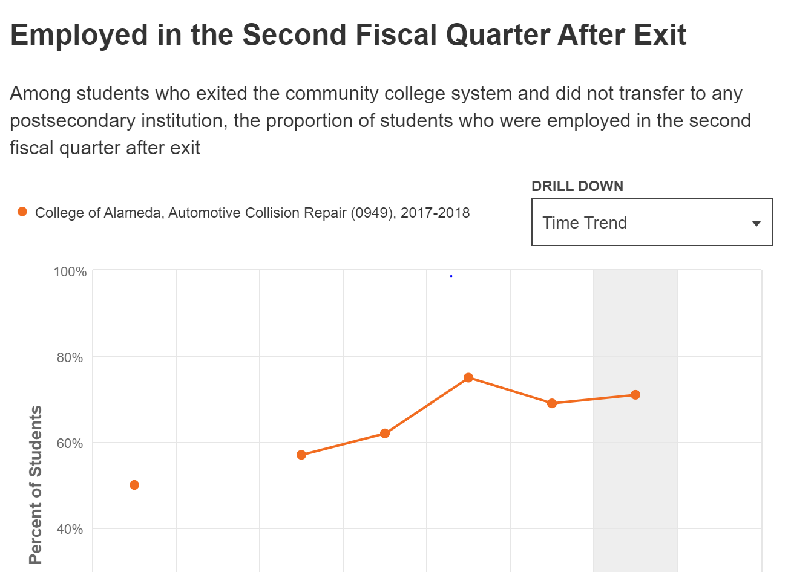

|  |  |  |
| --- | --- | --- |
| **College and Top Code** | **Year** | **Job placement rate within 3 months of exit** |
| College of Alameda, Automotive Collision Repair (0949) | 2017-18 | 71% |
| College of Alameda, Automotive Collision Repair (0949) | 2016-17 | 69% |
| College of Alameda, Automotive Collision Repair (0949) | 2015-16 | 75% |

Using the [**LaunchBoard**](https://www.calpassplus.org/LaunchBoard/Home.aspx), what are the projected job openings in your discipline for the next three years?

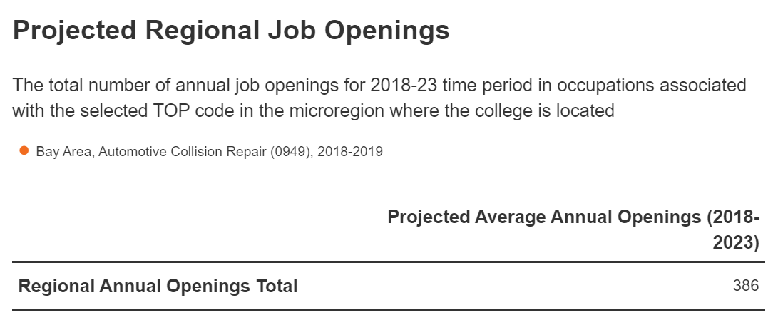

|  |
| --- |
|  |

How is your discipline or program responding regarding changes in labor market demand?

|  |
| --- |
| Faculty makes shop visits with local shop and vendors to see the constant change in the field and use gathered information to parallel to the department. |

Do you have an industry advisory board in place?

|  |
| --- |
| Yes |

Has your industry advisory board met regularly (at least once per quarter or semester)?

|  |
| --- |
| Yes |

Please list of your industry advisory board members.

|  |
| --- |
| Ben Shell & Marlon Medina-PPG Industries  Tiffany Silva- Accurate auto Body  Ron Arth- Arth and son auto body  Greg – Aaron auto body |

Please describe the number of activities and recommendations resulting from advisory committee meetings that have occurred in the past three years. What information was presented that required changes to be made to your program?

|  |
| --- |
| Advisory committee recommend we have various repair station such as Aluminum repair station, update various spray guns to keep up with today’s changing paint systems, change from solvent based paint system to water-based paint system. |

Does your program require state or national licensing? If yes, please specify. What is your college's set standard passing rate for this exam or license? If yes, what is the name of the exam or License? State the set standard pass rate.

|  |
| --- |
| No |

Do your students participate in other third-party certifications? If so, please provide their success rates (include the % of completing students successfully getting certified). If yes, what is the third-party certification? State the set standard pass rate

|  |
| --- |
| No |

Is your program working with a Deputy Sector Navigator?

|  |
| --- |
| Yes |

If yes, briefly describe your program's work with the Deputy Sector Navigator.

|  |
| --- |
| Our Deputy Sector Navigator help us setup training classes and assist in reaching out to industries leaders. |

What programs similar to yours exist in the surrounding area or at nearby East bay colleges? (Microregion in [**LaunchBoard**](https://www.calpassplus.org/LaunchBoard/Home.aspx))

|  |  |  |
| --- | --- | --- |
| **Year** | **College** | **No. of students who took .5 units or more in Automotive Collision & Repair** |
| 2018-19 | College of Alameda | 63 |
| 2018-19 | Contra Costa Community College | 64 |

In which ways is your program collaborating with other community colleges in the region?

|  |
| --- |
|  |

Please list and briefly describe the grant name, granting agency, and the goals of each grant as it relates to you discipline/department/program

|  |
| --- |
| Perkins: Federal funding. Goal is for program improvement. |

How is your program using Strong Workforce Funds?

|  |
| --- |
| To fund updating of equipment, purchase new equipment, provide professional development. |

**Enrollment Trends**

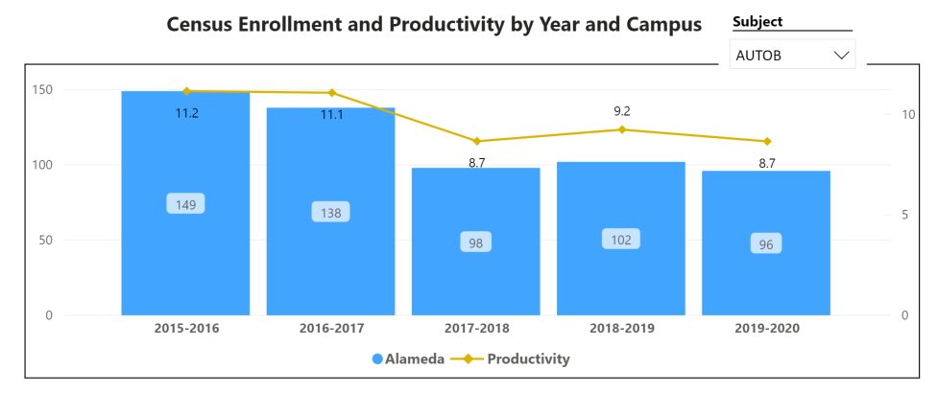

*Consider the most recent 3 to 5 years when answering the questions below.*

[**Enrollment Trends Dashboard link**](https://app.powerbi.com/view?r=eyJrIjoiNWJlOWZmYTEtNTY0MC00MDhkLWE5OTAtYmJjZjIxNzJiNWViIiwidCI6ImVlYTE2YTE2LTQ4YWYtNDc3Yi05MTEzLTA1YjFjMDExMjNmZiIsImMiOjZ9&pageName=ReportSection86d6f65e2fb41a73da4d)

Discuss enrollment trends over the past three years

*For additional analysis, click on the Enrollment Trends Dashboard, set the filters to Alameda and your discipline*

|  |
| --- |
|  |

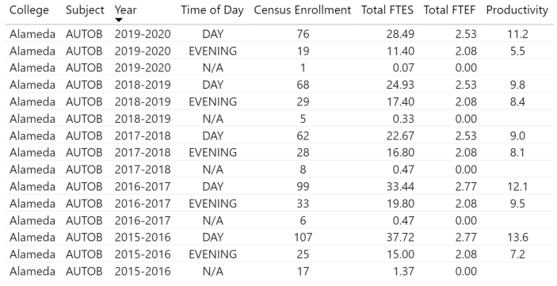

In the enrollment dashboard, set the filter to consider whether the time of day each course is offered meets the needs of students.

Are courses scheduled in a manner that meets student needs and demands? How do you know?

|  |
| --- |
| Yes. The day class is for students that are working in the afternoon and evening while the evening class is for students that are working a normal 9-5pm jobs. |

Describe effective and innovative teaching strategies used by faculty to increase student learning and engagement.

|  |
| --- |
| Groups and one-on-one projects work well with students. We also engage in oral presentation in which it helps out with job interviews. Hands on in lab is very effective. Reading, research and studying Tech sheets works well when working with mixing chemicals. |

How is technology used by the discipline, department?

|  |
| --- |
| Technology is always changing in Auto body and paint trade. We use items such as computers, automobile scanners, digital scales, computerized measuring systems, software updates, |

How does the discipline, department, or program maintain the integrity and consistency of academic standards with all methods of delivery, including face to face, hybrid, and Distance Education courses?

|  |
| --- |
| Lectures and hand-out materials became digital and online. I feel that students are having a positive experience with the online lectures. Lab work is still Face-to-Face. Pre-pandemic, the paint class has always had the PPE from head to toe and respirators/masks are always worn. |

**Curriculum**

Please review your course outlines of record in Curriqunet to determine if they have been updated or deactivated in the past three years

[](https://peralta.curricunet.com/)

**https://peralta.curricunet.com/**

Specify when your department will update each one, within the next three years.

|  |
| --- |
| Transition traditional face-to-face classes into Hybrid classes |

Please summarize curriculum plans and improvements for your discipline, department and or program of study.

|  |
| --- |
| By improving the discipline plan and program studies, we take measures to get the appropriate training and usage/understanding of industries standard tools and equipment into the student outcome |

**Student Learning Outcomes Assessment**

List your Student Learning Outcomes

|  |
| --- |
| Safely work with power and hand tools, welding equipment, and chemicals in an auto body repair shop.  Demonstrate competence and familiarity working with various metals, welding techniques, measurement and alignment equipment, and spraying equipment, including practicing all standard safety procedure  Safely work with power and hand tools and chemicals in an auto body repair shop. |

Were there any obstacles experienced during assessment? What worked well? (Mainly based on evidence in the report, attach other evidence as necessary)

|  |
| --- |
| Based on assessment, Students tend to work well in small groups, one-on-one. Test scores are greater when using a mixture of multiple choice, true or false and short answers questions |

What percent of your programs have been assessed? (mainly based on evidence in the report, attach other evidence as necessary; note: a complete program assessment means all Program Learning Outcomes (PLOs) have been assessed for that program)

|  |
| --- |
|  |

How has your dept worked together on assessment (planning together)? Describe things that went well or obstacles. What aspects of assessment work went especially well in your department and what improvements are most needed?

Planning Process

|  |
| --- |
| Student have a better understanding when starting their studies from Auto Body then transition into Auto paint department. |

What were the most important things your department learned from assessment? Did implementation of your action plans result in better student learning? In other words, how has your department used the results of assessment to improve student learning and/or curriculum? Please be as detailed as possible.

|  |
| --- |
| Testing and assignments should be shuffled every semester, testing style and questioners should randomly mix into pool, not keeping the same tests every time |

Does your department participate in the assessment of multidisciplinary programs? If Yes, describe your department's participation and what you learned from the assessment of the program that was applicable to your own discipline.

|  |
| --- |
|  |

College of Alameda Institutional Learning Outcomes (ILOs) were created to guide educational programs and services. They include:

* **Problem Solving:** Solve problems and make decisions in life and work using critical thinking, quantitative reasoning, community resources, and civil engagement.
* **Communication and Technology:** Use technology and written and oral communication to discover, develop, and relate critical ideas in multiple environments.
* **Creativity:** Exhibit aesthetic reflection to promote, participate and contribute to human development, expression, creativity, and curiosity.
* **Diversity:** Engage in respectful interpersonal communications, acknowledging ideas and values of diverse individuals that represent different ethnic, racial, cultural, and gender expressions.
* **Civic Responsibility:** Accept personal, civic, social and environmental responsibility in order to become a productive local and global community member.

How does your department participate in assessing the Institutional Learning Outcomes (ILOs)? If your department has not participated, how will you plan to incorporate these outcomes within your department?

|  |
| --- |
| Result of certificates and degrees achieved should be on high, keep encouraging students to apply and motivate to complete classes |

What support does your department need from administrators, assessment coordinators and/or your campus assessment committee to continue to make progress in assessment of outcomes and implementation of action plans?

|  |
| --- |
| More faculty/staff members will help |

**Course Completion**

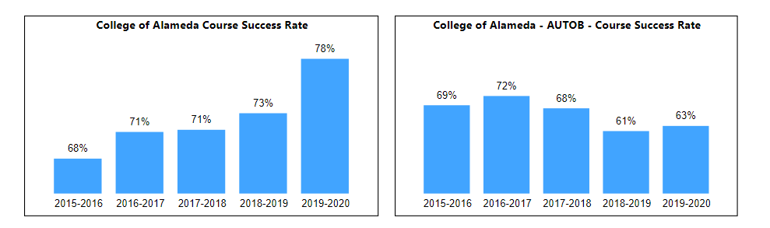

Consider your course completion rates over the past three to five years (% of student who earned a grade of "C" or better).

[**Course Completion Dashboard link**](https://app.powerbi.com/view?r=eyJrIjoiNjc2MDhiNTEtNTJhZi00MDM0LTk5NDItNTRiY2EzMGI1NTZiIiwidCI6ImVlYTE2YTE2LTQ4YWYtNDc3Yi05MTEzLTA1YjFjMDExMjNmZiIsImMiOjZ9&pageName=ReportSection86d6f65e2fb41a73da4d)

How do the course completion rates for your program or discipline compare to your college's Institution-Set Standard for course completion of **67%**?

|  |
| --- |
| On average, the AutoB program completion percentage is 66.6 |

How do the department's Hybrid course completion rates compare to the college course completion standard? Use the course completion dashboard to disaggregate.

|  |
| --- |
| Fall 2020,student in Autob30 success rate was 85% while using the Hybrid /lab face-to-Face |

Are there substantial differences in course completion rates between face to face and Distance Education/hybrid courses? If so, how does the discipline, department, or program address this? How do you assess the overall effectiveness of Distance Education/hybrid course?

|  |
| --- |
| Based on my experience for fall 2020 and spring 2021, the students have a greater test scores and material delivery with Hybrid /lab face-to-Face compared to traditional methods in the pass |

Are there substantial differences in course completion rates between courses taught during the day compared to evening course? If so, how does the discipline, department, or program address this?

|  |
| --- |
| The day classes are completely different then the evening courses. Department would change classes around to meet students’ needs |

If your program offers dual enrollment courses, examine the data, and discuss the course completion rates compared to the overall program rate.

|  |
| --- |
| Based on the industry and how the economy, normally we see higher enrollment when the economy is doing bad and lower enrollment when economy is good. |

On average the course retention rate (number of students are retained in the course) for College of Alameda has been **85%** for the past three years. Examine the course retention rates for your program over the last three years. How does your program or discipline course retention rates compare to the college?

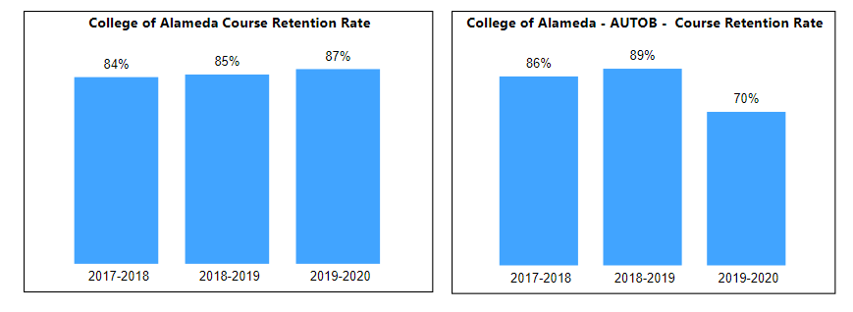

|  |
| --- |
| Based on data, AutoB retention rate is 81%, compared to College of Alameda 85% |

College of Alameda continues to focus on access, equity, and success. The goal is to create an inclusive environment where all students can thrive and meet their education and career goals.

To address equity gaps and work towards achieving equity in educational outcomes, examine your program data for evidence of disproportionate impact (DI). When disaggregating course success rates, are there any groups whose course completion rate falls more than 3 percentage points below the discipline average? If so, identify them and explain what your department is doing to address the disproportionate impact for the group.

*Note: The tables reflected use 2018-19 program data to calculate DI. Groups with 10 students or less are excluded from the analysis.*

**Ethnicity and Gender**

|  |  |  |  |  |  |
| --- | --- | --- | --- | --- | --- |
| **Cohort Name** | **Cohort Count** | **Outcome Count** | **Success Rate** | **Point Gap Index** | **MOE** |
| Asian - Male | 13 | 11 | 84.6 | 30.07 | -26.69 |
| Black / African American - Male | 13 | 9 | 69.2 | 11.66 | -26.69 |
| Hispanic / Latino - Male | 53 | 27 | 50.9 | -25.98 | -13.22 |
| Overall SR (Includes Comparison Group) | 79 | 47 | 59.5 |  |  |

|  |
| --- |
|  |

**Students with Disabilities (DSPS), First Generation, Foster Youth, Low Income or Veterans**

|  |  |  |  |  |  |
| --- | --- | --- | --- | --- | --- |
| **Cohort Name** | **Cohort Count** | **Outcome Count** | **Success Rate** | **Point Gap Index** | **MOE** |
| First Gen | 71 | 44 | 62.0 | -4.69 | -11.16 |
| Low Income | 57 | 38 | 66.7 | 4.69 | -12.46 |

|  |
| --- |
|  |

**Age Range**



|  |
| --- |
|  |

What has the discipline, department, or program done to improve course completion and retention rates?

|  |
| --- |
| Modified instruction methods and projects to keep the students interest and motivation |

**Degrees & Certificates Conferred**

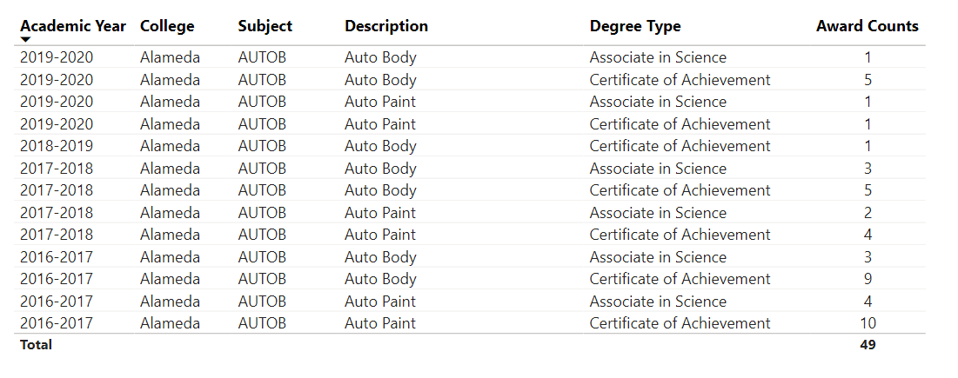

Since the last program review, what has the discipline, department, or program done to improve the number of degrees and certificates awarded?

|  |
| --- |
| Moving forward, students should be encourage to accomplish degrees and certificates regularly during every semester |

For more information on awards: [**Degrees & Certificates Dashboard link**](https://app.powerbi.com/view?r=eyJrIjoiZjU2M2M5MzItOTcwZi00Y2U1LWJmODUtYTc0YjlhZGI2ZDhjIiwidCI6ImVlYTE2YTE2LTQ4YWYtNDc3Yi05MTEzLTA1YjFjMDExMjNmZiIsImMiOjZ9&pageName=ReportSectionde32556e136b0a8caccd)

Increasing the number of students who complete a certificate or degree is a shared goal across CoA’s Ed Master Plan Goals, PCCD Goals, the Chancellor’s Office Vision for Success, the Student-Centered Funding Formula, and Guided Pathways. What is planned for the next 3 years to increase the number of certificates and degrees awarded?

|  |
| --- |
| Counselor and college peers should make appearance in class to help encourage students to apply and help motivate |

**Engagement**

Discuss how faculty and staff have engaged in institutional efforts such as committees, presentations, and departmental activities. Please list the committees that full-time faculty participate in.

|  |
| --- |
| Faculty is involve in department Advisory Committee. Seeks local business owner/management, collision shop, technician and vendors to welcome them into the committee. As met by semesters, committee would jointly and give valuable information and suggestions for the department on the ongoing changing in the industry. |

Discuss how faculty and staff have engaged in community activities, partnerships and/or collaborations.

|  |
| --- |
| Faculty would attend other institute and vendors with like programs, there discussions on issues and problem solving information is shared amongst the group |

Discuss how adjunct faculty members are included in departmental training, discussions, and decision-making.

|  |
| --- |
| Faculty take steps in getting trained, re-training and certification with various vendors in the industry. |

**Prioritized Resource Requests Summary**

In the boxes below, please add resource requests for your program. If there are no resource requested, leave the boxes blank.

|  |  |  |  |  |
| --- | --- | --- | --- | --- |
| **Resource Category** | **Description/Justification** | **Estimated Annual Salary Costs** | **Estimated Annual Benefits Costs** | **Total Estimated Cost** |
| Personnel: Classified Staff | N/A |  |  |  |
| Personnel: Student Worker | Instructors assistance | $8000 | 0 | $8000 |
| Personnel: Part Time Faculty | N/A |  |  |  |
| Personnel: Full Time Faculty | Full-time faculty | 86000 |  | 86000 |

|  |  |  |
| --- | --- | --- |
| **Resource Category** | **Description/Justification** | **Total Estimated Cost** |
| Professional Development: Department wide PD needed |  |  |
| Professional Development: Personal/Individual PD needed |  |  |

**Prioritized Resource Requests Summary - Continued**

|  |  |  |
| --- | --- | --- |
| **Resource Category** | **Description/Justification** | **Total Estimated Cost** |
| Supplies: Software | Software subscriptions for vehicle measuring system, Vehicle repair estimating program, vehicle repair specification program | 2000 |
| Supplies: Books, Magazines, and/or Periodicals | New book version | 500 |
| Supplies: Instructional Supplies | Consumables materials for sanding, welding, filling, maintenance tools, hand tools, hand power tools, welding gasses, | 15000 |
| Supplies: Non-Instructional Supplies | Printing paper, printer ink, computer, recording equipment | 9000 |
| Supplies: Library Collections | Book reservations | 1000 |

|  |  |  |
| --- | --- | --- |
| **Resource Category** | **Description/Justification** | **Total Estimated Cost** |
| Technology & Equipment: New | Mobile Smoke ventilators | 9000 |
| Technology & Equipment: Replacement | Welding stations | 75000 |

**Prioritized Resource Requests Summary - Continued**

|  |  |  |
| --- | --- | --- |
| **Resource Category** | **Description/Justification** | **Total Estimated Cost** |
| Facilities: Classrooms |  |  |
| Facilities: Offices | Office furniture | 2000 |
| Facilities: Labs | Lab stations, lab stools, Bench seats | 6000 |
| Facilities: Other |  |  |

|  |  |  |
| --- | --- | --- |
| **Resource Category** | **Description/Justification** | **Total Estimated Cost** |
| Library: Library materials | New book | 1000 |
| Library: Library collections |  |  |

|  |  |  |
| --- | --- | --- |
| **Resource Category** | **Description/Justification** | **Total Estimated Cost** |
| Other |  |  |