**College of Alameda**

2020-21 Program Review Template – Career & Employment Center

**Program Overview**

Please provide your program’s mission statement.

|  |
| --- |
| The CoA Career and Employment Center’s Mission Statement:  To transform lives by providing equitable career services, access and opportunities for students and the community. |

List your program staff including full-time and part-time faculty, classified staff, and other categories of employment.

|  |  |  |
| --- | --- | --- |
| **NAME** | **POSITION TITLE** | **POSITION TYPE** |
| Stefanie Bradshaw | Director | Fulltime Staff |
| Miesha Clipper Willis | Career Coach / Case Manger | Consultant |
| Kimari Williams | Career Coach / Case Manger | Consultant |
| Tiffany Ghoddoucy | Intake Specialist | Consultant |
| Valarie Carey | Career Coach / Case Manger | Consultant |
| Bonnie Black | Job Developer | Consultant |
| Anthony Patrick | Office Support | Consultant |
| An Phan | Office Support | Consultant |
| Tammy Arnold | Workshop Support | Consultant |

List your program goals from your most recent Program Review or APU. Then, provide an update on the status of the goal. Has your program achieved the goal? Have any of your goals been revised or any still in progress? Lastly, make sure to discuss which College or District goal your program goal aligns to: [Alignment of Goals](https://alameda.peralta.edu/wp-content/uploads/2021/02/Alignment-of-Goals-2022-Vision-for-Success-Peralta-Community-College-District-CoAs-Educational-Master-Plan.pdf)

If no program goals exist or if this is your first program review, create 2-3 goals and align them with a College or District goal.

|  |  |
| --- | --- |
| **Program Goal** | Increase the number of students dual enrolled for WIOA career services through the CoA Career and Employment Center. |
| Status: In-Progress or Complete? | Completed goal and will continue to strive to increase career & employability opportunities for students on campus. |
| Which college or district goal is aligned with your program goal? | College Goal 4: Increase the number of career exploration and Work Based Learning opportunities |

|  |  |
| --- | --- |
| **Program Goal** | Increase the number of employability workshops offered to students on campus to support job search preparation. |
| Status: In-Progress or Complete? | Completed goal and will continue to strive to increase career & employability opportunities for students on campus. |
| Which college or district goal is aligned with your program goal? | District Goal 4: Over five years, increase the percent of exiting CTE students who report being employed in their field of study, from the most recent statewide average of 60 percent to an improved rate of 69. |

|  |  |
| --- | --- |
| **Program Goal** | Increase the number of employer recruitment events (in-person and virtually) offered to students on campus to increase access to employment. |
| Status: In-Progress or Complete? | Completed goal and will continue to strive to increase career & employability opportunities for students on campus. |
| Which college or district goal is aligned with your program goal? | District Goal 4: Over five years, increase the percent of exiting CTE students who report being employed in their field of study, from the most recent statewide average of 60 percent to an improved rate of 69. |

List the essential functions of your department, program or unit and provide a description of how the unit aligns with the college mission.

|  |
| --- |
| The College of Alameda Career and Employment Center is funded by the Alameda County Workforce Development Board, the College of Alameda and the Peralta Community College District. Our career center is very unique thus allowing us to serve job seekers on campus as well as in the community. Our department supports the college and district’s employment goal by providing key employability services for students on campus. |

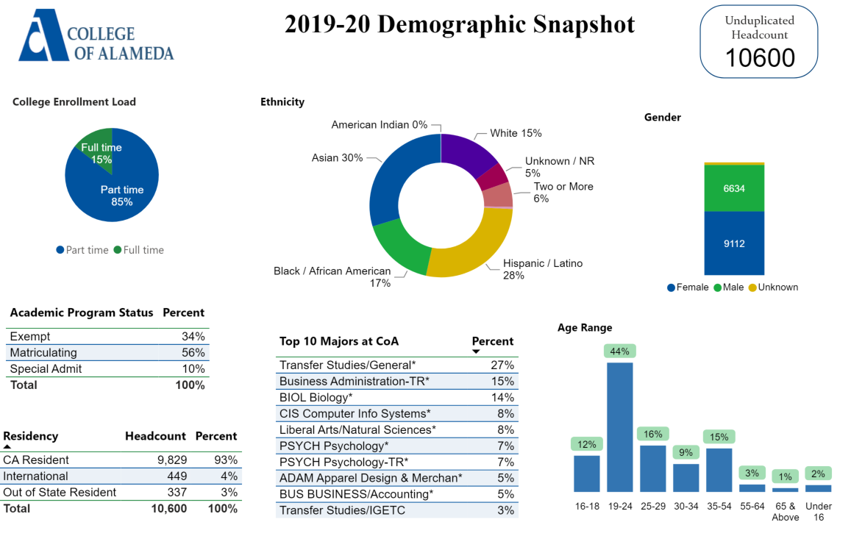

[**Demographics dashboard link**](https://app.powerbi.com/view?r=eyJrIjoiMzVhNGU3YzAtNTIyNy00ZDZmLWIyYzMtYWIzMzllMGViZDQ5IiwidCI6ImVlYTE2YTE2LTQ4YWYtNDc3Yi05MTEzLTA1YjFjMDExMjNmZiIsImMiOjZ9&pageName=ReportSectionb4e116c96a753400a00c)

Describe how external factors such as the implementation Guided Pathways, AB705, Student Centered Funding Formula, advisory board recommendations, changing demographics, and/or COVID-19 has impacted the support services your program or administrative unit provides.

How has your program addressed these changes or challenges to ensure students are supported and can continue to work towards meeting their educational goals?

Guided Pathways, AB705, or the Student-Centered Funding Formula (SCFF)

|  |
| --- |
| As a result of COVID-19 during the 2019-2020 program year, the CoA Career Center had to shift its service delivery model from in-person to remote based services. In doing so, we contacted all of our clients (students and community clients) to inform them that our office would be closed due to the pandemic but making sure our clients understood that we are still here to support them.  We provide continued career services support by:   * Using Google Voice to answer all incoming calls. We receive over 60 calls per week requesting assistance for various career services. * Scheduling Zoom one on one appointments for existing clients to create and update career plans. * Meeting new clients in the field, with proper PPE, to collect paperwork to enroll them as a client or to assist them in-person with questions they have regarding the career center client paperwork.   In addition to shifting our service delivery model, we also received CARES Act funding from the Alameda County Workforce Development Board to offer COVID Emergency Supportive Services one time bill assistance grants up to $800 to assist approved clients (students or community members) to help those financially impacted by COVID. The goal was to provide financial support for our students enrolled clients to hopefully help them better focus on their educational goals.  Our team found that providing in the field direct client/student support was essential for those student and clients that were impacted by the digital divide. These are students/clients that do not have access to technology at home and were unable to complete career center paperwork electronically. This presents a major equity issue. The students that we serves in the filed for the 2019-2020 program year that did not have access to technology at home were mostly African American and Latino students, both male and female, mostly around the ages of 35 and older. |

Advisory board recommendations

|  |
| --- |
| N/A |

Impact of COVID-19

|  |
| --- |
| As a result of COVID-19, our CoA Career and Employment Center has seen a surge in career services request during the 2019-2020 program year. |

**Data Analysis**

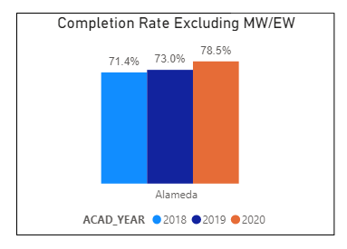

Consider your program’s course completion rates over the past three to five years (% of student who earned a grade of "C" or better).

How do the course completion rates for your program or discipline compare to your college's College-Set Standard for course completion of **67%**?

|  |
| --- |
| N/A |

On average the course retention rate (number of students are retained in the course) for College of Alameda has been **85%** for the past three years. Examine the course retention rates for your program over the last three years. How does your program or discipline course retention rates compare to the college?

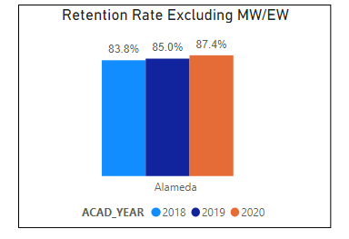

|  |
| --- |
| N/A |

**Equity**

College of Alameda continues to focus on access, equity, and success. The goal is to create an inclusive environment where all students can thrive and meet their education and career goals. In 2019 the Student Service Equity team [analyzed data](https://alameda.peralta.edu/wp-content/uploads/2019/06/CoA-equity-exec-summary-6.2019.docx) to identify groups that were disproportionately impacted in access, persistence, transfer rate, completion of transfer level English and Math, and goal completion.

* **Access:** Black or African American male students enroll at disproportionate rates. Additionally, female Black or African American, disabled and LGBTQIA students enroll at disproportionate rates.
* **Persistence:** Female Black or African American, Latinx, foster youth, LGBTQIA and veteran students are persisting at disproportionate rates. Male Black or African American, foster youth and LGBTQIA students are also persisting at disproportionate rates. The most significant retention equity gap was with male foster youth students.
* **Transfer to a Four-Year Institution:** Female American Indian or Alaska Native, Native Hawaiian or other Pacific Islander and disabled students transferred at disproportionate rates. American Indian or Alaska Native, Black or African American, Filipino, Latinx, disabled, first generation and foster youth males also transferred at disproportionate rates.
* **Complete both Transfer-level Math and English within the first year:** Female foster youth complete both transfer level math and English at disproportionate rates. Additionally, Black or African American, Latinx, disabled, economically disadvantaged, foster youth and LGBTQIA males transfer at disproportionate rates.
* **Vision 2022 Goal Completion:** Asian, Black or African American, Latinx, foster youth, LGBTQIA, and veteran female students complete at disproportionate rates. American Indian or Alaska Native and LGBTQIA male students are also completing at disproportionate rates.

Discuss how your program worked to address these equity gaps since 2019. Incorporate examples of your program data where applicable.

|  |
| --- |
| The CoA Career and Employment Center works closely with the college to help address the equity gaps. One example is our direct partnership with CoA CalWorks department. Our team provides specialized career services support for CalWorks students through the following:   * Host weekly CalWorks employability workshops focusing on resume building, interview skills, networking skills, emotional intelligence for the workplace, and other workshops. * Arrange virtual recruitment events for the CalWorks students allowing them to connect with employers in a smaller setting to get comfortable with interacting with employers. * Dual enroll CalWorks students in WIOA career center grant services to assign a career coach to support them with their journey to employment. * Offer On the Job Training placement opportunities for interested CalWorks students to place them in positions (if selected by the employer) and our department will pay the employer the first $5,000 of their salary. * Offer the one time CERSS grant bill assistance up to $800 for any Calworks students that were financially impacted by COVID-19 from June 2020 – December 31, 2020. |

**Degrees & Certificates Conferred**

For more information on awards: [**Degrees & Certificates Dashboard link**](https://app.powerbi.com/view?r=eyJrIjoiZjU2M2M5MzItOTcwZi00Y2U1LWJmODUtYTc0YjlhZGI2ZDhjIiwidCI6ImVlYTE2YTE2LTQ4YWYtNDc3Yi05MTEzLTA1YjFjMDExMjNmZiIsImMiOjZ9&pageName=ReportSectionde32556e136b0a8caccd)

**Degrees and Certificates**

Increasing the number of students who complete a certificate or degree is a shared goal across CoA’s Ed Master Plan Goals, PCCD Goals, the Chancellor’s Office Vision for Success, the Student-Centered Funding Formula, and Guided Pathways.

How can your program contribute to increasing the number of certificates and degrees awarded over the next three years?

|  |
| --- |
| N/A |

**Student Learning Outcomes Assessment**

List your program’s Student/Service Area Learning Outcomes that have been assessed in 2018-19 and 2019-20?

|  |
| --- |
| For the 2018-2019 program year, our main goal was to provide more direct career services to students on campus and gather more data on the students served including: career needs, career goals and the steps needed to reach their career/employment goals. |

How has your dept worked together on assessment (planning together)? Include the challenges and the successes. What aspects of assessment work went especially well in your department and what improvements are most needed?

Detail the planning process, examples of collaboration with other depts or faculty members, roles in leadership and how the dept used student satisfaction surveys, college surveys or outcome data to assess.

|  |
| --- |
| As a new team and a team comprised of mostly consultants, the department Director and one team member (consultant) worked on the department goals and assessment of goals. An area for improvement is for the department to include other department consultants in the planning and assessment process. |

What were the most important things your department learned from assessment? Did implementation of your action plans result in expansion or improvement of your departments service to students? If so, please explain:

|  |
| --- |
| One of the important areas we learned from our assessment was the need to include student ID#’s in our student data collection to better track how our department provides support for the college in the area of employability preparation. For some time, we would serve students and collect their contact information but not always collect their student ID#. In meeting with the college to learn how to better connect our department with the campus employability goals, .we learned that providing the college with student ID# was essential in the data collection process. This is something that we are doing a better job of collecting for the 20-21 program year. |

What support does your department need from administrators, assessment coordinators and/or your campus assessment committee to continue to make progress in assessment of outcomes and implementation of action plans?

|  |
| --- |
| The CoA Career and Employment Center, as a new team, can use additional training and support on SLO’s, Program Review and Annual Program Update process along with assessment process. |

**Engagement**

How has your department has participated in college wide efforts such as committees, presentations, and departmental activities?

|  |
| --- |
| The CoA Career and Employment Center Director is a member of the President’s cabinet and works closely with the campus management team to future the goals and mission of the college. In addition, the Director collaborates with most departments on campus including:  Counseling, instruction, Student Activities to name a few. |

How has your department has engaged in community activities, partnerships and/or collaborations?

|  |
| --- |
| The CoA Career and Employment Center is funded by the Alameda County Workforce Development Board which is a partner of PCCD. Through this workforce development grant and partnership, our department serves community partners in the North Cities region to provide career services for job seekers. These partners include:   * Alameda Housing Authority * Alameda Point Collaborative * Berkeley Housing Authority * Berkeley Adult School * Alameda Adult School * Bay Area Community Resource Group * Swords of Plowshares (to serve Veterans) * And others |

**Prioritized Resource Requests Summary**

In the boxes below, please add resource requests for your program. If there are no resource requested, leave the boxes blank.

|  |  |  |  |  |
| --- | --- | --- | --- | --- |
| **Resource Category** | **Description/Justification** | **Estimated Annual Salary Costs** | **Estimated Annual Benefits Costs** | **Total Estimated Cost** |
| Personnel: Classified Staff |  |  |  |  |
| Personnel: Student Worker |  |  |  |  |
| Personnel: Part Time Faculty |  |  |  |  |
| Personnel: Full Time Faculty |  |  |  |  |

|  |  |  |
| --- | --- | --- |
| **Resource Category** | **Description/Justification** | **Total Estimated Cost** |
| Professional Development: Department wide PD needed |  |  |
| Professional Development: Personal/Individual PD needed | As the Director for the CoA Career and Employment Center, I request PD in the following Areas:   1. Equity, Diversity & Inclusion in the Workplace 2. Current changes for regional Workforce Development needs and practices 3. Peralta Budget Training | $5,000 |

|  |  |  |
| --- | --- | --- |
| **Resource Category** | **Description/Justification** | **Total Estimated Cost** |
| Supplies: Software |  |  |
| Supplies: Books, Magazines, and/or Periodicals |  |  |
| Supplies: Instructional Supplies |  |  |
| Supplies: Non-Instructional Supplies |  |  |
| Supplies: Library Collections |  |  |

|  |  |  |
| --- | --- | --- |
| **Resource Category** | **Description/Justification** | **Total Estimated Cost** |
| Technology & Equipment: New |  |  |
| Technology & Equipment: Replacement |  |  |

|  |  |  |
| --- | --- | --- |
| **Resource Category** | **Description/Justification** | **Total Estimated Cost** |
| Facilities: Classrooms |  |  |
| Facilities: Offices | Review office space to determine the proper PPE needs to return to work and keep the team, students and community clients safe. | N/A |
| Facilities: Labs |  |  |
| Facilities: Other |  |  |

|  |  |  |
| --- | --- | --- |
| **Resource Category** | **Description/Justification** | **Total Estimated Cost** |
| Library: Library materials |  |  |
| Library: Library collections |  |  |

|  |  |  |
| --- | --- | --- |
| **Resource Category** | **Description/Justification** | **Total Estimated Cost** |
| Other |  |  |