**College of Alameda**

2020-21 Program Review Template – Financial Aid

**Program Overview**

Please provide your program’s mission statement. (We’ve had this since 2018-2019)

|  |
| --- |
| The purpose of College of Alameda Financial Aid department is to provide equitable assistance to all students who apply for financial aid (grants, loans, scholarships, work-study) that will enable them to obtain a certificate, a degree or to transfer to a four-year college. Our primary purpose is to ensure that all students have the opportunity to access and achieve their educational goals at College of Alameda.  The Financial Aid department recognizes and believes in equity through removing financial barriers for those farthest from opportunity. Therefore, we do not believe that students should be denied the opportunity to pursue a college education due to limited family resource contributions.    It is essential that the Financial Aid department provide assistance to address disparate educational needs through providing financial aid to assist those in greatest need to overcome financial barriers and achieve their goals. |

List your program staff including full-time and part-time faculty, classified staff, and other categories of employment.

|  |
| --- |
| Angie Harris – Director of Financial Aid  Jackie Vo – Financial Aid Officer  Miriam Fernandez – Financial Aid Specialist  Lan-Huong Pham – Financial Aid Specialist  Jiayu He – Financial Aid Specialist  Stephanie Hess – Financial Aid Placement Assistant  Li Shen – Work-study student |

List your program goals from your most recent Program Review or APU. Then, provide an update on the status of the goal. Has your program achieved the goal? Have any of your goals been revised or any still in progress? Lastly, make sure to discuss which College or District goal your program goal aligns to: [Alignment of Goals](https://alameda.peralta.edu/wp-content/uploads/2021/02/Alignment-of-Goals-2022-Vision-for-Success-Peralta-Community-College-District-CoAs-Educational-Master-Plan.pdf)

If no program goals exist or if this is your first program review, create 2-3 goals and align them with a College or District goal.

|  |  |
| --- | --- |
| **Program Goal** | Work towards increasing Financial Aid applicants by 3% |
| Status: In-Progress or Complete? | In-progress |
| Which college or district goal is aligned with your program goal? | Increase access to college programs  Advance Student Access, Equity, and Success.  Increase retention and persistence rate  SCFF Student Centered Funding Formula |

|  |  |
| --- | --- |
| **Program Goal** | Increase the number of Pell recipients by 3% |
| Status: In-Progress or Complete? | In progress |
| Which college or district goal is aligned with your program goal? | SCFF Student Centered Funding Formula  Advance Student Access, Equity, and Success  Increase retention and persistence rate |

|  |  |
| --- | --- |
| **Program Goal** | Closing equity gaps for disproportionate groups through more financial aid activities twice a month |
| Status: In-Progress or Complete? | In-Progress |
| Which college or district goal is aligned with your program goal? | SCFF Student Centered Funding Formula  Advance student success  Persistence rate |

List the essential functions of your department, program or unit and provide a description of how the unit aligns with the college mission.

|  |
| --- |
| College of Alameda’s Financial Aid department’s goals is to provide streamlined and efficient services that are responsive to student needs. Most of the Financial Aid department’s decisions that relate to the administration of financial aid programs are made by the Director of Financial Aid beginning with the 2020-2021 academic year. Decisions before that time were made by the Financial Aid Supervisor. Many of these decisions require consultation with the Dean of Enrollment Services, Finance department, Business department, and other appropriate student support services. The Financial Aid Director works closely with all the important stakeholders to ensure that students receive outstanding service and receive their money in an expeditious manner. |

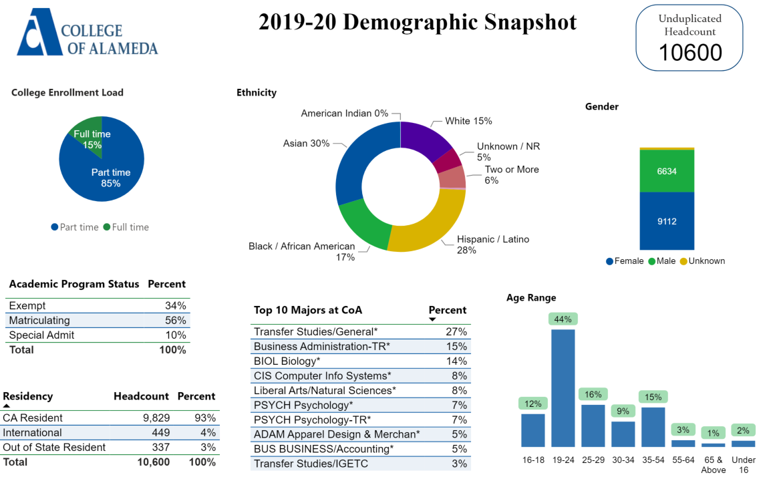

[**Demographics dashboard link**](https://app.powerbi.com/view?r=eyJrIjoiMzVhNGU3YzAtNTIyNy00ZDZmLWIyYzMtYWIzMzllMGViZDQ5IiwidCI6ImVlYTE2YTE2LTQ4YWYtNDc3Yi05MTEzLTA1YjFjMDExMjNmZiIsImMiOjZ9&pageName=ReportSectionb4e116c96a753400a00c)

Describe how external factors such as the implementation Guided Pathways, AB705, Student Centered Funding Formula, advisory board recommendations, changing demographics, and/or COVID-19 has impacted the support services your program or administrative unit provides.

How has your program addressed these changes or challenges to ensure students are supported and can continue to work towards meeting their educational goals?

|  |
| --- |
| The Student Centered Funding Formula (SCFF) has expanded how we outreach to students at the College of Alameda. We want to ensure that we are targeted populations that have experienced a decrease in enrollment. Pell eligible students have continued to decline over the years, so we have implemented outreach efforts that focus on the Pell population to encourage them to complete their FAFSAs and submit documents to complete their financial aid files.  Financial aid staff have participated in Guided Pathways events every semester with the student service team. The financial aid student worker is part of guided pathways. She participates in meetings and shares information from the student perspective. |

Advisory board recommendations

|  |
| --- |
| The Financial Aid Office does not have an advisory board. |

Impact of COVID-19

|  |
| --- |
| COVID-19 has impacted the way we deliver service to students for the Financial Aid Office. We are doing the following to address these challenges:   * We are utilizing zoom for advising students * During COVID-19, we have been utilizing tawk.to, a live chat software plugin tool that embeds in our website and allows us to assist students with Financial Aid questions. * We secured an agreement with CampusLogic, a third-party vendor, that provides students the ability to submit verification files online so that students can complete and upload their financial aid documents online without having to visit the Financial Aid Office. Dropbox was also available for students to submit/upload their FA forms * Members of the financial aid team have participated in activities surrounding food insecurities by volunteering time to help with distributing food to the community * In response to COVID-19, the FAO has proactively provided additional outreach to encourage students to submit their FAFSA/Dream Act applications and complete their FA files via calls, texting, emailing about 3 times a week. * Provide virtual financial aid workshops twice a week via Zoom. * We continued to pay students work-study since COVID-19 |

**Data Analysis**

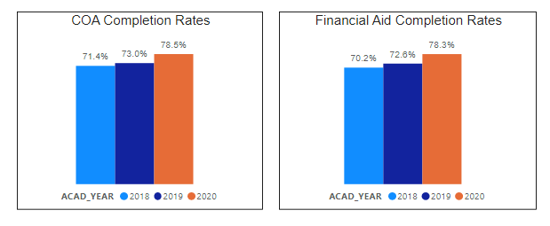

Consider your program’s course completion rates over the past three to five years (% of student who earned a grade of "C" or better).

How do the course completion rates for your program or discipline compare to your college's College-Set Standard for course completion of **67%**?

|  |
| --- |
| The completion rate for financial aid is aligned with the COA completion rates. |

On average the course retention rate (number of students are retained in the course) for College of Alameda has been **85%** for the past three years. Examine the course retention rates for your program over the last three years. How does your program or discipline course retention rates compare to the college?

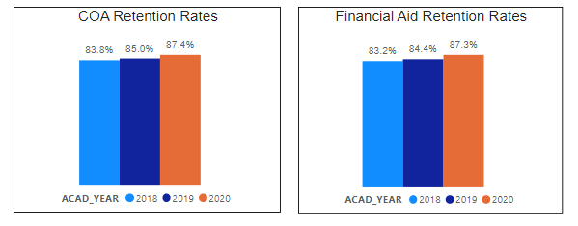

|  |
| --- |
| The retention rates for COA and the FA program are aligned. |

**Equity**

College of Alameda continues to focus on access, equity, and success. The goal is to create an inclusive environment where all students can thrive and meet their education and career goals. In 2019 the Student Service Equity team [analyzed data](https://alameda.peralta.edu/wp-content/uploads/2019/06/CoA-equity-exec-summary-6.2019.docx) to identify groups that were disproportionately impacted in access, persistence, transfer rate, completion of transfer level English and Math, and goal completion.

* **Access:** Black or African American male students enroll at disproportionate rates. Additionally, female Black or African American, disabled and LGBTQIA students enroll at disproportionate rates.
* **Persistence:** Female Black or African American, Latinx, foster youth, LGBTQIA and veteran students are persisting at disproportionate rates. Male Black or African American, foster youth and LGBTQIA students are also persisting at disproportionate rates. The most significant retention equity gap was with male foster youth students.
* **Transfer to a Four-Year Institution:** Female American Indian or Alaska Native, Native Hawaiian or other Pacific Islander and disabled students transferred at disproportionate rates. American Indian or Alaska Native, Black or African American, Filipino, Latinx, disabled, first generation and foster youth males also transferred at disproportionate rates.
* **Complete both Transfer-level Math and English within the first year:** Female foster youth complete both transfer level math and English at disproportionate rates. Additionally, Black or African American, Latinx, disabled, economically disadvantaged, foster youth and LGBTQIA males transfer at disproportionate rates.
* **Vision 2022 Goal Completion:** Asian, Black or African American, Latinx, foster youth, LGBTQIA, and veteran female students complete at disproportionate rates. American Indian or Alaska Native and LGBTQIA male students are also completing at disproportionate rates.

Discuss how your program worked to address these equity gaps since 2019. Incorporate examples of your program data where applicable.

|  |
| --- |
| The Financial Aid Office has partnered with other departments on campus to ensure intentional delivery of financial aid information to populations that have been disproportionately impacted in access, persistence and transfer to a four-year institution. The activities include the following:   * Worked with EOPS/CARE/NextUp/CalWorks department to disburse categorical funds as soon as possible. * Communicated with NextUp/foster youth students to see if they need assistance in completing their fa application or financial aid forms. * Expediated financial aid review for foster youth students. * Met with DSPS students and their counselors upon request. * Partnered with Veteran services to give individual advising to veteran students |

**Degrees & Certificates Conferred**

For more information on awards: [**Degrees & Certificates Dashboard link**](https://app.powerbi.com/view?r=eyJrIjoiZjU2M2M5MzItOTcwZi00Y2U1LWJmODUtYTc0YjlhZGI2ZDhjIiwidCI6ImVlYTE2YTE2LTQ4YWYtNDc3Yi05MTEzLTA1YjFjMDExMjNmZiIsImMiOjZ9&pageName=ReportSectionde32556e136b0a8caccd)

**Degrees and Certificates**

Increasing the number of students who complete a certificate or degree is a shared goal across CoA’s Ed Master Plan Goals, PCCD Goals, the Chancellor’s Office Vision for Success, the Student-Centered Funding Formula, and Guided Pathways.

How can your program contribute to increasing the number of certificates and degrees awarded over the next three years?

|  |
| --- |
| The Financial Aid Office is a partner in making sure that student success is achievable without the barrier of affordability. Student success includes ensuring that students are making Satisfactory Academic Progress (SAP) for financial aid eligibility. We partner with academic advising counselors for the SAP committee. This partnership contributes to a fair and balanced evaluation of SAP appeals and helps financial aid team members understand the academic challenges for students and ways we can support their progress. This partnership also supports efforts to show the student that we are all engaged in their academic success.  We will continue to contribute to increasing the number of certificates and degrees awarded over the next three years by doing the following:   * Increasing CCPG numbers * Increasing SSCG numbers * Partnering with faculty to include financial aid education for classroom presentations * SAP counseling for students on warning status * Promoting financial aid using social media for in-reach and outreach activities * Ensure that students receive their financial aid in the timely manner so they can have the funds for their educational goals. * Connect students to additional resources to support their basic needs such as housing, food, mental health, etc. * Increasing FAFSA and Dream Act numbers |
|  |

**Student Learning Outcomes Assessment**

List your program’s Student/Service Area Learning Outcomes that have been assessed in 2018-19 and 2019-20?

|  |
| --- |
| Process all financial aid files within 3-4 weeks  Improving services to 85% for “satisfied” or “very satisfied” |

How has your dept worked together on assessment (planning together)? Include the challenges and the successes. What aspects of assessment work went especially well in your department and what improvements are most needed?

Detail the planning process, examples of collaboration with other depts or faculty members, roles in leadership and how the dept used student satisfaction surveys, college surveys or outcome data to assess.

|  |
| --- |
| The Financial Aid Office worked together on the Student/Service Area Learning Outcomes by collaborating on the survey for the front counter. As a team, we also made sure that the survey was accessibility friendly and clear and easy for students to understand. We achieved this by working with DSPS.  We have been successful in meeting the goal of processing files within 3-4 weeks. We almost met the 85% goal to receive a “satisfied” or “very satisfied” rating from students but achieved at 81%. Please see the following describing some challenges that prevented us from meeting our goals:   * There was a vacancy, and we did not have 3 specialists to meet the goal * Collecting data was a challenge for the semester * The survey was not automated and relied on paper files * Due to COVID, we weren’t able to assess the full assessment     We plan to address the student satisfaction results by again surveying students to assess what other key areas we need to improve related to student service. We will ask additional questions that include, but are not limited, to if evening office hours for service are needed and if more financial aid workshops are needed. We also want to make sure that we look at other ways to distribute the survey and will explore automating the process. We want to increase the number of students who complete the survey and provide a more efficient way for us to collect the data. |

What were the most important things your department learned from assessment? Did implementation of your action plans result in expansion or improvement of your departments service to students? If so, please explain:

|  |
| --- |
| We learned that customer service training is needed for the financial aid team. A training was scheduled, but it was postponed due to COVID. We also learned that it is difficult to meet the 3-4 weeks goals if we’re not fully staffed. |

What support does your department need from administrators, assessment coordinators and/or your campus assessment committee to continue to make progress in assessment of outcomes and implementation of action plans?

|  |
| --- |
| We determined the following support is needed to make progress in meeting our outcomes and for our action plans:   * Training opportunities (customer service) * Professional development opportunities * Revisit goals yearly and be intentional with meeting assessment coordinator * Meet with assessment coordinator to discuss ways to share survey with students (QR codes), and research creative ways other departments are doing assessments * Find creative ways to get students to complete surveys |

**Engagement**

How has your department has participated in college wide efforts such as committees, presentations, and departmental activities?

|  |
| --- |
| The Financial Aid Office sees the importance of being visible in other capacities that impact the success of the college. We have participated in college wide efforts in the following ways:   * Collaborated with Puente program to outreach to students * We conducted welcome week and orientation presentations * Classroom presentation with English and Psychology departments * Collaboration with Umoja program * Served on hiring committees * Served on the Behavioral Intervention committee |

How has your department has engaged in community activities, partnerships and/or collaborations?

|  |
| --- |
| The Financial Aid Office (FAO) sees the importance of being visible in the community to educate about the financial aid process. We are also vital in the recruitment process for prospective students. We understand that outreach efforts are particularly crucial since the number of financial aid recipients has been on the decline for the past few years. As a result, the FAO has adopted a multi-pronged approach to target specific populations for our outreach efforts.  First, for our feeder high school students, we work closely with the Outreach Office to table at outreach events both on-campus at COA and off-campus at feeder high schools. Second, for our community partners, we have increased outreach at community partner events such as the Community Partner Breakfast and City-Wide College Night. Third, for our adult school students, the FAO worked with the COA Transition Liaison Project Manager to host events to assist adult school students with their financial aid. Fourth, current students and the community at large receive targeted outreach through specialized campus events as well as financial aid workshops offered twice-per-week. Additionally, we partner with the East Bay Cash for College Coalition to plan and strategize ways to strengthen collaborative relationships with high schools throughout the bay area. Lastly, the FAO posts financial aid workshops on I Can Afford College (https://icanaffordcollege.com) for students or the community to get workshop schedule. |

**Prioritized Resource Requests Summary**

In the boxes below, please add resource requests for your program. If there are no resource requested, leave the boxes blank.

|  |  |  |  |  |
| --- | --- | --- | --- | --- |
| **Resource Category** | **Description/Justification** | **Estimated Annual Salary Costs** | **Estimated Annual Benefits Costs** | **Total Estimated Cost** |
| Personnel: Classified Staff |  |  |  |  |
| Personnel: Student Worker | FAO would like to hire a student worker to help manage social media presence. Student will be Federal Work-Study funded. |  |  | $8,000/yr |
| Personnel: Part Time Faculty |  |  |  |  |
| Personnel: Full Time Faculty |  |  |  |  |

|  |  |  |
| --- | --- | --- |
| **Resource Category** | **Description/Justification** | **Total Estimated Cost** |
| Professional Development: Department wide PD needed | Student Employment Essentials Training hosted by the National Student Employment Association [www.nsea.info/student-employment-essentials](http://www.nsea.info/student-employment-essentials) | $400 |
| Professional Development: Personal/Individual PD needed | Customer service training | $5000 |

|  |  |  |
| --- | --- | --- |
| **Resource Category** | **Description/Justification** | **Total Estimated Cost** |
| Supplies: Software |  |  |
| Supplies: Books, Magazines, and/or Periodicals |  |  |
| Supplies: Instructional Supplies |  |  |
| Supplies: Non-Instructional Supplies | KAHOOT subscription | $300 |
| Supplies: Library Collections |  |  |

|  |  |  |
| --- | --- | --- |
| **Resource Category** | **Description/Justification** | **Total Estimated Cost** |
| Technology & Equipment: New |  |  |
| Technology & Equipment: Replacement | New fax machine | $1000 |

|  |  |  |
| --- | --- | --- |
| **Resource Category** | **Description/Justification** | **Total Estimated Cost** |
| Facilities: Classrooms |  |  |
| Facilities: Offices |  |  |
| Facilities: Labs |  |  |
| Facilities: Other |  |  |

|  |  |  |
| --- | --- | --- |
| **Resource Category** | **Description/Justification** | **Total Estimated Cost** |
| Library: Library materials |  |  |
| Library: Library collections |  |  |

|  |  |  |
| --- | --- | --- |
| **Resource Category** | **Description/Justification** | **Total Estimated Cost** |
| Other |  |  |