**College of Alameda**

2020-21 Program Review – Health Services

**Program Overview**

Please provide your program’s mission statement.

|  |
| --- |
| College of Alameda is committed to furthering the equality of the educational opportunity and success for all students by providing access to health services which promote the physical, emotional, social, and spiritual well-being of its students. This well-being contributes to the educational aim of our community colleges by promoting student retention and academic success. |

List your program staff including full-time and part-time faculty, classified staff, and other categories of employment.

|  |
| --- |
| Lisa Sawadogo, Health Services Coordinator – full-time faculty  Amy Tamayo, MFT Trainee – part-time volunteer  Kyle Lee, MFT Trainee – part-time volunteer  Tiffany Tung, MFT Trainee – part-time volunteer  Erica Hill, MFT Trainee – part-time volunteer  Community partner: Roots Clinic  Nurse Practitioner  Patient Health Navigator  Due to COVID-19, the Roots Clinic is currently providing medical services for all currently enrolled Peralta students from all four community colleges Monday – Friday from 9a.m. – 5p.m. College of Alameda mental health services are being provided remotely Monday-Thursday 9a.m. – 5p.m. and Friday 9a.m. – 2p.m.  *In previous years, medical services were offered on a part-time basis (Nursing services: Monday 1-5, Tuesday & Thursday 8:30-12 and massages/acupuncture Wednesdays 9a.m. – 1p.m.) Due to all services being remote, there are no acupuncture or massage services being offered at this time. |

List your program goals from your most recent Program Review or APU. Then, provide an update on the status of the goal. Has your program achieved the goal? Have any of your goals been revised or any still in progress? Lastly, make sure to discuss which College or District goal your program goal aligns to: [Alignment of Goals](https://alameda.peralta.edu/wp-content/uploads/2021/02/Alignment-of-Goals-2022-Vision-for-Success-Peralta-Community-College-District-CoAs-Educational-Master-Plan.pdf)

If no program goals exist or if this is your first program review, create 2-3 goals and align them with a College or District goal.

|  |  |
| --- | --- |
| **Program Goal** | Update or maintain service area outcomes annually and meet or exceed all service area outcome measures for health services. |
| Status: In-Progress or Complete? | In progress |
| Which college or district goal is aligned with your program goal? | College: Strengthen data driven/informed decision making  District: Develop and manage resources to advance our mission |

|  |  |
| --- | --- |
| **Program Goal** | Increase offering of student success workshops related to wellness and health education from 2 to 4 annually. |
| Status: In-Progress or Complete? | In progress |
| Which college or district goal is aligned with your program goal? | College: Increase retention and persistence rates  District: Advance student access, equity, and success |

|  |  |
| --- | --- |
| **Program Goal** | Assess for success at providing culturally sensitive services for students by surveying students about their experience with wellness services. |
| Status: In-Progress or Complete? | In progress |
| Which college or district goal is aligned with your program goal? | College: Increase retention and persistence rates  District: Advance student access, equity, and success |

List the essential functions of your department, program or unit and provide a description of how the unit aligns with the college mission.

|  |
| --- |
| The essential functions of wellness services are to provide students with access to services which promote physical, emotional, social, and spiritual well-being. Our department provides mental health wellness support for students by: providing individual counseling sessions, support groups, crisis intervention, consultation, referrals, and campus wide workshops and training.  The medical services provided through our community clinic partner Roots include, but are not limited to: first aid, pregnancy testing, health education, smoking cessation, health and wellness counseling, triage, flu shots, COVID-19 testing, health insurance counseling, and referrals to off-site facilities.  A new full-time Health Services Coordinator was recently hired in July 2020 after a year of a Psychologist/DSPS Counselor covering part-time hours in the Health Services Department in order to oversee mental health interns during the 2019-2020 academic school year. During the fall 2020 semester and pivot to remote services, 333 counseling appointments were utilized out of 384 appointments offered with an overall utilization rate of 87%. A total of 65 unduplicated students were supported by mental health services. As students and staff have adjusted to the remote campus, we imagine that there will be an increase in the number of students accessing services moving forward. Please note that the Health Services Coordinator is the only full-time faculty overseeing the above mental health services essential functions; there is currently no part-time faculty or classified staff assigned to support the department.  The data provided by Roots Clinic on student utilization is the following :  Spring 2020 – 29 unduplicated students across 53 nursing appointments and 4 navigation appointments  Fall 2021 – 2 unduplicated students across 3 appointments and 0 navigation appointments  Health Services aligns with the greater college mission statement as it provides services that address barriers to equal access and ability to complete courses. |

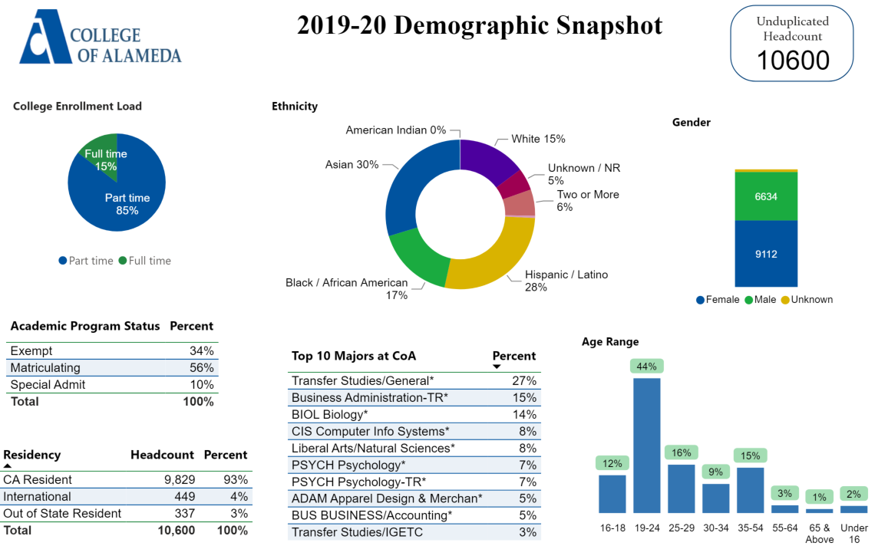

[**Demographics dashboard link**](https://app.powerbi.com/view?r=eyJrIjoiMzVhNGU3YzAtNTIyNy00ZDZmLWIyYzMtYWIzMzllMGViZDQ5IiwidCI6ImVlYTE2YTE2LTQ4YWYtNDc3Yi05MTEzLTA1YjFjMDExMjNmZiIsImMiOjZ9&pageName=ReportSectionb4e116c96a753400a00c)

Describe how external factors such as the implementation Guided Pathways, AB705, Student Centered Funding Formula, advisory board recommendations, changing demographics, and/or COVID-19 has impacted the support services your program or administrative unit provides.

How has your program addressed these changes or challenges to ensure students are supported and can continue to work towards meeting their educational goals?

Guided Pathways, AB705, or the Student-Centered Funding Formula (SCFF)

|  |
| --- |
| The new Health Services Coordinator was involved in the Guided Pathways Taskforce in previous work at a Peralta institution and is looking forward to utilizing past knowledge to listen to College of Alameda student voices and feedback regarding health services. The department will continue to strategize while creating program goals and student learning outcomes that will ensure student success. There will be a focus on creating student surveys in order to support retention and best meet each student’s educational goals. |

Advisory board recommendations

|  |
| --- |
| There is currently no advisory board, however; there is a monthly district health services committee meeting where there is advice and expertise given by the Director of Health Services. In addition to the monthly meeting, the Health Services Coordinator participates in a weekly meeting with counterparts at the other Peralta Colleges to discuss best practices, programming ideas, and law/ethics considerations in providing mental health counseling. |

Impact of COVID-19

|  |
| --- |
| There has been an increase in the need for mental health services over the past several years, and the impact of COVID-19 has been especially devastating for our students. There has been an increase in the severity of symptoms (severe depression, severe social anxiety, trauma concerns, etc.), as well as an increase in food and housing insecurities. There has also been a noticeable shortage of community mental health referrals with availability. One student, for example, called CoA to request an appointment after calling 20 therapists on an insurance panel that had no openings and no option for a waitlist. Mental health access was an issue before the pandemic, and now the need for access and culturally responsive services has been illuminated and will continue to grow. |

**Data Analysis**

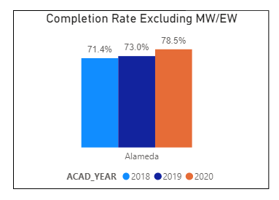

Consider your program’s course completion rates over the past three to five years (% of student who earned a grade of "C" or better).

How do the course completion rates for your program or discipline compare to your college's College-Set Standard for course completion of **67%**?

|  |
| --- |
| The course completion rate in 2020 for the subpopulation is 84%. The college course completion rate for 2020 is 78%. Data suggests that students who received support or direct services from Health Services have higher course completion rates in 2020. |

On average the course retention rate (number of students are retained in the course) for College of Alameda has been **85%** for the past three years. Examine the course retention rates for your program over the last three years. How does your program or discipline course retention rates compare to the college?

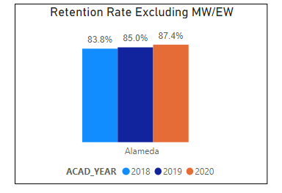

|  |
| --- |
| The course retention rate in 2020 for the subpopulation is 90% compared to the college course retention rate of 87%. Data suggests that students who received support or direct services from Health Services have higher retention rates in 2020. |

**Equity**

College of Alameda continues to focus on access, equity, and success. The goal is to create an inclusive environment where all students can thrive and meet their education and career goals. In 2019 the Student Service Equity team [analyzed data](https://alameda.peralta.edu/wp-content/uploads/2019/06/CoA-equity-exec-summary-6.2019.docx) to identify groups that were disproportionately impacted in access, persistence, transfer rate, completion of transfer level English and Math, and goal completion.

* **Access:** Black or African American male students enroll at disproportionate rates. Additionally, female Black or African American, disabled and LGBTQIA students enroll at disproportionate rates.
* **Persistence:** Female Black or African American, Latinx, foster youth, LGBTQIA and veteran students are persisting at disproportionate rates. Male Black or African American, foster youth and LGBTQIA students are also persisting at disproportionate rates. The most significant retention equity gap was with male foster youth students.
* **Transfer to a Four-Year Institution:** Female American Indian or Alaska Native, Native Hawaiian or other Pacific Islander and disabled students transferred at disproportionate rates. American Indian or Alaska Native, Black or African American, Filipino, Latinx, disabled, first generation and foster youth males also transferred at disproportionate rates.
* **Complete both Transfer-level Math and English within the first year:** Female foster youth complete both transfer level math and English at disproportionate rates. Additionally, Black or African American, Latinx, disabled, economically disadvantaged, foster youth and LGBTQIA males transfer at disproportionate rates.
* **Vision 2022 Goal Completion:** Asian, Black or African American, Latinx, foster youth, LGBTQIA, and veteran female students complete at disproportionate rates. American Indian or Alaska Native and LGBTQIA male students are also completing at disproportionate rates.

Discuss how your program worked to address these equity gaps since 2019. Incorporate examples of your program data where applicable.

|  |  |  |  |  |  |  |  |  |  |  |  |  |  |  |  |  |  |  |  |  |  |  |  |  |  |  |  |  |  |  |
| --- | --- | --- | --- | --- | --- | --- | --- | --- | --- | --- | --- | --- | --- | --- | --- | --- | --- | --- | --- | --- | --- | --- | --- | --- | --- | --- | --- | --- | --- | --- |
| In terms of ethnicity, the largest group of students served by Health Services are Hispanic/Latinx students, followed by the Asian student population, the students who identify as multi ethnic and Black/African American students.   |  |  |  | | --- | --- | --- | |  | **Values** |  | | **Ethnicity** | **Headcount** | **Percent** | | Asian | 10 | 24% | | Black / African American | 5 | 12% | | Hispanic / Latino | 16 | 38% | | Two or More | 6 | 14% | | Unknown / NR | 3 | 7% | | White | 2 | 5% | | **Grand Total** | **42** | **100%** | |  |  |  |   Of the subpopulation 60% are first generation students and 90% are low income. Low income is defined as students who are eligible to receive federal pell or CA Promise Grant, OR have indicated that they are receiving SSI, CalWorks (TANF), or general assistance, OR have indicated their annual income meets the low-income limits as defined by the Department of Housing and Urban Development (HUD) for Alameda County.  Health Services is committed to recruiting and supporting MFT Trainees that represent College of Alameda’s diverse campus community. We currently have MOU’s with St. Mary’s, the Wright Institute, University of San Francisco, SF State University, and JFK to ensure that there is a wide range of applicants to provide mental health services. We prioritize recruiting BIPOC and LGBTQ+ candidates.  Our community partner, the Roots Clinic aligns with our access, equity and success roles in providing medical services for our students. Their vision and mission are the following:  -Founded in Oakland, California, the mission of Roots Community Health Center is to uplift those impacted by systemic inequities and poverty. We accomplish this through medical and behavioral health care, health navigation, workforce enterprises, housing, outreach, and advocacy.  -We envision a United States where all communities of African descent are resilient, healthy, self-sufficient, and self-determined. We are proudly serving the greater Bay Area and are expanding to other CA regions.  Please see their website for more information: <https://rootsclinic.org/> |

**Degrees & Certificates Conferred**

For more information on awards: [**Degrees & Certificates Dashboard link**](https://app.powerbi.com/view?r=eyJrIjoiZjU2M2M5MzItOTcwZi00Y2U1LWJmODUtYTc0YjlhZGI2ZDhjIiwidCI6ImVlYTE2YTE2LTQ4YWYtNDc3Yi05MTEzLTA1YjFjMDExMjNmZiIsImMiOjZ9&pageName=ReportSectionde32556e136b0a8caccd)

**Degrees and Certificates**

Increasing the number of students who complete a certificate or degree is a shared goal across CoA’s Ed Master Plan Goals, PCCD Goals, the Chancellor’s Office Vision for Success, the Student-Centered Funding Formula, and Guided Pathways.

How can your program contribute to increasing the number of certificates and degrees awarded over the next three years?

|  |
| --- |
| Health Services provides a lifeline for students in pursuing their educational goals. We’re committed to supporting students and strategizing how to best capture data to display our department’s contribution moving forward. |

**Student Learning Outcomes Assessment**

List your program’s Student/Service Area Learning Outcomes that have been assessed in 2018-19 and 2019-20?

|  |
| --- |
| 1. **Healthier Decisions: Students will be able to utilize the necessary information, resources, and options available for them to make sound educational, emotional, and health-related lifelong decisions.**(ILO 1 Problem Solving & Decision Making; ILO 4 Interpersonal Skills; ILO 5 Civic Responsibility) 2. **Improved coping: Students will be able to identify healthier coping skills and strategies for maintaining wellness, managing stress, managing anger, or meeting personal goals.** (ILO 1 Problem Solving & Decision Making; ILO 4 Interpersonal Skills; ILO 5 Civic Responsibility)   Our records show the above SLO’s were assessed in the past. Since there is a new Health Services Coordinator, the department will reassess SLO’s and create effective surveys moving forward. |

How has your dept worked together on assessment (planning together)? Include the challenges and the successes. What aspects of assessment work went especially well in your department and what improvements are most needed?

Detail the planning process, examples of collaboration with other depts or faculty members, roles in leadership and how the dept used student satisfaction surveys, college surveys or outcome data to assess.

|  |
| --- |
| Health Services is currently a one-person team, and the Coordinator will move forward by planning and collaborating across departments at College of Alameda and the district in order to obtain be able to valuable feedback (DSPS, learning communities, student services area, across district health services staff and faculty, etc.)  Health Services Coordinator will work closely with the Dean of Enrollment Services and Director of College Research & Planning to discuss challenges and areas that need improvement. There will also be planning in creating student satisfaction surveys that support SLO’s and best practices in supporting student success moving forward. |

What were the most important things your department learned from assessment? Did implementation of your action plans result in expansion or improvement of your departments service to students? If so, please explain:

|  |
| --- |
| Since Health Services Coordinator was hired in the middle of the pandemic and before the fall 2020 academic semester, the assessment will be a work in progress. The next program review will have more comprehensive updates. |

What support does your department need from administrators, assessment coordinators and/or your campus assessment committee to continue to make progress in assessment of outcomes and implementation of action plans?

|  |
| --- |
| Will need support from Dean of Enrollment Services to gain a better understanding of past assessment best practices and areas of focus in moving forward. Will also need the Director of Research & College Planning to pull data and help create student satisfaction surveys. Collaboration with other departments and creating space to hear student voices will be critical in order to ensure SLO’s and goals that make sense for the department. |

**Engagement**

How has your department has participated in college wide efforts such as committees, presentations, and departmental activities?

|  |
| --- |
| There is participation and attendance at the following:  -District Health & Wellness monthly meetings  -Weekly licensed clinician consultation meetings and discussing best practices  -Weekly Student Services meetings  -Flex Day events  -Offered campus wide workshops for both students and faculty/staff on important mental health related topics.  Note that it can be difficult for a one-person team to manage daily operations of the department, as well as make time to connect with larger college wide efforts and collaboration. |

How has your department has engaged in community activities, partnerships and/or collaborations?

|  |
| --- |
| As mentioned above, our partnership with Roots Clinic has been invaluable in providing our students with medical services. It has also been critical to stay connected with community referrals and up-to-date resources. Some of the agencies we work with consistently: Alameda County ACCESS line, Crisis Support Services, Sausal Creek Outpatient Stabilization, Korean Community Center of the East Bay, and Summit Bereavement Services.  We also have significant partnerships with multiple graduate schools to ensure that we have a consistent diverse pool of MFT Trainee applicants to provide direct mental health services for our students. We currently have MOU’s with St. Mary’s, USF, San Francisco State University, The Wright Institute, and JFK University.  In order to provide relevant and culturally sensitive training for the MFT Trainee’s, the Health Service Coordinator brings in a variety of community agencies and experts. A few examples include: BAWAR-sexual assault training, Summit Bereavement Services to talk about grief counseling and the Felton Institute on Early Psychosis. |

**Prioritized Resource Requests Summary**

In the boxes below, please add resource requests for your program. If there are no resource requested, leave the boxes blank.

|  |  |  |  |  |
| --- | --- | --- | --- | --- |
| **Resource Category** | **Description/Justification** | **Estimated Annual Salary Costs** | **Estimated Annual Benefits Costs** | **Total Estimated Cost** |
| Personnel: Classified Staff |  |  |  |  |
| Personnel: Student Worker |  |  |  |  |
| Personnel: Part Time Faculty | 1 Part-Time Mental Health Counselor Faculty  2 Part-Time FDIP (Faculty Diversity Internship Program)  Consistent increase in severe mental health needs of students and need for experienced, licensed therapist to assist with crisis assessments and on-going support for students. There is also a need for licensed mental health counselor to cover summer hours and supervision of interns.  Need for BIPOC and LGBTQ+ counselors to support diverse campus community and provide individual and group counseling support. | 1 PT-MH Counselor. - $58,000  2-FDIP’s - $50,000 | 1 PT-MH Counselor - $14,000  2 FDIP’s - $4,000 | 1 PT-MH Counselor = $72,000  2 Part-time FDIP’s = $54,000 |
| Personnel: Full Time Faculty | There is a need for an 11- month contract and extra service. The Health Services Coordinator position (and the only position in Health Services) is a big job with multiple essential functions. The demand for mental health and wellness services will continue to grow. The job is impossible to do in a 10-month, 30 hour per week contract. |  |  | 11 month contract - $10,000  Extra service - $6,100 |

|  |  |  |
| --- | --- | --- |
| **Resource Category** | **Description/Justification** | **Total Estimated Cost** |
| Professional Development: Department wide PD needed | Graduate level MFT Trainees provide the majority of direct individual counseling sessions for students and need up-to-date information on best practices in the field including, but not limited to: law & ethics, crisis intervention, cultural sensitivity, and trauma. | $750 |
| Professional Development: Personal/Individual PD needed | Licensed Professional Clinical Counselors are required to obtain 36 hours of continuing education every two years in order to maintain the license and continue the ability to supervise MFT Trainees/Interns. | $500 |

|  |  |  |
| --- | --- | --- |
| **Resource Category** | **Description/Justification** | **Total Estimated Cost** |
| Supplies: Software |  |  |
| Supplies: Books, Magazines, and/or Periodicals |  |  |
| Supplies: Instructional Supplies |  |  |
| Supplies: Non-Instructional Supplies |  |  |
| Supplies: Library Collections |  |  |

|  |  |  |
| --- | --- | --- |
| **Resource Category** | **Description/Justification** | **Total Estimated Cost** |
| Technology & Equipment: New | During COVID-19, need for 2 new work computers with video capabilities (for MFT Trainees). | $4000 |
| Technology & Equipment: Replacement |  |  |

|  |  |  |
| --- | --- | --- |
| **Resource Category** | **Description/Justification** | **Total Estimated Cost** |
| Facilities: Classrooms |  |  |
| Facilities: Offices |  |  |
| Facilities: Labs |  |  |
| Facilities: Other |  |  |

|  |  |  |
| --- | --- | --- |
| **Resource Category** | **Description/Justification** | **Total Estimated Cost** |
| Library: Library materials |  |  |
| Library: Library collections |  |  |

|  |  |  |
| --- | --- | --- |
| **Resource Category** | **Description/Justification** | **Total Estimated Cost** |
| Other |  |  |