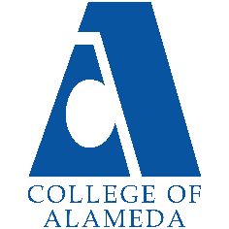
College of Alameda
2021-22 Program Review – Business

Program Overview
Please provide your program’s mission statement
College and District Mission Statement:
The Mission of College of Alameda to serve the educational needs of its diverse community by providing comprehensive and flexible programs and resources that empower students to achieve their goals.
Peralta Community College District Mission Statement:

We are a collaborative community of colleges. Together, we provide educational leadership for the East Bay, delivering programs and services that sustainably enhance the region’s human, economic, environmental, and social development. We empower our students to achieve their highest aspirations. We develop leaders who create opportunities and transform lives. Together with our partners, we provide our diverse students and communities with equitable access to the educational resources, experiences, and life-long opportunities to meet and exceed their goals. In part, the Peralta Community College District provides accessible, high quality, educational programs and services to meet the following needs of our multi-cultural communities:
• Articulation agreements with a broad array of highly respected Universities;
• Achievement of Associate Degrees of Arts and Science, and certificates of achievement;
• Acquisition of career-technical skills that are compatible with industry demand;
• Promotion of economic development and job growth;
• Foundational basic skills and continuing education;
• Lifelong learning, life skills, civic engagement, and cultural enrichment;
• Early college programs for community high school students;
• Supportive, satisfying, safe and functional work environment for faculty and staff; and
• Preparation for an environmentally sustainable future

Program Mission:

The Business Discipline's mission is closely aligned to COA's Mission: To serve the educational needs of its diverse community by providing comprehensive and flexible programs and resources that empower students to achieve their goals. The Business Discipline strives to accomplish this mission by offering courses to students:
• Seeking to transfer to a four year institution, or
• Enhance their existing job skills, or
• Aspiring to become Entrepreneurs/Small business managers.

List your program faculty and/or staff
Full time:
- Olga Fish
- Carolyn Johnson
- Rochelle Olive

Part time:
- Long Nguyen
- PJ Shelton

List your program goals from your most recent Program Review or APU. Then, provide an update on the status of the goal. Has your program achieved the goal? Have any of your goals been revised or any still in progress? Lastly, make sure to discuss which College or District goal your program goal aligns to.
If no program goals exist or if this is your first program review, work to create 2-3 goals and align them with a College or District goal.

Program Goal | New Entrepreneurship Program
Status: In-Progress or Complete? | Complete
Which college or district goal is aligned with your program goal? | College Goal: empower students to achieve their goals.

Program Goal | Collaborative Teaching (Discipline/Program/Division/Campus]
Status: In-Progress or Complete? | Revised
Which college or district goal is aligned with your program goal? | College Goal: empower students to achieve their goals.

Program Goal | Continue to complete assessment per each semester and make quality improvement to the scheduling, courses and services provided to students in reference to their successful completion of Accounting/Business courses at COA
Status: In-Progress or Complete? | In-Progress
Which college or district goal is aligned with your program goal? | College Goal: Increase retention and persistence rates

Describe your current utilization of facilities, including labs and other space
Prior to the pandemic, the business dept occupied smart classrooms, that allow for a seamless integration between the face to face and online learning
Since the pandemic all online with assumption that we will back in physical classrooms by Fall 2022.

Enrollment Trends
Consider the most recent 3 to 5 years when answering the questions below.
Enrollment Trends Dashboard link
Discuss enrollment trends over the past three years
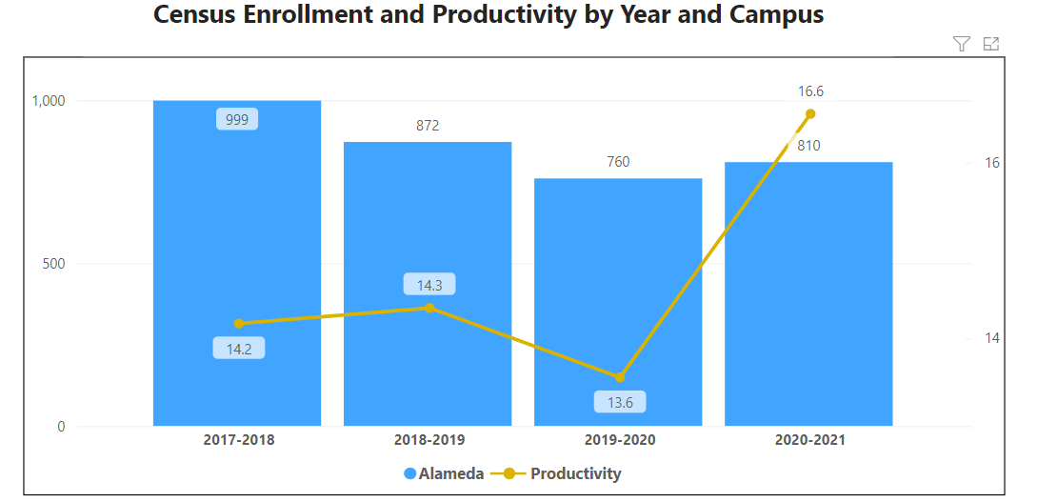
FTES/FTEF = productivity
Our college goal is 17.5, this past year our college productivity goal is 16.5.
For additional analysis, click on the Enrollment Trends Dashboard, set the filters to Alameda and your discipline
Business department’s productivity number for the past three years has been very closely aligned to the overall college trend and productivity.

In the enrollment dashboard, set the filter to consider whether the time of day each course is offered meets the needs of students.
Are courses scheduled in a manner that meets student needs and demands? How do you know?
During the pandemic, classes were offered online. Online manner of teaching showed increased in enrollment of classes offered in a different manner prior. Evening courses show steady decline in enrollment.

Describe effective and innovative teaching strategies used by faculty to increase student learning and engagement.
This department pays close attention to the pedagogy and the strategies used in the classroom. All business instructors meet the minimum standards required by AP 4105. Some of the instructors have been certified by @ONE and by District educational program “Becoming a More Effective Online Educator Training (BMEOE)”. Since the last program review, we have tried to infuse more effective technology in the classroom to generate data that would inform us about the student success and student challenges. Business faculty in this college continuously invest in their professional development being this by staying always in touch with the most recent research in teaching business and accounting classes (attending annual conferences); and also always in touch with cutting edge technology that increases student success and safeguards the integrity of learning.

How is technology used by the discipline, department?
This department has been in avant-garde of utilizing technology to effectively teach courses face to face, in a hybrid or fully online format. Faculty use technology, such as software that produce high quality videos, or other learning platforms that provide interactive learning opportunities. Business department is always in search of new technology and technological products to improve the quality of learning/teaching.

How does the discipline, department, or program maintain the integrity and consistency of academic standards with all methods of delivery, including face to face, hybrid, and Distance Education courses?
The faculty who teach in this department are seasoned educators who have invested in their professional growth and have earned several professional degrees in accounting, business and education. Each faculty has more than 10 years of experience teaching accounting and business courses at introductory level. As business majors they do understand the importance of a robust introductory foundation as essential for intermediate and advanced accounting and business courses. Faculty has been consistently exposed to new learning methodologies and technology and it has positioned this department as a leader in creating high level of academic standard as demonstrated by high success rate and transfer and success in some of the most prominent accounting and business schools in California and the nation.

Curriculum
Please review your course outlines of record in Curriqunet to determine if they have been updated or deactivated in the past three years

https://peralta.curricunet.com/
Specify when your department will update each one, within the next three years.
All courses have been updated in the last three years with the following exceptions:

BUS 216 - Legal Secretarial Studies (Family/Corporate/Criminal/Real Estate)

BUS 217 - Legal Secretarial Studies (Probate/Personal Injury/Intellectual Property/Bankruptcy)
- BUS 024 - Computerized Accounting Principles

Courses listed above are scheduled to be updated this year.

Please summarize curriculum plans and improvements for your discipline, department and or program of study.
This department created several new courses and developed online classes within the framework of CTE Online Grant during 2020-2021 academic year to increase the list of accounting/business courses for students who aspire to major in accounting/business as well as for students transferring to UC/SCU. In addition, the department has created a clear path for students majoring with accounting/business AA-T as part of the Guided Pathways cohort work.

Program Learning Outcomes Assessment
Using the CurriQunet public search, list your Program Learning Outcomes for all approved degrees and certificates.
https://peralta.curricunet.com/PublicSearch/Index
PLOs for AA degree in Accounting:
Upon completion of this program a student will be able to:
- Analyze a business situation and recommend a solution or plan for improvement, applying legal and ethical principles in business decision making .
- Obtain information related to the profession using traditional and electronic sources and synthesize the information into a business report .
- Analyze data and prepare common business and personal financial reports.
- Analyze impact of globalization on culture, politics, and economics .
- Analyze business issues, interpret financial data and identify economic trends
PLOs for The Associate in Science in Business Administration for Transfer
Upon completion of this program a student will be able to:
- Analyze a business situation and recommend a solution or plan for improvement, applying legal and ethical principles in business decision making .
- Obtain information related to the profession using traditional and electronic sources and synthesize the information into a business report .
- Analyze data and prepare common business and personal financial reports.
- Analyze impact of globalization on culture, politics, and economics .
PLOs for The Entrepreneurship Certificate
Upon completion of this program a student will be able to:
- Identify and utilize four key pillars to launch, grow and manage a successful business (launch, growth and management) including marketing, finance (obtaining and managing), law and ethics and operations and management .
- Exhibit key professional skills for entrepreneurial success: a . Leadership b . Innovation c . Creativity d . Negotiation e . Problem Solving f . Communication g . Conceptualization h . Branding (Personal and Business)
- Demonstrate personal attributes for entrepreneurial success: a . Enthusiasm b . Drive c . Trustworthiness and Ethics d. Productivity e. Efficiency f. Life Balance g . Collaborative h . Professional
PLOs for Certificate of Proficiency
Upon completion of this program a student will be able to:
- Prepare a comprehensive business plan
- Demonstrate working knowledge of a balance sheet, income statement, and cash flow statement
- Describe funding sources and the capital structure of a business
- Describe operational and organizational structures for business
- Apply critical thinking and technology skills to select appropriate software to solve a business problem
- Communicate an understanding of business concepts professionally through written, oral and visual presen- tations using current technology .
- Recognize ethical behavior in their chosen profession and behave in a socially responsible manner .
- Analyze business issues, interpret financial data and identify economic trends

Were there any obstacles experienced during assessment? What worked well? (Mainly based on evidence in the report, attach other evidence as necessary)
No obstacles. PLOs are appropriate for business programs. PLOs needed to be updated in CurriQnet.

What percent of your programs have been assessed? (mainly based on evidence in the report, attach other evidence as necessary; note: a complete program assessment means all Program Learning Outcomes (PLOs) have been assessed for that program)
SLO’s have assessed by 30% with the intent that the remaining 70% will be assessed this year. 50% of PLOs are assessed. The remaining 50% are in process this year.

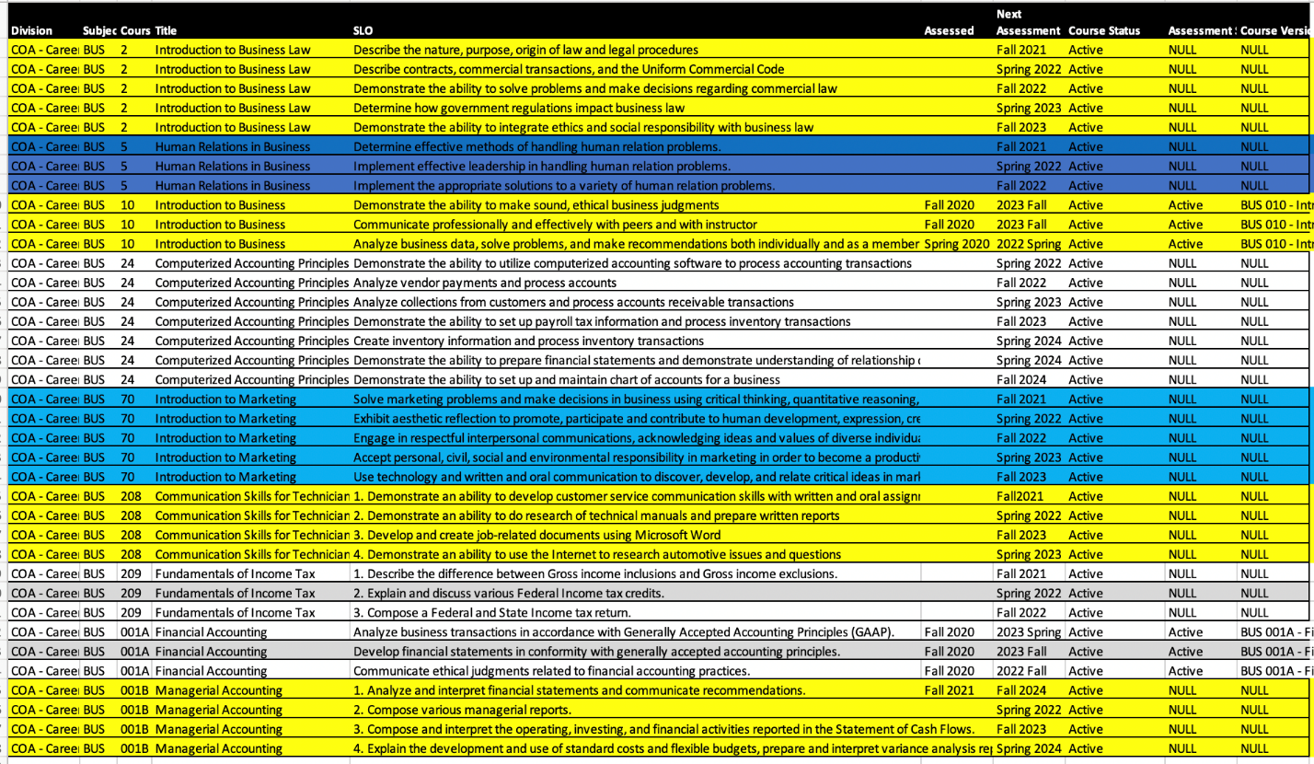

How has your dept worked together on assessment (planning together)? Describe things that went well or obstacles. What aspects of assessment work went especially well in your department and what improvements are most needed?

Planning Process
Monthly Department meetings during which we discuss assessments. Division meetings during the Flex days are also opportunities to discuss assessments.

What were the most important things your department learned from assessment? Did implementation of your action plans result in better student learning? In other words, how has your department used the results of assessment to improve student learning and/or curriculum? Please be as detailed as possible.

The most important thing we learned is that students all struggle with the quantitive aspect of these courses. Robust mathematical preparation is needed to overcome these challenges and also more tutors.

Does your department participate in the assessment of multidisciplinary programs? If Yes, describe your department's participation and what you learned from the assessment of the program that was applicable to your own discipline.
No.

College of Alameda Institutional Learning Outcomes (ILOs) were created to guide educational programs and services. They include:
- Problem Solving: Solve problems and make decisions in life and work using critical thinking, quantitative reasoning, community resources, and civil engagement.
- Communication and Technology: Use technology and written and oral communication to discover, develop, and relate critical ideas in multiple environments.
- Creativity: Exhibit aesthetic reflection to promote, participate and contribute to human development, expression, creativity, and curiosity.
- Diversity: Engage in respectful interpersonal communications, acknowledging ideas and values of diverse individuals that represent different ethnic, racial, cultural, and gender expressions.
- Civic Responsibility: Accept personal, civic, social and environmental responsibility in order to become a productive local and global community member.

How does your department participate in assessing the Institutional Learning Outcomes (ILOs)? If your department has not participated, how will you plan to incorporate these outcomes within your department?
Institutional Effectiveness Committee plans to assess the Diversity ILO in 2021-22. We plan to participate in that discussion.

What support does your department need from administrators, assessment coordinators and/or your campus assessment committee to continue to make progress in assessment of outcomes and implementation of action plans?
We need additional tutors as well as more support for part time faculty to complete and record the faculty assessment results.

Course Completion
Consider your course completion rates over the past three to five years (% of student who earned a grade of "C" or better).
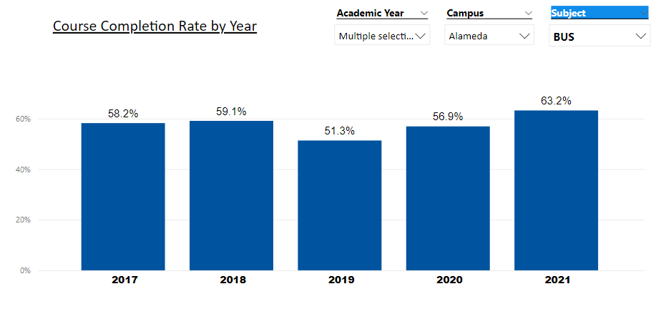
How do the course completion rates for your program or discipline compare to your college's Institution-Set Standard for course completion of 67%?
Prior to the Pandemic, the course completion rate was below Institution rate, but during the pandemic, online accounting classes were offered online and overall completion rate went up. Different modes of instruction helped to increase the course of completion.

How do the department's Hybrid course completion rates compare to the college course completion standard? Use the course completion dashboard to disaggregate.
The hybrid and especially online sessions have a very good completion rate and this is the result of a massive investment in online technology and resources that provide robust assessment and opportunities for students and faculty to make an early assessment of success and make needed intervention to keep students engaged in class.

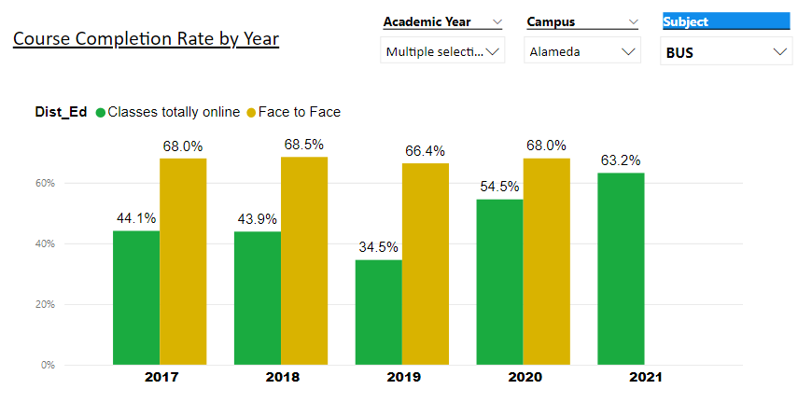
Are there substantial differences in course completion rates between face to face and Distance Education/hybrid courses? If so, how does the discipline, department, or program address this? How do you assess the overall effectiveness of Distance Education/hybrid course?
We see some difference and the trend: online students are getting close to a face to face students performance in 2020, 2021. This could be a multivariate issue, with the most important criterion being that online courses have been brough up to a required standards of online teaching by faculty who participated in a rigorous training exceeded the minimum standards required by AP 4105. Instructors of BUS department have been certified by @ONE and by District educational program Becoming a More Effective Online Educator Training (BMEOE).

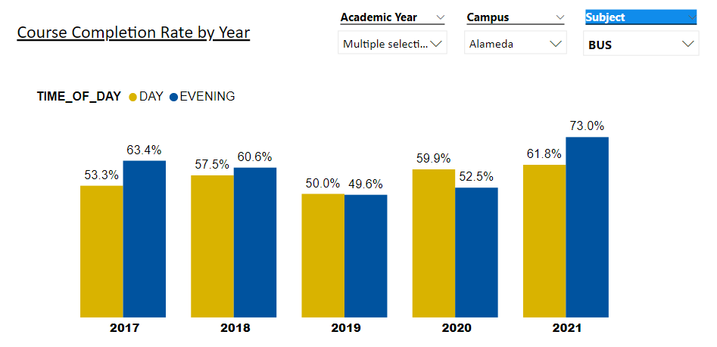

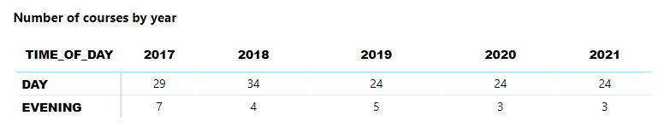

Are there substantial differences in course completion rates between courses taught during the day compared to evening course? If so, how does the discipline, department, or program address this?
No substantial differences.

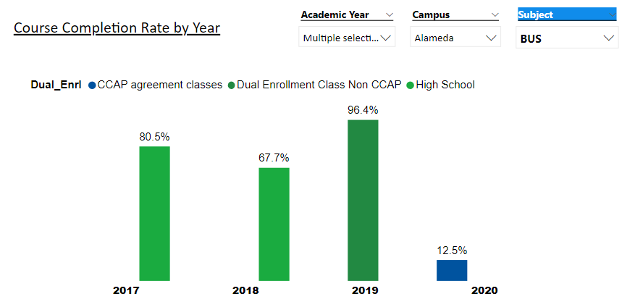

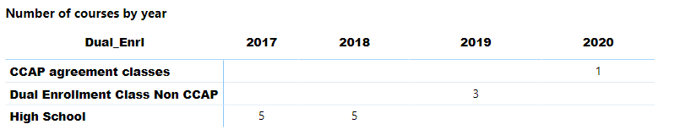
If your program offers dual enrollment courses, examine the data, and discuss the course completion rates compared to the overall program rate.
When DE classes are offered, they have higher completion rate then the Institutional, and college completion rate.

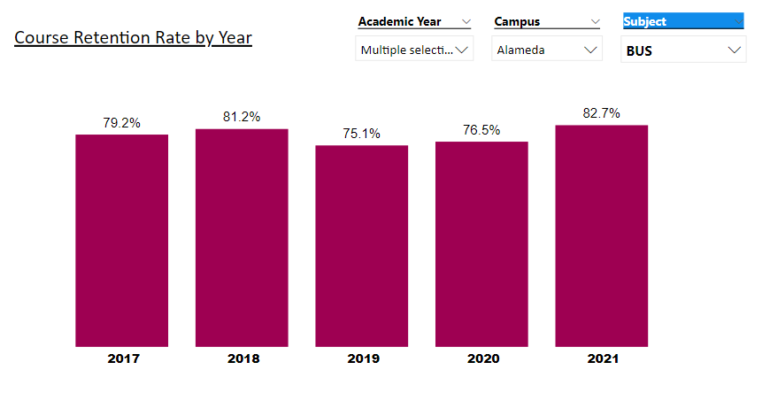

On average the course retention rate (number of students are retained in the course) for College of Alameda has been 85% for the past three years. Examine the course retention rates for your program over the last three years. How does your program or discipline course retention rates compare to the college?
The retention rate is close to college retention rate.

College of Alameda continues to focus on access, equity, and success. The goal is to create an inclusive environment where all students can thrive and meet their education and career goals.
To address equity gaps and work towards achieving equity in educational outcomes, examine your program data for evidence of disproportionate impact (DI). When disaggregating course success rates, are there any groups whose course completion rate falls more than 3 percentage points below the discipline average? If so, identify them and explain what your department is doing to address the disproportionate impact for the group.
Note: The tables reflected use 2018-19 program data to calculate DI. Groups with 10 students or less are excluded from the analysis.
Cohort Name | Cohort Count | Outcome Count | Success Rate | Point Gap Index | MOE
Asian - Female | 115 | 84 | 73 | 24.92 | -9.14
Asian - Male | 129 | 95 | 74 | 26.09 | -8.63
Black / African American - Female | 128 | 40 | 31 | -23.50 | -8.66
Black / African American - Male | 79 | 33 | 42 | -10.94 | -11.02
Hispanic / Latina - Female | 119 | 56 | 47 | -5.35 | -8.98
Hispanic / Latino - Male | 117 | 50 | 43 | -9.93 | -9.06
Two or More - Female | 24 | 9 | 38 | -14.58 | -20.00
Two or More - Male | 32 | 16 | 50 | -1.41 | -17.32
Unknown / NR - Female | 10 | 5 | 50 | -1.41 | -30.98
Unknown / NR - Male | 15 | 6 | 40 | -11.41 | -22.32
White- Female | 52 | 26 | 50 | -1.41 | -13.40
White - Male | 66 | 35 | 53 | 53.03 | -12.25
Overall SR (Includes Comparison Group) | 886 | 455 | 51

Ethnicity and Gender
Faculty is actively participating in equity Institute and Aal CE faculty (those developing courses for the Improving Online CTE Pathways Grant and CE faculty not developing courses for the grant) participated in a 5-week, online equity training. Instructors were guided through the process of revising or building a new online courses to meet the eight criteria in the Peralta Online Equity Rubric. The rubric was developed by faculty in our district and won a national award last year.

Cohort Name | Cohort Count | Outcome Count | Success Rate | Point Gap Index | MOE
Student with disabilities | 33 | 16 | 48 | -2.33 | -17.06
First Generation | 492 | 253 | 51 | 0.85 | -4.42
Low Income | 649 | 324 | 50 | -1.24 | -3.85
Veterans | 10 | 3 | 30 | -20.87 | -30.99

Students with Disabilities (DSPS), First Generation, Foster Youth, Low Income or Veterans
N/A

Cohort Name | Cohort Count | Outcome Count | Success Rate | Point Gap Index | MOE
16-18 | 99 | 54 | 55 | 3.60 | -9.85
19-24 | 438 | 238 | 54 | 5.88 | -4.68
25-29 | 140 | 67 | 48 | -4.14 | -8.28
30-34 | 70 | 38 | 54 | 3.19 | -11.71
35-54 | 131 | 58 | 44 | -8.29 | -8.56
55-64 | 14 | 3 | 21 | -30.39 | -26.18

Age Range

N/A

What has the discipline, department, or program done to improve course completion and retention rates?
The department is currently in the process of reviewing, analyzing, and enhancing the current course offerings. Curriculum is constantly updated, textbooks and courses are revised to augment/improve course completion and retention rates.

Degrees & Certificates Conferred
Since the last program review, what has the discipline, department, or program done to improve the number of degrees and certificates awarded?
Faculty actively participated in Guided Pathway to create a structured step-by-step guidance for students to take courses in specific sequence to obtain a degree or a certificate.

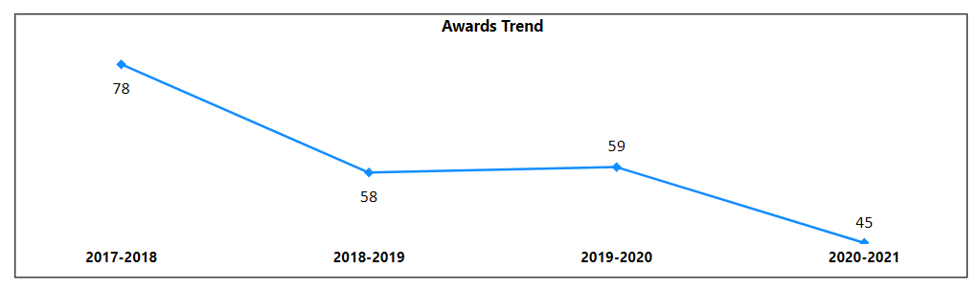
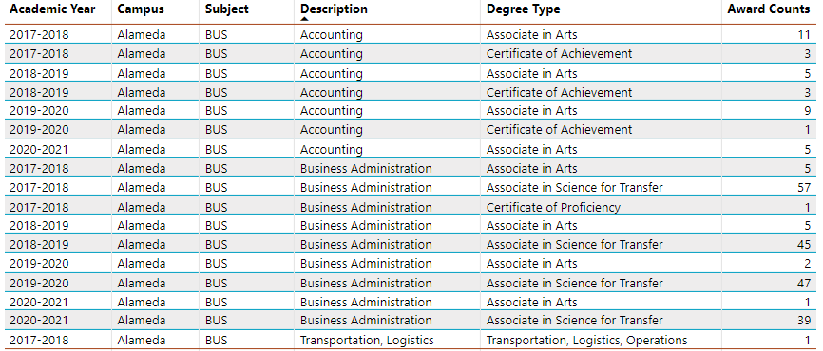

For more information on awards: Degrees & Certificates Dashboard link
Increasing the number of students who complete a certificate or degree is a shared goal across CoA’s Ed Master Plan Goals, PCCD Goals, the Chancellor’s Office Vision for Success, the Student-Centered Funding Formula, and Guided Pathways. What is planned for the next 3 years to increase the number of certificates and degrees awarded?
We have created a well detailed pathway for students to facilitate their focus on certificates
and degrees. In addition, we are working closely with student services to continuously to review the path and make needed changes.

Engagement
Discuss how faculty and staff have engaged in institutional efforts such as committees, presentations, and departmental activities. Please list the committees that full-time faculty participate in.
The full me faculty in this department has always been active in institutional efforts to improve student success. Faculty engages as members or participate in:
- Academic Senate
- Professional Development
- Curriculum Committee
- Guided Pathways Committee
- District Academic Senate Committee
- District Education Committee
- Planning & Budget Committee
- COA Budget Committee
- COA College Council
- ASCCC Local Senate Relations Committee
- ASCCC Resolution Committee
- President’s Cabinet
- Department Chair
- Student Equity and Achievement Committee
16. Tenure Review Committee.

Discuss how faculty and staff have engaged in community activities, partnerships and/or collaborations.
The full-time faculty of this department worked closely with the Robert’s Half of San Francisco stuffing agency, and is currently a member of Financial Women Association of San Francisco. The department has collaborated with Alameda County (SBDC) Small Business Development Center on several proposed grants. The department has participated in the Fresno State Entrepreneurship training.

Discuss how adjunct faculty members are included in departmental training, discussions, and decision-making.
The part me faculty are always invited and have effectively participated in department meetings, and always engaged in focused and purposeful discussion of promoting student success and increasing enrollment.

Prioritized Resource Requests Summary
In the boxes below, please add resource requests for your program. If there are no resource requested, leave the boxes blank.
Resource Category | Description/Justification | Estimated Annual Salary Costs | Estimated Annual Benefits Costs | Total Estimated Cost
Personnel: Classified Staff

Personnel: Student Worker

Personnel: Part Time Faculty

Personnel: Full Time Faculty

Resource Category | Description/Justification | Total Estimated Cost
Professional Development: Department wide PD needed

Professional Development: Personal/Individual PD needed | Funds to participate in national conferences.  $3000 to cover conference participation and lodging per person | $15,000

Prioritized Resource Requests Summary - Continued

Resource Category | Description/Justification | Total Estimated Cost
Supplies: Software

Supplies: Books, Magazines, and/or Periodicals | Subscription for WSJ, and other professional periodicals | $2,000
Supplies: Instructional Supplies | Calculators, pencils, markers, paper, whiteboard | $5,000
Supplies: Non-Instructional Supplies | Memberships to professional organizations such as FWSF, CalCPA | $10,000
Supplies: Library Collections

Resource Category | Description/Justification | Total Estimated Cost
Technology & Equipment: New | Laptops, printers, copy machines, scantrons | $50,000
Technology & Equipment: Replacement | Copy machine, printers, scantrons | $50,000

Prioritized Resource Requests Summary - Continued

Resource Category | Description/Justification | Total Estimated Cost
Facilities: Classrooms | Smart classrooms, space for Entrepreneur/Business Tutorial Center | TBD
Facilities: Offices | Dedicated space for each faculty members | TBD
Facilities: Labs

Facilities: Other

Resource Category | Description/Justification | Total Estimated Cost
Library: Library materials

Library: Library collections

Resource Category | Description/Justification | Total Estimated Cost
Other

