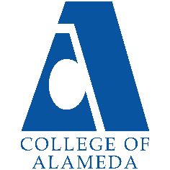
College of Alameda
2023-24 Program Review – Auto Body & Paint

Lead Author:
Peter Ha

Program Overview
Provide your program’s mission statement. If your program does not have a mission statement, what is your timeline for creating a mission statement?
The mission statement for the department of Auto Body & Paint is to ensure students get the most current training safely. We offer a 2-year program with certificates of completion and AS degrees in both fields, Auto Body and Auto Paint

List your program faculty and/or staff.
Peter Ha

Describe your current utilization of facilities, including labs and other space.
Currently, lectures are on Zoom and B203. Lectures include PowerPoint presentations, visuals via online videos or footage taken from class. Written tests are conducted in B203 and on Canvas.

Lab takes place in B107. Depending on what class, (AutoB16,12,49,30,40) we would operate MIG welders, plastic welders, grinders, drills, sanding, materials application, frame straightening, automobile measuring, polishing of paints, machine sanding and other various pneumatic hand tools.

List your program goals from your most recent Program Review or APU. Then, provide an update on the status of the goal. Has your program achieved the goal? Have any of your goals been revised or are any still in progress? Lastly, make sure to discuss which College or District goal your program goal aligns to.
If no program goals exist or if this is your first program review, work to create 2-3 goals and align them with a College or District goal.

Program Goal | Complete and move into new building
Status: In-Progress or Complete? | In progress
Which college or district goal is aligned with your program goal? | COA

Program Goal | Create new Plastic repair class and integrate into Auto Paint certificate.
Status: In-Progress or Complete? | In progress
Which college or district goal is aligned with your program goal? | COA

Program Goal | Need modern vehicles
Status: In-Progress or Complete? | In progress
Which college or district goal is aligned with your program goal? | COA

Career Education
Using Launch Board or other labor market data, what are the employment rates for students that have exited your program for the past three years?
Automotive Collision Repair (0949) | 2019-20 | 2018-19 | 2017-18
 | 61% | 56% | 71%
Source: https://www.calpassplus.org/LaunchBoard/Community-College-Pipeline.aspx
Employed in the second fiscal quarter after exit.

Using the EDD’s Job Outlook for CA Community College Educational Programs or Launch Board, what are the projected job openings in your discipline for the next three years?

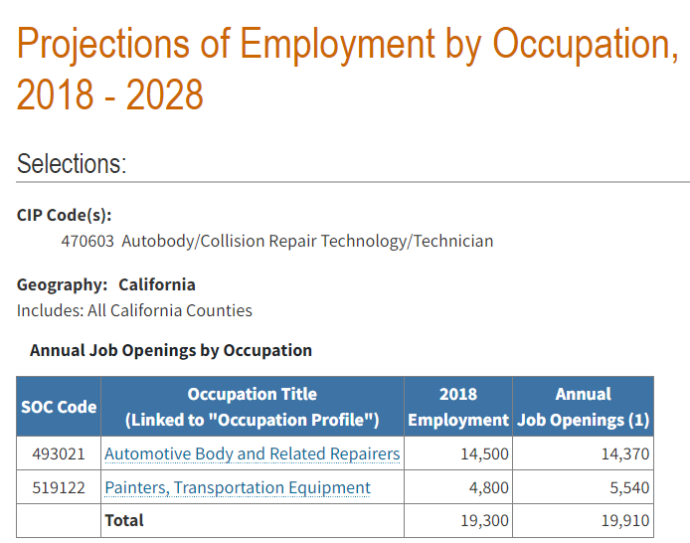
Source: https://labormarketinfo.edd.ca.gov/commcolleges/

How is your discipline or program responding regarding changes in labor market demand?
Faculty makes shop visits with local shop and vendors to see the constant change in the field and use gathered information to better students’ education and experience

Do you have an industry advisory board in place? If so, list your board members. Has your industry advisory board met regularly (at least once per quarter or semester)?
Yes.

Ben Shell – PPG
Marlin Madina- PPG
Tiffany – Accurate Autobody
Greg- Aarons Auto body
Ron – Arth and Son

Please describe the number of activities and recommendations resulting from advisory committee meetings that have occurred in the past three years. What information was presented that required changes to be made to your program?
Meeting take place on Zoom or In building B, room B203- Some of the changes mention by Ben was to acquire newer vehicles 2015 and newer to have students work on the most updated vehicles. Create and apply plastic repair class to the paint certificate.

Does your program require state or national licensing? If yes, are there substantial differences between the set standard pass rate for this exam or license and the percentage of students passing this exam?
No

Do your students participate in other third-party certifications? If yes, are there substantial differences between the standard pass rate and the percentage of students getting successfully certified?
Optional. Students have an option to take ASE test B2, if pass final exam is waived for class AutoB30- Has to be taken within same semester

What programs similar to yours exist in the surrounding area or at nearby East Bay colleges? In which ways is your program collaborating with other community colleges in the region?
Contra Costa college has the same like program although we are not jointed.

Enrollment Trends
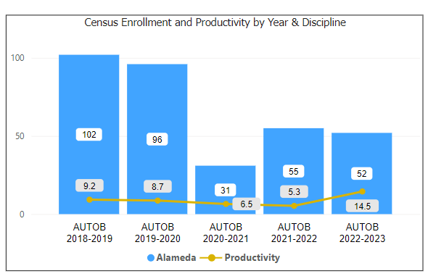
Enrollment Trends Dashboard link

Discuss enrollment trends over the past three years.
For additional analysis, click on the Enrollment Trends Dashboard, set the filters to Alameda and your discipline.
Productivity has increased from 9.2 to 14.5

Describe effective and innovative teaching strategies used by faculty to increase student learning and engagement.
Zoom meeting and other methods has increase students learning and participation zoom meeting, we can use a document camera to display tools or fixtures on subject

How does the discipline, department, or program maintain the integrity and consistency of academic standards with all methods of delivery, including face to face, hybrid, and Distance Education courses?
Although Lab takes place in-person, by utilizing tools such as Zoom and cameras has been positive in student education

Curriculum
Have all your course outlines of record in CurriQunet been reviewed within the past three years?

https://peralta.curricunet.com/
☐ Yes X No, please explain:
AutoB12 has not been dated because the lack of Lab space and equipment. When we move into the new building, then we can review and update.

Please list any planned changes from the current semester forward for curriculum (courses, degrees, and/or certificates) and the rationale for those changes (e.g., labor market data, advisory committee recommendations, transfer institution changes, industry trends, state-wide transfer model curriculum).
No plans to change

How is your program meeting the needs of students, and/or articulation with four-year institutions?
I personally visit local shops that have hired our previous students. Convocation is across the board from new equipment, materials, vehicles and follow up on hired students

Student Learning Outcomes Assessment
List your Student Learning Outcomes
SLO1 - Safely work with power and hand tools, welding equipment, and chemicals in an auto body repair shop.
SLO2 - Demonstrate competence and familiarity working with various metals, welding techniques, measurement and alignment equipment, and spraying equipment, including practicing all standard safety procedures.
SLO3 - Apply critical thinking and problem-solving skills in the process of following instructions and professional interpersonal communication with management and coworkers.

Please provide a high-level summary and your program’s interpretation of your SLO findings over the past year.
Autob16 was established, lunched and adapted to the auto paint certificate of completion.

What were the most important things your department learned from assessment? Did implementation of your action plans result in better student learning?
Update on some of outdated equipment and office manager with help current faculty focus more on education

Have you assessed your program learning outcomes (PLOs) within the past few years? How have your assessments informed improvements/changes to your program. If you have not assessed your PLOs, explain the plan to assess and the expected timeline.
Yes, we’ve integrated the program to use Canvas in which positive both student engagement and getting the information to students has improved.

College of Alameda Institutional Learning Outcomes (ILOs) were created to guide educational programs and services. They include:
- Problem Solving: Solve problems and make decisions in life and work using critical thinking, quantitative reasoning, community resources, and civil engagement.
- Communication and Technology: Use technology and written and oral communication to discover, develop, and relate critical ideas in multiple environments.
- Creativity: Exhibit aesthetic reflection to promote, participate and contribute to human development, expression, creativity, and curiosity.
- Diversity: Engage in respectful interpersonal communications, acknowledging ideas and values of diverse individuals that represent different ethnic, racial, cultural, and gender expressions.
- Civic Responsibility: Accept personal, civic, social and environmental responsibility in order to become a productive local and global community member.

How does your program participate in assessing the Institutional Learning Outcomes (ILOs)? If your program has not participated, how will you plan to incorporate these outcomes within your program?
Has not participated.

Course Completion

Consider your course completion rates over the past three to five years (% of students who earned a grade of "C" or better).
Alameda | Total Graded | Course Completions | Course Completion Success Rate
2023 | 50 | 41 | 82%
AUTOB | 50 | 41 | 82%
In-Person | 50 | 41 | 82%
2022 | 55 | 44 | 80%
AUTOB | 55 | 44 | 80%
In-Person | 35 | 27 | 77%
Online | 20 | 17 | 85%
2021 | 31 | 24 | 77%
AUTOB | 31 | 24 | 77%
Hybrid | 9 | 7 | 78%
In-Person | 8 | 6 | 75%
Online | 14 | 11 | 79%
2020 | 56 | 35 | 63%
AUTOB | 56 | 35 | 63%
In-Person | 56 | 35 | 63%
2019 | 102 | 62 | 61%
AUTOB | 102 | 62 | 61%
In-Person | 102 | 62 | 61%

Course Completion Dashboard link
How does the course completion rate for your program or discipline compared to your college's Institution-Set Standard for course completion of 72% and the stretch goal of 78%?
Currently exceed stretch goal at 82%

Are there substantial differences in course completion rates between face to face and Distance Education/hybrid courses? If so, how does the discipline, department, or program address this?
100 % in person but also imply online such as Zoom and Canvas

If your program offers dual enrollment courses, examine the data, and discuss the course completion rates compared to the overall program rate.
Does not offer

Alameda | Census Enrollment | Total Retained | Course Retention Rate
2023 | 52 | 45 | 87%
AUTOB | 52 | 45 | 87%
In-Person | 52 | 45 | 87%
2022 | 55 | 51 | 93%
AUTOB | 55 | 51 | 93%
In-Person | 35 | 33 | 94%
Online | 20 | 18 | 90%
2021 | 31 | 28 | 90%
AUTOB | 31 | 28 | 90%
Hybrid | 9 | 8 | 89%
In-Person | 8 | 8 | 100%
Online | 14 | 12 | 86%
2020 | 96 | 39 | 41%
AUTOB | 96 | 39 | 41%
In-Person | 96 | 39 | 41%
2019 | 102 | 91 | 89%
AUTOB | 102 | 91 | 89%
In-Person | 102 | 91 | 89%

On average the course retention rate (number of students are retained in the course) for College of Alameda has been 85% for the past three years. Examine the course retention rates for your program over the last three years. How do your program or discipline course retention rates compare to the college?
Current rate is above

College of Alameda continues to focus on access, equity, and success. The goal is to create an inclusive environment where all students can thrive and meet their education and career goals.
To address equity gaps and work towards achieving equity in educational outcomes, examine your program data for evidence of disproportionate impact (DI). Using the percentage point gap method to identify DI, subgroups whose course completion rate falls more than -3 percentage points below the All-Students success rate are highlighted red. The Margin of Error value (MOE) is used to determine the presence of DI using the Point Gap Method. Values lower than the corresponding MOE are reflective of disproportionate impact (i.e., pink highlighted cells). Groups with 10 students or less are excluded from the analysis.
not enough disaggregated data available

What can your discipline, department, or program do to improve course completion for disproportionate impacted groups?
Small program analyzing the group is difficult

Degrees & Certificates Conferred
Does your program offer any degree/certificate programs? If your program does not, skip this section and continue to Engagement
Since the last program review, what has the discipline, department, or program done to improve the number of degrees and certificates awarded?
It is always to remind and encourage the students to apply for the degrees and certificates both verbally and online (canvas)

For more information on awards: Degrees & Certificates Dashboard link
Increasing the number of students who complete a certificate or degree is a shared goal across CoA’s Ed Master Plan Goals, PCCD Goals, the Chancellor’s Office Vision for Success, the Student-Centered Funding Formula, and Guided Pathways. What is planned for the next 3 years to increase the number of certificates and degrees awarded?
With the new building and new updated equipment, it will be encouraging to the students to engage into their education at deeper depths, hopefully they will trigger and interest them to apply for degrees and certificates

Engagement
Discuss how faculty and staff have engaged in institutional efforts such as committees, presentations, and departmental activities. Please list the committees that full-time faculty participate in.
Currently assisting the construction designers and contractors in meeting on going with Autobody department.

Discuss how faculty and staff have engaged in community activities, partnerships and/or collaborations.
Vendors and local businesses meet for potential collaboration with projects or materials

Discuss how adjunct faculty members are included in departmental training, discussions, and decision-making.
Currently there are no adjunct since the retirement of Bill Andrews. It would be great to get an adjunct and/or even a department office manager dedicated to Autobody like we once had. There’ s only one full time faculty for the entire department and that person is stretch thin. From instructing the classes to ordering materials, checking materials, setting up equipment it would be nice to get some help.

Prioritized Resource Requests Summary
In the boxes below, please add resource requests for your program. If there are no resource requested, leave the boxes blank.

Resource Category | Description/Justification | Total Estimated Cost
Personnel: Classified Staff

Personnel: Student Worker | Tool room keeper, assist in tools to be check in and out by students. Setting up for lecture/lab
Personnel: Part Time Faculty | Instruct minor classes.
Personnel: Full Time Faculty

Resource Category | Description/Justification | Total Estimated Cost
Professional Development: Department wide PD needed. | Training for updated material and equipment
Professional Development: Personal/Individual PD needed.

Supplies: Software | Desktop replacement in office, computers for students for lab research
Supplies: Books, Magazines, and/or Periodicals | Update book
Supplies: Instructional Supplies | Paint booth maintenance, frame machine maintenance welders service
Supplies: Non-Instructional Supplies | Abrasives, masking, filler material, tonners, and paint system, consumables
Supplies: Library Collections

Technology & Equipment | Spot welders, mobile fume extractor, paint assist light
Library: Library materials/collections

Facilities: Classrooms/Labs | Update current projector input and sound system
Facilities: Offices

Other

