**College of Alameda**

2021-22 Annual Program Update – **Admissions and Records**

**Program Overview**

Please provide your program’s mission statement and program’s learning outcomes

|  |
| --- |
| The mission of College of Alameda is to serve the educational needs of its diverse community by providing comprehensive and flexible programs and resources that empower students to achieve their goals.  The mission of College of Alameda Student Services Division is committed to guiding, empowering, and inspiring students to achieve their academic, career and personal goals through a student centered and caring approach.  The Office of Admissions and Records is committed to the values by welcoming and admitting diverse population from the community we serve. We provide face to face and online service to ensure students continue their success with achieving their certificate or degree. |

List your program staff or faculty

|  |
| --- |
| Dr. Amy H. Lee, Dean of Enrollment Services  Marcean Bryant, Senior Admissions & Records Specialist  Munira Ahmed, Admissions & Records Clerk  Connie Wu, A&R Evaluator  Michelle Chen, Part Time Evaluator  Rudy Rudijator, Student Worker |

Your program goals have been listed from your most recent Program Review or APU. Provide an update on the status of the goal. Has your program achieved the goal? Have any of your goals been revised or any still in progress? Lastly, make sure to discuss which College or District goal your program goal aligns to.

*If no program goals exist or if this is your first program review, work to create 2-3 goals and align them with a College or District goal.*

|  |  |
| --- | --- |
| **Program Goal** | A&R will continue to post important deadlines and dates around campus such as add/drop with W and without Ws, and degree petition dates. |
| Status: In-Progress or Complete? | In Progress |
| Which college or district goal is aligned with your program goal? | CoA’s goal is to strengthen data driven/informed decision making and to reduce loss of students prior to start of classes |

|  |  |
| --- | --- |
| **Program Goal** | Working with Institutional Research and Student Services at large to create a comprehensive student satisfaction survey to assess our services in the next year. |
| Status: In-Progress or Complete? | In progress |
| Which college or district goal is aligned with your program goal? | CoA’s goal to strengthen data driven/informed decision making. |

List the essential functions of your department, program or unit and provide a description of how the unit aligns with the college mission.

|  |
| --- |
| Admissions & Records enrolls students into courses online, via phone and prior to Covid-19 in person. We assist with enrollment issues, enrollment verification, census, and attendance verification (faculty), residency verification, dual enrollment, and contract education courses.  We work with students to process degree and certificate requests. |

**Program Update**

Using the dashboards, review and reflect upon the data for your program.

[**Course Completion and Retention Rates – Instructional Dashboard**](https://app.powerbi.com/view?r=eyJrIjoiNjc2MDhiNTEtNTJhZi00MDM0LTk5NDItNTRiY2EzMGI1NTZiIiwidCI6ImVlYTE2YTE2LTQ4YWYtNDc3Yi05MTEzLTA1YjFjMDExMjNmZiIsImMiOjZ9&pageName=ReportSection86d6f65e2fb41a73da4d)

[**Course Completion and Retention Rates – Student Services Dashboard**](https://app.powerbi.com/view?r=eyJrIjoiNjk3NDJjOTItNzI5MS00MDhjLWJhN2EtZjcxNzU4OTBiZDBjIiwidCI6ImVlYTE2YTE2LTQ4YWYtNDc3Yi05MTEzLTA1YjFjMDExMjNmZiIsImMiOjZ9&pageName=ReportSection86d6f65e2fb41a73da4d)

[**Enrollment Trends and Productivity Dashboard**](https://app.powerbi.com/view?r=eyJrIjoiNWJlOWZmYTEtNTY0MC00MDhkLWE5OTAtYmJjZjIxNzJiNWViIiwidCI6ImVlYTE2YTE2LTQ4YWYtNDc3Yi05MTEzLTA1YjFjMDExMjNmZiIsImMiOjZ9&pageName=ReportSection86d6f65e2fb41a73da4d)

[**Degrees and Certificates Dashboard**](https://app.powerbi.com/view?r=eyJrIjoiZjU2M2M5MzItOTcwZi00Y2U1LWJmODUtYTc0YjlhZGI2ZDhjIiwidCI6ImVlYTE2YTE2LTQ4YWYtNDc3Yi05MTEzLTA1YjFjMDExMjNmZiIsImMiOjZ9&pageName=ReportSectionde32556e136b0a8caccd)

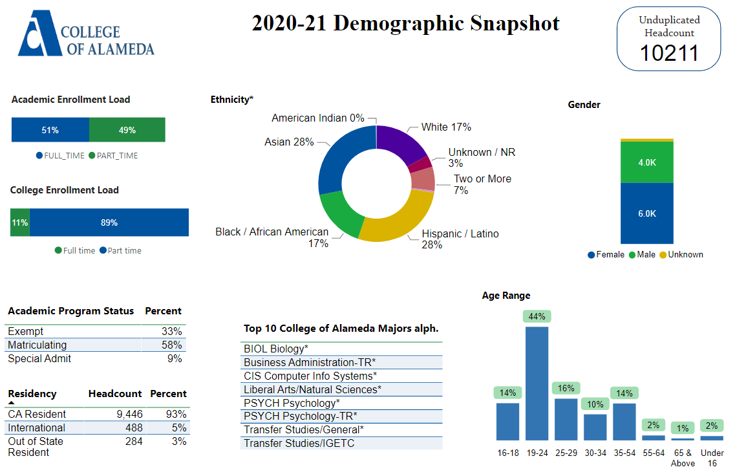

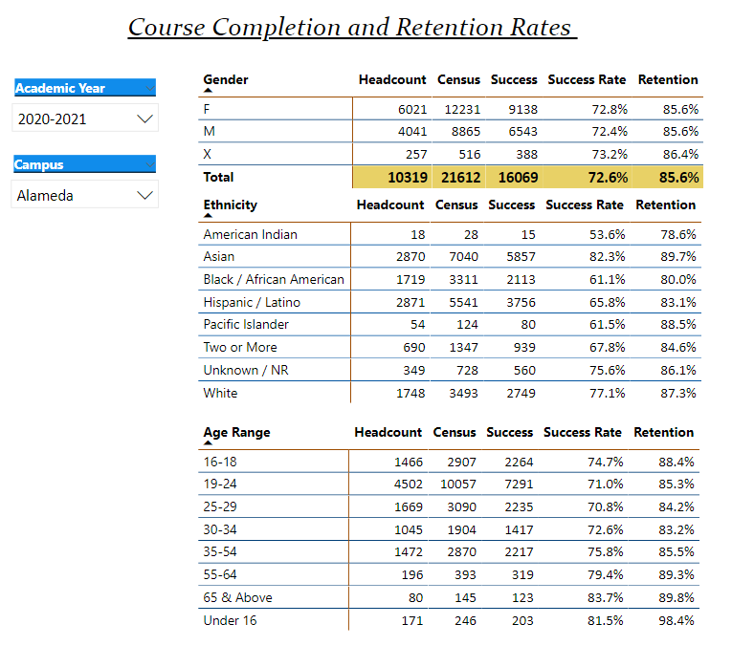

Describe any significant changes and discuss what the changes mean to your program. Consider whether performance gaps exist for disproportionality impacted students by using filters to disaggregate the data. Focus upon the most recent year and/or the years since your last comprehensive program review. Cite data points to support your reflection.

|  |
| --- |
| We need an additional full-time evaluator, we currently have only 1 full time evaluator we now have to scan and update outside transcripts into our database. And there has been an increase of ADT petitions as well. Our registration has also converted to online because of COVID we have also extended our deadline to process degree and Certificate and ADT Petitions |

Describe the department's progress on Student Learning Outcomes (SLOs) and/or Service Area Outcomes (SAOs) since the last Program Review/APU.

|  |
| --- |
| We were approved for a part-time hourly to assist our evaluator with the posting of the degrees and certificates |

Describe the outcomes and accomplishments from previous year’s funded resource allocation request.

|  |  |  |  |
| --- | --- | --- | --- |
| **Brief description of funded request** | **Source (any additional award outside your base allocation)** | **Total Award Amount** | **Outcome/Accomplishment** |
|  |  |  |  |
|  |  |  |  |
|  |  |  |  |

**Prioritized Resource Requests Summary**

In the boxes below, please add resource requests for your program. If there are no resource requested, leave the boxes blank.

|  |  |  |  |  |
| --- | --- | --- | --- | --- |
| **Resource Category** | **Description/Justification** | **Estimated Annual Salary Costs** | **Estimated Annual Benefits Costs** | **Total Estimated Cost** |
| **Personnel: Classified Staff** | Permanent full time evaluator/ increased in ADT posting/ assist with outside transcripts |  |  | $60K  annually |
| **Personnel: Student Worker** | Student worker |  |  | $7K  annually |
| **Personnel: Part Time Faculty** |  |  |  |  |
| **Personnel: Full Time Faculty** |  |  |  |  |

|  |  |  |
| --- | --- | --- |
| **Resource Category** | **Description/Justification** | **Total Estimated Cost** |
| **Professional Development: Department wide PD needed** | Attend CACRO meeting $250.00 per person | $1000. |
| **Professional Development: Personal/Individual PD needed** |  |  |

**Prioritized Resource Requests Summary - Continued**

|  |  |  |
| --- | --- | --- |
| **Resource Category** | **Description/Justification** | **Total Estimated Cost** |
| **Supplies: Software** |  |  |
| **Supplies: Books, Magazines, and/or Periodicals** |  |  |
| **Supplies: Instructional Supplies** |  |  |
| **Supplies: Non-Instructional Supplies** |  |  |
| **Supplies: Library Collections** |  |  |

|  |  |  |
| --- | --- | --- |
| **Resource Category** | **Description/Justification** | **Total Estimated Cost** |
| **Technology & Equipment: New** | Three (3) laptops for Admissions and Records currently A&R is borrowing laptops from other departments to enable staff to work from home  Four (4) touchpad computers in all workstations to assist students complete online surveys screen |  |
| **Technology & Equipment: Replacement** |  |  |

**Prioritized Resource Requests Summary - Continued**

|  |  |  |
| --- | --- | --- |
| **Resource Category** | **Description/Justification** | **Total Estimated Cost** |
| **Facilities: Classrooms** |  |  |
| **Facilities: Offices** |  |  |
| **Facilities: Labs** |  |  |
| **Facilities: Other** |  |  |

|  |  |  |
| --- | --- | --- |
| **Resource Category** | **Description/Justification** | **Total Estimated Cost** |
| **Library: Library materials** |  |  |
| **Library: Library collections** |  |  |

|  |  |  |
| --- | --- | --- |
| **Resource Category** | **Description/Justification** | **Total Estimated Cost** |
| **OTHER** |  |  |