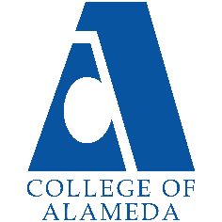
College of Alameda
2021-22 Annual Program Update – Adult Education

Program Overview
Please provide your program’s mission statement and program’s learning outcomes
The mission of the Adult Transitions Department at the College of Alameda is to collaborate with Adult Schools and Community Based Organizations to enable adults (18+) to advance education, obtain employment, and improve wages.

List your program staff or faculty
Paula Armstead, Associate Dean of Educational Success
Kawanna Rollins, Project Manager, Adult Transitions Liaison

Your program goals have been listed from your most recent Program Review or APU. Provide an update on the status of the goal. Has your program achieved the goal? Have any of your goals been revised or any still in progress? Lastly, make sure to discuss which College or District goal your program goal aligns to.
If no program goals exist or if this is your first program review, work to create 2-3 goals and align them with a College or District goal.

Program Goal | Strengthen Adult Education Transitions Program with a particular focus on re-entry adults.
Status: In-Progress or Complete? | Since the departure of our previous Project Manager of Adult Education on January 1, 2021, we have hired a new full time project manager and have maintained online services such as 1:1 workshop appointments. Our focused efforts on re-entry adults includes making connections by attending Community Corrections Partnership Executive Committee (CCPEC) Meetings.
Which college or district goal is aligned with your program goal? | • Increase retention and persistence rates  • Increase community & educational partnerships  • Advance COA teaching and learning  That we are responsible for providing a smooth transition for students from adult schools, local community-based organizations, and re-entry clients to academic programs and services at College of Alameda.

Program Goal | Increase the number of concurrent enrollment students from adult schools.
Status: In-Progress or Complete? | The program will continue to promote non-credit courses; host application one on one assistance and workshops; strengthen pathway from Alameda Adult school to increase concurrent enrollment. We anticipate that we should see numbers stabilize or grow as more sections are eventually added.
Which college or district goal is aligned with your program goal? | • Increase retention and persistence rates  • Increase community & educational partnerships  • Advance COA teaching and learning  That we are responsible for providing a smooth transition for students from adult schools, local community-based organizations, and re-entry clients to academic programs and services at College of Alameda.

List the essential functions of your department, program or unit and provide a description of how the unit aligns with the college mission.
The essential functions of the department that aligns with the college mission are:
- That we are responsible for providing a smooth transition for students from adult schools, local community-based organizations, and re-entry clients to academic programs and services at College of Alameda.
- We work with other departments such as Welcome Center, EOPS, Financial Aid, DSPS, Counseling, to provide adult students additional support as they enroll in services to help them be successful.
- Works to demystify fear and challenges of the enrollment processes for students, such as asylum pending students, concurrently enrolled students, ESOL students, and others who may feel intimidated by the admissions process.

Program Update
Using the dashboards, review and reflect upon the data for your program.
Course Completion and Retention Rates – Instructional Dashboard
Course Completion and Retention Rates – Student Services Dashboard
Enrollment Trends and Productivity Dashboard
Degrees and Certificates Dashboard

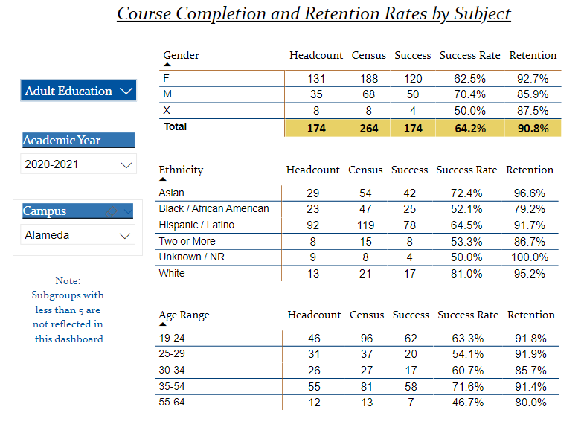
Describe any significant changes and discuss what the changes mean to your program. Consider whether performance gaps exist for disproportionality impacted students by using filters to disaggregate the data. Focus upon the most recent year and/or the years since your last comprehensive program review. Cite data points to support your reflection.
The program will continue to promote non-credit courses; host application one on one assistance and workshops. Power BI data show concurrent enrollment numbers are low but remain steady since the last comprehensive program review, which we had previously anticipated. The program will continue to strengthen pathway from Alameda Adult school to increase concurrent enrollment. We anticipate a growth in enrollment as more sections are eventually added.

Describe the department's progress on Student Learning Outcomes (SLOs) and/or Service Area Outcomes (SAOs) since the last Program Review/APU.
Despite the impact of covid 19 the students in the ESOL noncredit courses are continuing to stay enrolled and complete the course sequence. We also see an increase of students enrolled in the new non-credit CNA program.

Service Area Outcomes includes the new hire of a permanent project manager, and she has continued online services such as 1:1 workshop appointments and presentations for our CBO partners. We anticipate increased participation during the Spring 2022 semester.
Our focused efforts on re-entry adults includes making connections by attending Bay Area Systems Impact Consortium (BASIC), and Community Corrections Partnership Executive Committee (CCPEC) Meetings, which focuses on outreach and community engagement. Additionally, we attend NAAEC meetings to improve upon internal processes relating to data, marketing, reporting, and advocacy.

Describe the outcomes and accomplishments from previous year’s funded resource allocation request.

We have no funding requests at this time.
Brief description of funded request | Source (any additional award outside your base allocation) | Total Award Amount | Outcome/Accomplishment

Prioritized Resource Requests Summary
In the boxes below, please add resource requests for your program. If there are no resource requested, leave the boxes blank.
Resource Category | Description/Justification | Estimated Annual Salary Costs | Estimated Annual Benefits Costs | Total Estimated Cost
Personnel: Classified Staff

Personnel: Student Worker

Personnel: Part Time Faculty

Personnel: Full Time Faculty

Resource Category | Description/Justification | Total Estimated Cost
Professional Development: Department wide PD needed

Professional Development: Personal/Individual PD needed

Prioritized Resource Requests Summary - Continued

Resource Category | Description/Justification | Total Estimated Cost
Supplies: Software

Supplies: Books, Magazines, and/or Periodicals

Supplies: Instructional Supplies

Supplies: Non-Instructional Supplies

Supplies: Library Collections

Resource Category | Description/Justification | Total Estimated Cost
Technology & Equipment: New

Technology & Equipment: Replacement

Prioritized Resource Requests Summary - Continued

Resource Category | Description/Justification | Total Estimated Cost
Facilities: Classrooms

Facilities: Offices

Facilities: Labs

Facilities: Other

Resource Category | Description/Justification | Total Estimated Cost
Library: Library materials

Library: Library collections

Resource Category | Description/Justification | Total Estimated Cost
OTHER

