**College of Alameda**

2021-22 Annual Program Update – **Counseling**

**Program Overview**

Please provide your program’s mission statement and program’s learning outcomes

|  |
| --- |
| The mission of the College of Alameda’s Counseling Department is to provide comprehensive services and programs that empower students to identify and achieve educational, career and personal goals. Additionally, the Counseling Department strives to assist students in meeting life’s many opportunities and challenges.  Counseling faculty have identified the following Student Learning Outcomes for students who use Counseling services:  1. Students will be able to articulate an understanding of their personal responsibility in creating their own academic, personal, and professional successes. (ILO 1 Problem Solving & Decision Making; ILO 2 Technology & Communication; ILO 3 Reflection, Participation, Creativity; ILO 4 Interpersonal Skills; ILO 5 Civic Responsibility)  2. Students will be able to utilize the necessary information, resources, and options available for them to make sound educational and lifelong decisions. (ILO 1 Problem Solving & Decision Making; ILO 2 Technology & Communication; ILO 3 Reflection, Participation, Creativity; ILO 5 Civic Responsibility)  3. Students will be able to identify specific tactics and strategies used in order to achieve their desired goals (ILO 1 Problem Solving & Decision Making; ILO 2 Technology &Communication; ILO 3 Reflection, Participation, Creativity; ILO 4 Interpersonal Skills; ILO 5 Civic Responsibility) |

List your program staff or faculty

|  |
| --- |
| **Classified**  Vincent Catacutan, SEA Clerical Assistant  **Student Employees**  We currently have 5 student employees working under the Welcome Center to help provide support to the Counseling Department.  **Faculty/Counselors**   * Maha Elaidy * Betty Frias * Vivian Virkkila * Jamar Mears * Edwin Towle * Nila Adina * Julie Saechao * Cynthia Haro |

List your program goals from your most recent Program Review or APU. Then, provide an update on the status of the goal. Has your program achieved the goal? Have any of your goals been revised or any still in progress? Lastly, make sure to discuss which College or District goal your program goal aligns to.

If no program goals exist or if this is your first program review, work to create 2-3 goals and align them with a College or District goal.

|  |  |
| --- | --- |
| **Program Goal** | **Goal from APU 2020-2021:**  Increase student access to Counseling services provide comparable in person and online counseling services   * Counseling Department piloted Live Video Counseling Appointments and went live March 2020. * Counseling Department Live Chat for quick questions * Welcome Center live video workshops to assist students remotely with enrollment steps   **Follow up to goal in 2021-2022**:   * Due to COVID-19 and the Spring 2020 shutdown of all services at COA, Counseling was required to implement Live Video Counseling more urgently than planned in Summer 2019 * Counseling met this goal by providing at-home all-in-one computer desktops, Zoom accounts affiliated with COA, and headphones * Counseling support staff met the Welcome Center Live Video workshops. They continue to be conducted * Implementation of Tawk.to app was installed on Counseling website to serve students who needed quick counseling support and services referrals |
| Status: In-Progress or Complete? | Complete. |
| Which college or district goal is aligned with your program goal? | COA Master Plan Alignment:   * 2.2 Evaluate student preparedness for program/coursework through assessment, pre-requisites, advising, and development of individualized Ed plan * 6.3 Increase college and classroom technology   PCCD Master Plan Alignment:   * A. Advance Student Access, Equity, and Success |

|  |  |
| --- | --- |
| **Program Goal** | **Goal from APU 2020-2021:**  Increase the number of full and part time matriculating students with a comprehensive education plan to 80%.  **Follow up to goal in 2021-2022**:   * Based on our numbers collected in 2020-2021 and COVID-19, we modify this goal to **60%** of full and part time matriculating students with a comprehensive education plan |
| Status: In-Progress or Complete? | In-progress and updated |
| Which college or district goal is aligned with your program goal? | COA Master Plan Alignment:   * 2.2 Evaluate student preparedness for program/coursework through assessment, pre-requisites, advising, and development of individualized Ed plan   PCCD Master Plan Alignment:   * A. Advance Student Access, Equity, and Success |

|  |  |
| --- | --- |
| **Program Goal** | **New Goal 2021-2022:**   * Increase student access to virtual, phone, and in-person counseling services * Streamline technology for counselors and counseling support staff with new platform (ConexEd) designed for college services |
| Status: In-Progress or Complete? | In Progress |
| Which college or district goal is aligned with your program goal? | COA Master Plan Alignment:   * 2.2 Evaluate student preparedness for program/coursework through assessment, pre-requisites, advising, and development of individualized Ed plan * 6.3 Increase college and classroom technology   PCCD Master Plan Alignment:   * A. Advance Student Access, Equity, and Success |

List the essential functions of your department, program or unit and provide a description of how the unit aligns with the college mission.

|  |
| --- |
| * Develop student education plans (comprehensive and abbreviated) and help students clarify and develop realistic educational/career plans * Provide career counseling/planning * Assistance to petition for certificate and associate degrees * Provide transcript evaluation for California Community colleges and referral to PCCD Admission for other transcript types * Conduct workshops, counseling courses, virtual counseling, and referral to On-Campus/ Off-Campus Services * Assist students in planning an academic program consistent with their abilities and interests. * Monitor student progress toward educational/career goals. * Discuss relationships between instructional programs and careers/occupations. * Interpret and provide rationale for academic policies, procedures, and requirements. * Approve designated educational transactions (e.g., schedule, drop/adds, withdrawals, change of major, waivers, and graduation petitions). * Inform students of the nature of the counselor/counselee relationship. * Inform students of special services available to them for remediation, academic assistance, and other needs. * Assist students in transferring to four-year Universities (CSU, UC, out of state, etc.) * Provide guidance to students for Math/English Placement   Essential functions of the Counseling department align with College of Alameda’s Mission:  *The mission of College of Alameda is to serve the educational needs of its diverse community by providing comprehensive and flexible programs and resources that empower students to achieve their goals.* |

**Program Update**

Using the dashboards, review and reflect upon the data for your program.

[**Course Completion and Retention Rates – Instructional Dashboard**](https://app.powerbi.com/view?r=eyJrIjoiNjc2MDhiNTEtNTJhZi00MDM0LTk5NDItNTRiY2EzMGI1NTZiIiwidCI6ImVlYTE2YTE2LTQ4YWYtNDc3Yi05MTEzLTA1YjFjMDExMjNmZiIsImMiOjZ9&pageName=ReportSection86d6f65e2fb41a73da4d)

[**Course Completion and Retention Rates – Student Services Dashboard**](https://app.powerbi.com/view?r=eyJrIjoiNjk3NDJjOTItNzI5MS00MDhjLWJhN2EtZjcxNzU4OTBiZDBjIiwidCI6ImVlYTE2YTE2LTQ4YWYtNDc3Yi05MTEzLTA1YjFjMDExMjNmZiIsImMiOjZ9&pageName=ReportSection86d6f65e2fb41a73da4d)

[**Enrollment Trends and Productivity Dashboard**](https://app.powerbi.com/view?r=eyJrIjoiNWJlOWZmYTEtNTY0MC00MDhkLWE5OTAtYmJjZjIxNzJiNWViIiwidCI6ImVlYTE2YTE2LTQ4YWYtNDc3Yi05MTEzLTA1YjFjMDExMjNmZiIsImMiOjZ9&pageName=ReportSection86d6f65e2fb41a73da4d)

[**Degrees and Certificates Dashboard**](https://app.powerbi.com/view?r=eyJrIjoiZjU2M2M5MzItOTcwZi00Y2U1LWJmODUtYTc0YjlhZGI2ZDhjIiwidCI6ImVlYTE2YTE2LTQ4YWYtNDc3Yi05MTEzLTA1YjFjMDExMjNmZiIsImMiOjZ9&pageName=ReportSectionde32556e136b0a8caccd)

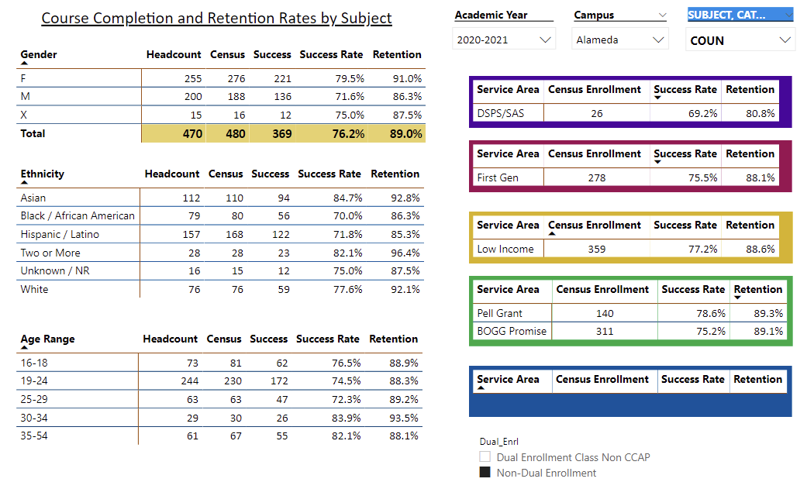

Describe any significant changes and discuss what the changes mean to your program. Consider whether performance gaps exist for disproportionality impacted students by using filters to disaggregate the data. Focus upon the most recent year and/or the years since your last comprehensive program review. Cite data points to support your reflection.

|  |
| --- |
| In reflecting upon data from 2020-2021, our success rate without dual enrollment data is 76.2%. We decided to filter out the Dual Enrollment success rate based on the APU information provided in 2019-2020.  In the disaggregation of data for 2020-2021, we notice that there are two ethnic groups who are disproportionately impacted with the lowest success rates (under 72%): the Hispanic/LatinX and Black/African American ethnic groups. To support these populations more, counseling can promote and refer students to the Puente/Acesso (launched in Fall 2020) and Umoja learning communities.  We feel that due to COVID-19 pandemic restrictions and the abrupt transition to virtual learning in Spring 2020 heavily impacted 2020-2021 success rate data. |

Describe the department's progress on Student Learning Outcomes (SLOs) and/or Service Area Outcomes (SAOs) since the last Program Review/APU.

|  |
| --- |
| The courses offered through the Counseling Discipline are current with SLO and SAO assessments and updated in CurriQnet. The SLO coordinator assisted counseling co-chairs and instructors with updating any outstanding assessments. SLO and SAO are all current in CurriQnet fall 2020 and spring 2021.  **Fall 2020 Counseling Courses assessed SLO #3**  **COUN 24 (College Success)**  #3 Identify, access, and use educational and campus resources (individuals, programs, services, electronic and the like) to plan and pursue their academic, career, and personal goals.  **COUN 30 (Personal Growth and Development)**  #3 Explain life span changes and challenges  **COUN 57 (Career and Life Planning)**  #3 Function as a productive member of a group by cooperating in interactive learning tasks  **Spring 2021 SAO #3 was assessed**  The Counseling Department’s non-instructional Service Area Outcomes are current and was assessed during the Spring 2021 semester.  SAO # 3: Students will be able to identify specific tactics and strategies used in order to achieve their desired goals ((ILO 1 Problem Solving & Decision Making; ILO 2 Technology &Communication; ILO 3 Reflection, Participation, Creativity; ILO 4 Interpersonal Skills; ILO 5 Civic Responsibility)  Results: Based on the number of students assessed, 95.24% of students who met with a counselor were able to identify services and resources that support their academic goal. |

Describe the outcomes and accomplishments from previous year’s funded resource allocation request.

|  |  |  |  |
| --- | --- | --- | --- |
| **Brief description of funded request** | **Source (any additional award outside your base allocation)** | **Total Award Amount** | **Outcome/Accomplishment** |
|  |  |  |  |
|  |  |  |  |
|  |  |  |  |

**Prioritized Resource Requests Summary**

In the boxes below, please add resource requests for your program. If there are no resource requested, leave the boxes blank.

|  |  |  |  |  |
| --- | --- | --- | --- | --- |
| **Resource Category** | **Description/Justification** | **Estimated Annual Salary Costs** | **Estimated Annual Benefits Costs** | **Total Estimated Cost** |
| **Personnel: Classified Staff** |  |  |  |  |
| **Personnel: Student Worker** |  |  |  |  |
| **Personnel: Part Time Faculty** |  |  |  |  |
| **Personnel: Full Time Faculty** |  |  |  |  |

|  |  |  |
| --- | --- | --- |
| **Resource Category** | **Description/Justification** | **Total Estimated Cost** |
| **Professional Development: Department wide PD needed** |  |  |
| **Professional Development: Personal/Individual PD needed** |  |  |

**Prioritized Resource Requests Summary - Continued**

|  |  |  |
| --- | --- | --- |
| **Resource Category** | **Description/Justification** | **Total Estimated Cost** |
| **Supplies: Software** |  |  |
| **Supplies: Books, Magazines, and/or Periodicals** |  |  |
| **Supplies: Instructional Supplies** |  |  |
| **Supplies: Non-Instructional Supplies** |  |  |
| **Supplies: Library Collections** |  |  |

|  |  |  |
| --- | --- | --- |
| **Resource Category** | **Description/Justification** | **Total Estimated Cost** |
| **Technology & Equipment: New** |  |  |
| **Technology & Equipment: Replacement** |  |  |

**Prioritized Resource Requests Summary - Continued**

|  |  |  |
| --- | --- | --- |
| **Resource Category** | **Description/Justification** | **Total Estimated Cost** |
| **Facilities: Classrooms** |  |  |
| **Facilities: Offices** |  |  |
| **Facilities: Labs** |  |  |
| **Facilities: Other** |  |  |

|  |  |  |
| --- | --- | --- |
| **Resource Category** | **Description/Justification** | **Total Estimated Cost** |
| **Library: Library materials** |  |  |
| **Library: Library collections** |  |  |

|  |  |  |
| --- | --- | --- |
| **Resource Category** | **Description/Justification** | **Total Estimated Cost** |
| **OTHER** |  |  |