**College of Alameda**

2021-22 Annual Program Update – **Career and Employment Center**

**Program Overview**

Please provide your program’s mission statement and program’s learning outcomes

|  |
| --- |
| The CoA Career and Employment Center’s Mission Statement:  To transform lives by providing equitable career services, access and opportunities for students and the community. |

List your program staff or faculty

|  |
| --- |
| Stefanie Bradshaw, Director of Workforce Systems |

Your program goals have been listed from your most recent Program Review or APU. Provide an update on the status of the goal. Has your program achieved the goal? Have any of your goals been revised or any still in progress? Lastly, make sure to discuss which College or District goal your program goal aligns to.

*If no program goals exist or if this is your first program review, work to create 2-3 goals and align them with a College or District goal.*

|  |  |
| --- | --- |
| **Program Goal** | Increase the number of students dual enrolled for WIOA career services through the CoA Career and Employment Center. |
| Status: In-Progress or Complete? | This is an ongoing goal for the 2021-2022 program year. For the 2021-2022 program year, the CoA Career and Employment Center has partnered with the Dean of Workforce and CTE department to offer increased dedicated career services for students on campus enrolled in Career Education programs.  During the 2020-2021 program year, the CoA Career and Employment Center provided virtual career services to students on campus, students across the district, and community members. The Career Center provided the following services for over 50 students:   * Dual enrollment in Career Center WIOA program. * CARES Act funding (called the CERSS grant) provided by the Alameda County Workforce Development Board, to support qualifying enrolled clients with bill assistance (rent, mortgage, car note) during the COVID-19 pandemic. * Access to free refurbished laptops through a partnership with the Alameda County Workforce Development Board and Goodwill Industries. * Access to virtual hiring events. * Assistance with securing employment. |
| Which college or district goal is aligned with your program goal? |  |

|  |  |
| --- | --- |
| **Program Goal** | Increase the number of employability workshops offered to students on campus to support job search preparation. |
| Status: In-Progress or Complete? | In progress  *Due to the Covid-19 pandemic, all workshops and hiring events were moved to virtual. For the 2020-2021 program year, the Career Center offered workshops and career services remotely. |
| Which college or district goal is aligned with your program goal? |  |

|  |  |
| --- | --- |
| **Program Goal** | Increase the number of employer recruitment events (in-person and virtually) offered to students on campus to increase access to employment. |
| Status: In-Progress or Complete? | Complete - For the 2020-2021 program year, the Career Center offered several virtual career services workshops and hiring events.  We will continue with this goal for the 2021-2022 program year as we slowly move back to in person services for Spring 2022. |
| Which college or district goal is aligned with your program goal? |  |

List the essential functions of your department, program or unit and provide a description of how the unit aligns with the college mission.

|  |
| --- |
| The College of Alameda Career and Employment Center is funded by the Alameda County Workforce Development Board, the College of Alameda and the Peralta Community College District. Our career center is very unique thus allowing us to serve job seekers on campus as well as in the community. Our department supports the college and district’s employment goal by providing key employability services for students on campus. |

**Program Update**

Using the dashboards, review and reflect upon the data for your program.

[**Course Completion and Retention Rates – Instructional Dashboard**](https://app.powerbi.com/view?r=eyJrIjoiNjc2MDhiNTEtNTJhZi00MDM0LTk5NDItNTRiY2EzMGI1NTZiIiwidCI6ImVlYTE2YTE2LTQ4YWYtNDc3Yi05MTEzLTA1YjFjMDExMjNmZiIsImMiOjZ9&pageName=ReportSection86d6f65e2fb41a73da4d)

[**Course Completion and Retention Rates – Student Services Dashboard**](https://app.powerbi.com/view?r=eyJrIjoiNjk3NDJjOTItNzI5MS00MDhjLWJhN2EtZjcxNzU4OTBiZDBjIiwidCI6ImVlYTE2YTE2LTQ4YWYtNDc3Yi05MTEzLTA1YjFjMDExMjNmZiIsImMiOjZ9&pageName=ReportSection86d6f65e2fb41a73da4d)

[**Enrollment Trends and Productivity Dashboard**](https://app.powerbi.com/view?r=eyJrIjoiNWJlOWZmYTEtNTY0MC00MDhkLWE5OTAtYmJjZjIxNzJiNWViIiwidCI6ImVlYTE2YTE2LTQ4YWYtNDc3Yi05MTEzLTA1YjFjMDExMjNmZiIsImMiOjZ9&pageName=ReportSection86d6f65e2fb41a73da4d)

[**Degrees and Certificates Dashboard**](https://app.powerbi.com/view?r=eyJrIjoiZjU2M2M5MzItOTcwZi00Y2U1LWJmODUtYTc0YjlhZGI2ZDhjIiwidCI6ImVlYTE2YTE2LTQ4YWYtNDc3Yi05MTEzLTA1YjFjMDExMjNmZiIsImMiOjZ9&pageName=ReportSectionde32556e136b0a8caccd)

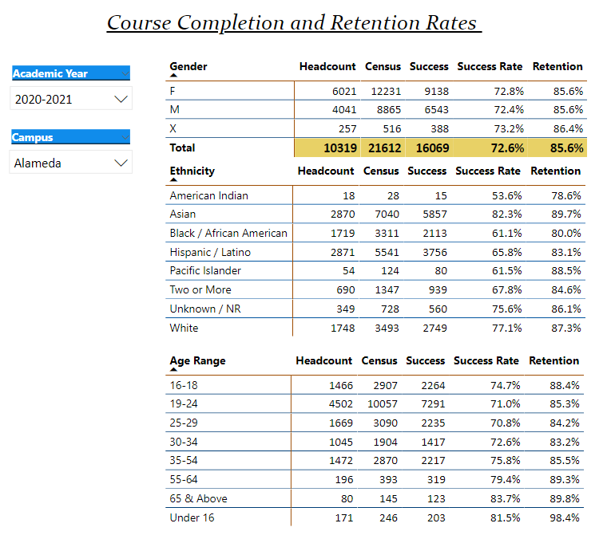

Describe any significant changes and discuss what the changes mean to your program. Consider whether performance gaps exist for disproportionality impacted students by using filters to disaggregate the data. Focus upon the most recent year and/or the years since your last comprehensive program review. Cite data points to support your reflection.

|  |
| --- |
|  |

Describe the department's progress on Student Learning Outcomes (SLOs) and/or Service Area Outcomes (SAOs) since the last Program Review/APU.

|  |
| --- |
| The CoA Career and Employment Center Service Area Outcomes (SAO) are directly tied to the WIOA grant outcomes set forth by our funder, the Alameda County Workforce Development Board. For the 2020-2021 program year, the Career Center met (virtual services) all required county goals including:   * Enrolling 108 new clients * Placing 4 clients in On the Job Training (OJT) * Spending down $100k in training funding to support clients with earning industry recognized certifications   Additional Goals:   * Spend down $35k in CARES Act funding to support clients with bill assistance * Deliver refurbished laptops to clients to provide access to virtual services (due to the digital divide) |

Describe the outcomes and accomplishments from previous year’s funded resource allocation request.

|  |  |  |  |
| --- | --- | --- | --- |
| **Brief description of funded request** | **Source (any additional award outside your base allocation)** | **Total Award Amount** | **Outcome/Accomplishment** |
| CalWorks  The Career Center received funding from the CoA CalWorks during the 2020-2021 program year. | This was in addition to the departments county WIOA grant. | $20,000 | Held Weekly Ongoing Employability Workshops (virtual) to support CalWorks students with preparing to enter the workplace. |
| Veterans  The Career Center received funding from CoA Veterans department during the 2020-2021 program year. | This was in addition to the departments county WIOA grant. | $20,000 | Invited Veterans to attend weekly employability workshops, sent the department hiring events and job resources, connected department to Swords to Plowshares through an existing MOU with the Career Center. |
| District Strong Workforce Funding  The Career Center received funding from district SWP during the 2020-2021 program year. This was funding provided by the Chancellor to support increased career services to students across the distric | This was in addition to the departments county WIOA grant. | $145,0000 | Brought on Handshake (education platform) to support students with job search district wide,  Provided career services across the district for all students including dual enrollment in WIOA. |

**Prioritized Resource Requests Summary**

In the boxes below, please add resource requests for your program. If there are no resource requested, leave the boxes blank.

|  |  |  |  |  |
| --- | --- | --- | --- | --- |
| **Resource Category** | **Description/Justification** | **Estimated Annual Salary Costs** | **Estimated Annual Benefits Costs** | **Total Estimated Cost** |
| **Personnel: Classified Staff** |  |  |  |  |
| **Personnel: Student Worker** |  |  |  |  |
| **Personnel: Part Time Faculty** |  |  |  |  |
| **Personnel: Full Time Faculty** |  |  |  |  |

|  |  |  |
| --- | --- | --- |
| **Resource Category** | **Description/Justification** | **Total Estimated Cost** |
| **Professional Development: Department wide PD needed** |  |  |
| **Professional Development: Personal/Individual PD needed** |  |  |

**Prioritized Resource Requests Summary - Continued**

|  |  |  |
| --- | --- | --- |
| **Resource Category** | **Description/Justification** | **Total Estimated Cost** |
| **Supplies: Software** |  |  |
| **Supplies: Books, Magazines, and/or Periodicals** |  |  |
| **Supplies: Instructional Supplies** |  |  |
| **Supplies: Non-Instructional Supplies** |  |  |
| **Supplies: Library Collections** |  |  |

|  |  |  |
| --- | --- | --- |
| **Resource Category** | **Description/Justification** | **Total Estimated Cost** |
| **Technology & Equipment: New** |  |  |
| **Technology & Equipment: Replacement** |  |  |

**Prioritized Resource Requests Summary - Continued**

|  |  |  |
| --- | --- | --- |
| **Resource Category** | **Description/Justification** | **Total Estimated Cost** |
| **Facilities: Classrooms** |  |  |
| **Facilities: Offices** |  |  |
| **Facilities: Labs** |  |  |
| **Facilities: Other** |  |  |

|  |  |  |
| --- | --- | --- |
| **Resource Category** | **Description/Justification** | **Total Estimated Cost** |
| **Library: Library materials** |  |  |
| **Library: Library collections** |  |  |

|  |  |  |
| --- | --- | --- |
| **Resource Category** | **Description/Justification** | **Total Estimated Cost** |
| **OTHER** |  |  |