Program Overview
Please provide your program’s mission statement and service-learning outcomes
EOPS/CARE/CalWORKs and NextUP provides above and beyond academic and career counseling that serves the vulnerable and underrepresented students at College of Alameda. Faculty and staff strive to provide culturally relevant and transformative experiences that support students’ goals and learning outcomes. We lean of the values of equity and social justice that is in direct correlation with the civil rights movement.

List your program staff or faculty
Funding from Dean is from General Funds: Shalamon Duke – 1.0 FTE Dean of Counseling and Special Programs.

Funding for EOPS/CARE/CalWORKs and NextUP Staff comes from EOPS/CARE/CalWORKs and NextUP Categorical Funds
- Louie Martirez y McFarland – 1.0 FTE Project Manager EOPS/CARE/CalWORKs and NextUP
- Mary Shaughnessy – 1.0 FTE Counselor EOPS/CARE/CalWORKs and NextUP
- Marissa Nakano – 1.0 FTE Counselor EOPS/CARE/CalWORKs and NextUP
- Charles Washington – 1.0 FTE Counselor EOPS/CARE/CalWORKs and NextUP
- Wendy Odath - 1.0 FTE Staff Assistant to the Dean and EOPS/CARE/CalWORKs and NextUP
- Fathia Mohammed – 0.50 FTE Adjunct Counselor EOPS/CARE/CalWORKs and NextUP
- Hector Corrales – 0.50 FTE Adjunct Counselor EOPS/CARE/CalWORKs and NextUP

Your program goals have been listed from your most recent Program Review or APU. Provide an update on the status of the goal. Has your program achieved the goal? Have any of your goals been revised or any still in progress? Lastly, make sure to discuss which College or District goal your program goal aligns to.
If no program goals exist or if this is your first program review, work to create 2-3 goals and align them with a College or District goal.
Program Goal | Serving more effectively emancipated foster youth
Status: In-Progress or Complete? | Working with Alameda County Social Services Agency to identify Emancipated Foster Youth especially those who are any federal entitlement programs such as CalFRESH and may benefit from EOPS/CARE and NEXT UP Services
Which college or district goal is aligned with your program goal? | COA – Hispanic Serving Institution, Guided Pathway, Student Equity and Achievement (SEA), Goal 1 to 6, PCCD’s Alignment of 2022 Vision for Success & CoA's 2016-21 Educational Master Plan Goals.
Program Goal | Serving more effectively Cal Works students by coordinating County Welfare Department with COA - Career Technical Education Programs (CTE).
Status: In-Progress or Complete? | Working with COA – CTE to support Cal Works students to connect and support their COA – CTE courses, especially those who are eligible for Temporary Assistance for Needy Families (TANF).
Which college or district goal is aligned with your program goal? | COA – Hispanic Serving Institution, Guided Pathway, Student Equity and Achievement (SEA), Goal 1 to 6, PCCD’s Alignment of 2022 Vision for Success & CoA's 2016-21 Educational Master Plan Goals.
Program Goal | Increase presence of Chicano/Latinos/Hispanics, Pacific Islander and African American Males
Status: In-Progress or Complete? | Working with ACCESO, Puente Program and Undocumented Program Services to coordinate services.
Which college or district goal is aligned with your program goal? | COA – Hispanic Serving Institution, Guided Pathway, Student Equity and Achievement (SEA) , Goal 1 to 6, PCCD’s Alignment of 2022 Vision for Success & CoA's 2016-21 Educational Master Plan Goals.
Program Goal | Ensure that EOPS/CARE students are enjoying a diverse collegiate experience which remaining focused on achieving their academic goal.
Status: In-Progress or Complete? | Working to enhance virtual program by improving website services, automate deposit of grants and vouchers through Bank Mobile, and implementing ConexED/Cranium Café.
Which college or district goal is aligned with your program goal? | COA – Hispanic Serving Institution, Guided Pathway, Student Equity and Achievement (SEA), Goal 1 to 6, PCCD’s Alignment of 2022 Vision for Success & CoA's 2016-21 Educational Master Plan Goals.

List the essential functions of your department, program or unit and provide a description of how the unit aligns with the college mission.
COA Mission: The mission of College of Alameda is to serve the educational needs of its diverse community by providing comprehensive and flexible programs and resources that empower students to achieve their goals.

Essential Functions that will be developed by EOPS/CARE/CAL WORKS & NEXT UP Programs is to provide a uniform process that allows comprehensive and flexible programming and resources :

- Develop Common Application for all EOPS/CARE/CAL WORKS & NEXT UP Programs which will be implemented in Fall 2022.
- Develop Common Mutual Responsibility Contract EOPS/CARE/CAL WORKS & NEXT UP form which will be implemented in Fall 2022.
- Develop comprehensive semester orientation for continuing and new EOPS/CARE/CAL WORKS & NEXT UP program participants, starting in the Spring 2023
- Develop Summer Bridge program for EOPS/CARE/CAL WORKS & NEXT UP participants starting in the Summer 2023
- Establish a College Visitation programs (HBCU, Sacramento Region and Southern California Region UCs and CSUs) for EOPS/CARE/CAL WORKS & NEXT UP participants starting in the Summer 2023
Program Update
Using the dashboards, review and reflect upon the data for your program.
Course Completion and Retention Rates – Instructional Dashboard
Course Completion and Retention Rates – Student Services Dashboard
Enrollment Trends and Productivity Dashboard
Degrees and Certificates Dashboard

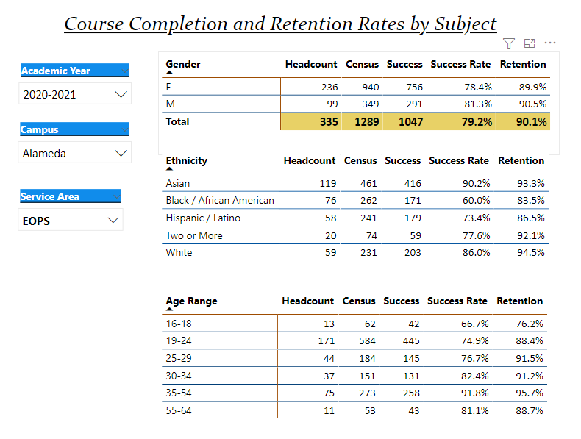
Describe any significant changes and discuss what the changes mean to your program. Consider whether performance gaps exist for disproportionality impacted students by using filters to disaggregate the data. Focus upon the most recent year and/or the years since your last comprehensive program review. Cite data points to support your reflection.
We have seen a decline due to the two-year Covid-19 Pandemic in completion and retention process. We have done a Fall 2021 EOPS/CARE/CAL WORKS & NEXT UP Retreat to review and streamline our non-face to face presence to improve our access and breaking down student barriers to access by providing mobile hot spot devices, loaner computers and ancillary services such as meal vouchers.

Student Data 2020-2021 shows that Completion- 85.6% and Retention-85.3% remains high despite the Covid-19 pandemic. The completion and retention remain above 80% overall which has been consistent year after year from FY2018-2019; however, we do see slight declines due to Covid-19 pandemic period, during FY19-20 and FY20-21 periods. There were no significant changes in the data presented for students.

The number of EOPS/CARE/CAL WORKS & NEXT UP participants have declined year after year because our program model has not evolved which is currently a paper process, no dedicated management and classified staffing which runs counter to legislative mandates for EOPS/CARE Ed Code. As such, the Program Review reflects the needs to staff appropriately, updates all computer hardware used by staff to actual support the programs (current desktops PC running at 8 RAMS and processing speed below I -5 which is out of compliance of current DISTRICT IT requirements) and increase outreach services to Black and Brown males students especially those who are foster care, juvenile probationers, first generation and non-traditional students.

Describe the department's progress on Student Learning Outcomes (SLOs) and/or Service Area Outcomes (SAOs) since the last Program Review/APU.
SLO and SAO process has been challenging due to the two-year Covid-19 Pandemic. We have done a Fall 2021 EOPS/CARE/CAL WORKS & NEXT UP Retreat to review and streamline our application and other process for each program to one master application and master mutual responsibility contract. Also moving towards a web and mobile process/organizational mind-set to connect through student using ConexED/Cranium Café. Overall, the Black and Brown males’ participation and award trends in EOPS/CARE/CALWORKS and NEXT UP remains low and success rates for degree and certificates award remain higher for Black and Brown females’ students in EOPS/CARE/CALWORKS and NEXT UP.

We have seen census enrollment and productivity drop from FY19 to FY21 for all terms. At the same time, EOPS/CARE/CAL WORKS & NEXT UP Programs are working to offset declines by providing some loaner computers, hot spot devices and ancillary services such as meal vouchers to bridge the gaps; However, we recognize we need to do more and think outside the box for student services. We need restructure our programs and update our staff needs to work differently which has not changed in the last decade. Our number of EOPS/CARE/CALWORKS and NEXT UP new participants year after year have declined and we must change our model of delivery, outreach and staffing structures which our State Program Officers noted an overwhelming support.

We have observed EOPS/CARE/CALWORKS and NEXT UP degrees and certificates grow compared from FY20 to FY21, see picture below. Please note the sample size is small which we have to keep this in mind when reviewing the data. Our Black and Brown males award rates are lower when compared to Black and Brown females in EOPS/CARE/CALWORKS and NEXT UP. As such, Black and Brown females are matriculating at higher rate which coincides with higher participation rates in the EOPS/CARE/CALWORKS and NEXT UP Programs and overall campus.

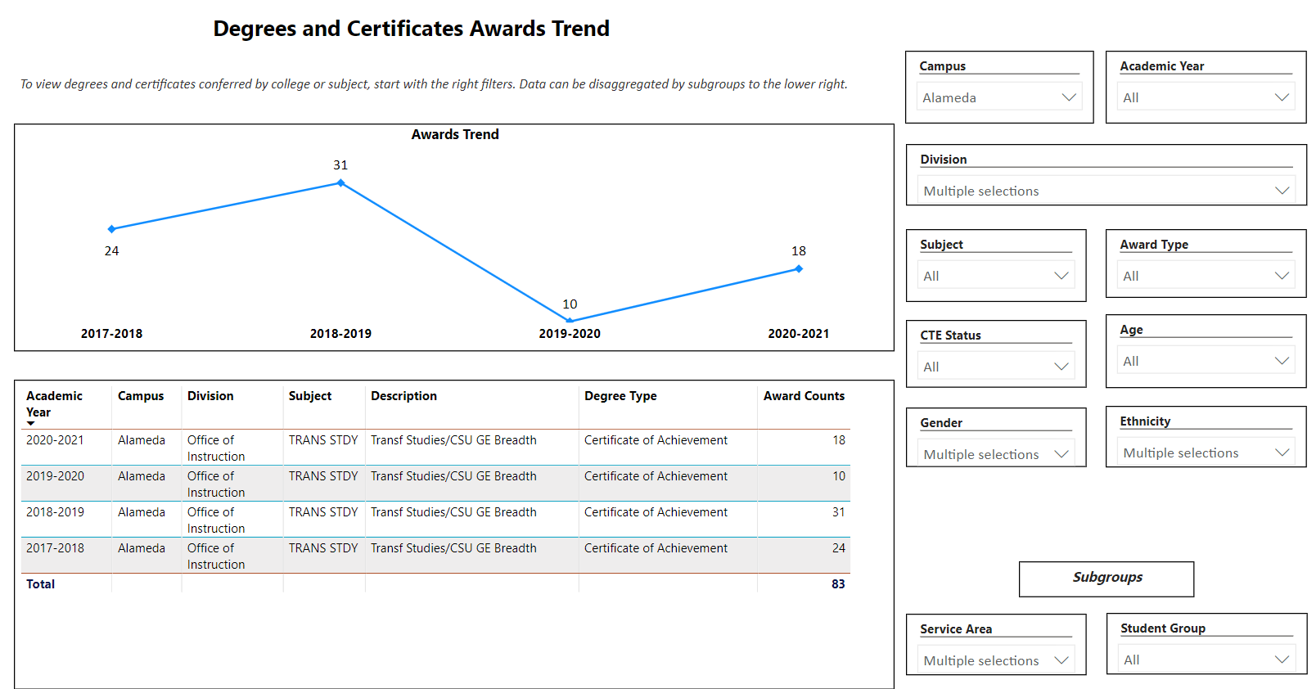

Describe the outcomes and accomplishments from previous year’s funded resource allocation request.
Brief description of funded request | Source (any additional award outside your base allocation) | Total Award Amount | Outcome/Accomplishment
N/A | N/A | N/A | N/A

Prioritized Resource Requests Summary
In the boxes below, please add resource requests for your program. If there are no resource requested, leave the boxes blank.
Resource Category | Description/Justification | Estimated Annual Salary Costs | Estimated Annual Benefits Costs | Total Estimated Cost
Personnel: Administration | 1.0 FTE - Director of EOPS/CARE. Required by EOPS/CARE Ed Code/State Legislation | $108,947 | $49,026 | $157,973
Personnel: Classified Staff | 1.0 FTE - Student Services Specialist; Program Support Services EOPS/CARE/CalWORKs/NextUp | $56,918 | $25,613 | $82,531
Personnel: Classified Staff | 1.0 FTE - Student Services Specialist/Fiscal; Assist Grants Management EOPS/CARE/CalWORKs/NextUp | $56,918 | $25,613 | $82,531
Personnel: Classified Staff | 0.50 FTE – Staff Assistant to the Dean of Counseling and Special Programs | $28,459 | $12,806 | $41,265
Personnel: Student Worker
Personnel: Part Time Faculty
Personnel: Full Time Faculty

Resource Category | Description/Justification | Total Estimated Cost
Professional Development: Department wide PD needed | Microsoft Professional Training – Word, Excel, Outlook and Project from Basic to Intermediate level for Certificated and Classified Staff in EOPS/CARE/CALWORKS and NEXT UP. | $5,000
Professional Development: Personal/Individual PD needed

Prioritized Resource Requests Summary - Continued
Resource Category | Description/Justification | Total Estimated Cost
Supplies: Computer Hardware and Software | Purchase Levano loaner computers, hotspot devices and scientific calculators for EOPS/CARE/CAL Works & NEXT UP for our students; Required by EOPS/CARE Ed CODE to provide matching funding from the PCCD. | $25,000
Supplies: Books, Magazines, and/or Periodicals
Supplies: Instructional Supplies
Supplies: Non-Instructional Supplies
Supplies: Library Collections | Purchase of common general education required books for English and Math copies for our EOPS/CARE/CAL Works & NEXT UP Students. Required by EOPS/CARE Ed CODE to provide matching funding from the PCCD. | $25,000

Resource Category | Description/Justification | Total Estimated Cost
Technology & Equipment: New

Technology & Equipment: Replacement | Update all EOPS/CARE/CAL WORKS and NEXT UP PC Desktop Computers. Current desktop computers are running on 8 RAM and processing below I5. The current configuration cannot run existing PCCD requirements for Microsoft 365, Microsoft Professional, SARS, ConexED/Cranium Café, ONE PERALTA and other programs. 10 Desktop Computers are needed and 10 outreach laptops. Replace all individual printers with two high-capacity share printers. This includes current staffing and student workers for Desktop computers and outreach work (use of laptops by Certificated and Classified staff). | $70,000

Prioritized Resource Requests Summary - Continued
Resource Category | Description/Justification | Total Estimated Cost
Facilities: Classrooms
Facilities: Offices | Smart Board for EOPS/CARE/CAL WORKS and NEXT UP ; Conference room with a Smart Board helps with planning and Zoom calls; Special Programs like EOPS/CARE/CALWORKS and NEXT Up does not have institutional devices to help plan and support program services such as conference room and related equipment. | $5,000
Facilities: Labs
Facilities: Other

Resource Category | Description/Justification | Total Estimated Cost
Library: Library materials
Library: Library collections

Resource Category | Description/Justification | Total Estimated Cost
OTHER

