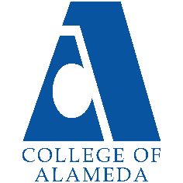
College of Alameda
2021-22 Annual Program Update – Financial Aid

Program Overview
Please provide your program’s mission statement and program’s learning outcomes
The purpose of College of Alameda Financial Aid department is to provide equitable assistance to all students who apply for financial aid (grants, loans, scholarships, work-study) that will enable them to obtain a certificate, a degree or to transfer to a four-year college. Our primary purpose is to ensure that all students have the opportunity to access and achieve their educational goals at College of Alameda.

The Financial Aid department recognizes and believes in equity through removing financial barriers for those farthest from opportunity. Therefore, we do not believe that students should be denied the opportunity to pursue a college education due to limited family resource contributions.

It is essential that the Financial Aid department provide assistance to address disparate educational needs through providing financial aid to assist those in greatest need to overcome financial barriers and achieve their goals.

List your program staff or faculty
Jackie Vo – Financial Aid Officer
Miriam Fernandez – Financial Aid Specialist
Jiayu He – Financial Aid Specialist
Stephanie Hess – Financial Aid Placement Assistant
Alex Peto – Work-study student
Ailleen Perez – Work-study student

Your program goals have been listed from your most recent Program Review or APU. Provide an update on the status of the goal. Has your program achieved the goal? Have any of your goals been revised or any still in progress? Lastly, make sure to discuss which College or District goal your program goal aligns to.
If no program goals exist or if this is your first program review, work to create 2-3 goals and align them with a College or District goal.
Program Goal | Work towards increasing Financial Aid applicants by 3%
Status: In-Progress or Complete? | In-progress
Which college or district goal is aligned with your program goal? | Increase access to college programs  Advance Student Access, Equity, and Success.  Increase retention and persistence rate  SCFF Student Centered Funding Formula

Program Goal | Increase the number of Pell recipients by 3%
Status: In-Progress or Complete? | In-Progress
Which college or district goal is aligned with your program goal? | SCFF Student Centered Funding Formula  Advance Student Access, Equity, and Success  Increase retention and persistence rate

Program Goal | Closing equity gaps for disproportionate groups through more financial aid activities twice a month
Status: In-Progress or Complete? | In-Progress; we have completed outreach via workshops in collaboration with the Umoja and Acceso/Puente programs
Which college or district goal is aligned with your program goal? | SCFF Student Centered Funding Formula  Advance student success  Persistence rate

List the essential functions of your department, program or unit and provide a description of how the unit aligns with the college mission.
College of Alameda’s Financial Aid department’s goals is to provide streamlined and efficient services that are responsive to student needs. Most of the Financial Aid department’s decisions that relate to the administration of financial aid programs are made by the Director of Financial Aid beginning with the 2020-2021 academic year. Decisions before that time were made by the Financial Aid Supervisor. Many of these decisions require consultation with the Dean of Enrollment Services, Finance department, Business department, and other appropriate student support services. The Financial Aid Director works closely with all the important stakeholders to ensure that students receive outstanding service and receive their money in an expeditious manner.

Program Update
Using the dashboards, review and reflect upon the data for your program.
Course Completion and Retention Rates – Instructional Dashboard
Course Completion and Retention Rates – Student Services Dashboard
Enrollment Trends and Productivity Dashboard
Degrees and Certificates Dashboard

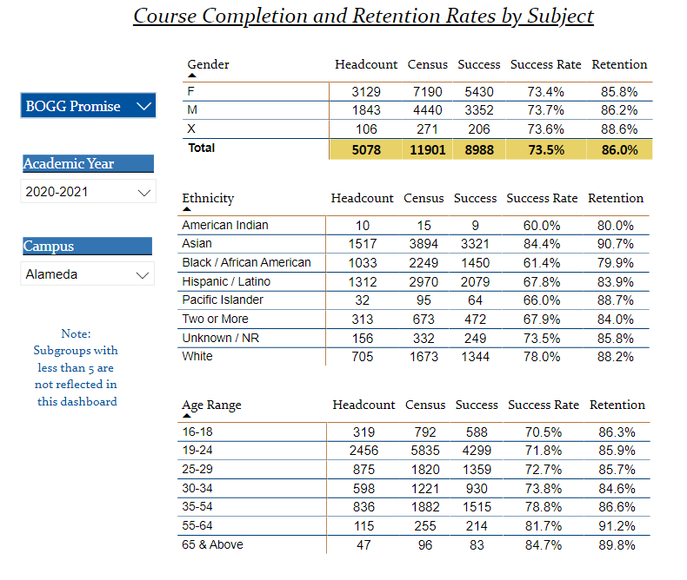
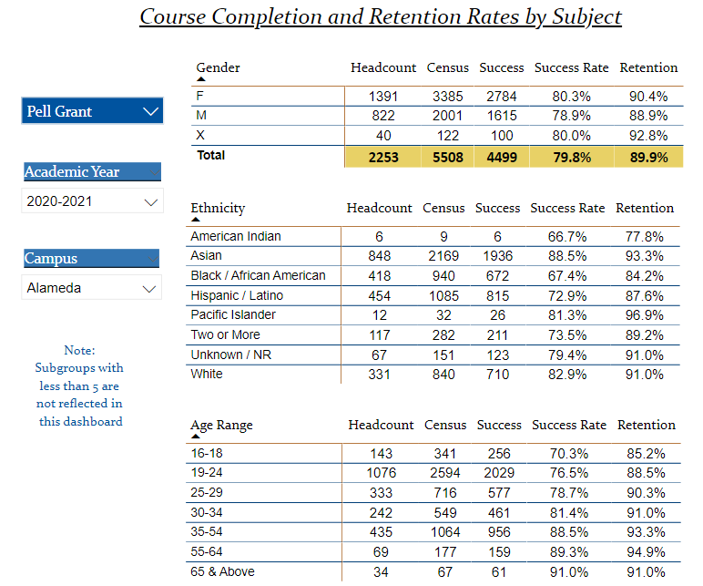

Describe any significant changes and discuss what the changes mean to your program. Consider whether performance gaps exist for disproportionality impacted students by using filters to disaggregate the data. Focus upon the most recent year and/or the years since your last comprehensive program review. Cite data points to support your reflection.
COVID-19 has impacted the way we deliver service to students for the Financial Aid Office. We are doing the following to address these challenges:

- We are using a virtual front desk to provide one-on-one service to students from 9-4:30 three times a week. We are utilizing zoom for advising students

- During COVID-19, we have been utilizing tawk.to, a live chat software plugin tool that embeds in our website and allows us to assist students with Financial Aid questions.

- We secured an agreement with CampusLogic, a third-party vendor, that provides students the ability to submit verification files online so that students can complete and upload their financial aid documents online without having to visit the Financial Aid Office. Dropbox was also available for students to submit/upload their FA forms

- Members of the financial aid team have participated in activities surrounding food insecurities by volunteering time to help with distributing food to the community

- In response to COVID-19, the FAO has proactively provided additional outreach to encourage students to submit their FAFSA/Dream Act applications and complete their FA files via calls, texting, emailing about 3 times a week.

- Provide virtual financial aid workshops twice a week via Zoom.

Describe the department's progress on Student Learning Outcomes (SLOs) and/or Service Area Outcomes (SAOs) since the last Program Review/APU.
Our SLOs are:
Process all financial aid files within 3-4 weeks
Improving services to 85% for “satisfied” or “very satisfied”

The Financial Aid Office worked together on the Student/Service Area Learning Outcomes by collaborating on the survey for the front counter. As a team, we also made sure that the survey was accessibility friendly and clear and easy for students to understand. We achieved this by working with DSPS.

We have been successful in meeting the goal of processing files within 3-4 weeks. We almost met the 85% goal to receive a “satisfied” or “very satisfied” rating from students but achieved at 81%. Please see the following describing some challenges that prevented us from meeting our goals:

- There was a vacancy, and we did not have 3 specialists to meet the goal
- Collecting data was a challenge for the semester
- The survey was not automated and relied on paper files
- Due to COVID, we weren’t able to assess the full assessment

We plan to address the student satisfaction results by again surveying students to assess what other key areas we need to improve related to student service. We will ask additional questions that include, but are not limited, to if evening office hours for service are needed and if more financial aid workshops are needed. We also want to make sure that we look at other ways to distribute the survey and will explore automating the process. We want to increase the number of students who complete the survey and provide a more efficient way for us to collect the data

Describe the outcomes and accomplishments from previous year’s funded resource allocation request.
Brief description of funded request | Source (any additional award outside your base allocation) | Total Award Amount | Outcome/Accomplishment
Customer Service Training |  | $10,000 | All staff members were given an extensive month training on customer service skills; the training included theory and practical steps to service our students.
Presentation skills training |  | $5000 | All staff members were given an extensive training on presentation skills that included practice sessions, process improvements and confidence building.

Prioritized Resource Requests Summary
In the boxes below, please add resource requests for your program. If there are no resource requested, leave the boxes blank.
Resource Category | Description/Justification | Estimated Annual Salary Costs | Estimated Annual Benefits Costs | Total Estimated Cost
Personnel: Classified Staff

Personnel: Student Worker

Personnel: Part Time Faculty

Personnel: Full Time Faculty

Resource Category | Description/Justification | Total Estimated Cost
Professional Development: Department wide PD needed | Student Employment Essentials Training hosted by the National Student Employment Association www.nsea.info/student-employment-essentials | $400
Professional Development: Personal/Individual PD needed | NASFAA Leadership conference | $4000

Prioritized Resource Requests Summary - Continued

Resource Category | Description/Justification | Total Estimated Cost
Supplies: Software

Supplies: Books, Magazines, and/or Periodicals

Supplies: Instructional Supplies | KAHOOT subscription | $300
Supplies: Non-Instructional Supplies

Supplies: Library Collections

Resource Category | Description/Justification | Total Estimated Cost
Technology & Equipment: New

Technology & Equipment: Replacement

Prioritized Resource Requests Summary - Continued

Resource Category | Description/Justification | Total Estimated Cost
Facilities: Classrooms

Facilities: Offices

Facilities: Labs

Facilities: Other

Resource Category | Description/Justification | Total Estimated Cost
Library: Library materials

Library: Library collections

Resource Category | Description/Justification | Total Estimated Cost
OTHER

