**College of Alameda**

2021-22 Annual Program Update – **Health Services**

**Program Overview**

Please provide your program’s mission statement and program’s learning outcomes

|  |
| --- |
| College of Alameda is committed to furthering the equality of the educational opportunity and success for all students by providing access to health services which promote the physical, emotional, social, and spiritual well-being of its students. This well-being contributes to the educational aim of our community colleges by promoting student retention and academic success. |

List your program staff or faculty

|  |  |
| --- | --- |
| |  | | --- | | **Lisa Sawadogo, Health Services Coordinator** – full-time faculty  **Jennifer Maghsoudi Golden, Psychologist, Mental Health Counselor** – part-time faculty (recently hired 10/2021 due to high demand for services)  **Erica Gibbons, MFT Trainee** – part-time volunteer  **Elizabeth Montes, MFT Trainee** – part-time volunteer  Community partner: Roots Clinic  Nurse Practitioner  Patient Health Navigator  Due to COVID-19, the Roots Clinic is currently providing medical services for all currently enrolled Peralta students from all four community colleges Monday – Friday from 9a.m. – 5p.m. College of Alameda mental health services are being provided remotely Monday-Friday 9a.m. – 5p.m.  *In previous years, medical services were offered on a part-time basis (Nursing services: Monday 1-5, Tuesday & Thursday 8:30-12 and massages/acupuncture Wednesdays 9a.m. – 1p.m.) Due to all services being remote, there are no acupuncture or massage services being offered at this time. | |

Your program goals have been listed from your most recent Program Review or APU. Provide an update on the status of the goal. Has your program achieved the goal? Have any of your goals been revised or any still in progress? Lastly, make sure to discuss which College or District goal your program goal aligns to.

*If no program goals exist or if this is your first program review, work to create 2-3 goals and align them with a College or District goal.*

|  |  |
| --- | --- |
| **Program Goal** | Update or maintain service area outcomes annually and meet or exceed all service area outcome measures for health services. |
| Status: In-Progress or Complete? | In-progress |
| Which college or district goal is aligned with your program goal? | College: Strengthen data driven/informed decision making  District: Develop and manage resources to advance our mission |

|  |  |
| --- | --- |
| **Program Goal** | Increase offering of student success workshops related to wellness and health education from 2 to 4 annually. |
| Status: In-Progress or Complete? | Completed |
| Which college or district goal is aligned with your program goal? | College: Increase retention and persistence rates  District: Advance student access, equity, and success |

|  |  |
| --- | --- |
| **Program Goal** | Assess for success at providing culturally sensitive services for students by surveying students about their experience with wellness services. |
| Status: In-Progress or Complete? | In-progress |
| Which college or district goal is aligned with your program goal? | College: Increase retention and persistence rates  District: Advance student access, equity, and success |

List the essential functions of your department, program or unit and provide a description of how the unit aligns with the college mission.

|  |
| --- |
| The essential functions of wellness services are to provide students with access to services which promote physical, emotional, social, and spiritual well-being. Our department provides mental health wellness support for students by providing individual counseling sessions, support groups, crisis intervention, consultation, referrals, and campus wide workshops and training.  The medical services provided through our community clinic partner Roots include, but are not limited to: first aid, pregnancy testing, health education, smoking cessation, health and wellness counseling, triage, flu shots, COVID-19 testing, health insurance counseling, and referrals to off-site facilities. |

**Program Update**

Using the dashboards, review and reflect upon the data for your program.

[**Course Completion and Retention Rates – Instructional Dashboard**](https://app.powerbi.com/view?r=eyJrIjoiNjc2MDhiNTEtNTJhZi00MDM0LTk5NDItNTRiY2EzMGI1NTZiIiwidCI6ImVlYTE2YTE2LTQ4YWYtNDc3Yi05MTEzLTA1YjFjMDExMjNmZiIsImMiOjZ9&pageName=ReportSection86d6f65e2fb41a73da4d)

[**Course Completion and Retention Rates – Student Services Dashboard**](https://app.powerbi.com/view?r=eyJrIjoiNjk3NDJjOTItNzI5MS00MDhjLWJhN2EtZjcxNzU4OTBiZDBjIiwidCI6ImVlYTE2YTE2LTQ4YWYtNDc3Yi05MTEzLTA1YjFjMDExMjNmZiIsImMiOjZ9&pageName=ReportSection86d6f65e2fb41a73da4d)

[**Enrollment Trends and Productivity Dashboard**](https://app.powerbi.com/view?r=eyJrIjoiNWJlOWZmYTEtNTY0MC00MDhkLWE5OTAtYmJjZjIxNzJiNWViIiwidCI6ImVlYTE2YTE2LTQ4YWYtNDc3Yi05MTEzLTA1YjFjMDExMjNmZiIsImMiOjZ9&pageName=ReportSection86d6f65e2fb41a73da4d)

[**Degrees and Certificates Dashboard**](https://app.powerbi.com/view?r=eyJrIjoiZjU2M2M5MzItOTcwZi00Y2U1LWJmODUtYTc0YjlhZGI2ZDhjIiwidCI6ImVlYTE2YTE2LTQ4YWYtNDc3Yi05MTEzLTA1YjFjMDExMjNmZiIsImMiOjZ9&pageName=ReportSectionde32556e136b0a8caccd)

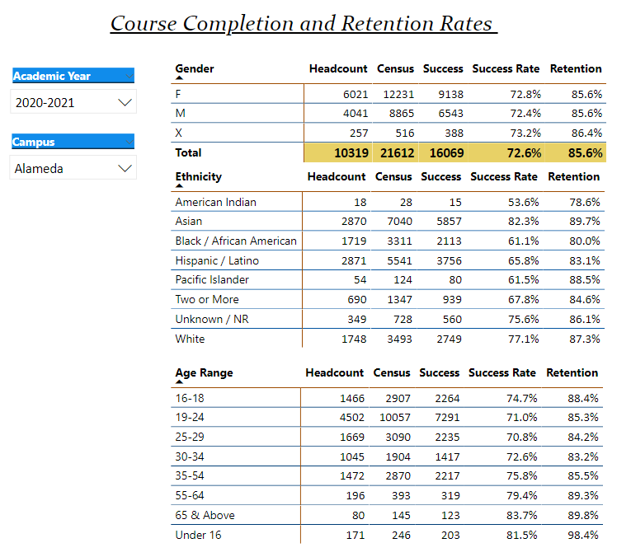

Describe any significant changes and discuss what the changes mean to your program. Consider whether performance gaps exist for disproportionality impacted students by using filters to disaggregate the data. Focus upon the most recent year and/or the years since your last comprehensive program review. Cite data points to support your reflection.

|  |  |  |  |  |  |  |  |  |  |  |  |  |  |  |  |  |  |  |  |  |  |  |  |  |  |  |  |  |  |  |  |  |  |  |  |  |  |  |  |  |
| --- | --- | --- | --- | --- | --- | --- | --- | --- | --- | --- | --- | --- | --- | --- | --- | --- | --- | --- | --- | --- | --- | --- | --- | --- | --- | --- | --- | --- | --- | --- | --- | --- | --- | --- | --- | --- | --- | --- | --- | --- |
| Data utilization for success/retention rates will be collected over the next few months. See below for current demographics of students utilizing mental health services fall 2021 for 55 unduplicated students that have utilized 258 appointments:   |  |  | | --- | --- | | GENDER |  | | F | 36 | | M | 19 | | X | 0 |  |  |  | | --- | --- | | RACE |  | | American Indian | 1 | | Asian | 8 | | Black/African American | 11 | | Hispanic/Latinx | 18 | | Two or more races | 6 | | Middle Eastern | 2 | | Unknown | 2 | | White | 7 |      |  |  | | --- | --- | | AGE |  | | 55-64 | 1 | | 35-54 | 7 | | 30-34 | 11 | | 25-29 | 9 | | 19-24 | 25 | | 16-18 | 2 | |

Describe the department's progress on Student Learning Outcomes (SLOs) and/or Service Area Outcomes (SAOs) since the last Program Review/APU.

|  |
| --- |
| 1.Healthier Decisions: Students will be able to utilize the necessary information, resources, and options available for them to make sound educational, emotional, and health-related lifelong decisions.(ILO 1 Problem Solving & Decision Making; ILO 4 Interpersonal Skills; ILO 5 Civic Responsibility)  2. Improved coping: Students will be able to identify healthier coping skills and strategies for maintaining wellness, managing stress, managing anger, or meeting personal goals. (ILO 1 Problem Solving & Decision Making; ILO 4 Interpersonal Skills; ILO 5 Civic Responsibility)  For the four workshops that were provided this fall 2021 semester, the following student survey data was collected to support the SLO goals:  100% of students reported STRONGLY AGREE to the following survey statements:  -“My counselor helped me identify new skills or ways of coping.”  -“I feel confident using the information that I learned from the training.”  -”The workshop increased my knowledge about the topic covered.”  The department is still waiting for students to respond to evaluations that went out regarding experience in individual counseling sessions. An update will be provided at the next program review cycle. |

Describe the outcomes and accomplishments from previous year’s funded resource allocation request.

|  |  |  |  |
| --- | --- | --- | --- |
| **Brief description of funded request** | **Source (any additional award outside your base allocation)** | **Total Award Amount** | **Outcome/Accomplishment** |
| Stipends and salary for MFT Trainee’s and part-time Psychologist |  |  | Able to onboard 2 MFT Trainee’s and part-time psychologist to meet increased demand for mental health services |
| 11-month contract for full-time Health Services Coordinator |  |  | Allowed for preparation for new internship orientation, supervision over 2 weeks of winter break for continuity of mental health services, and planning/organizing for heading back to campus |
|  |  |  |  |

**Prioritized Resource Requests Summary**

In the boxes below, please add resource requests for your program. If there are no resources requested, leave the boxes blank.

|  |  |  |  |  |
| --- | --- | --- | --- | --- |
| **Resource Category** | **Description/Justification** | **Estimated Annual Salary Costs** | **Estimated Annual Benefits Costs** | **Total Estimated Cost** |
| **Personnel: Classified Staff** |  |  |  |  |
| **Personnel: Student Worker** |  |  |  |  |
| **Personnel: Part Time Faculty** | 1 Part-Time Mental Health Counselor Faculty    2 Part-Time FDIP (Faculty Diversity Internship Program)    Consistent increase in severe mental health needs of students and need for experienced, licensed therapist to assist with crisis assessments and on-going support for students. There is also a need for licensed mental health counselor to cover summer hours and supervision of interns.    Need for BIPOC and LGBTQ+ counselors to support diverse campus community and provide individual and group counseling support. | |  | | --- | | 1 PT-MH Counselor - $58,000    3-FDIP’s - $75,000 | | |  | | --- | | 1 PT-MH Counselor - $14,000  3 FDIP’s - $6,000 | | 1 PT-MH Counselor = $72,000    3 Part-time FDIP’s = $67,000 |
| **Personnel: Full Time Faculty** |  |  |  |  |

|  |  |  |
| --- | --- | --- |
| **Resource Category** | **Description/Justification** | **Total Estimated Cost** |
| **Professional Development: Department wide PD needed** | Graduate level MFT Trainees provide the majority of direct individual counseling sessions for students and need up-to-date information on best practices in the field including, but not limited to: law & ethics, crisis intervention, cultural sensitivity, and trauma. | $1000 |
| **Professional Development: Personal/Individual PD needed** | Licensed Professional Clinical Counselors are required to obtain 36 hours of continuing education every two years in order to maintain the license and continue the ability to supervise MFT Trainees/Interns. | $750 |

**Prioritized Resource Requests Summary - Continued**

|  |  |  |
| --- | --- | --- |
| **Resource Category** | **Description/Justification** | **Total Estimated Cost** |
| **Supplies: Software** |  |  |
| **Supplies: Books, Magazines, and/or Periodicals** |  |  |
| **Supplies: Instructional Supplies** | New art supplies: to integrate more art therapy options into sessions, as well as support groups | $200 |
| **Supplies: Non-Instructional Supplies** | Updated signs for the F-building, paper and printing costs: current signs reflect outdated information | $200 |
| **Supplies: Library Collections** |  |  |

|  |  |  |
| --- | --- | --- |
| **Resource Category** | **Description/Justification** | **Total Estimated Cost** |
| **Technology & Equipment: New** | Need 4 new web-cams for desktop computers: with return to campus many students are still requesting remote video appointments | $150 |
| **Technology & Equipment: Replacement** |  |  |

**Prioritized Resource Requests Summary - Continued**

|  |  |  |
| --- | --- | --- |
| **Resource Category** | **Description/Justification** | **Total Estimated Cost** |
| **Facilities: Classrooms** |  |  |
| **Facilities: Offices** |  |  |
| **Facilities: Labs** |  |  |
| **Facilities: Other** |  |  |

|  |  |  |
| --- | --- | --- |
| **Resource Category** | **Description/Justification** | **Total Estimated Cost** |
| **Library: Library materials** |  |  |
| **Library: Library collections** |  |  |

|  |  |  |
| --- | --- | --- |
| **Resource Category** | **Description/Justification** | **Total Estimated Cost** |
| **OTHER** |  |  |