**College of Alameda**

2021-22 Annual Program Update – **Student Activities and Campus Life**

**Program Overview**

Please provide your program’s mission statement and program’s learning outcomes

|  |
| --- |
| The mission of Student Activities and Campus Life is to improve student persistence, retention and completion rates by offering opportunities and experiences beyond the classroom that encourage learning and student success. |

List your program staff or faculty

|  |
| --- |
| Natalie Rodriguez, Interim Director of Student Activities and Campus Life  Jeremy Simmons, Staff Assistant Student Activities and Campus Life/Career Center |

Your program goals have been listed from your most recent Program Review or APU. Provide an update on the status of the goal. Has your program achieved the goal? Have any of your goals been revised or any still in progress? Lastly, make sure to discuss which College or District goal your program goal aligns to.

*If no program goals exist or if this is your first program review, work to create 2-3 goals and align them with a College or District goal.*

|  |  |
| --- | --- |
| **Program Goal** | Create consistent and engaging campus life programs and activities. |
| Status: In-Progress or Complete? | In-Progress – Due to shelter in place restrictions student participation in both virtual and on campus events have been challenging. Nevertheless, the Office of Student Activities and Campus Life, often in partnership with other on campus programs and support services, continues to offer monthly programs and activities for students. |
| Which college or district goal is aligned with your program goal? | **College Goal –** Increase retention and persistence rates.  **District Goal –** Advance Student Access, Equity, and Success |

|  |  |
| --- | --- |
| **Program Goal** | Implement a comprehensive leadership program for ASCOA student leaders. |
| Status: In-Progress or Complete? | In-Progress. Again, due to shelter in place restrictions there has been a severe lack of student interest in student government. After the conclusion of our most recent special election one Senator has been voted into office and three other students are currently in the process of joining ASCOA. |
| Which college or district goal is aligned with your program goal? | **College Goal –** Increase retention and persistence rates  **District Goal –** Advance Student Access, Equity and Success |

|  |  |
| --- | --- |
| **Program Goal** |  |
| Status: In-Progress or Complete? |  |
| Which college or district goal is aligned with your program goal? |  |

List the essential functions of your department, program or unit and provide a description of how the unit aligns with the college mission.

|  |
| --- |
| Student Activities and Campus Life, which includes the Associated Students of College of Alameda (ASCOA) and campus clubs is the cradle for campus life programming. It is an information and resource center as well as the hub for student leadership, community service, and recreational and cultural programs.  Services include:  • Office of Discipline  • Campus Posting Review  • Literature Distribution Guidelines  • Campus Social, Recreational, Cultural and Educational Programming  • Campus Life Calendar/Master Activities Calendar Clearance  • Campus Lost and Found  • Use and Maintenance of Student Center  • Multicultural Programming (Latino Heritage Month, Black History Month, Women’s  History Month, Asian Pacific Islander Heritage Month, LGBTQ)  • Support for the College’s Student Government, Associated Students of College of Alameda (ASCOA)  • Campus Club Organizations, Formation, Support and Advising  • Supervision of Office of Student Activities Student Employee Support Staff  • Supervision of Campus Food Services  • Supervision of Campus Safety Aides  • Coordinate annual commencement ceremony and student awards banquet  The department aligns with the college mission by providing programs and services that empower students to achieve their goals and serve their educational needs. |

**Program Update**

Using the dashboards, review and reflect upon the data for your program.

[**Course Completion and Retention Rates – Instructional Dashboard**](https://app.powerbi.com/view?r=eyJrIjoiNjc2MDhiNTEtNTJhZi00MDM0LTk5NDItNTRiY2EzMGI1NTZiIiwidCI6ImVlYTE2YTE2LTQ4YWYtNDc3Yi05MTEzLTA1YjFjMDExMjNmZiIsImMiOjZ9&pageName=ReportSection86d6f65e2fb41a73da4d)

[**Course Completion and Retention Rates – Student Services Dashboard**](https://app.powerbi.com/view?r=eyJrIjoiNjk3NDJjOTItNzI5MS00MDhjLWJhN2EtZjcxNzU4OTBiZDBjIiwidCI6ImVlYTE2YTE2LTQ4YWYtNDc3Yi05MTEzLTA1YjFjMDExMjNmZiIsImMiOjZ9&pageName=ReportSection86d6f65e2fb41a73da4d)

[**Enrollment Trends and Productivity Dashboard**](https://app.powerbi.com/view?r=eyJrIjoiNWJlOWZmYTEtNTY0MC00MDhkLWE5OTAtYmJjZjIxNzJiNWViIiwidCI6ImVlYTE2YTE2LTQ4YWYtNDc3Yi05MTEzLTA1YjFjMDExMjNmZiIsImMiOjZ9&pageName=ReportSection86d6f65e2fb41a73da4d)

[**Degrees and Certificates Dashboard**](https://app.powerbi.com/view?r=eyJrIjoiZjU2M2M5MzItOTcwZi00Y2U1LWJmODUtYTc0YjlhZGI2ZDhjIiwidCI6ImVlYTE2YTE2LTQ4YWYtNDc3Yi05MTEzLTA1YjFjMDExMjNmZiIsImMiOjZ9&pageName=ReportSectionde32556e136b0a8caccd)

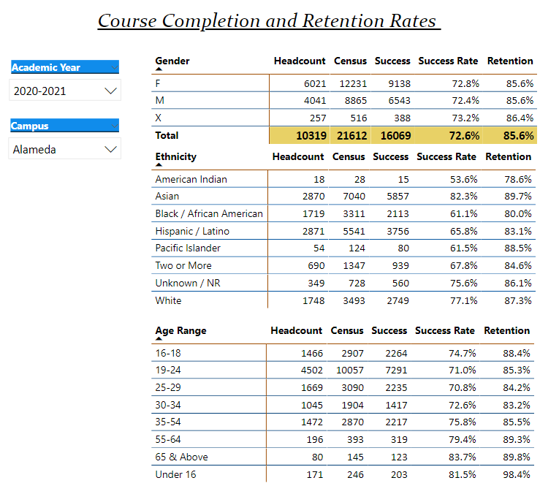

Describe any significant changes and discuss what the changes mean to your program. Consider whether performance gaps exist for disproportionality impacted students by using filters to disaggregate the data. Focus upon the most recent year and/or the years since your last comprehensive program review. Cite data points to support your reflection.

|  |
| --- |
| Due to the government mandated shelter-in-place directive, College of Alameda has seen a dramatic decrease in student enrollment.    Another major challenge for the Office of Student Activities and Campus Life has been engaging students remotely. In addition to the challenges of having students engage electronically, this has severely impacted ASCOA participation.  In response to these challenges the Office of Student Activities and Campus Life launched a digital outreach strategy that includes making presentations and announcements in classes and special programs, and cross posting all promotional material via social media (Facebook, Twitter, Instagram), e-mail blasts, and GradGuru. It has become increasingly important to collaborate with learning communities Puente/ACCESO and UMOJA in order to be able to reach our special population students.  The office of Student Activities and Campus Life has been engaged in addressing the challenges of external factors such as campus closure restrictions and the digital divide by providing direct support to students.    The department has provided students with support via:   * The Free Produce Market – Every 2nd and 4th Tuesday of the month * Emergency Food Grants in the amount of $100 per award * CalFresh Application Assistance * CalFresh Outreach * Hot Spot Distribution for any CoA student enrolled in a minimum of 1 unit at the college or working at CoA as a student worker * For students who were not able to access a computer for remote learning purposes, the college provides a Chromebook loan program * Black History Month programing * API Heritage Month programming * Latin Heritage Month programming * Dia de los Muertos Celebration   And workshops and lectures geared at special populations such as:   * Wellness Wednesday Workshops in partnership with Health Services   In the coming semester we will continue to provide direct support via:   * The Free Produce Market – Every 2nd and 4th Tuesday of the month * Emergency Food Grants in the amount of $250 per award * Additional pantry assistance via The Cougar Closet – Personal care items and baby needs (Diapers and Formula) will be available for students with a need * Hot Spot Distribution for any CoA student enrolled in a minimum of 1 unit at the college or working at CoA as a student worker * For students who were not able to access a computer for remote learning purposes, the college provides a Chromebook loan program |

Describe the department's progress on Student Learning Outcomes (SLOs) and/or Service Area Outcomes (SAOs) since the last Program Review/APU.

|  |
| --- |
| **SAO: Celebrate cultural backgrounds and examine the relationship of cultural experiences and educational attainment.**  Given the state mandated shutdown and the fact that the department was in transition for a year, there is some disconnect between previously assessed data and the current SLO. Offering multiple ways of participating in cultural events and celebrations seems to be of interest to students. Partnering with instruction in offering extra credit for attending workshops and events always draws a larger crowd. Offering students opportunities to engage with cultural events and celebrations via social media would also increase participation, especially in cases of emergency such as the one we have found ourselves in due to the Covid-19 pandemic.  Partnering with learning communities UMOJA, Puente/ACCESO has proven to be essential in increasing student participation. We have seen a larger turnout at events when we partner directly with the learning communities.  **SAO: Analyze obstacles to community college student success and examine strategies and resources to overcome obstacles.**  Through the Equity Research Survey conducted by the Guided Pathways Equity Team we learned that the most common outside factor that contributed to students not passing successfully was that they had anxiety about succeeding. The other three most popular reasons were that they had a mental or physical health crisis, they felt out of place and/or they had to care for a child or family member. According to the survey results the top four reasons in which we could have better helped these students was by providing guidance or advice from a counselor, providing more assistance with financial aid, providing more information about mental health services, and/or providing zoom tutoring sessions.  Based on this analysis there is much opportunity for connecting students to services and resources that are both already on campus and those that are external. The CoA Resource Guide that the Office of Student Activities and Campus Life has put together has been helpful in publicizing resources to students in addition to:   * The Free Produce Market – Every 2nd and 4th Tuesday of the month * Emergency Food Grants in the amount of $100 per award * CalFresh Application Assistance * CalFresh Outreach * Hot Spot Distribution for any CoA student enrolled in a minimum of 1 unit at the college or working at CoA as a student worker * For students who were not able to access a computer for remote learning purposes, the college provides a Chromebook loan program * Black History Month programing * API Heritage Month programming * Latin Heritage Month programming * Dia de los Muertos Celebration |

Describe the outcomes and accomplishments from previous year’s funded resource allocation request.

|  |  |  |  |
| --- | --- | --- | --- |
| **Brief description of funded request** | **Source (any additional award outside your base allocation)** | **Total Award Amount** | **Outcome/Accomplishment** |
|  |  |  |  |
|  |  |  |  |
|  |  |  |  |

**Prioritized Resource Requests Summary**

In the boxes below, please add resource requests for your program. If there are no resource requested, leave the boxes blank.

|  |  |  |  |  |
| --- | --- | --- | --- | --- |
| **Resource Category** | **Description/Justification** | **Estimated Annual Salary Costs** | **Estimated Annual Benefits Costs** | **Total Estimated Cost** |
| **Personnel: Classified Staff** | Currently the department shares a staff assistant with another campus department. Having a part-time staff assistant negatively affects department operations by limiting productivity and effectiveness. The addition of a full-time 10-month staff assistant would help increase productivity and program support. | $39,000 | $20,000 | $59,000 |
| **Personnel: Classified Staff** | Reinstate full-time program specialist to support the department activities related to student clubs, leadership workshops, coordinating campus events and basic needs initiatives. | $55,000 | $20,000 | $75,000 |
| **Personnel: Student Worker** |  |  |  |  |
| **Personnel: Part Time Faculty** |  |  |  |  |
| **Personnel: Full Time Faculty** |  |  |  |  |

|  |  |  |
| --- | --- | --- |
| **Resource Category** | **Description/Justification** | **Total Estimated Cost** |
| **Professional Development: Department wide PD needed** |  |  |
| **Professional Development: Personal/Individual PD needed** |  |  |

**Prioritized Resource Requests Summary - Continued**

|  |  |  |
| --- | --- | --- |
| **Resource Category** | **Description/Justification** | **Total Estimated Cost** |
| **Supplies: Software** |  |  |
| **Supplies: Books, Magazines, and/or Periodicals** |  |  |
| **Supplies: Instructional Supplies** |  |  |
| **Supplies: Non-Instructional Supplies** |  |  |
| **Supplies: Library Collections** |  |  |

|  |  |  |
| --- | --- | --- |
| **Resource Category** | **Description/Justification** | **Total Estimated Cost** |
| **Technology & Equipment: New** | HP Office Deskjet All in One Printer | $499.99 |
| **Technology & Equipment: Replacement** |  |  |

**Prioritized Resource Requests Summary - Continued**

|  |  |  |
| --- | --- | --- |
| **Resource Category** | **Description/Justification** | **Total Estimated Cost** |
| **Facilities: Classrooms** |  |  |
| **Facilities: Offices** |  |  |
| **Facilities: Labs** |  |  |
| **Facilities: Other** |  |  |

|  |  |  |
| --- | --- | --- |
| **Resource Category** | **Description/Justification** | **Total Estimated Cost** |
| **Library: Library materials** |  |  |
| **Library: Library collections** |  |  |

|  |  |  |
| --- | --- | --- |
| **Resource Category** | **Description/Justification** | **Total Estimated Cost** |
| **OTHER** |  |  |