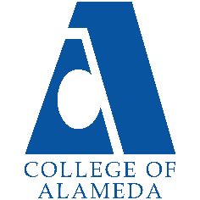
College of Alameda
2021-22 Annual Program Update – Umoja

Program Overview
Please provide your program’s mission statement and program’s learning outcomes
Umoja, (a Kiswahili word meaning unity) is a community and critical resource dedicated to
enhancing the cultural and educational experiences of African American and other students.
We believe that when the voices and histories of students are deliberately and intentionally
recognized, the opportunity for self-efficacy emerges and a foundation is formed for academic
success. Umoja actively serves and promotes student success for all students through a
curriculum and pedagogy responsive to the legacy of the African and African American
Diasporas.

List your program staff or faculty
Paula Armstead, Associate Dean
Stefanie Ulrey, English Faculty
Jerel McGiffert, Counselor
Jody Campbell, African American Studies Faculty
Khalilah Beal-Uribe, Mathematics Faculty
Betty Frias, Counselor

Your program goals have been listed from your most recent Program Review or APU. Provide an update on the status of the goal. Has your program achieved the goal? Have any of your goals been revised or any still in progress? Lastly, make sure to discuss which College or District goal your program goal aligns to.
If no program goals exist or if this is your first program review, work to create 2-3 goals and align them with a College or District goal.
Program Goal | To continue to develop and sustain the Umoja community at  College of Alameda.
Status: In-Progress or Complete? | In progress
Which college or district goal is aligned with your program goal? | • Advance COA teaching and learning  • Increase retention and persistence rates

Program Goal | To improve the retention rates from term to term of students enrolled in the Umoja community at College of Alameda.
Status: In-Progress or Complete? | In-progress
Which college or district goal is aligned with your program goal? | • Increase retention and persistence rates  • Advance COA teaching and learning

Program Goal | To increase student engagement in both on and off campus activities for students enrolled in the Umoja community.
Status: In-Progress or Complete? | In progress
Which college or district goal is aligned with your program goal? | • Increase community & educational partnerships  • Advance COA teaching and learning

List the essential functions of your department, program or unit and provide a description of how the unit aligns with the college mission.
Umoja actively serves and promotes student success for all students through a curriculum and pedagogy responsive to the legacy of the African and African American Diasporas. With the Umoja Community, students are our highest priority, and we promote student success for all students. We invest in building community as a means of empowering students. Through community building, we aim to create an environment that encourages students to be accountable to each other’s learning and spaces where students are supported and challenged. Umoja creates these spaces by offering a village space, cultural enrichment/personal development opportunities, intrusive counseling, and transfer-level courses taught by Umoja faculty.

Program Update
Using the dashboards, review and reflect upon the data for your program.
Course Completion and Retention Rates – Instructional Dashboard
Course Completion and Retention Rates – Student Services Dashboard
Enrollment Trends and Productivity Dashboard
Degrees and Certificates Dashboard

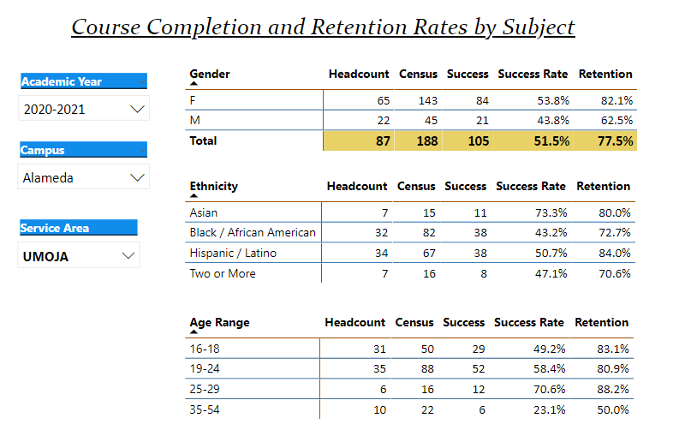

Describe any significant changes and discuss what the changes mean to your program. Consider whether performance gaps exist for disproportionality impacted students by using filters to disaggregate the data. Focus upon the most recent year and/or the years since your last comprehensive program review. Cite data points to support your reflection.
COVID-19 is pushing our team to reimagine the Umoja Community at COA. As a team, we attempted to be as available a possible for our students while our professors adjusted to the transition to the world of Zoom. For Spring 2021, our team late started all three of our courses To aide in our recruitment. Two of the three elected synchronous modality, while the third instructor insisted on teaching asynchronous with periodic Zoom meetings. In Fall 2021, all three Umoja courses were again, late started and two of the three Umoja professors opted to teach their classes asynchronously, while our Math instructed elected to offer a hybrid course. As the semester progressed, on-campus course student retention in the Math course decreased dramatically. Our AFRAM course was initially waitlisted but it was determined that the course was overfilled with false/fake students.

Building community is a high priority for Umoja at COA. Prior to the pandemic our dedicated space helped foster an environment that students wanted to come back to. Without that space and an on-campus presence, growing our program has been a challenge. We moved from a model where the access to our village space (and events) were primary connectors for Umoja students to shifting to making the virtual classrooms spaces were we created community. Proceeding with asynchronous classes reduces Umoja’s ability to foster community.

Having a Counselor/Coordinator that is a part time hire is a challenge. Helping to build a program requires an enormous amount of time from front-line staff. Twenty hours a week is not enough for the responsibilities and speaks to the district and campus’ desire, need, intention and commitment to support the growth of Umoja and to promote student success of African/African American students. Twenty hours a week for a Counselor/Coordinator does not set the program for up the long-term success. Providing in-reach and outreach is a challenge during normal conditions. Having a counselor/coordinator as a part time employee and the lack of full-time or part time counselor support compounds these challenges.

Describe the department's progress on Student Learning Outcomes (SLOs) and/or Service Area Outcomes (SAOs) since the last Program Review/APU.
Umoja’s three program goals identified on the last annual program review are as follows:
- To continue to develop and sustain the Umoja community at College of Alameda.
- To increase student engagement in both on and off campus activities for students enrolled in the Umoja community.
- To improve the retention rates from term to term of students enrolled in the Umoja community at College of Alameda.

COVID-19 pandemic continues to disrupt the momentum and traction that Umoja started to build at the College of Alameda. Much like community colleges across the county, Umoja has lost students. Some opted not to engage in online learning while others attempted to direct their time and energy to adapt to this new world and reality.

The Umoja Community continues to have to redesign itself to effectively serve students. Umoja’s focus is to continue building the community and provide events that encourage students to be more active at the college, foster community, and seek educational opportunities beyond College of Alameda. Again, without the physical space and presence, our efforts have been reduced.

To engage our students Umoja partnered with ACCESSO to engage students in knowledge-building Last semester the Umoja Community & ACCESO program partnered to offer a three-part Money Matters series. This semester, the Umoja and ACCESO programs continued their collaboration during the workshop, Financial Aid: PAST, PRESENT, and FUTURE and a workshop centered on budgeting and investing and topics included helping students understand credit and cryptocurrency.

Without an on campus presence and without in-person recruiting as an option, our team moved to contacting new and continuing African American COA applicants and students directly. To further our efforts to outreach. Umoja has attempted to partner with campus community partners. The Counselor/Coordinator connected with Oakland Unified School District, San Lorenzo high school and Alameda Unified School District administrators/counselors to promote Umoja classes and the Umoja Community at COA. Umoja’s late start, asynchronous courses are now a new recruitment tool that creates greater access for our dual enrollment students.

Describe the outcomes and accomplishments from previous year’s funded resource allocation request.
Brief description of funded request | Source (any additional award outside your base allocation) | Total Award Amount | Outcome/Accomplishment

Prioritized Resource Requests Summary
In the boxes below, please add resource requests for your program. If there are no resource requested, leave the boxes blank.
Resource Category | Description/Justification | Estimated Annual Salary Costs | Estimated Annual Benefits Costs | Total Estimated Cost
Personnel: Classified Staff

Personnel: Student Worker

Personnel: Part Time Faculty

Personnel: Full Time Faculty | Counselor/Coordinator  The UMOJA Coordinator assists African American and other student populations in transitioning into and connecting with the campus community, enhancing cultural and educational experiences, and increasing persistence and retention rates to achieve their educational goals. The assignment also involves providing educational, career, and personal counseling to students. The Counselor/Coordinator is expected to coordinate and facilitate a variety of workshops utilizing the UMOJA Community statewide practices for new and continuing UMOJA students, classroom presentations, outreach activities, evening and Saturday assignments. The Counselor will also provide referrals for students to other services and agencies. The UMOJA coordinator/counselor will also provide leadership in areas of student intervention strategies, enhancing student completions, teaching, career, and orientation to college courses. This assignment also includes curriculum development, participation in the shared governance process through work in normal professional activities, committee work, and student activities. | $85,598.32 - $112,512.02 | $49,115-$58,310 | $134-713-$170,822

Resource Category | Description/Justification | Total Estimated Cost
Professional Development: Department wide PD needed

Professional Development: Personal/Individual PD needed

Prioritized Resource Requests Summary - Continued

Resource Category | Description/Justification | Total Estimated Cost
Supplies: Software

Supplies: Books, Magazines, and/or Periodicals

Supplies: Instructional Supplies

Supplies: Non-Instructional Supplies

Supplies: Library Collections

Resource Category | Description/Justification | Total Estimated Cost
Technology & Equipment: New

Technology & Equipment: Replacement

Prioritized Resource Requests Summary - Continued

Resource Category | Description/Justification | Total Estimated Cost
Facilities: Classrooms

Facilities: Offices

Facilities: Labs

Facilities: Other

Resource Category | Description/Justification | Total Estimated Cost
Library: Library materials

Library: Library collections

Resource Category | Description/Justification | Total Estimated Cost
OTHER

