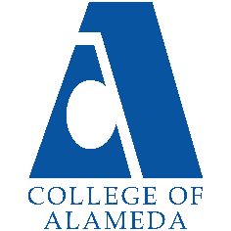
College of Alameda
2022-23 Annual Program Update – Admissions and Records

Program Overview
Please provide your program’s mission statement and program’s learning outcomes
The mission of College of Alameda is to serve the educational needs of its diverse community by providing comprehensive and flexible programs and resources that empower students to achieve their goals.

The mission of College of Alameda Student Services Division is committed to guiding, empowering, and inspiring students to achieve their academic, career and personal goals through a student centered and caring approach.

The Office of Admissions and Records is committed to the values by welcoming and admitting diverse population from the community we serve. We provide face to face and online service to ensure students continue their success with achieving their certificate or degree.

List your program staff or faculty
Dr. Amy Lee, Dean of Enrollment
Marcean Bryant , Senior Admissions & Records Specialist
Munira Ahmed, Admissions & Records Clerk
Michelle Chen , Part Time Evaluator
Sandi Rivera Cordova, Admissions & Records Evaluator
Connie Wu, Admissions & Records Evaluator

Your program goals have been listed from your most recent Program Review or APU. Provide an update on the status of the goal. Has your program achieved the goal? Have any of your goals been revised or any still in progress? Lastly, make sure to discuss which College or District goal your program goal aligns to.
If no program goals exist or if this is your first program review, work to create 2-3 goals and align them with a College or District goal.

Program Goal | A&R will continue to post and email priority registration dates and post important deadlines around campus such as add/drop with W and without Ws, and degree petition dates.
Status: In-Progress or Complete? | In progress
Which college or district goal is aligned with your program goal? | CoA’s goal is to strengthen data driven/informed decision making and to reduce loss of students prior to start of classes

Program Goal | Working with Institutional Research and Student Services at large to create a comprehensive student satisfaction survey to assess our services in the next year.
Status: In-Progress or Complete? | In progress
Which college or district goal is aligned with your program goal? | CoA’s goal to strengthen data driven/informed decision making.

List the essential functions of your department, program or unit and provide a description of how the unit aligns with the college mission.
Admissions & Records assist students with enrollment issues via online, due to Covid -19 we just started in-person service as of 8/2022. We also assist with application and enrollment issues, student can also submit enrollment verification, (faculty submits their census, and attendance verification to our office we assist faculty with add/drops , students submit residency questionnaire forms to request residency along with their supporting documents , we also assist with high school and adult education dual enrollment, enroll students from contract education courses. We also assist students with degree and certificate application

Program Update
Using the dashboards, review and reflect upon the data for your program.
Course Completion and Retention Rates – Instructional Dashboard
Course Completion and Retention Rates – Student Services Dashboard
Enrollment Trends and Productivity Dashboard
Degrees and Certificates Dashboard
Demographics dashboard link
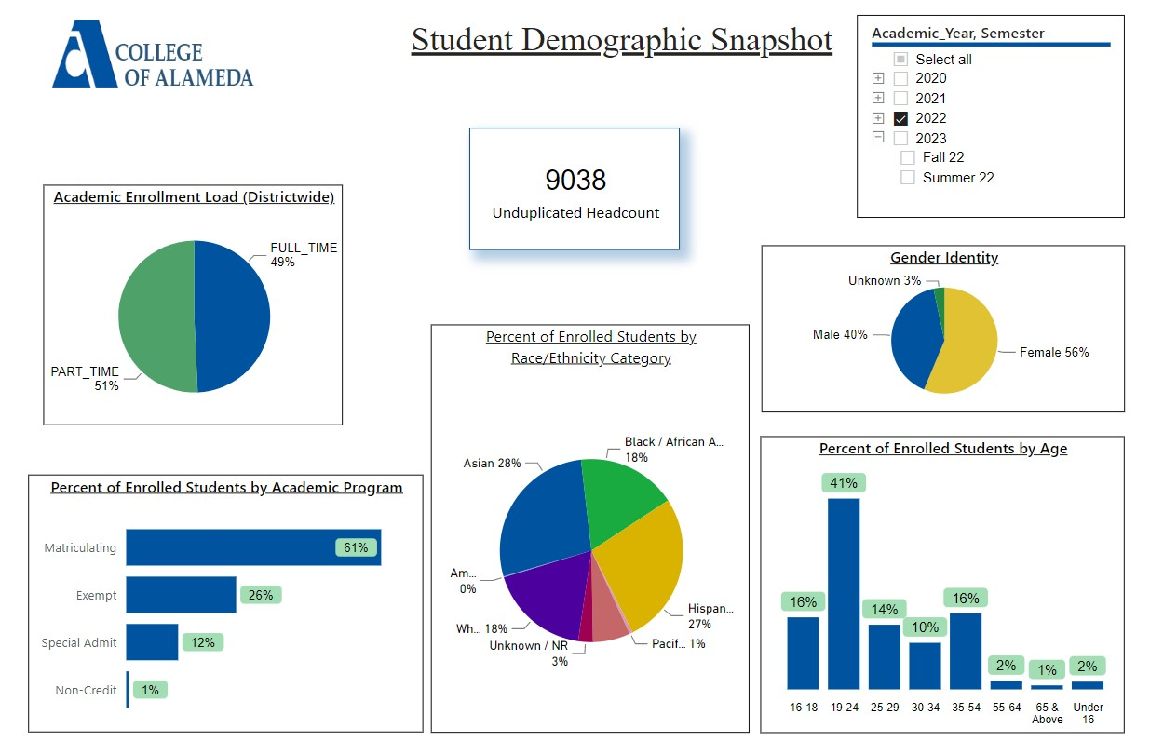

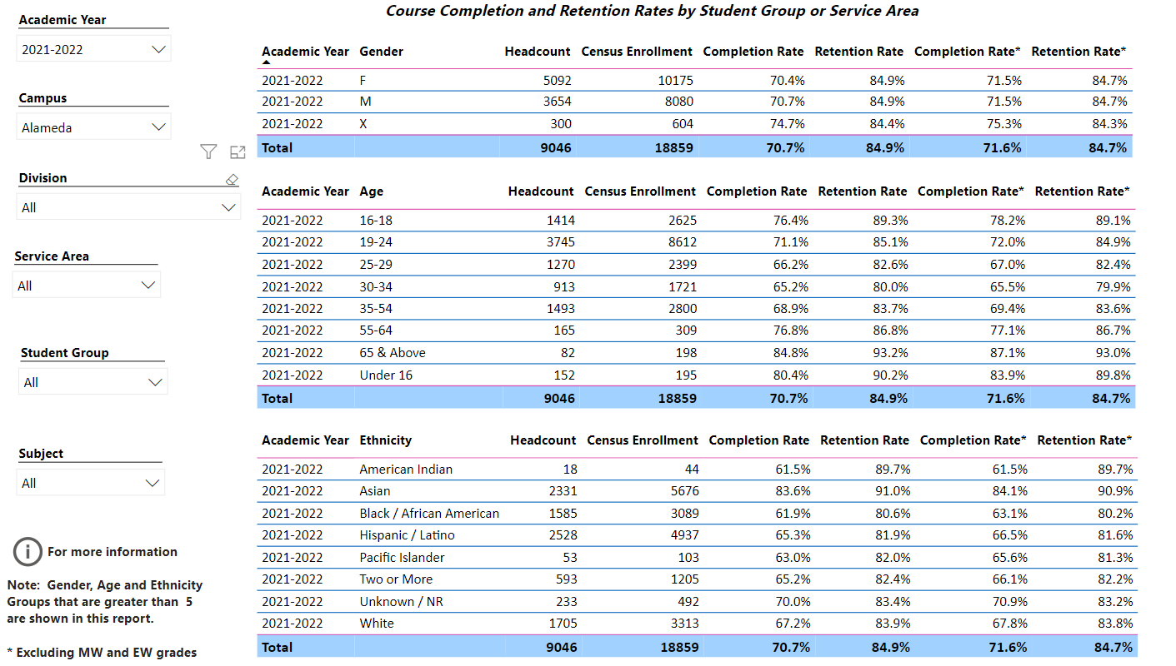
Describe any significant changes and discuss what the changes mean to your program. Consider whether performance gaps exist for disproportionality impacted students by using filters to disaggregate the data. Focus upon the most recent year and/or the years since your last comprehensive program review. Cite data points to support your reflection.
Admission and Records is such a critical operational unit which is providing day to day service in person as of 8/2022 and continuing to assist via online and zoom to students, staff, faculty and administrators, the unit is supporting all current efforts. In the future, A&R staff hopes to contribute to college wide conversations around students’ success. With COVID -19 we are now servicing students via email and zoom. Emails have increased immensely which required us to hire a part time evaluator. When the pandemic first hit, we referred students to District A&R to process emergency excused withdrawals. Since A&R is usually the first line of contact, we also refer students to appropriate resources.

Describe the department's progress on Student Learning Outcomes (SLOs) and/or Service Area Outcomes (SAOs) since the last Program Review/APU.

Describe the outcomes and accomplishments from previous year’s funded resource allocation request.
Brief description of funded request | Source (any additional award outside your base allocation) | Total Award Amount | Outcome/Accomplishment
N/A

Prioritized Resource Requests Summary
In the boxes below, please add resource requests for your program. If there are no resource requested, leave the boxes blank.
Resource Category | Description/Justification | Total Estimated Cost
Personnel: Classified Staff | Full time evaluator / pert time hourly
Personnel: Student Worker | 2 student workers
Personnel: Part Time Faculty
Personnel: Full Time Faculty

Resource Category | Description/Justification | Total Estimated Cost
Professional Development: Department wide PD needed | CACRO meeting (4) person | $1000.00
Professional Development: Personal/Individual PD needed
Supplies: Software
Supplies: Books, Magazines, and/or Periodicals
Supplies: Instructional
Supplies: Non-Instructional | Toner, office supplies
Supplies: Library Collections
Technology & Equipment | (3) laptops / we are currently borrowing laptops from different departments, (4) touchpad computers in all work stations
Library: Library materials/collections
Facilities: Classrooms/Labs
Facilities: Offices
Other

