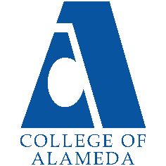
College of Alameda
2022-23 Annual Program Update – Career and Employment Center

Program Overview
Please provide your program’s mission statement and program’s learning outcomes
The CoA Career and Employment Center’s Mission Statement:
To transform lives by providing equitable career services, access and opportunities for students and the community.

List your program staff or faculty
Stefanie Bradshaw, Director of Workforce Systems (Career Center)
Tiffany Ghoddocuy, Intake Specialist Consultant
Miesha Clipper Willis, Career Coach Consultant
Haven of Hope, Career Coach Consultants
Tammy Arnold, Workshop Consultant

Your program goals have been listed from your most recent Program Review or APU. Provide an update on the status of the goal. Has your program achieved the goal? Have any of your goals been revised or any still in progress? Lastly, make sure to discuss which College or District goal your program goal aligns to.
If no program goals exist or if this is your first program review, work to create 2-3 goals and align them with a College or District goal.
Program Goal | Increase the number of students dual enrolled for WIOA career services through the CoA Career and Employment Center.
Status: In-Progress or Complete? | This goal is a continuation from last year now that we are back on campus. We also have projects with different departments on campus (MESA, CE, CalWorks, EOPS, Veterans) to support increased access to employment services for students.
Which college or district goal is aligned with your program goal? | PCCD Goal: Strengthen Accountability, Innovation, and Collaboration

Program Goal | Increase the number of employability workshops offered to students on campus to support job search preparation.
Status: In-Progress or Complete? | This goal is in progress. We will resume the Career Academy Workshop series for 22/23 program year and continue to track student participation.
Which college or district goal is aligned with your program goal? | PCCD Goal: Advance Student Access, Equity, and Success
List the essential functions of your department, program or unit and provide a description of how the unit aligns with the college mission.
The College of Alameda Career and Employment Center is funded externally by the Alameda County Workforce Development Board and internally by the college. Our career center allows us to serve both students and the community. Our department supports the college and district’s employment goal by providing key employability services for students on campus.

Program Update
Using the dashboards, review and reflect upon the data for your program.
Course Completion and Retention Rates – Instructional Dashboard
Course Completion and Retention Rates – Student Services Dashboard
Enrollment Trends and Productivity Dashboard
Degrees and Certificates Dashboard
Demographics dashboard link
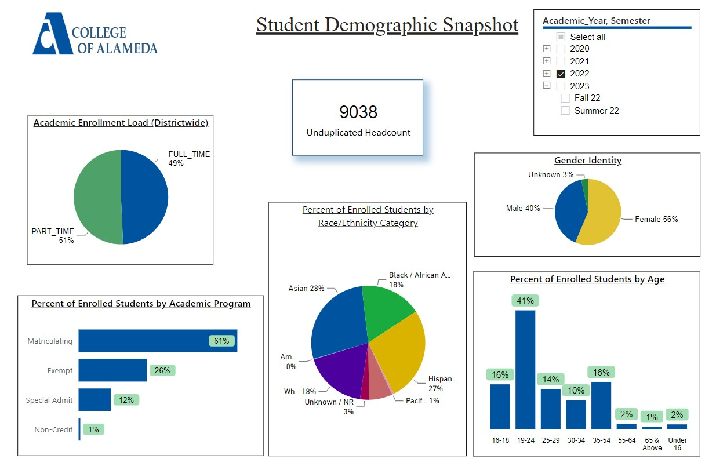

Describe any significant changes and discuss what the changes mean to your program. Consider whether performance gaps exist for disproportionality impacted students by using filters to disaggregate the data. Focus upon the most recent year and/or the years since your last comprehensive program review. Cite data points to support your reflection.
N/A

Describe the department's progress on Student Learning Outcomes (SLOs) and/or Service Area Outcomes (SAOs) since the last Program Review/APU.
N/A

Describe the outcomes and accomplishments from previous year’s funded resource allocation request.
Describe the outcomes and accomplishments from previous year’s funded resource allocation request.
Brief description of funded request | Source (any additional award outside your base allocation) | Total Award Amount | Outcome/Accomplishment
N/A

Prioritized Resource Requests Summary
In the boxes below, please add resource requests for your program. If there are no resource requested, leave the boxes blank.
Resource Category | Description/Justification | Total Estimated Cost
Personnel: Classified Staff | Staff Assistant (position charged to college not grant)
Personnel: Student Worker
Personnel: Part Time Faculty
Personnel: Full Time Faculty

Resource Category | Description/Justification | Total Estimated Cost
Professional Development: Department wide PD needed
Professional Development: Personal/Individual PD needed | Professional Development for Director of Workforce to stay current and relevant with industry changes | $2,500
Supplies: Software
Supplies: Books, Magazines, and/or Periodicals
Supplies: Instructional
Supplies: Non-Instructional
Supplies: Library Collections
Technology & Equipment
Library: Library materials/collections
Facilities: Classrooms/Labs
Facilities: Offices
Other

