**College of Alameda**

2022-23 Annual Program Update – **Financial Aid**

**Program Overview**

Please provide your program’s mission statement and program’s learning outcomes

|  |
| --- |
| The purpose of College of Alameda Financial Aid department is to provide equitable assistance to all students who apply for financial aid (grants, loans, scholarships, work-study) that will enable them to obtain a certificate, a degree or to transfer to a four-year college. Our primary purpose is to ensure that all students have the opportunity to access and achieve their educational goals at College of Alameda.  The Financial Aid department recognizes and believes in equity through removing financial barriers for those farthest from opportunity. Therefore, we do not believe that students should be denied the opportunity to pursue a college education due to limited family resource contributions.    It is essential that the Financial Aid department provide assistance to address disparate educational needs through providing financial aid funds to assist those in greatest need to overcome financial barriers and achieve their educational goals. |

List your program staff or faculty

|  |
| --- |
| Jackie Vo – Financial Aid Officer  Miriam Fernandez – Financial Aid Specialist  Jiayu He – Financial Aid Specialist  Stephanie Grigg – Financial Aid Specialist  Laura Aguilar – Financial Aid Specialist  Qiman (Emma) Zheng – Financial Aid Placement Assistant (Hourly) |

Your program goals have been listed from your most recent Program Review or APU. Provide an update on the status of the goal. Has your program achieved the goal? Have any of your goals been revised or any still in progress? Lastly, make sure to discuss which College or District goal your program goal aligns to.

*If no program goals exist or if this is your first program review, work to create 2-3 goals and align them with a College or District goal.*

|  |  |
| --- | --- |
| **Program Goal** | Increase student FAFSA/Dream Act completion rate by 3% at College of Alameda |
| Status: In-Progress or Complete? | In-Progress |
| Which college or district goal is aligned with your program goal? | Increase access to college programs  Advance Student Access, Equity, and Success.  Increase retention and persistence rate  SCFF Student Centered Funding Formula |

|  |  |
| --- | --- |
| **Program Goal** | Increase the number of Pell recipients by 3% |
| Status: In-Progress or Complete? | In-Progress |
| Which college or district goal is aligned with your program goal? | SCFF Student Centered Funding Formula  Advance Student Access, Equity, and Success  Increase retention and persistence rate |

|  |  |
| --- | --- |
| **Program Goal** | Closing equity gaps for disproportionate groups through more financial aid outreach and in-reach activities twice a month |
| Status: In-Progress or Complete? | In-progress |
| Which college or district goal is aligned with your program goal? | SCFF Student Centered Funding Formula  Advance student success  Persistence rate |

**List the essential functions of your department, program or unit and provide a description of how the unit aligns with the college mission.**

|  |
| --- |
| The financial aid office provides financial aid dollars and services to our students in order to support them through their educational journey at College of Alameda. The essential services include student assistance in the student financial aid application process, awarding students aid, and outreaching to our low-income student population. In addition, the financial aid office is responsible in managing a variety of local, state, and federal aid programs. Along with providing access to these aid programs, the financial aid office must adhere to compliance regulations in order to continue administrating these programs. Lastly, the financial aid office works with other departments and programs within the college to collaborate to increase aid recipients and dollar amounts to students with financial need, advance student success and persistence. |

**Program Update**

Using the dashboards, review and reflect upon the data for your program.

[**Course Completion and Retention Rates – Instructional Dashboard**](https://app.powerbi.com/view?r=eyJrIjoiNjc2MDhiNTEtNTJhZi00MDM0LTk5NDItNTRiY2EzMGI1NTZiIiwidCI6ImVlYTE2YTE2LTQ4YWYtNDc3Yi05MTEzLTA1YjFjMDExMjNmZiIsImMiOjZ9&pageName=ReportSection86d6f65e2fb41a73da4d)

[**Course Completion and Retention Rates – Student Services Dashboard**](https://app.powerbi.com/view?r=eyJrIjoiNjk3NDJjOTItNzI5MS00MDhjLWJhN2EtZjcxNzU4OTBiZDBjIiwidCI6ImVlYTE2YTE2LTQ4YWYtNDc3Yi05MTEzLTA1YjFjMDExMjNmZiIsImMiOjZ9&pageName=ReportSection86d6f65e2fb41a73da4d)

[**Enrollment Trends and Productivity Dashboard**](https://app.powerbi.com/view?r=eyJrIjoiNWJlOWZmYTEtNTY0MC00MDhkLWE5OTAtYmJjZjIxNzJiNWViIiwidCI6ImVlYTE2YTE2LTQ4YWYtNDc3Yi05MTEzLTA1YjFjMDExMjNmZiIsImMiOjZ9&pageName=ReportSection86d6f65e2fb41a73da4d)

[**Degrees and Certificates Dashboard**](https://app.powerbi.com/view?r=eyJrIjoiZjU2M2M5MzItOTcwZi00Y2U1LWJmODUtYTc0YjlhZGI2ZDhjIiwidCI6ImVlYTE2YTE2LTQ4YWYtNDc3Yi05MTEzLTA1YjFjMDExMjNmZiIsImMiOjZ9&pageName=ReportSectionde32556e136b0a8caccd)

[**Demographics dashboard link**](https://app.powerbi.com/view?r=eyJrIjoiMzVhNGU3YzAtNTIyNy00ZDZmLWIyYzMtYWIzMzllMGViZDQ5IiwidCI6ImVlYTE2YTE2LTQ4YWYtNDc3Yi05MTEzLTA1YjFjMDExMjNmZiIsImMiOjZ9&pageName=ReportSectionb4e116c96a753400a00c)

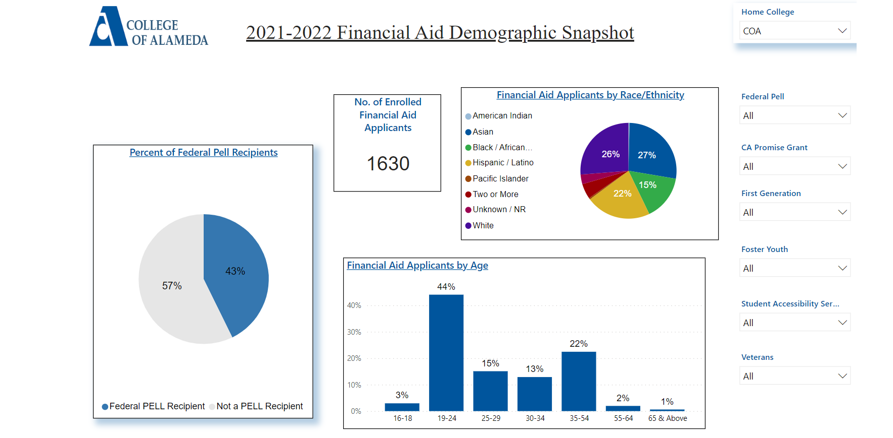

Describe any significant changes and discuss what the changes mean to your program. Consider whether performance gaps exist for disproportionality-impacted students by using filters to disaggregate the data. Focus upon the most recent year and/or the years since your last comprehensive program review. Cite data points to support your reflection.

|  |
| --- |
| 1. Due to the pandemic, the financial aid office has adapted our services to meet the needs of our students. To meet the demand for both in-person and online service options, we offer hybrid services to students as outlined below  * We have reverted to pre-pandemic in-person services and hours. We are open on Mondays until 7:00PM and daily until 4:30PM. Along with in-person availability, we are using a virtual front desk to provide one-on-one service to students from 9-4:30 every day during peak registration and two times a week afterwards. We are utilizing zoom platform to work directly with students regarding financial aid. * We have launched a live chat service on our financial aid website that allows students to chat and ask questions to an active COA financial aid employee to answer questions regarding the financial aid process * In collaboration with the student services departments, we participated in “Rock Enroll” and “Tasty Tuesday” events on campus to boost engagement with students and to assist in enrollment and financial aid application completion. * Hosted three financial aid in-person on-campus events this past year. * Reached out to students via text messaging for FAFSA or Dream completion, file completion, enrollment in late-start coursework and promotion of upcoming financial aid events. * Provide both in-person and virtual financial aid workshops once a week.  1. Over the past few years, the department of education has selected a higher volume of students for V4 or V5 verification. This selection requires students to prove identity and HS completion status. This federal requirement requires students to come in-person to the office to submit documentation. This requirement has proven to be burdensome to the student and is a barrier to access financial aid dollars. Our FA award data shows this as only 11 students selected for V4 or V5 verification submitted documentation for the 2021-2022 year and received financial aid. 2. At College of Alameda, our Pell grant headcount dropped from 930 in 2020-2021 to 708 in 2021-2022. Part of that is due to the correlation in the decline of student enrollment. In addition, part of the low aid recipient count was due to PeopleSoft system configuration issues. Over the past aid year, we have worked closely with the District financial aid team to address system errors and worked on enhancements that streamline financial aid application processing to automate processes that reduce manual workload for staff and remove unnecessary barriers to students. |

Describe the department's progress on Student Learning Outcomes (SLOs) and/or Service Area Outcomes (SAOs) since the last Program Review/APU.

|  |
| --- |
| In our last submitted SLO, we assessed the success rate of students’ who submitted a financial aid appeal. The assessment of financial aid appeal students measured their term success rate based on the standards of a term GPA of 2.0 and term completion rate of 66.7% of all taken coursework for the term.  The results of the assessment show a 77.14% term success rate for students who submitted a FA appeal. The high success rate might be attributed to several key factors. Students who submit FA appeals must engage with an academic counselor to discuss the student’s situation and map out the student educational path to completion of degree/certificate/transfer. In addition, students are required to take an online satisfactory academic progress course to understand the terms of academic progress as it relates to financial aid eligibility. After taking the online session, students are then required to complete a SAP quiz that educates them on required academic performance metrics. The level of engagement from the student and support provided by counseling and financial aid can be attributed to higher student success rates. |

Describe the outcomes and accomplishments from previous year’s funded resource allocation request.

|  |  |  |  |
| --- | --- | --- | --- |
| **Brief description of funded request** | **Source (any additional award outside your base allocation)** | **Total Award Amount** | **Outcome/Accomplishment** |
| Professional Development Training |  | $5000 | Staff were provided training from outside organizations such as NASFAA, the State Chancellors Office and the California Student Aid Commission (CSAC) |
|  |  |  |  |
|  |  |  |  |

**Prioritized Resource Requests Summary**

In the boxes below, please add resource requests for your program. If there are no resource requested, leave the boxes blank.

|  |  |  |
| --- | --- | --- |
| **Resource Category** | **Description/Justification** | **Total Estimated Cost** |
| Personnel: Classified Staff |  |  |
| Personnel: Student Worker |  |  |
| Personnel: Part Time Faculty |  |  |
| Personnel: Full Time Faculty |  |  |

|  |  |  |
| --- | --- | --- |
| **Resource Category** | **Description/Justification** | **Total Estimated Cost** |
| Professional Development: Department wide PD needed | Customer Service Training – Equity Focused | $3000 |
| Professional Development: Personal/Individual PD needed | NASFAA Leadership Conference | $4000 |
| Supplies: Software |  |  |
| Supplies: Books, Magazines, and/or Periodicals |  |  |
| Supplies: Instructional | KAHOOT subscription | $300 |
| Supplies: Non-Instructional |  |  |
| Supplies: Library Collections |  |  |
| Technology & Equipment | Document Imaging System. System in which students can securely upload FA documents and is integrated with our SIS | $25,000/year? |
| Library: Library materials/collections |  |  |
| Facilities: Classrooms/Labs |  |  |
| Facilities: Offices | Conference room for student services department to hold staff meetings |  |
| Other |  |  |