
College of Alameda
2022-23 Annual Program Update – Health Services

Program Overview
Please provide your program’s mission statement and program’s learning outcomes
College of Alameda is committed to furthering the equality of the educational opportunity and success for all students by providing access to health services which promote the physical, emotional, social, and spiritual well-being of its students. This well-being contributes to the educational aim of our community colleges by promoting student retention and academic success.

List your program staff or faculty
Lisa Sawadogo, Health Services Coordinator – full-time faculty
Erica Gibbons, Associate Marriage & Family Therapist – part-time faculty diversity internship
Reynaldo Vargas, MFT Trainee – part-time volunteer (small stipend)
Jasmine Sharma, MFT Trainee – part-time volunteer (small stipend)
Jay Conui, MFT Trainee – part-time volunteer (small stipend)

Contracted community health center: Roots Clinic
Due to COVID-19 and staffing shortages, the district made the decision to provide medical services through the Roots Clinic at Laney College for all enrolled Peralta students. All students have access to the Peralta Wellness Center at Laney College: Monday – Thursday from 8:30pm – 4:30pm in-person and by phone.

*Even though medical services are being offered in-person, there is still no acupuncture or massage services being offered at this time.

Your program goals have been listed from your most recent Program Review or APU. Provide an update on the status of the goal. Has your program achieved the goal? Have any of your goals been revised or any still in progress? Lastly, make sure to discuss which College or District goal your program goal aligns to.
If no program goals exist or if this is your first program review, work to create 2-3 goals and align them with a College or District goal.
Program Goal | Update or maintain service area outcomes annually and meet or exceed all service area outcome measures for health services.
Status: In-Progress or Complete? | Complete
Which college or district goal is aligned with your program goal? | College: Strengthen data driven/informed decision making  District: Develop and manage resources to advance our mission

Program Goal | Assess for success at providing culturally sensitive services for students by surveying students about their experience with wellness services.
Status: In-Progress or Complete? | Complete
Which college or district goal is aligned with your program goal? | College: Increase retention and persistence rates  District: Advance student access, equity, and success

List the essential functions of your department, program or unit and provide a description of how the unit aligns with the college mission.
The essential functions of wellness services are to provide students with access to services which promote physical, emotional, social, and spiritual well-being. Our department provides mental health wellness support for students by providing individual counseling sessions, support groups, crisis intervention, consultation, referrals, and campus wide workshops and training.

The medical services provided through our community clinic partner Roots include, but are not limited to: first aid, pregnancy testing, health education, smoking cessation, health and wellness counseling, triage, flu shots, COVID-19 testing, health insurance counseling, and referrals to off-site facilities.

Program Update
Using the dashboards, review and reflect upon the data for your program.
Course Completion and Retention Rates – Instructional Dashboard
Course Completion and Retention Rates – Student Services Dashboard
Enrollment Trends and Productivity Dashboard
Degrees and Certificates Dashboard
Demographics dashboard link
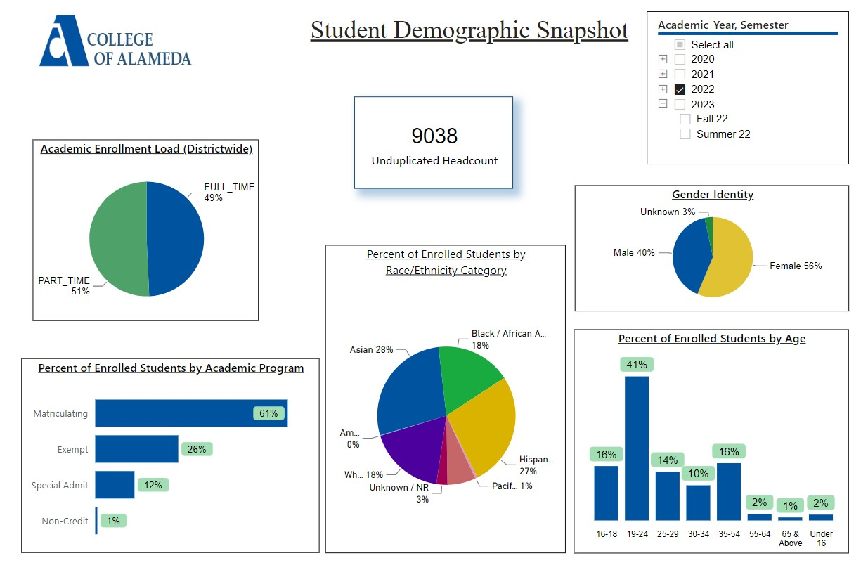
Describe any significant changes and discuss what the changes mean to your program. Consider whether performance gaps exist for disproportionality impacted students by using filters to disaggregate the data. Focus upon the most recent year and/or the years since your last comprehensive program review. Cite data points to support your reflection.
Request was made for the data and will be updated when the data is provided.

Describe the department's progress on Student Learning Outcomes (SLOs) and/or Service Area Outcomes (SAOs) since the last Program Review/APU.

1.Healthier Decisions: Students will be able to utilize the necessary information, resources, and options available for them to make sound educational, emotional, and health-related lifelong decisions. (ILO 1 Problem Solving & Decision Making; ILO 4 Interpersonal Skills; ILO 5 Civic Responsibility)
2. Improved coping: Students will be able to identify healthier coping skills and strategies for maintaining wellness, managing stress, managing anger, or meeting personal goals.
(ILO 1 Problem Solving & Decision Making; ILO 4 Interpersonal Skills; ILO 5 Civic Responsibility)

Data for fall 2022 and spring 2023 will be gathered at the completion of each semester and updates will be provided for the next program review. An update from last 2021-2022 academic year’s program review is the data that was gathered from students' experience in individual counseling sessions that came out in spring 2022. Due to COVID-19 and most mental health services being remote, surveys were sent out through email to a total of 60 students who participated in mental health counseling appointments. There was a total of 13 responses, which included the following information connected to the student learning outcomes:

For the survey question:
“Do you feel that you are better able to make healthier educational, emotional, or health related decisions after participating in counseling?”

-10 students reported “yes”
- 2 students reported “maybe”
-1 student reported “no”

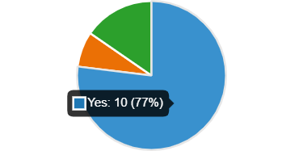

For the survey question:
“Do you feel that you are better able to cope with problems after participating in counseling?”
-11 students reported “yes”
- 1 student reported “maybe”
- 1 student reported “no”

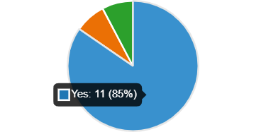

Describe the outcomes and accomplishments from previous year’s funded resource allocation request.
Brief description of funded request | Source (any additional award outside your base allocation) | Total Award Amount | Outcome/Accomplishment
Stipends for the MFT Trainees and FDIP |  | FDIP - $36,000  Trainees -  $12,000 | Able to onboard 3 MFT Trainees and a part-time Faculty Diversity Internship Program Associate Marriage and Family Therapist to meet increased demand for mental health services.
Art supplies |  | $250 | Able to buy art supplies that supported wellness day events and workshops that students benefited from.
11-month contract for Health Services Coordinator |  | $115,000 | Allowed for preparation for internship orientation, on-call supervision of interns on Fridays, and planning/organizing before the onset of each semester.

Prioritized Resource Requests Summary
In the boxes below, please add resource requests for your program. If there are no resources requested, leave the boxes blank.
Resource Category | Description/Justification | Total Estimated Cost
Personnel: Classified Staff
Personnel: Student Worker | 1 - 2 student workers – there is a need to make progress with alcohol and drug prevention on campus. Student workers could create a campaign, do outreach, and plan one speaker or event focused on this topic. There is also a need for more outreach to classrooms and providing an overview of mental health/health services along with wellness events that are taking place. | Work/Study
Personnel: Part Time Faculty | 2 – FDIP (Faculty Diversity Internship Program – Ongoing need for BIPOC and LGBTQIA+ counselors to support a diverse campus community and provide individual and group counseling support. | $72,000
Personnel: Full Time Faculty | 1 – Licensed Mental Health Counselor Faculty – Consistent increase in severe mental health needs of students and need for experienced licensed therapist to assist with crisis intervention, ongoing support for students and coverage for mental health counseling appointment access for students Monday – Friday. There is also a need for a licensed therapist to cover summer hours and supervision of interns.  11-month contract for current Full-Time Health Services Coordinator – Recruiting interns who provide most of the direct services for students takes a lot of time, as well as planning and preparing for the interns' orientation and training calendar. | $117,000  $8,000

Resource Category | Description/Justification | Total Estimated Cost
Professional Development: Department wide PD needed | Graduate level MFT Trainees and recent master’s level graduates provide most of the direct individual counseling sessions for students and need to be trained on up-to-date and relevant best practices in the field including, but not limited to: law & ethics, crisis intervention, cultural sensitivity, alcohol and drug abuse intervention, and trauma | $1500
Professional Development: Personal/Individual PD needed | Licensed Professional Clinical Counselors are required to obtain 36 hours of continuing education every two years in order to maintain the license and continue the ability to supervise MFT/PCC Trainees/Interns. Need for EMDR training and consultation to provide much needed support for students dealing with trauma concerns. | $3650
Supplies: Software
Supplies: Books, Magazines, and/or Periodicals
Supplies: Instructional | Colored copies of flyers for events and wellness services information | $200
Supplies: Non-Instructional | There is a need for updated signage for the F-building | $200
Supplies: Library Collections
Technology & Equipment
Library: Library materials/collections
Facilities: Classrooms/Labs
Facilities: Offices | New lamps for offices since some of the staff are sensitive to fluorescent overhead lights | $300
Other

