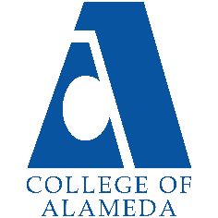
College of Alameda
2022-23 Program Review – Student Accessibility Services

Lead Author:
Rachel Goodwin, SAS Coordinator/Counselor
rgoodwin@peralta.edu

Program Overview
Provide your service area’s mission statement. If your service area does not have a mission statement, what is your timeline for creating a mission statement?
The mission of Student Accessibility Services (SAS) is to provide exemplary support services, instruction and access to students with disabilities. SAS supports students with disabilities in instructionally related activities consistent with the mission, vision, and values of the College of Alameda and in compliance with federal and state laws. With equal access as its hallmark, the faculty and staff of SAS are committed to the following:
- Opportunity: To ensure equal educational opportunities to students with disabilities who have the potential for achieving academic and vocational goals consistent with a community college program.
- Empowerment: To empower students with disabilities to achieve independence and integration leading to maximum participation in the college and the community.
- Awareness: To provide information and support to College of Alameda employees and students in carrying out the institution’s responsibility to students with disabilities.
List your program faculty and/or staff

Full Time

Michelle Custino, Adapted Computer Technician (1.0 FTE classified professional)
Nadeesha Dias, SAS Counselor (1.0 FTE Faculty)
Rachel Goodwin, SAS Coordinator/Counselor (1.0 FTE faculty)
Aurora Laniohan, SAS Data Specialist/WAIII Assistant (hourly full-time classified professional)
Denise Maffett, SAS Staff Assistant (1.0 FTE classified professional)
Jacinda Marshall, SAS Counselor (1.0 FTE faculty)
Lynn Rex, Learning Disability Specialist/Instructor (1.0 FTE faculty)
Belinda Van Buhler, Support Services Specialist (hourly full-time classified professional)
Wanda Wright, Instructional Assistant/Educational Coach, C2C, Contract Ed and SAS (hourly full-time classified professional)

Part Time
Michelle Custino, Alternate Media Specialist (overtime extra assignment classified professional)
Maria Brown, Instructor for contract education (hourly part-time faculty)
Phyllis Tappe, Instructor for SAS (Cognitive Skills) & College to Career (hourly part-time)
Nancy Freed, Instructional Aide Learning Skills Program (hourly part-time classified professional)

Geraldine Hasse, Instructional Aide Learning Skills Program (hourly part-time classified professional)
Van Tran, Instructional Aide Learning Skills Program (hourly part-time classified professional)
Vy Tran, Instructional Aide Learning Skills Program (hourly part-time classified professional)
Student Workers (hired as note takers for SAS students, and as lab and office assistants)
Sign Language Interpreters (variable number and hours based on student accommodation needs)

VACANT
0.5 FTE faculty: Assistive Technology Instructor

List the essential functions of your department, program or unit and provide a description of how the unit aligns with the college mission.
The essential function of SAS is to provide the services, academic adjustments and auxiliary aids necessary to support the success of students with disabilities, and to meet the requirements of federal and state non-discrimination laws. SAS supports College of Alameda in complying with Sections 504 and 508 of the federal Rehabilitation Act, the Americans with Disabilities Act (ADA), the Americans with Disabilities Amendment Act (ADAA) and State Government Code Sections 11135-11139.5.

SAS provides direct services to nearly 600 students in a typical year. In addition, SAS is a resource to faculty and staff and offers training on strategies to increase success of both students and instructors. SAS is proactive and works with COA faculty, classified staff, and administrators to identify and remove potential institutional and instructional barriers to student success.

In addition to the services, auxiliary aids, and academic adjustments provided by SAS, SAS offers specialized instruction through Educational Assistance Classes (EACs) that support students in their general academic courses (Learning Skills and Computer Access classes) and courses that develop/rehabilitate cognitive skills for students with brain injuries, learning disabilities and ADHD. SAS also supports the operation of the grant-funded College to Career program and contract education programs that support individuals with disabilities who are transitioning to adulthood and/or preparing for competitive independent employment. SAS, in partnership with Alameda Unified School District, offers contract education classes to students with disabilities enrolled in AUSD’s transition program for youth ages 18-21 who are still affiliated with AUSD. These EACs focus on the skills needed to transition to independent living, and possibly prepare for entry into special programs or general classes at the College of Alameda.

These SAS program directly aligns with and supports the mission of College of Alameda, serving “the educational needs of its diverse community by providing comprehensive and flexible programs and resources that empower students to achieve their goals”.

List your program goals from your most recent Program Review or APU. Then, provide an update on the status of the goal. Has your program achieved the goal? Have any of your goals been revised or any still in progress? Lastly, make sure to discuss which College or District goal your program goal aligns to: Alignment of Goals
If no program goals exist or if this is your first program review, create 2-3 goals and align them with a College or District goal.
Program Goal | SAS will work with the District to complete the implementation of Accessible Information Management (AIM), a district-wide SAS file and accommodation management system which will serve to: Improve remote access for SAS faculty and classified professionals to student SAS files, increase the fluidity with which students’ accommodations can be provided, improve the student experience for students enrolled at multiple PCCD campuses.
Status: In-Progress or Complete? | In progress – Instructor notification letters and student file elements are enabled; instructor portals. Alternate Media components, notetaking component and several other essential elements are not yet active.
Which college or district goal is aligned with your program goal? | PCCD Goals  A - Advance Student Access, Equity, and Success  C- Build Programs of Distinction  D-Strengthen Accountability, Innovation and Collaboration  COA Goals  Increase access to college programs/coursework through collaboration with other PCCD colleges  Advance COA Teaching and learning.  Reduce loss of students prior to the start of classes.  Strengthen data-driven/informed decision making.

Program Goal | SAS seeks to hire sufficient permanent classified professional staff to meet the program’s staffing needs. To date SAS has had to rely on long-term, full-time, hourly classified staff. These positions deserve the respect and security of permanency. SAS relies on these staff members for the provision of mandated MIS data reporting, student accommodations, and instructional faculty support.
Status: In-Progress or Complete? | In-Progress
Which college or district goal is aligned with your program goal? | PCCD Goals  A – Advance Student Access, Equity, and Success  D– Strengthen Accountability, Innovation, and Collaboration  E – Develop and Manage Resources to Advance Our Mission  COA Goals  Advance COA teaching and learning.  Reduce loss of students prior to the start of classes.  Strengthen data-driven/informed decision making.

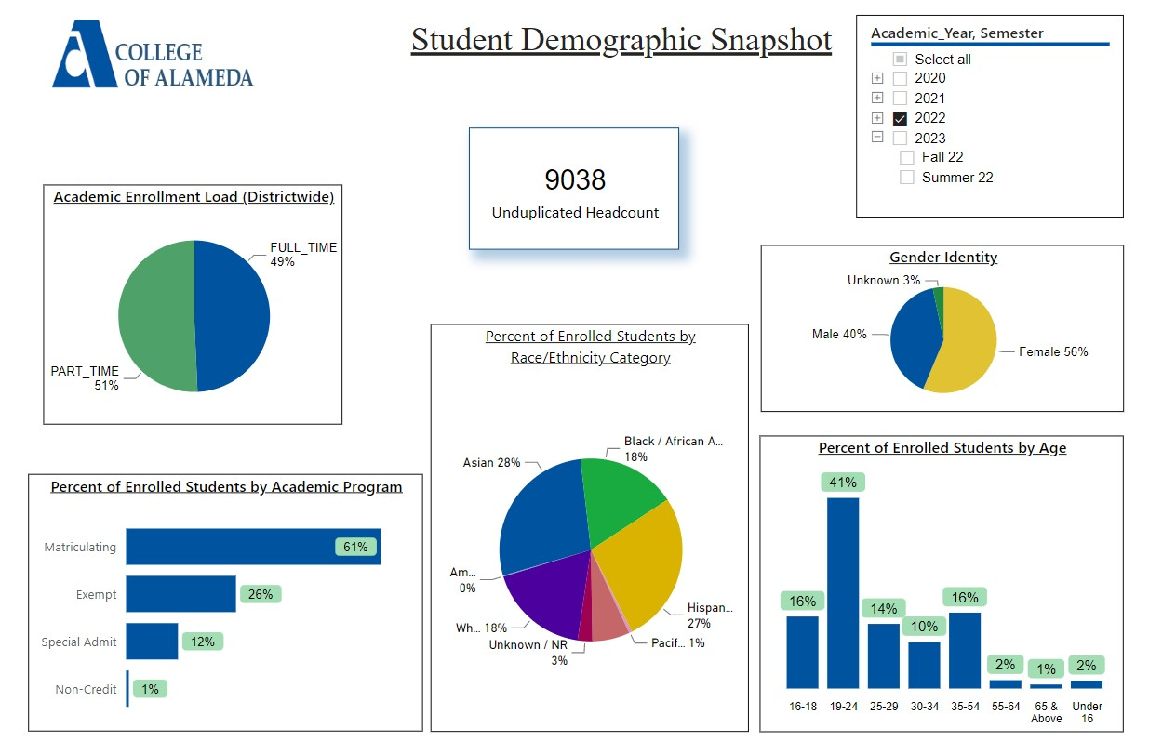
Demographics dashboard link
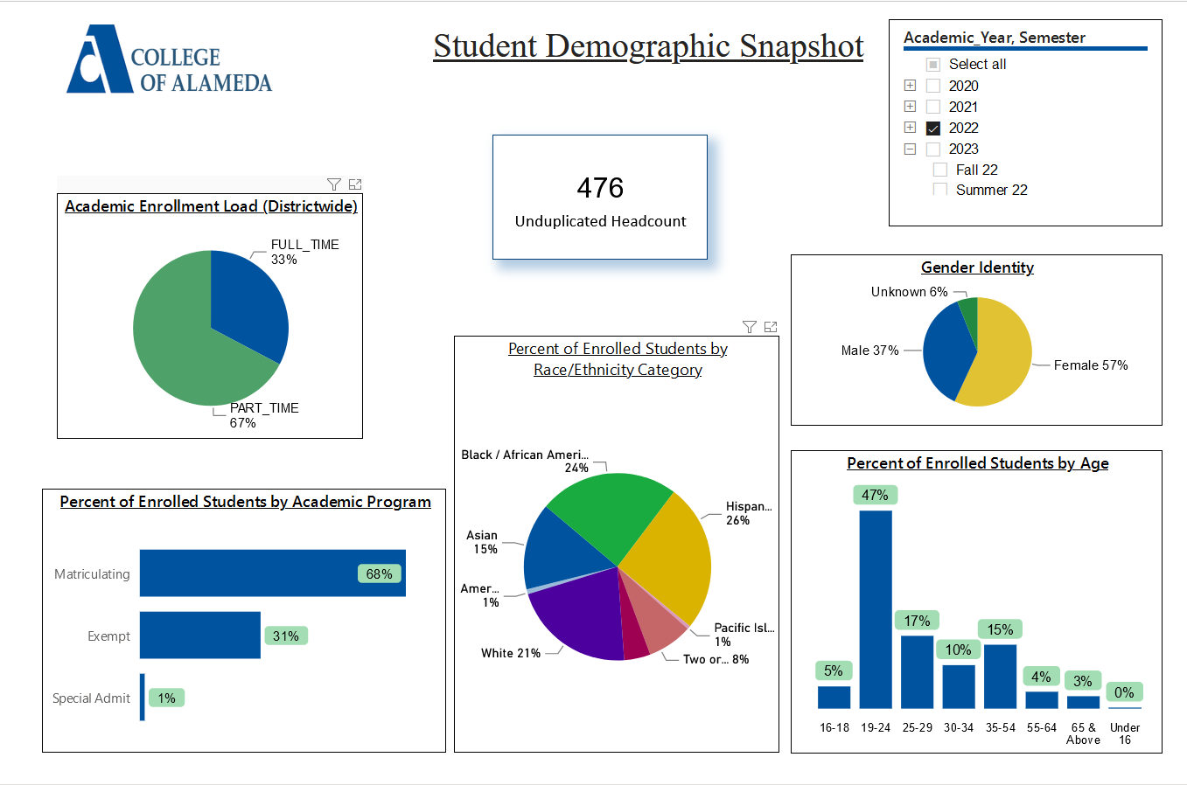
Do the students served by your service area differ from the College's overall student population? If so, elaborate on how the service area is identifying and addressing the needs of the student population
The students served by SAS largely reflect those of the College’s overall student population. SAS serve black/African American students in a greater percentage, and Asian students in a smaller percentage than in the College’s overall student population. A greater percentage of SAS students enroll part-time versus the College’s overall student population, 67% of SAS students versus 51% overall. While SAS encourages students to take full-time course loads when appropriate, the nature of disability often necessitates part-time enrollment to support successful outcomes.

Which groups of students are underrepresented among those who received services, particularly by race/ethnicity and gender?
Asian students are underrepresented among those who receive SAS services. 15% of the SAS population identifies as Asian versus 28% of the College’s overall student population.

Describe how external factors such as advisory board recommendations, federal or state mandates, changing demographics, and/or COVID-19 has impacted the support services your program or administrative unit provides.
How has your program addressed these changes or challenges to ensure students are supported and can continue to work towards meeting their educational goals? Consider implications for outreach, marketing, and/or communication, for example.
Student Accessibility Services (SAS) student populations fluctuate and the changes in enrollment of students with disabilities may be due to numerous factors. While the current data dashboards do not yet reflect changes in population for 2022-23, SAS saw a significant drop in student enrollment since the onset of the COVID-19 pandemic. Fall 2019 SAS served 405 students, in fall 2020 SAS served 254 students, in fall 2021 SAS service 266 students, to date in fall 2022 SAS has served 283 students. Much of this drop is likely due to the change in instructional modality to distance learning and the many impacts that the COVID-19 pandemic has had on our students.

Over the past four years SAS unduplicated student count has dropped from 582 in 2018-19 to 399 in 2021-22. The pandemic, teaching modality, reduced availability of in-person instruction and supports, and interplay of these factors with the specific nature of students’ disabilities has impacted student participation in SAS, a trend that is reflected state-wide at Community Colleges.

Comparing available overall College of Alameda student completion and retention rates to those of SAS students, students enrolled in SAS have completion rates which somewhat lower than those of the campus population as a whole. SAS engages in the campus-wide planning to improve course completion and retention.

SAS personnel continue to participate in the implementation process for Guided Pathways, as well as engaged in discussions about the role of SAS in response to AB705 and AB1705 implementation.

Implementation of AB 705 and AB 1705 may compound the need for added Educational Assistance classes and additional supports as students are compelled to take college and transfer level courses in English and math, particularly with the reduction and/or elimination of remedial coursework. Many students with disabilities arrive at the college without adequate academic preparation, having had their high school curriculum modified significantly. These students will require greater support in order to succeed in college coursework given that college work is not modified, truncated, or altered in the manner that much of their prior K-12 work may have been.

SAS has also experienced a significant challenge in identifying and hiring qualified Sign Language Interpreters. In the wake of AB 5, a state law that required companies statewide to reclassify/hire independent contractors as employees, many ASL interpreters have left the field. This statewide shortage, in conjunction with PCCD’s low pay rate for hourly interpreters versus the industry standard, has severely negatively impacted Deaf students in need of interpreting services. While SAS has sought ICC’s with agencies, PCCD processes for ICC approval and worker shortages within those agencies, continues to present challenges when ASL interpreting is needed for basic communication access in COA classes.

SAS provides class presentations to numerous classes, including math, accounting, science, African-American studies, and English, to make students aware of our services. SAS provides outreach presentations to high schools and adult transition programs throughout the year.

SAS reaches out to all students registered with our program to ensure that they are aware of Priority Registration dates and counseling availability. In spring of 2022 SAS sent emails to all students who registered with our program in spring 2020 through present, encouraging students who may have stopped out to meet with a SAS counselor and resume their academic and career pursuits at College of Alameda.

Data Analysis
Consider your program’s course completion rates over the past three to five years (% of student who earned a grade of "C" or better).
College | Academic Year | Cohort | Headcount | Total Graded | Course Completions | Course Completion Rate
Alameda | 2022 | SAS - COA | 356 | 1424 | 1058 | 74%
Alameda | 2021 | SAS - COA | 303 | 1267 | 984 | 78%
Alameda | 2020 | SAS - COA | 435 | 1579 | 1211 | 77%
Alameda | 2019 | SAS - COA | 482 | 2000 | 1395 | 70%
Alameda | 2018 | SAS - COA | 500 | 2035 | 1465 | 72%

How do the course completion rates for your program or discipline compare to your college's College-Set Standard for course completion of 67%?
Course completion rates for the SAS program or discipline exceed the College-Set Standard for course completion.

College | Academic Year | Subject | Total Graded | Course  Completions | Course Completion Rate
Alameda | 2022 | LRNRE | 234 | 161 | 69%
Alameda | 2021 | LRNRE | 147 | 123 | 84%
Alameda | 2020 | LRNRE | 291 | 253 | 87%
Alameda | 2019 | LRNRE | 348 | 299 | 86%
Alameda | 2018 | LRNRE | 399 | 354 | 89%

College | Academic Year | Subject | Mode of Instruction | Total Graded | Completions | Course Completion Rate
Alameda | 2022 | LRNRE | Online | 234 | 161 | 68.80%
Alameda | 2021 | LRNRE | Online | 147 | 123 | 83.70%
Alameda | 2020 | LRNRE | On Campus | 291 | 253 | 86.90%
Alameda | 2019 | LRNRE | On Campus | 348 | 299 | 85.90%
Alameda | 2018 | LRNRE | On Campus | 399 | 354 | 88.70%

Are there substantial differences in course completion rates between face to face and Distance Education/hybrid courses? If so, how does the discipline, department, or program address this?
Course completion in on campus classes is higher than that of online classes. SAS has been making every effort to return classes to on-campus modalities whenever possible.

On average the course retention rate (number of students are retained in the course) for College of Alameda has been 85% for the past three years. Examine the course retention rates for your program over the last three years. How does your program or discipline course retention rates compare to the college?
College | Academic Year | Cohort | Headcount | Total Graded | Retained | Retention Rate
Alameda | 2022 | SAS - COA | 356 | 1424 | 1246 | 88%
Alameda | 2021 | SAS - COA | 303 | 1267 | 1088 | 86%
Alameda | 2020 | SAS - COA | 435 | 1579 | 1384 | 88%
Alameda | 2019 | SAS - COA | 482 | 2000 | 1688 | 84%
Alameda | 2018 | SAS - COA | 500 | 2035 | 1732 | 85%

College | Academic Year | Subject | Total Graded | Retained | Retention Rate
Alameda | 2022 | LRNRE | 234 | 218 | 93%
Alameda | 2021 | LRNRE | 147 | 139 | 95%
Alameda | 2020 | LRNRE | 291 | 285 | 98%
Alameda | 2019 | LRNRE | 348 | 346 | 99%
Alameda | 2018 | LRNRE | 399 | 391 | 98%

SAS course retention rates are at or above the College’s overall retention rate of 85%. Students routinely report that these LRNRE Educational Assistance classes are integral to their skill development and support success in general academic courses.

Equity
College of Alameda continues to focus on access, equity, and success. The goal is to create an inclusive environment where all students can thrive and meet their education and career goals. In 2019 the Student Service Equity team analyzed data to identify groups that were disproportionately impacted in access, persistence, transfer rate, completion of transfer level English and Math, and goal completion.
- Access: Black/African American male students enroll at disproportionate rates. Additionally, female Black/ African American, disabled and LGBTQIA students enroll at disproportionate rates.
- Persistence: Female Black or African American, Latinx, foster youth, LGBTQIA and veteran students are persisting at disproportionate rates. Male Black or African American, foster youth and LGBTQIA students are also persisting at disproportionate rates. The most significant retention equity gap was with male foster youth students.
- Transfer to a Four-Year Institution: Female American Indian or Alaska Native, Native Hawaiian or other Pacific Islander and disabled students transferred at disproportionate rates. American Indian or Alaska Native, Black or African American, Filipino, Latinx, disabled, first generation and foster youth males also transferred at disproportionate rates.
- Complete both Transfer-level Math and English within the first year: Female foster youth complete both transfer level math and English at disproportionate rates. Additionally, Black/African American, Latinx, disabled, economically disadvantaged, foster youth and LGBTQIA males transfer at disproportionate rates.
- Vision 2022 Goal Completion: Asian, Black/African American, Latinx, foster youth, LGBTQIA, and veteran female students complete at disproportionate rates. American Indian or Alaska Native and LGBTQIA male students are also completing at disproportionate rates.
Discuss how your program has worked to address these equity gaps. Incorporate examples of your program data where applicable.

SAS participates in the campus Student Equity and Achievement efforts. We provide outreach to students, and have reinstated in-person Learning Disability assessments and hybrid Educational Assistance support classes.
Student Learning Outcomes Assessment
List your Service Area Outcomes (SAOs) and/or Student Learning Outcomes (SLOs)
SAS SAO1 – Student Accessibility Services will provide services in a welcoming and positive environment making it comfortable for students to request assistance.
SAS SAO2 - Goal Setting: Through an interactive process with their SAS counselor students will identify and develop a Student Educational Plan, focused on individual academic, vocational, and/or personal growth goals.
SAS SAO3 Educational Accommodations: Students will work with SAS staff and faculty to identify the appropriate academic accommodations necessary to address their individual disability needs.

Please provide a high-level summary and your program’s interpretation of your SAO/SLO findings over the past year.
SAS SAO 1 was assessed in Spring 2022:
A survey was sent out by email to all students who registered with SAS during the 2021-22 academic year.

One survey question included was "The SAS program is a welcoming and positive environment making it comfortable to request assistance." Students could respond by selecting: "Strongly Agree", "Agree", "Disagree", or "Strongly Disagree". The surveys were also made available in alternate formats and information on how to request alternate format surveys was included in the original email and at the beginning of the online survey.
Despite sending the survey to all students who were registered with SAS in 2021-22 (336 unduplicated students at the time of survey) we had only 38 responses, a 11.31% response rate. Of those responding, 97.37 percent of students reported that they either "Strongly Agree" (n=35) or "Agree" (n=2) that SAS provides services in a welcoming and positive environment. This indicates that those students who completed the survey felt positive about SAS. Only one student replied "Disagree" (n=1). While this response is highly positive and the results demonstrate that SAS has met the assessment criteria, the overall number of respondents was very low.
While SAS identifies no service gap based on the results of this survey, and the survey results indicate high levels of satisfaction among the survey respondents, the very low response rate may result in sample bias. In the future, SAS hopes to be able to present such a survey to students through additional avenues (in-person, email, text, etc.) in order to elicit a greater response rate.
SAO 3 was assessed in Spring 2021
A survey was sent out by email to all students who registered with SAS during the 2020-2021 academic year. Students were asked to assess the degree to which they agree that SAS staff and faculty worked with them to identify the appropriate academic accommodations necessary to address their individual disability needs using Likert scale responses.
Student Accessibility Services (SAS) sent this survey to the 292 unduplicated students who were enrolled with SAS for the 2020-2021 academic year. We received 30 responses, a 10.27% response rate. Of the 30 responses, 24 (80%) answered "Strongly Agree" (N=22 or 73.3%) or "Agree" (N=2 or 6.7%) to the question: "SAS staff and faculty worked with me to identify the appropriate academic accommodations necessary to address my individual disability needs". The remaining 6 responses included "Disagree" (N=4 or 13.3%) and "Strongly Disagree" (N=2 or 6.7%).
SAS exceeded our 75% SAO goal with 80% of the student who responded to the survey reporting agreement (strongly agree or agree) that SAS staff and faculty worked with me to identify the appropriate academic accommodations necessary to address my individual disability needs.
While SAS exceeded our goal based on the survey respondents, it would be beneficial to find a way to increase the response rate. Additionally, it would be useful to request students provide contact information if they would be willing to discuss their survey responses in greater detail.

SAO 2 was assessed in Spring 2020
SAO 2 was assessed through an analysis of student records demonstrating completion of a Student Educational Plan. Utilization of MIS data for COA DSPS (now called SAS) for the term being assessed provided the sample of students to review; review of the Peralta student information system (Promt) to review the SEPs for the sample group of SAS students. Our SAO goal was that at least 80% of SAS students would have a Student Education Plan on file.
SAS services were delivered through in-person, online, and phone meetings between the students and their DSPS counselors. Prior to COVID-19 campus closure (which began March 13, 2020 and continued through the remainder of spring 2020, and beyond) meetings were primarily in-person counseling sessions, starting in March 2020 services were migrated to online Zoom counseling sessions and some phone sessions.
Data analysis found that 244/298 students met the standard, a 81.88% success rate that meets the 80% goal.

What were the most important things your department learned from assessment? Did implementation of your action plans result in better student learning?
This survey assessment of SAS SAOs indicate that the standards were met/exceeded. However, while specific action on the SAOs may not be needed, additional methods for surveying students to improve response rates will be beneficial. Action Plan: Develop additional methods for distribution of survey/instrument to improve student response rate.

Degrees & Certificates Conferred
Increasing the number of students who complete a certificate or degree is a shared goal across CoA’s Ed Master Plan Goals, PCCD Goals, the Chancellor’s Office Vision for Success, the Student-Centered Funding Formula, and Guided Pathways.
How can your program contribute to increasing the number of certificates and degrees awarded over the next three years? For more information on awards click on the Degrees & Certificates Dashboard link
College of Alameda Degrees and Certificates Awards Trend:
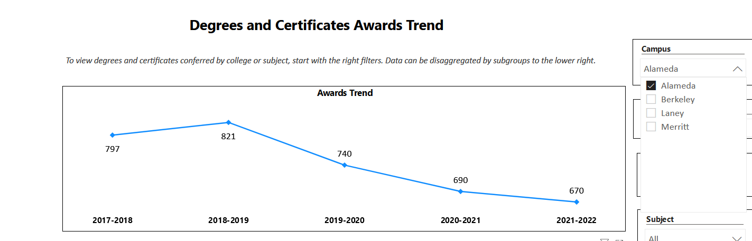
College of Alameda SAS Degrees and Certificates Awards Trend:
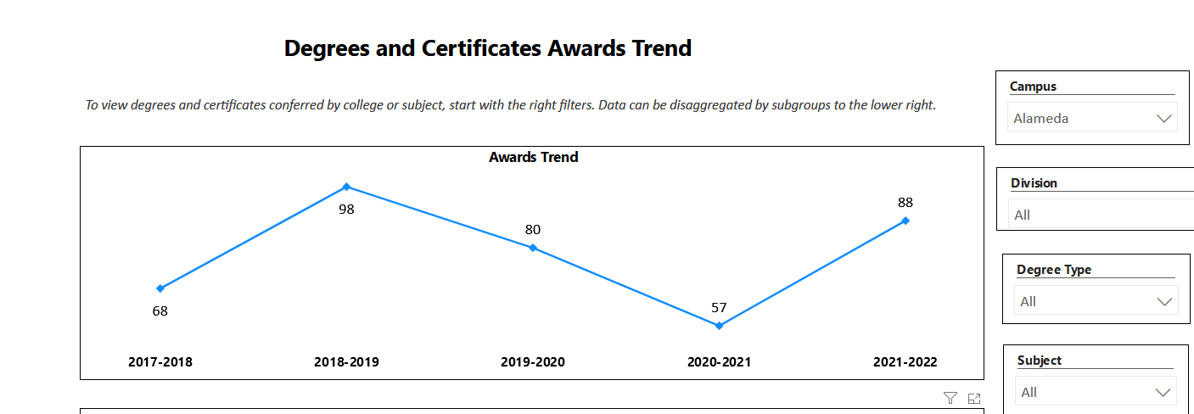
The number of degrees and certificates awarded to College of Alameda students overall has been consistently dropping since the 821 in 2018-19, the trend for students enrolled in SAS have seen improvement, with a return to near 2018-19 levels in 2021-22.

Engagement
How has your department has participated in college wide efforts such as committees, presentations, and departmental activities?
SAS faculty and staff participate as members and co-chairs at both college and district level committees, including: COA Academic Senate, COA Health & Safety, COA Facilities & Technology, COA SEA, COA BIT, District Facilities Committee, and District Holistic Health and Safety. SAS makes presentations to: classes, mental health interns, instructional faculty and at department meetings. SAS participates in District and campus flex days, and offers workshops at those events. SAS tables at campus events and community partnership events.

How has your department has engaged in community activities, partnerships and/or collaborations?
SAS has an ongoing partnership to serve AUSD students with disabilities who are enrolled in their Adult Transition program through exclusive contract classes. SAS presents at outreach events for high school students with disabilities, recruiting and assisting students through the enrollment process. SAS has Community Advisory Committee meetings annually, inviting community members (faculty, staff, students, high school SPED personnel, Department of Rehabilitation, Regional Center, Center for Independent Living and other agencies that work with individuals with disabilities. SAS refers students to community resources and receives student referrals from those resources. SAS refers student to COA grant funded programs like WorkAbility III and College to Career.

Prioritized Resource Requests Summary
In the boxes below, please add resource requests for your program. If there are no resource requested, leave the boxes blank.
Resource Category | Description/Justification | Total Estimated Cost
Personnel: Classified Staff | - 1.0 FTE Support Services Specialist (Accommodations) – cost split college/SAS (responsible for instructor notification, accommodated testing, note taking services, equipment check out to students and compliance issues for alternative media requests). Justification: legal compliance with ADA/Section 504/ SAS currently relies upon long term, hourly full-time personnel who receive no assurance of reemployment and whose position has been threatened by the PCCD HR department with some regularity.  - 1.0 FTE Senior Clerical Assistant cost split college/SAS (responsible for student file maintenance/compliance, MIS input, data management, and other tasks). SAS currently relies upon hourly full-time personnel who receive no assurance of reemployment and whose position has been threatened by the PCCDHR department with some regularity.  - Hourly IAs to assist in SAS Learning Skills, Cognitive Skills and Computer Access courses for students with disabilities. Needed to support access and success for students with disabilities.  - Hourly sign language interpreters and real-time captioners. Required to provide language appropriate access to students who are deaf and hard of hearing.  These positions are essential to the operation of the SAS and meeting federal, state and Title 5 requirements and laws | $79000  $79000  $25000  Varies greatly dependent on enrollment of Deaf students & instructional modality.
Personnel: Student Worker | - Note-takers to provide legally mandated accommodations  - Student workers for labs & office. | $50/notetaker/class – total number of notetakers/classes varies each term.  Depends on instructional & service modality & needs
Personnel: Part Time Faculty | - Part-time faculty to teach Educational Assistance Classes to support the success of students with disabilities.  - 0.5 FTE Assistive Technology Instructor. Previous instructor retired. We need to reinstitute these critically important Assistive Technology classes as we are able to return to on-campus instruction.  - Up to 0.5 FTE Cognitive Skills Instructor. Previous instructor retired spring 2020. SAS is offering limited offerings of these classes utilizing a part-time hourly instructor. | $20000/year  $20000/year
Personnel: Full Time Faculty | - College funding to support additional SAS Counselors hours (adjunct, extra service, or additional month). To ensure appropriate coverage during spring intersession, summer, fall intersession and throughout the academic year.  - College funding to support additional SAS Coordinator hours (additional month or extra service). To ensure appropriate program coverage. | $15500-$30000 depending on the number of counselors/hours/and contracting options.  $12000

Resource Category | Description/Justification | Total Estimated Cost
Professional Development: Department wide PD needed | - Training by the college/district on budget, newly implemented technology, system changes, reporting requirements.  - Health and Safety trainings. | TBD
Professional Development: Personal/Individual PD needed | - Support for registration and travel for Professional Development workshops, trainings, and conferences for faculty and classified professionals to ensure that program personnel remain current in their fields of work. | $6000-8000 if travel inclusive
Supplies: Software | - Updated adaptive software for Adapted Computer Learning Center lab and classes.  - Support for Instructional Neuropsychonline instructional computer program for Cognitive Skills program.  - Updated adaptive technology hardware for use by students.  - Ongoing District or College support of district-wide online data/accommodation management software. | $8000-$10000
Supplies: Books, Magazines, and/or Periodicals | N/A
Supplies: Instructional | - Assorted Classroom Supplies to be determined as needs may vary based on mode of instruction.  - Learning Disability Assessment licensed standardized testing materials | $500-2000
Supplies: Non-Instructional | - Office Supplies  - Cleaning/sanitizing supplies needed for safety of classified professionals, faculty, and student.  - Personal Protective Equipment for use when working on campus. | TBD
Supplies: Library Collections | N/A
Technology & Equipment | - OWL or other equipment to support HyFlex teaching options for SAS Educational Assistance Classes.  - Smartboards for Adapted Computer Learning Center and Learning Skills Program  - Replacement Braille Embosser and computer required to produce brailled materials.  - Refresh of computers, printers, and equipment in the Adapted Computer Learning Center and Learning Skills Program, and in the SAS offices.  - Maintenance contract for the high speed scanner used for creating texts in alternate format to ensure reliable access to curriculum and extend hardware life. | TBD  TBD  $8000  TBD  TBD
Library materials/collections
Facilities: Classrooms/Labs | - Learning Skills Program is currently assigned to the H Building – SAS requests that this re-location is made permanent as an unshared space. The former L210 classroom and requires major upgrades to HVAC in order to ensure a safe, healthy learning environment free of extreme heat and cold and in alignment with COVID safety precaution guidelines, and it needs electrical upgrades to ensure consistent power and functionality necessary for effective teaching.  - Adapted Computer Learning Center (D116) – requires functional HVAC in order to ensure a safe, healthy learning environment free of extreme heat and cold and in alignment with COVID safety precaution guidelines
Facilities: Offices | - SAS office /ACLC (D117 & D116) and Learning Skills Program (L210) offices need upgrades to HVAC in order to ensure a safe, healthy work environment free of extreme heat and cold.  - SAS office (D117) needs removal of tripping hazard (1” lip at entry door).  - SAS office door needs repair/adjustment by the manufacturer (per COA engineering) in order to operate correctly.
Other | - Dedicated space appropriate for the provision of proctored testing for student with disabilities. Space must allow for appropriate distancing for health and safety precautions and allow sufficient ventilation and air exchange.  - Dedicated space for the production of brailled material. This space must be secured to store SAS brailling equipment. Due to the loud nature of braille production this space needs to be separate from SAS classes, labs and offices.  - Dedicated, accessible space, for the storage of materials that have been removed from previously assigned spaces.

